Chapter 3. Apache Spark’s Structured APIs

Spark SQL introduced high-level expressive operational functions, mimicking SQL-like syntax, and DataFrames, which laid the foundation for more structure in subsequent releases, paved the path to performant operations in Spark’s computational queries.

Resilient Distributed Dataset(RDD)

Spark: What’s Underneath an RDD?

The RDD is the most basic abstraction in Spark. There are three vital characteristics associated with an RDD:
- Dependencies
- Partitions (with some locality information)
- Compute function: Partition => Iterator[T]
First, a list of dependencies that instructs Spark how an RDD is constructed with its inputs is required. When necessary to reproduce results, Spark can recreate an RDD from these dependencies and replicate operations on it. This characteristic gives RDDs resiliency.
Second, partitions provide Spark the ability to split the work to parallelize computation on partitions across executors. In so me cases—for example, reading from HDFS—Spark will use locality information to send work to executors close to the data. That way less data is transmitted over the network.
And finally, an RDD has a compute function that produces an Iterator[T] for the data that will be stored in the RDD.

Structuring Spark

One is to express computations by using common patterns found in data analysis. These patterns are expressed as high-level operations such as filtering, selecting, counting, aggregating, averaging, and grouping. This provides added clarity and simplicity.
Spark Session?
Spark Context?

Schemas and Creating DataFrames
A schema in Spark defines the column names and associated data types for a DataFrame. Most often, schemas come into play when you are reading structured data from an external data source (more on this in the next chapter). Defining a schema up front as opposed to taking a schema-on-read approach offers three benefits:
- You relieve Spark from the onus of inferring data types.
- You prevent Spark from creating a separate job just to read a large portion of your file to ascertain the schema, which for a large data file can be expensive and time-consuming.
- You can detect errors early if data doesn’t match the schema.
A relation schema is the logical definition of a table - it defines what the name of the table is, and what the name and type of each column is. It's like a plan or a blueprint. A database schema is the collection of relation schemas for a whole database.(SQL).

Common DataFrame Operations
To perform common data operations on DataFrames, you’ll first need to load a DataFrame from a data source that holds your structured data. Spark provides an interface, DataFrameReader, that enables you to read data into a DataFrame from myriad data sources in formats such as JSON, CSV, Parquet, Text, Avro, ORC, etc. Likewise, to write a DataFrame back to a data source in a particular format, Spark uses DataFrameWriter.

Using DataFrameReader and DataFrameWriter
Reading and writing are simple in Spark because of these high-level abstractions and contributions from the community to connect to a wide variety of data sources, including common NoSQL stores, RDBMSs, streaming engines such as Apache Kafka and Kinesis, and more.
Parquet is an open source file format available to any project in the Hadoop ecosystem. Apache Parquet is designed for efficient as well as performant flat columnar storage format of data compared to row based files like CSV or TSV files.
Parquet uses the record shredding and assembly algorithm which is superior to simple flattening of nested namespaces. Parquet is optimized to work with complex data in bulk and features different ways for efficient data compression and encoding types. This approach is best especially for those queries that need to read certain columns from a large table. Parquet can only read the needed columns therefore greatly minimizing the IO.( Don’t understand).

The following table compares the savings as well as the speedup obtained by converting data into Parquet from CSV.

Dataset | Size on Amazon S3 | Query Run Time | Data Scanned | Cost
Data stored as CSV files | 1 TB | 236 seconds | 1.15 TB | $5.75
Data stored in Apache Parquet Format | 130 GB | 6.78 seconds | 2.51 GB | $0.01
Savings | 87% less when using Parquet | 34x faster | 99% less data scanned | 99.7% savings

https://databricks.com/glossary/what-is-parquet#:~:text=Parquet%20is%20an%20open%20source,like%20CSV%20or%20TSV%20files.

Transformations and actions

Now that you have a distributed DataFrame composed of San Francisco Fire Department calls in memory, the first thing you as a developer will want to do is examine your data to see what the columns look like. Are they of the correct types? Do any of them need to be converted to different types? Do they have null values?

Projections and filters:

A projection in relational parlance is a way to return only the rows matching a certain relational condition by using filters. In Spark, projections are done with the select() method, while filters can be expressed using the filter() or where() method.

Renaming, adding, and dropping columns
Sometimes you want to rename particular columns for reasons of style or convention, and at other times for readability or brevity.
Renaming:
Because DataFrame transformations are immutable, when we rename a column using withColumnRenamed() we get a new DataFrame while retaining the original with the old column name.

Aggregations:
A handful of transformations and actions on DataFrames, such as groupBy(), orderBy(), and count(), offer the ability to aggregate by column names and then aggregate counts across them.
The DataFrame API also offers the collect() method, but for extremely large DataFrames this is resource-heavy (expensive) and dangerous, as it can cause out-of-memory (OOM) exceptions. Unlike count(), which returns a single number to the driver, collect() returns a collection of all the Row objects in the entire DataFrame or D ataset. If you want to take a peek at some Row records you’re better off with take(n), which will return only the first n Row objects of the DataFrame.

The Dataset API
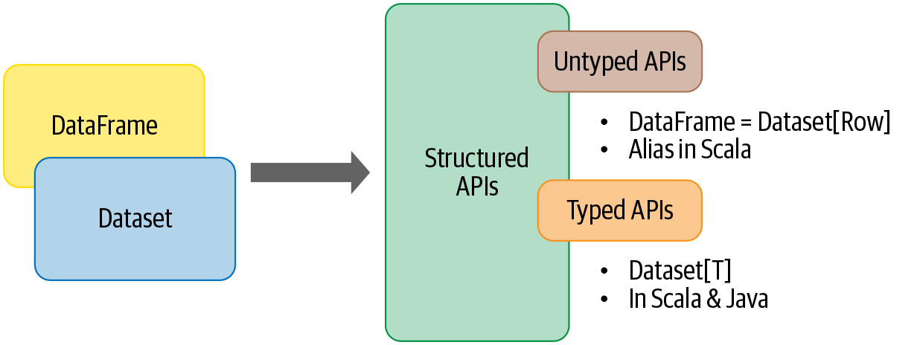

Again, for brevity, we won’t include all the example code here; however, we have furnished the notebook in the GitHub repo. The notebook explores common operations you might conduct with this data set. Using the Dataset API, we attempt to do the following:
- Detect failing devices with battery levels below a threshold.
- Identify offending countries with high levels of CO2 emissions.
- Compute the min and max values for temperature, battery level, CO2, and humidity.
- Sort and group by average temperature, CO2, humidity, and country.

Spark SQL and the Underlying Engine

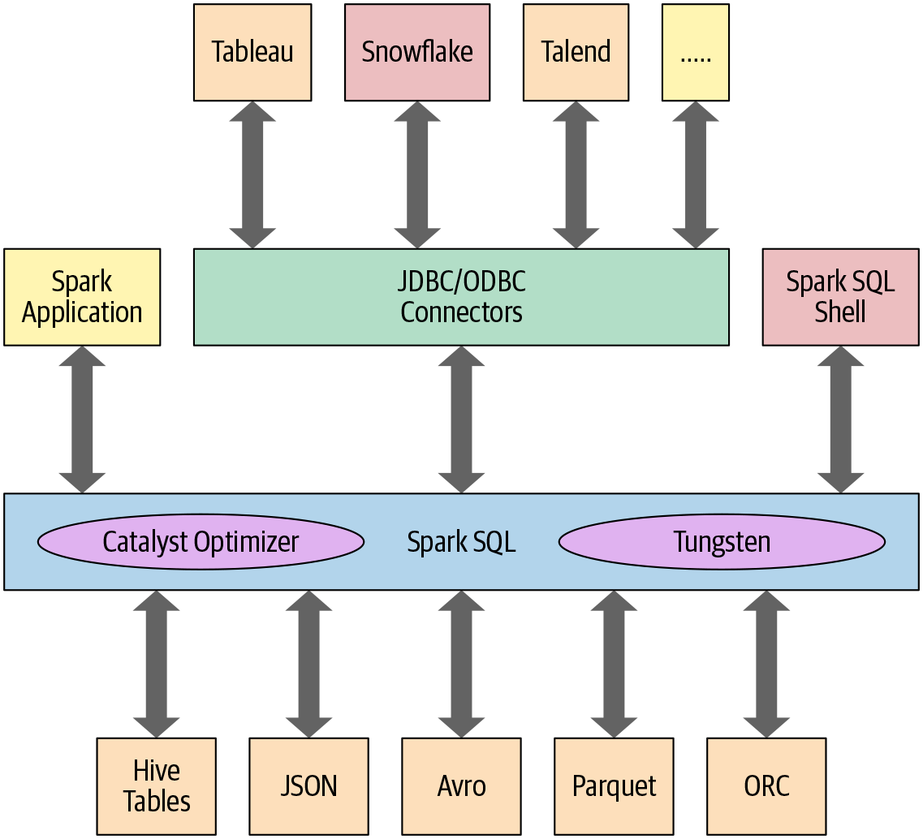
At the core of the Spark SQL engine are the Catalyst optimizer and Project Tungsten. Together, these support the high-level DataFrame and Dataset APIs and SQL queries.

The Catalyst Optimizer

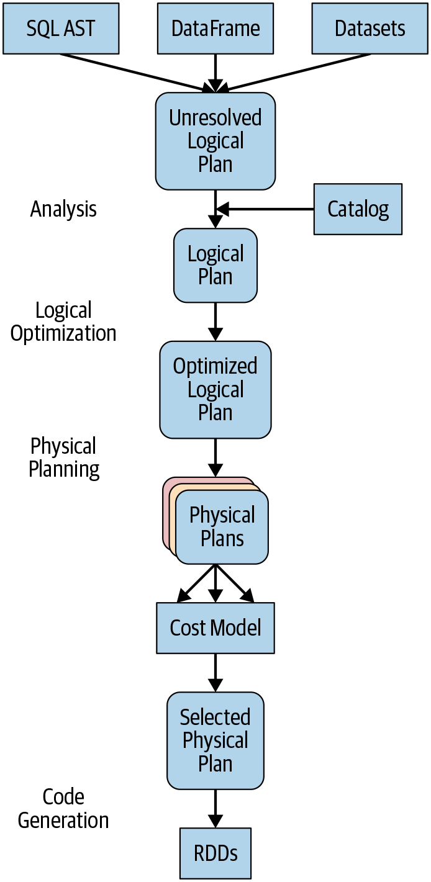

The Catalyst optimizer takes a computational query and converts it into an execution plan. It goes through four transformational phases, as shown in Figure 3-4:
- Analysis
- Logical optimization
- Physical planning
- Code generation

