**ASSIGNMENT DBI**

**GROUP 4: PICO.VN**

**MÔ HÌNH ER**

1. **Biểu đồ ER**

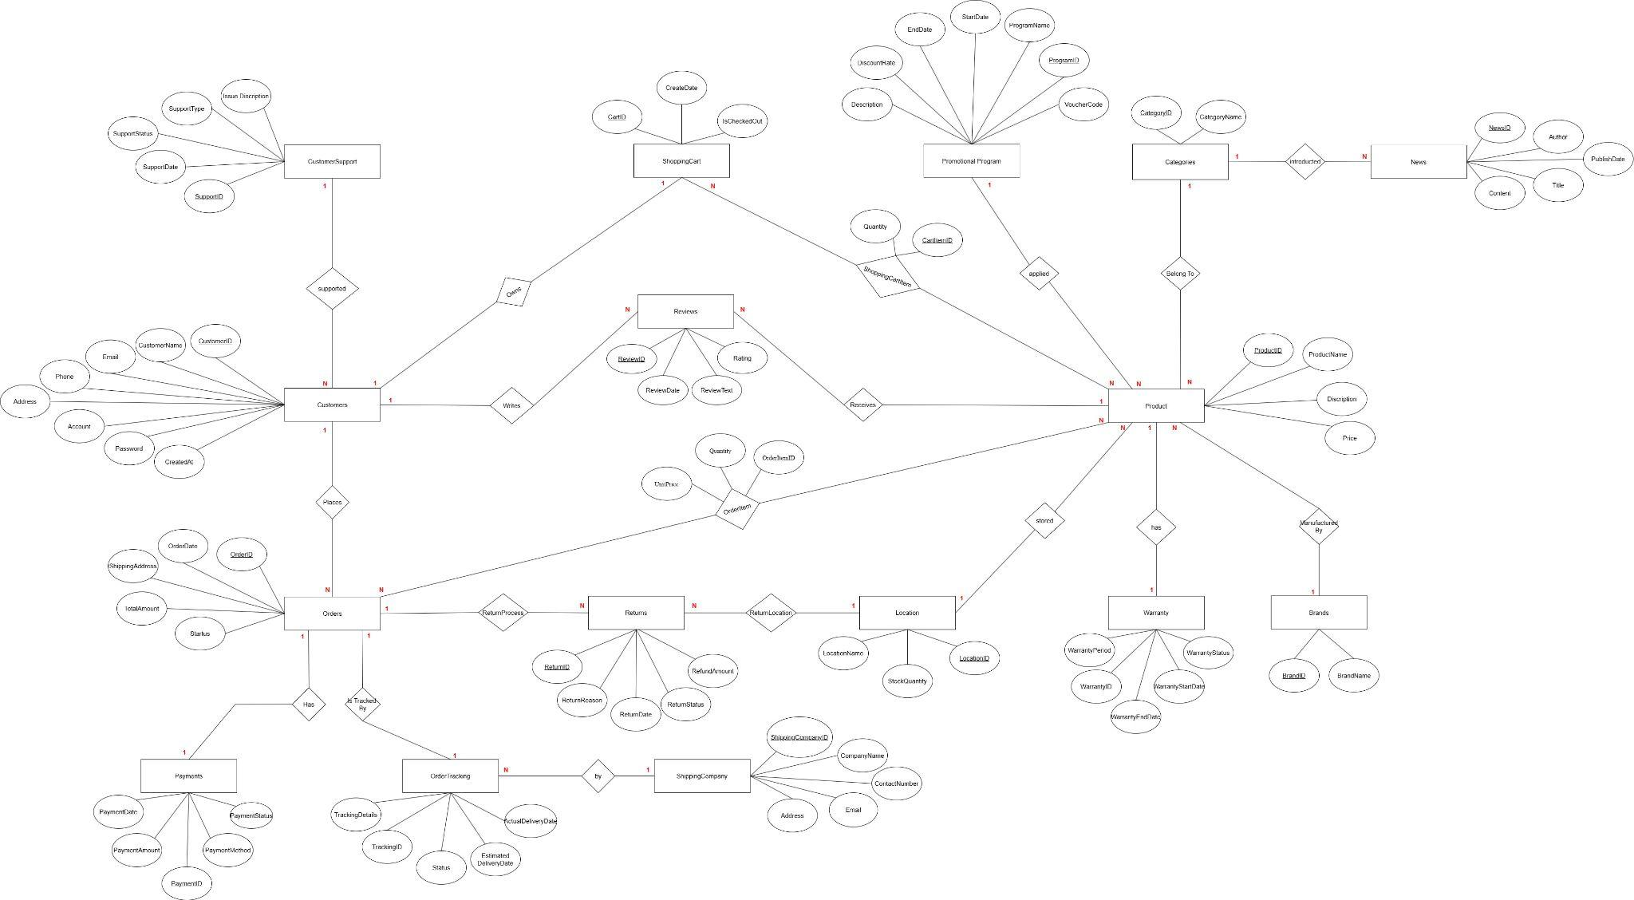

1. **Mô hình dữ liệu quan hệ**

* **Customers**(CustomerID, CustomerName, Email, Phone, Address, Account, Password, CreatedAt)
* **Products**(ProductID, ProductName, Description, Price, *CategoryID, BrandID, LocationID, ProgramID*)
* **Categorie**s(CategoryID, CategoryName)
* **Brands**(BrandID, BrandName)
* **Orders**(OrderID, OrderDate, ShippingAddress, TotalAmount, Status, *CustomerID*)
* **OrderItems**(OrderItemID, Quantity, UnitPrice , *OrderID, ProductID*)
* **Payments**(PaymentID, PaymentMethod, PaymentStatus, PaymentAmount, PaymentDate, *OrderID*)
* **Reviews**(ReviewID, Rating, ReviewText, ReviewDate, *CustomerID, ProductID*)
* **Promotional program**(ProgramID, ProgramName, StartDate, EndDate, DiscountRate, Description, VoucherCode, *ProductID*).
* **OrderTracking**(TrackingID, Status, EstimatedDeliverate, ActualDeliveryDate, TrackingDetails, *ShippingCompanyID, OrderID*).
* **ShippingCompany**(ShippingCompanyID, CompanyName, ContactNumber, Email, Address, *TrackingID*)
* **ShoppingCart**(CartID, CreatedDate, IsCheckedOut, *CustomerID*)
* **ShoppingCartItems**(CartItemID, Quantity, *CartID, ProductID*)
* **Location**(LocationID, LocationName, StockQuantity, *ProductID*)
* **CustomerSupport**(SupportID, SupportDate, SupportType, IssueDescription, SupportStatus, *CustomerID*)
* **Warranty**(WarrantyID, WarrantyPeriod, WarrantyStartDate, WarrantyEndDate, WarrantyStatus, *ProductID*)
* **Returns**(ReturnID, ReturnReason, ReturnDate, ReturnStatus, RefundAmount, *OrderID, ProductID, LocationID*)