Medical Laboratory Management, WhatsApp Automation & AI Patient Engagement Platform
Business Requirements Document | Version 1.2 | 08 August 2026
HIGHLY CONFIDENTIAL — CLIENT REVIEW COPY
Illustrative POC UI designs have been added to demonstrate the intended product experience. These screens are visual prototypes and will be refined during final UI/UX implementation.

1. Executive Summary

Overview
The proposed platform is a modern digital system for medical laboratories. It is intended to manage laboratory operations and improve the patient experience from registration through report delivery, AI assistance and follow-up.

Business value
- Reduce manual laboratory work.
- Centralize patient, test, sample, result and report information.
- Generate and deliver reports digitally.
- Use WhatsApp for convenient patient communication.
- Allow patients to request AI-assisted report explanations.
- Enable appointment booking through WhatsApp.
- Support approved patient engagement and promotional campaigns with consent controls.
- Provide operational dashboards.

2. Proposed Solution

Core journey
Patient Registration → Test Booking → Sample Collection → Testing → Result Entry → Report Verification → Report Delivery → AI Assistance → Follow-up / Appointment.

Operating flexibility
The system can support a single-user laboratory as well as laboratories with multiple staff members and branches. Access can be configured according to the laboratory's operating model.

3. Laboratory Management

Patient management
- Patient registration and unique patient ID.
- Patient contact details and history.
- Search and previous report access.
- Communication preferences.

Test management
- Configurable test catalog.
- Test parameters, units and reference ranges.
- Test packages and profiles.
- Pricing configuration.

Sample management
- Sample registration and tracking.
- Barcode readiness.
- Collection and processing status.
- Rejected/recollection workflow.

Result and verification
- Technician result entry.
- Review and verification by authorized personnel.
- Controlled finalization of reports.
- Audit trail for important changes.

4. Report Management

Features
- Professional digital report generation.
- Customizable report formats.
- Patient and report identifiers.
- Reference ranges and abnormal indicators.
- Authorized reviewer information.
- Secure report storage.
- Optional QR-based report verification.

5. WhatsApp Automation

Automated report delivery
Once a report is finalized, the system can automatically initiate the configured WhatsApp communication flow so the patient receives the report without requiring staff to repeat the communication manually.

Patient actions
- View/download report
- Analyze with AI
- Book appointment
- Request assistance
- Receive approved reminders and notifications

Automation
A workflow automation layer will coordinate report delivery, WhatsApp messages, AI requests, appointment actions and follow-up notifications.

6. AI Report Assistance

Patient experience
After receiving a report, the patient can choose an Analyze with AI option. The system retrieves the relevant report and provides a simple explanation of the report and its terminology.

Capabilities
- Simple report summary.
- Explanation of report parameters.
- Explanation of values using the reference information displayed on the report.
- General questions about report terminology.
- Historical comparison where enabled.

Safety
AI assistance is intended for information and education. It is not a substitute for a doctor and will be designed not to present AI output as a diagnosis or treatment instruction.

7. Appointment Booking through WhatsApp

Workflow
A patient can select an appointment action from WhatsApp, choose an available service/date/time, confirm the booking and receive a confirmation message.

Potential services
- Laboratory visit
- Follow-up testing
- Home sample collection
- Other services configured by the laboratory

8. Patient Engagement & Promotional Campaigns

Business requirement
The platform can provide a campaign capability for patient reminders, preventive testing communications, service announcements, approved offers and follow-up messages through WhatsApp.

Personalized engagement
Where permitted and properly consented, communications may be tailored using configured patient information and service eligibility rules. The objective is relevant patient engagement rather than generic mass messaging.

Example
A patient may receive an approved follow-up testing message with a Book Appointment action. Eligibility rules and message wording can be configured and approved by the laboratory.

Privacy principle
Health information is sensitive. The platform will use consent, purpose controls, access restrictions and approved campaign rules. Health information should not be automatically exported to external advertising platforms for individual targeting without a separately validated lawful basis and policy review.

9. Notifications & Reminders

Examples
- Report ready notification
- Appointment confirmation
- Appointment reminder
- Home collection reminder
- Service/follow-up reminder
- Approved promotional campaign
- Important operational notifications

10. Dashboards & Reporting

Laboratory dashboard
- Patients
- Orders
- Pending samples
- Pending results
- Reports awaiting verification
- Completed reports
- Report delivery status

Management insights
- Test volumes
- Revenue/collections where billing is enabled
- Turnaround time
- Branch performance
- WhatsApp engagement
- AI usage
- Appointment activity
- Campaign performance

11. User Access

Flexible access
The system can support a single-user laboratory where one authorized user manages the complete workflow, while also supporting multiple users with different responsibilities.

Typical roles
Administrator, Reception, Technician, Authorized Reviewer/Pathologist, Billing, Collection Staff and other roles as required.

12. Security & Privacy

Requirements
- Secure login and role-based access.
- Controlled access to patient reports.
- Audit history for important activities.
- Secure report links.
- Backup and recovery controls.
- Consent and communication preference management.
- Separate operational and promotional communications.

Compliance
The solution will be designed with applicable Indian data-protection and healthcare requirements in mind. Final legal notices, consent language, retention periods and compliance controls should be confirmed with the client's authorized legal/compliance representatives before production launch.

13. Implementation Approach

Phase 1
- Laboratory core
- Patient and test management
- Sample/result workflow
- Report generation
- WhatsApp report delivery
- AI report assistance
- Basic appointment booking
- Basic dashboard

Phase 2
- Advanced roles and permissions
- Barcode workflows
- Patient portal
- Home collection
- Engagement campaigns
- Advanced analytics
- Multi-branch features

Phase 3
- Advanced external integrations
- Analyzer/device integrations
- Advanced AI capabilities
- Enterprise analytics

14. Expected Business Outcomes

Outcomes
- Faster report delivery.
- Reduced manual communication effort.
- Better patient access to reports.
- Improved patient engagement.
- Convenient appointment booking.
- Better operational visibility.
- Reusable digital workflows for future growth.
- Ability to offer new patient services and approved campaigns.

15. Assumptions & Dependencies

Assumptions
- The laboratory will provide required test catalogs, report formats and operational rules.
- Authorized staff will validate medical results before final publication.
- WhatsApp Business setup and approved messaging configuration will be completed.
- AI will be configured for patient education and report understanding.
- Campaigns will operate under agreed consent and communication policies.

Dependencies
- WhatsApp Business Platform/provider availability and approval.
- Cloud/hosting environment.
- AI service availability.
- Client-approved report templates.
- Client-approved appointment rules and availability.
- Client-approved communication and campaign content.

16. Acceptance Overview

Pilot readiness
- A patient can be registered and a test order created.
- Samples/results can be managed through the configured workflow.
- An authorized user can finalize a report.
- The report can be delivered through the configured WhatsApp flow.
- The patient can request AI assistance for the correct report.
- An appointment can be initiated and confirmed through the supported flow.
- Authorized staff can manage communication preferences and approved campaigns.
- Operational dashboards show key workflow statuses.

17. Next Steps

Recommended next steps
- Confirm the laboratory's current workflow.
- Finalize test catalog and report formats.
- Confirm WhatsApp Business requirements.
- Define user roles and operating model.
- Define appointment types and availability.
- Define consent and communication requirements.
- Confirm AI use cases and safety wording.
- Freeze Phase 1 scope.
- Prepare implementation schedule and acceptance testing plan.

18. POC UI Designs & User Experience
The following polished visual concepts represent the proposed direction for the product's proof of concept. They demonstrate how the laboratory dashboard, report, WhatsApp experience and complete workflow can work together.
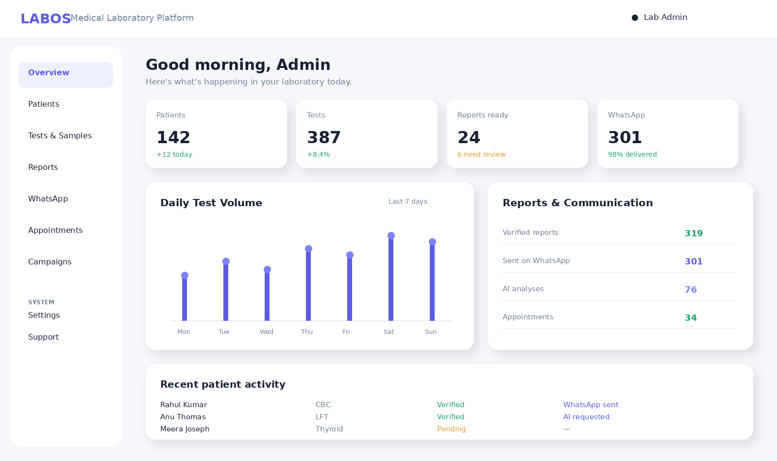
POC Screen 1 — Laboratory Dashboard
A clean operational dashboard provides a single view of patients, tests, reports, WhatsApp delivery, AI usage and appointments.

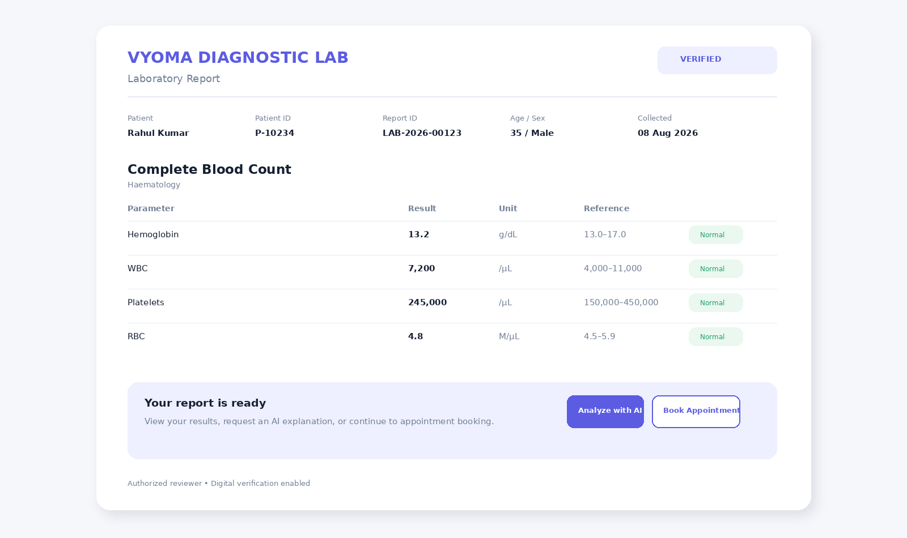
POC Screen 2 — Digital Laboratory Report
The report interface is designed around clarity, verification status and patient actions such as AI assistance and appointment booking.

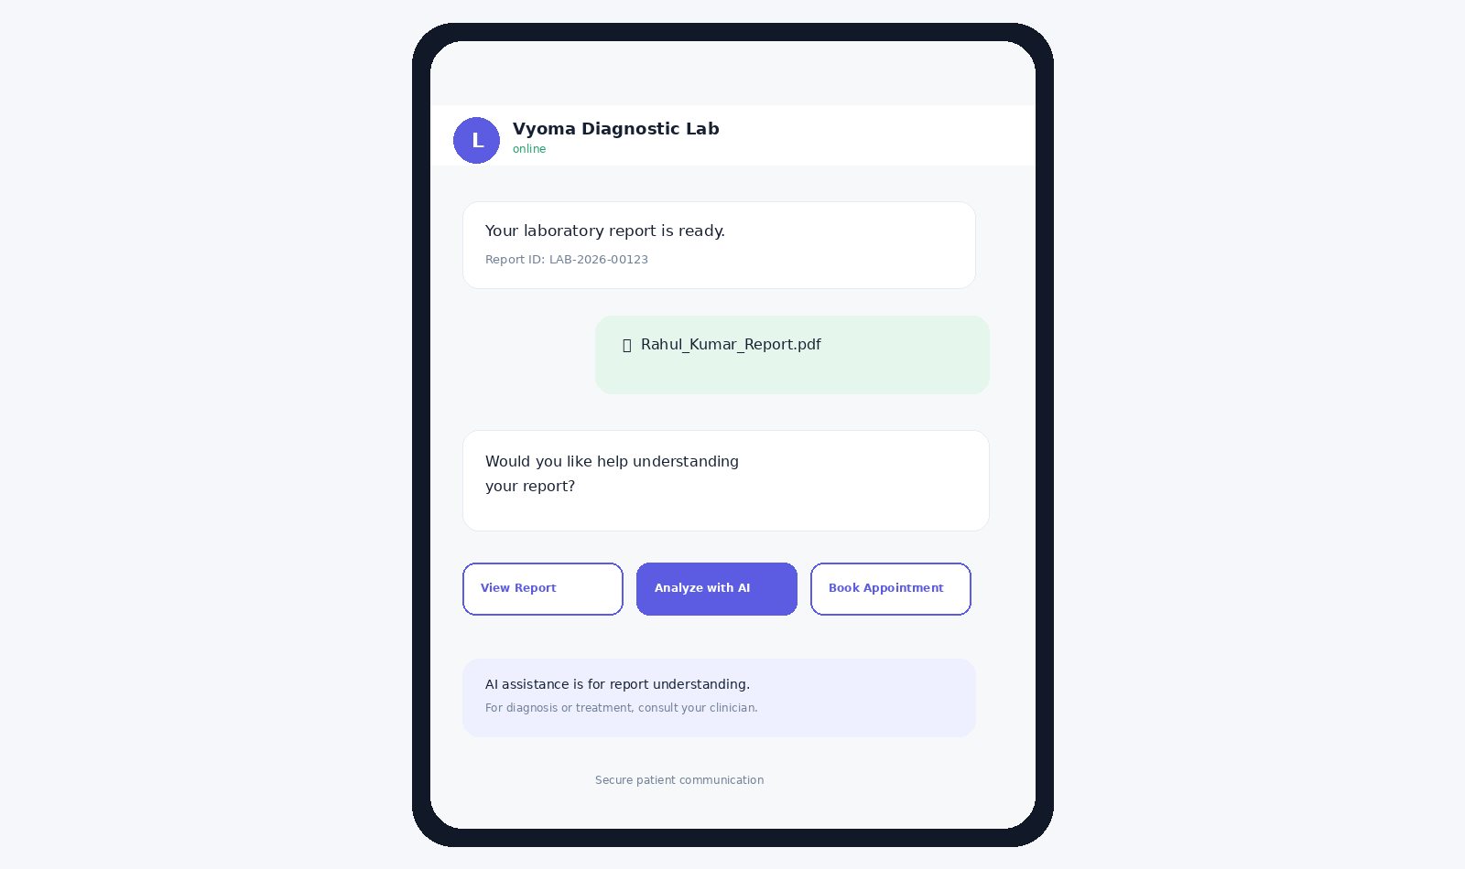
POC Screen 3 — WhatsApp Patient Experience
The patient receives the report and can continue directly into AI assistance or appointment booking from the same communication journey.

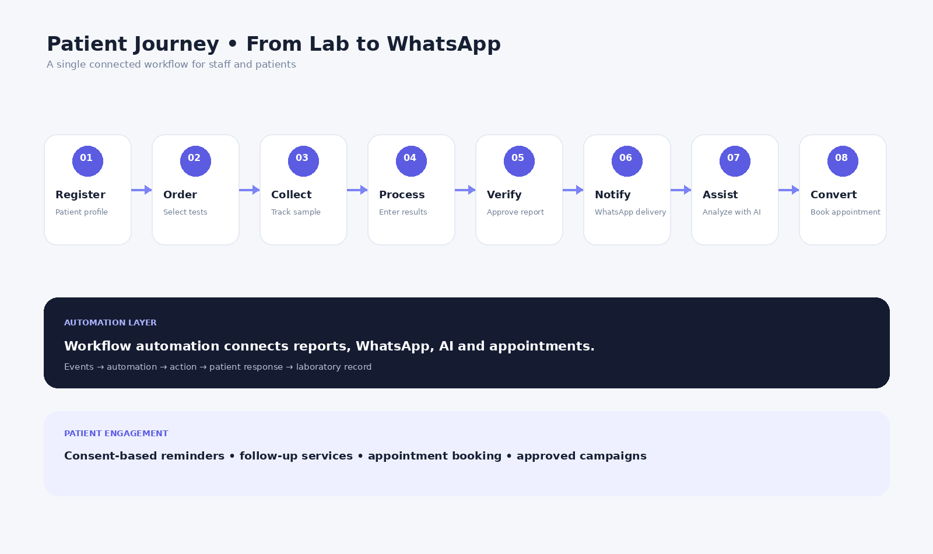
POC Screen 4 — Connected Patient Workflow
The complete journey connects laboratory operations, workflow automation, WhatsApp, AI assistance and consent-based patient engagement.

19. Simplified Patient Journey
Patient Registration → Test Order → Sample Collection → Result Processing → Report Verification → WhatsApp Delivery → Analyze with AI → Follow-up / Appointment.

20. Scope Boundary
The platform supports laboratory operations and patient communication. It is not intended to replace clinical professionals or independently diagnose or treat patients. Promotional communication will be subject to consent, approved business rules and applicable policies.

