Vyom Desai – 24BCE10318

1. package CRUD;
import java.sql.Connection;
import java.sql.DriverManager;
public class DB_Connection {
public static void main(String[] args) {
DB_Connection obj_DB_Connection=new DB_Connection();
System.out.println(obj_DB_Connection.get_connection());
}
public Connection get_connection(){
Connection connection=null;
try {
Class.forName("com.mysql.cj.jdbc.Driver");
connection = DriverManager.getConnection("jdbc:mysql://localhost:3306/crud","root", "Vyommd@020406");
} catch (Exception e) {
System.out.println(e);
}
return connection;
}
}

2. package CRUD;
import java.sql.Connection;
import java.sql.PreparedStatement;
import java.sql.ResultSet;
public class CRUD_Test {

public static void main(String[] args) {
CRUD_Test objTest=new CRUD_Test();
//insert data
objTest.create_data("1", "jinu", "jinu@gmail.com");
objTest.create_data("2", "jawad", "jawad@gmail.com");
//read data
objTest.read_data("2");
//update data
objTest.update_data("2", "22", "jawad2", "jawad2@gmail");
//delete data
objTest.delete_data("1");
}

public void create_data(String sl_no,String name,String email){
DB_Connection obj_DB_Connection=new DB_Connection();
Connection connection=obj_DB_Connection.get_connection();
PreparedStatement ps=null;
try {
String query="insert into user(sl_no,name,email) values (?,?,?)";
ps=connection.prepareStatement(query);
ps.setString(1, sl_no);
ps.setString(2, name);
ps.setString(3, email);
System.out.println(ps);
ps.executeUpdate();
} catch (Exception e) {
System.out.println(e);
}
}

public void read_data(String sl_no){
DB_Connection obj_DB_Connection=new DB_Connection();
Connection connection=obj_DB_Connection.get_connection();
PreparedStatement ps=null;
ResultSet rs=null;
try {
String query="select * from user";
ps=connection.prepareStatement(query);
//ps.setString(1, sl_no);
System.out.println(ps);
rs=ps.executeQuery();
while(rs.next()){
System.out.println("Sl no -"+rs.getString("sl_no"));
System.out.println("name -"+rs.getString("name"));
System.out.println("email -"+rs.getString("email"));
System.out.println("---------------");
}
} catch (Exception e) {
System.out.println(e);
}
}

public void update_data(String sl_no,String new_sl_no,String name,String email){
DB_Connection obj_DB_Connection=new DB_Connection();
Connection connection=obj_DB_Connection.get_connection();
PreparedStatement ps=null;
try {
String query="update user set sl_no=?,name=?,email=? where sl_no=?";
ps=connection.prepareStatement(query);
ps.setString(1, new_sl_no);
ps.setString(2, name);
ps.setString(3, email);
ps.setString(4, sl_no);
System.out.println(ps);
ps.executeUpdate();
} catch (Exception e) {
System.out.println(e);
}
}

public void delete_data(String sl_no){
DB_Connection obj_DB_Connection=new DB_Connection();
Connection connection=obj_DB_Connection.get_connection();
PreparedStatement ps=null;
try {
String query="delete from user where sl_no=?";
ps=connection.prepareStatement(query);
ps.setString(1, sl_no);
System.out.println(ps);
ps.executeUpdate();
} catch (Exception e) {
System.out.println(e);
}

}
}

Output
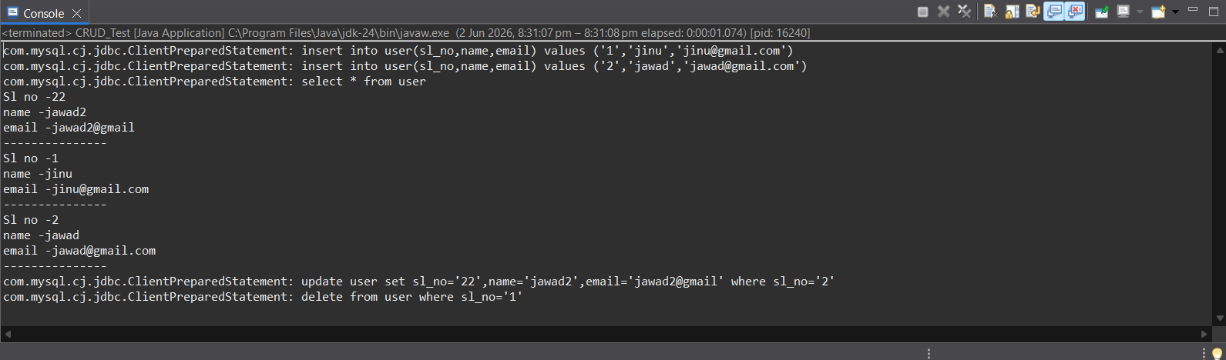
3. package CRUD;

import java.sql.Connection;
import java.sql.PreparedStatement;
import java.sql.ResultSet;

public class connect {

public static void main(String[] args) {

connect objTest = new connect();

// Insert
objTest.create_data("1", "jinu", "jinu@gmail.com");
objTest.create_data("2", "jawad", "jawad@gmail.com");

// Read
objTest.read_data("2");

// ALTER TABLE
objTest.alterTable();

// TRUNCATE TABLE

objTest.truncateTable();
}

public void create_data(String sl_no, String name, String email) {

DB_Connection obj_DB_Connection = new DB_Connection();
Connection connection = obj_DB_Connection.get_connection();

try {
String query = "insert into user(sl_no,name,email) values (?,?,?)";

PreparedStatement ps = connection.prepareStatement(query);

ps.setString(1, sl_no);
ps.setString(2, name);
ps.setString(3, email);

System.out.println(ps);

ps.executeUpdate();

} catch (Exception e) {
System.out.println(e);
}
}

public void read_data(String sl_no) {

DB_Connection obj_DB_Connection = new DB_Connection();
Connection connection = obj_DB_Connection.get_connection();

try {
String query = "select * from user where sl_no=?";

PreparedStatement ps = connection.prepareStatement(query);

ps.setString(1, sl_no);

System.out.println(ps);

ResultSet rs = ps.executeQuery();

while (rs.next()) {

System.out.println("Sl no - " + rs.getString("sl_no"));
System.out.println("Name - " + rs.getString("name"));
System.out.println("Email - " + rs.getString("email"));
System.out.println("----------------");
}

} catch (Exception e) {
System.out.println(e);
}
}

public void alterTable() {

DB_Connection obj_DB_Connection = new DB_Connection();
Connection connection = obj_DB_Connection.get_connection();

try {

String query =
"ALTER TABLE user ADD phone VARCHAR(20)";

PreparedStatement ps = connection.prepareStatement(query);

System.out.println(ps);

ps.executeUpdate();

System.out.println("Column phone added successfully");

} catch (Exception e) {
System.out.println(e);
}
}

public void truncateTable() {

DB_Connection obj_DB_Connection = new DB_Connection();
Connection connection = obj_DB_Connection.get_connection();

try {

String query = "TRUNCATE TABLE user";

PreparedStatement ps = connection.prepareStatement(query);

System.out.println(ps);

ps.executeUpdate();
System.out.println("All records deleted successfully");

} catch (Exception e) {
System.out.println(e);
}
}
}
Output
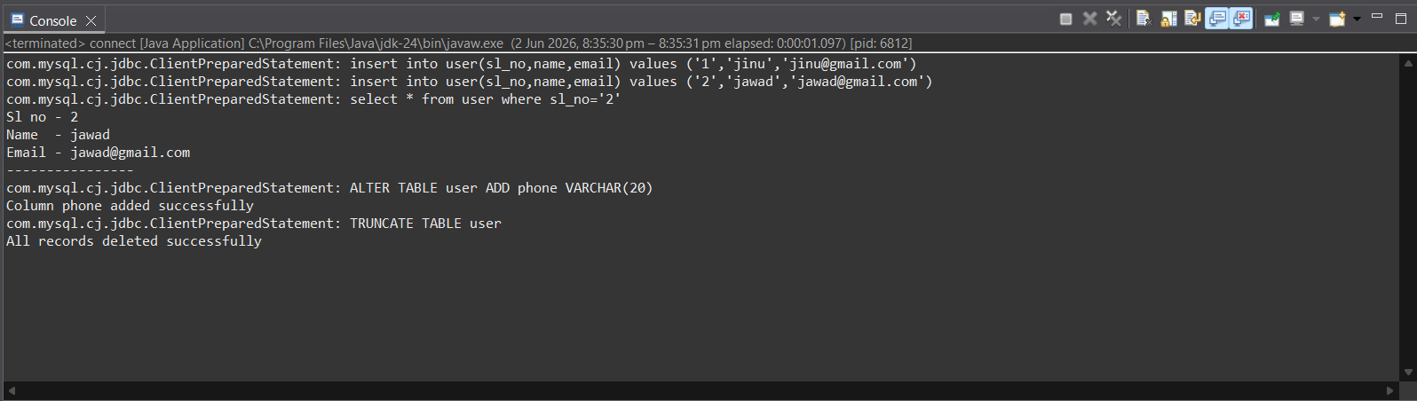

4.
