PROJECT REPORT
Inventory Management
System
Backend REST API using Spring Boot and MongoDB

Submitted By
Vyom Desai
Registration No: 24BCE10318

1. Introduction
The Inventory Management System is a backend-based application developed using Spring Boot and MongoDB. The system is designed to manage inventory records efficiently by maintaining information related to suppliers, categories, products, and orders. It provides RESTful APIs for performing CRUD operations, inventory tracking, stock management, and order processing.

2. Objectives
- Develop a backend-based Inventory Management System using Spring Boot and MongoDB.
- Manage Products, Suppliers, Categories, and Orders efficiently.
- Implement CRUD operations for all entities.
- Establish relationships between MongoDB collections.
- Track inventory stock and maintain order records.
- Test APIs using Postman and document them using Swagger.

3. Tools and Technologies Used
The following tools and technologies were used in the development of this project:
Tool / Technology | Version | Purpose
Java | 17 | Primary programming language
Spring Boot | 3.2.0 | Backend framework for building REST APIs
Spring Data MongoDB | 3.2.0 | MongoDB integration and repository layer
Spring Validation | 3.2.0 | Jakarta Bean Validation for request DTOs
MongoDB | 6.x | NoSQL document database
Maven | 3.9+ | Build tool and dependency management
Swagger / OpenAPI | 2.3.0 | Interactive API documentation (Swagger UI)
Lombok | Latest | Reduces boilerplate — getters, builders
Postman | Latest | API testing and collection management
IntelliJ IDEA | 2025.3 | Integrated Development Environment (IDE)

4. Collections Used
The application uses four MongoDB collections to store all data:
Collection | Description
suppliers | Stores supplier details — name, email, phone, and address.
categories | Stores product category name and description.
products | Stores product details including price, stock quantity, and references to supplier and category.
orders | Stores order date, status, total amount, and an embedded list of ordered products (OrderItems).

5. Relationships Between Collections
Although MongoDB is a NoSQL database, logical relationships are maintained between collections using ID references enforced at the service layer.

Relationship Diagram
Supplier (1) ─────────────────── (M) Product
Category (1) ─────────────────── (M) Product
Order (1) ─────────────────── (M) OrderItem
Product (1) ─────────────────── (M) OrderItem

Relationship Details
- One Supplier can supply multiple Products (One-to-Many)
- One Category can contain multiple Products (One-to-Many)
- One Order can contain multiple Order Items (One-to-Many)
- A Product can appear in multiple Order Items (One-to-Many)

6. Methodology
The project was developed following a structured, iterative approach. Each entity was built layer by layer — from model to repository to service to controller — before moving on to the next entity. This ensured each component was fully functional and testable before proceeding.

Development Steps
- Requirement Analysis — Identify all entities, their fields, and the CRUD operations needed for each.
- Database Design — Define MongoDB collections and the relationships between them.
- Backend Development — Implement models, repositories, services, and controllers in layered order.
- API Development — Expose REST endpoints for all four entities using Spring MVC controllers.
- Validation & Exception Handling — Apply Jakarta Bean Validation on DTOs and handle all errors globally using @RestControllerAdvice.
- Testing — Test all 20 API endpoints using Postman and Swagger UI in sequence — Supplier → Category → Product → Order.
- Documentation — Auto-generate Swagger / OpenAPI documentation using SpringDoc.

7. API Endpoints
Base URL: http://localhost:8080/api/v1

Group | Method | Endpoint | Description
Supplier | POST | /api/v1/suppliers | Create a new supplier
 | GET | /api/v1/suppliers | Get all suppliers
 | GET | /api/v1/suppliers/{supplierId} | Get supplier by ID
 | PUT | /api/v1/suppliers/{supplierId} | Update supplier
 | DELETE | /api/v1/suppliers/{supplierId} | Delete supplier
Category | POST | /api/v1/categories | Create a new category
 | GET | /api/v1/categories | Get all categories
 | GET | /api/v1/categories/{categoryId} | Get category by ID
 | PUT | /api/v1/categories/{categoryId} | Update category
 | DELETE | /api/v1/categories/{categoryId} | Delete category
Product | POST | /api/v1/products | Create a new product
 | GET | /api/v1/products | Get all products
 | GET | /api/v1/products/{productId} | Get product by ID
 | PUT | /api/v1/products/{productId} | Update product
 | DELETE | /api/v1/products/{productId} | Delete product
Order | POST | /api/v1/orders | Create order (deducts stock)
 | GET | /api/v1/orders | Get all orders
 | GET | /api/v1/orders/{orderId} | Get order by ID
 | PUT | /api/v1/orders/{orderId} | Update order
 | DELETE | /api/v1/orders/{orderId} | Delete order (restores stock)

8. API Testing and Documentation
The REST APIs were tested using Postman. Swagger was used to generate interactive API documentation for easy testing and understanding of all endpoints.
Swagger UI URL: http://localhost:8080/swagger-ui/index.html

9. Output Screenshots and Behavioral Explanation

A) Suppliers

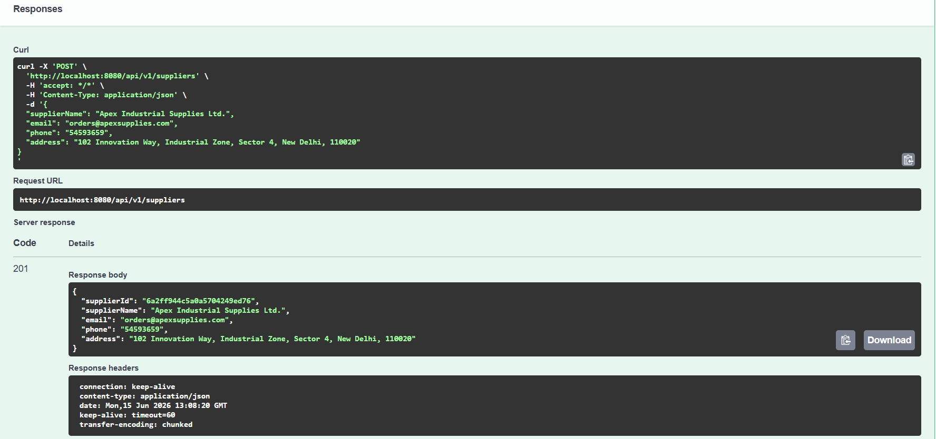

Explanation: The POST API successfully created a new supplier record in the database and returned HTTP status code 201 (Created) along with the supplier details.

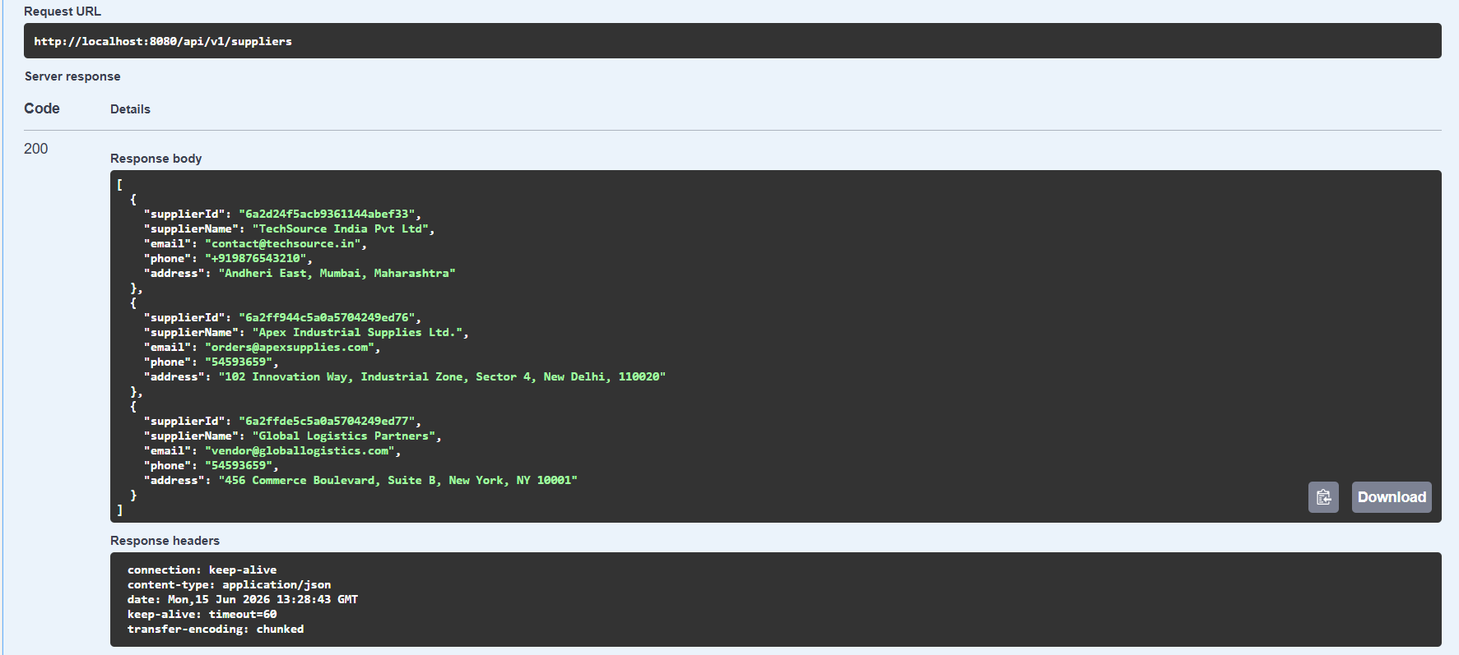

Explanation: The GET API successfully retrieved and displayed all supplier records stored in the database, returning HTTP status code 200 (OK).

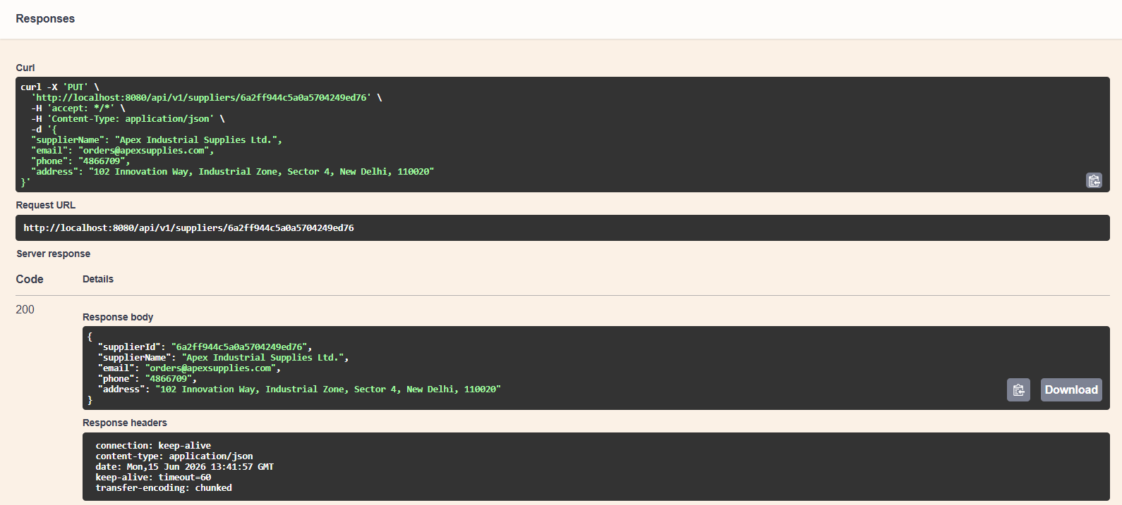

Explanation: The PUT API successfully updated the supplier information in the database and returned the modified supplier record with HTTP status code 200 (OK).

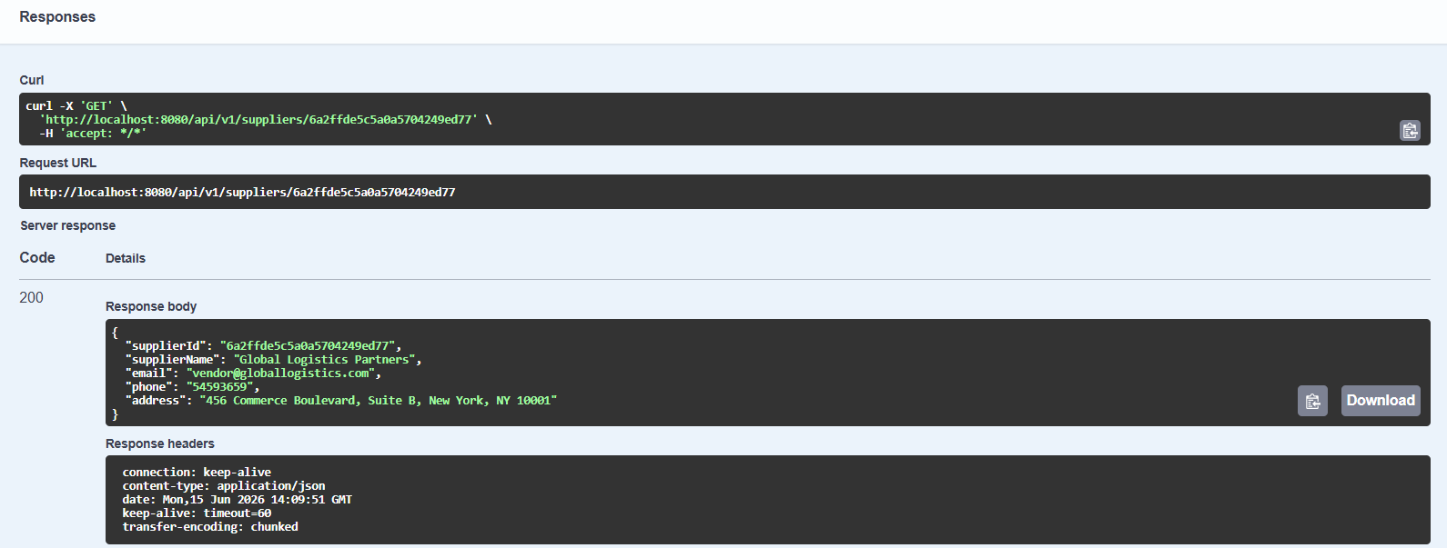

Explanation : The GET API successfully retrieved the details of a specific supplier using its unique supplier ID and returned the record with HTTP status code 200 (OK).

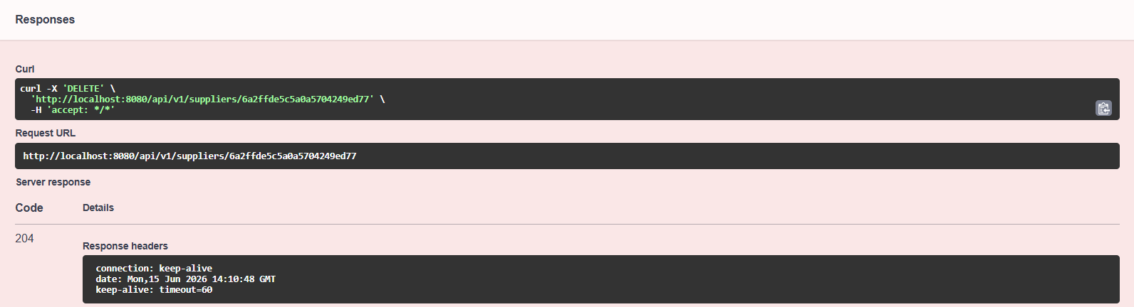

Explanation : The DELETE API successfully removed the specified supplier record from the database and returned HTTP status code 204 (No Content) to confirm successful deletion.

B) Categories

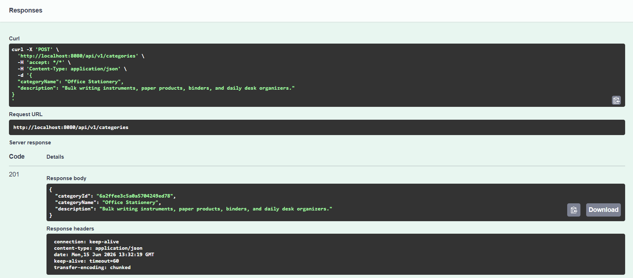

Explanation : The POST API successfully created a new product category in the database and returned HTTP status code 201 (Created) along with the category details.

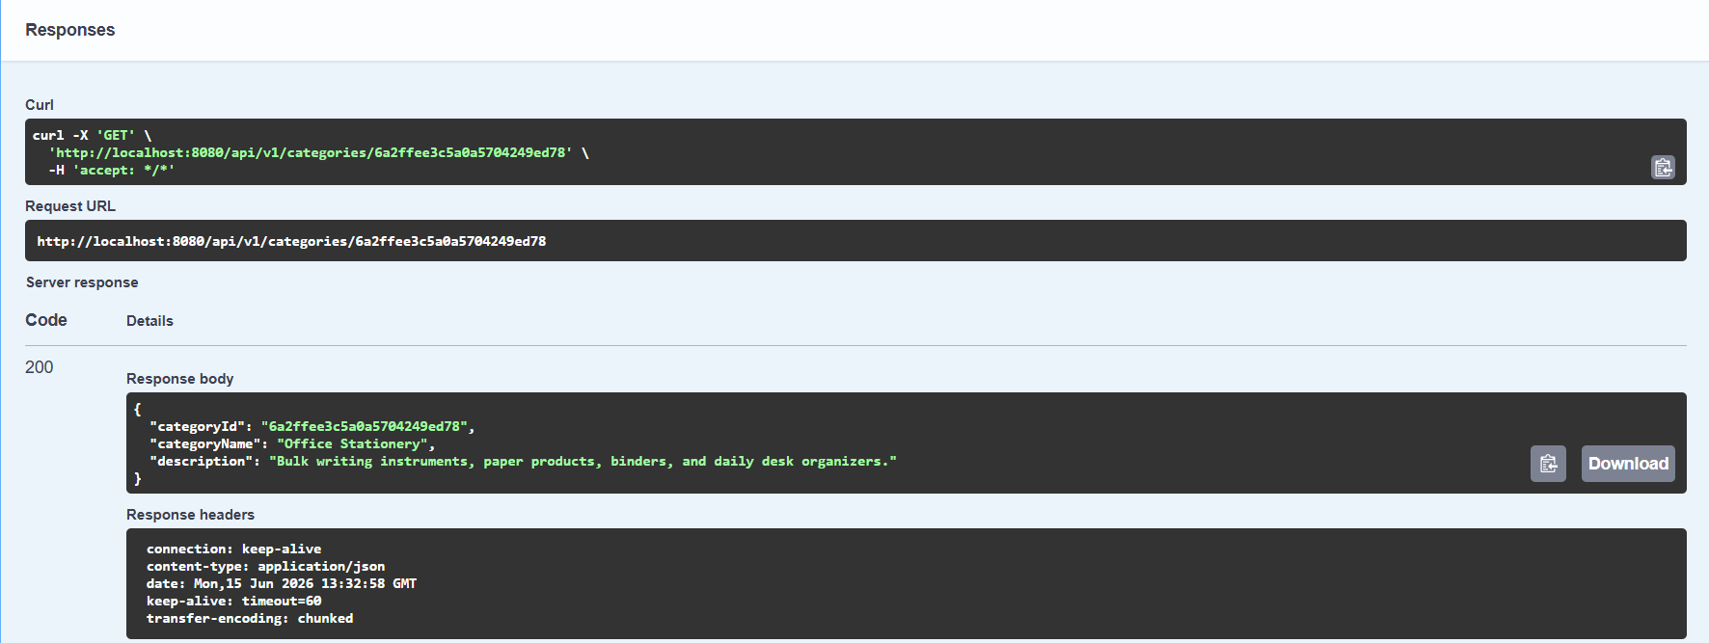

Explanation : The GET API successfully retrieved the details of a specific category using its unique category ID and returned the record with HTTP status code 200 (OK).

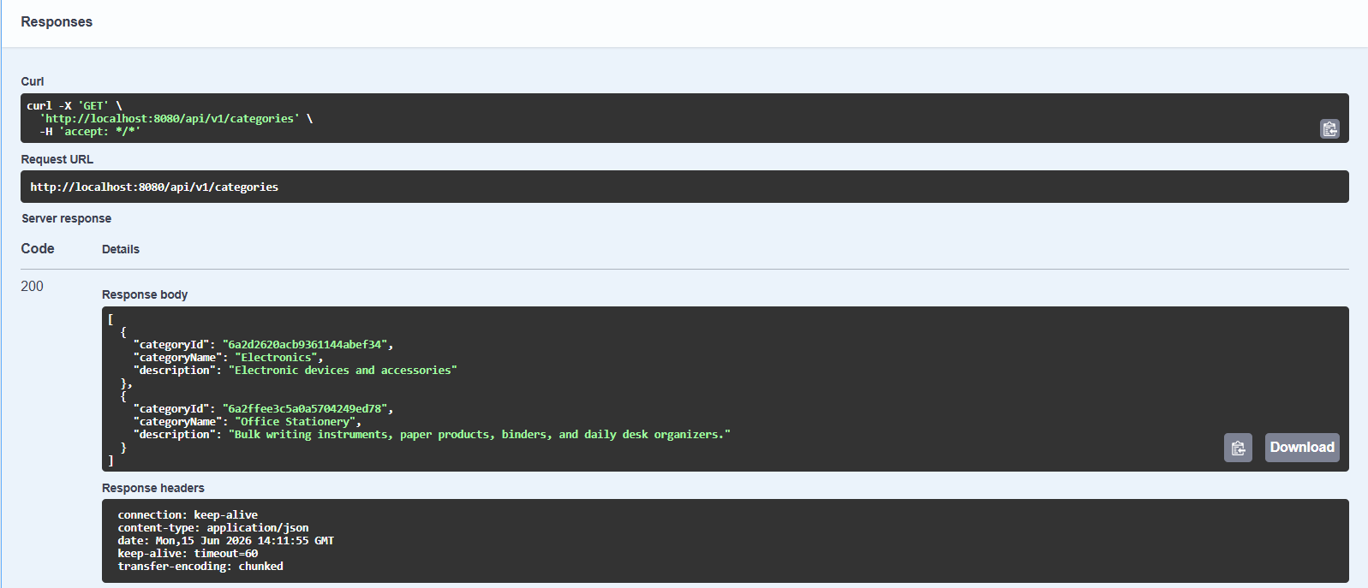

Explanation : The GET API successfully retrieved and displayed all category records available in the database, returning HTTP status code 200 (OK).

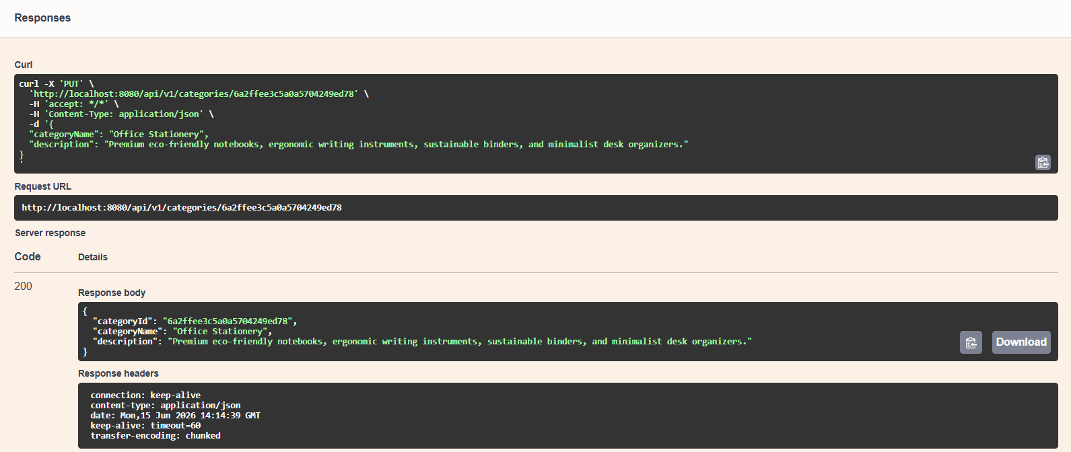

Explanation : The PUT API successfully updated the category information in the database and returned the modified category record with HTTP status code 200 (OK).

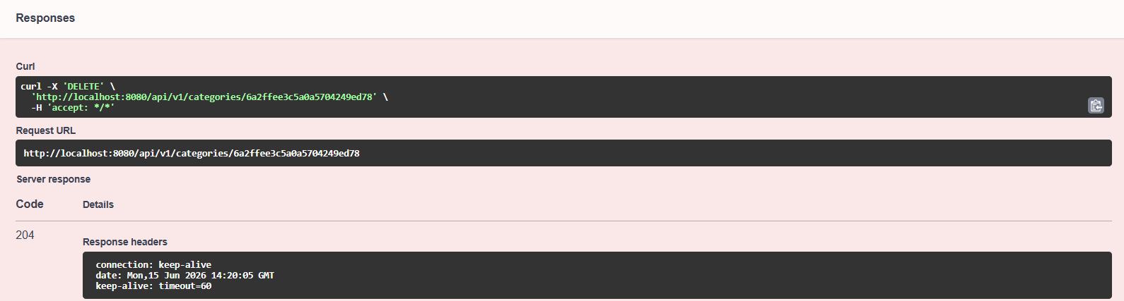

Explanation : The DELETE API successfully removed the specified category from the database and returned HTTP status code 204 (No Content) to confirm successful deletion.

C) Products

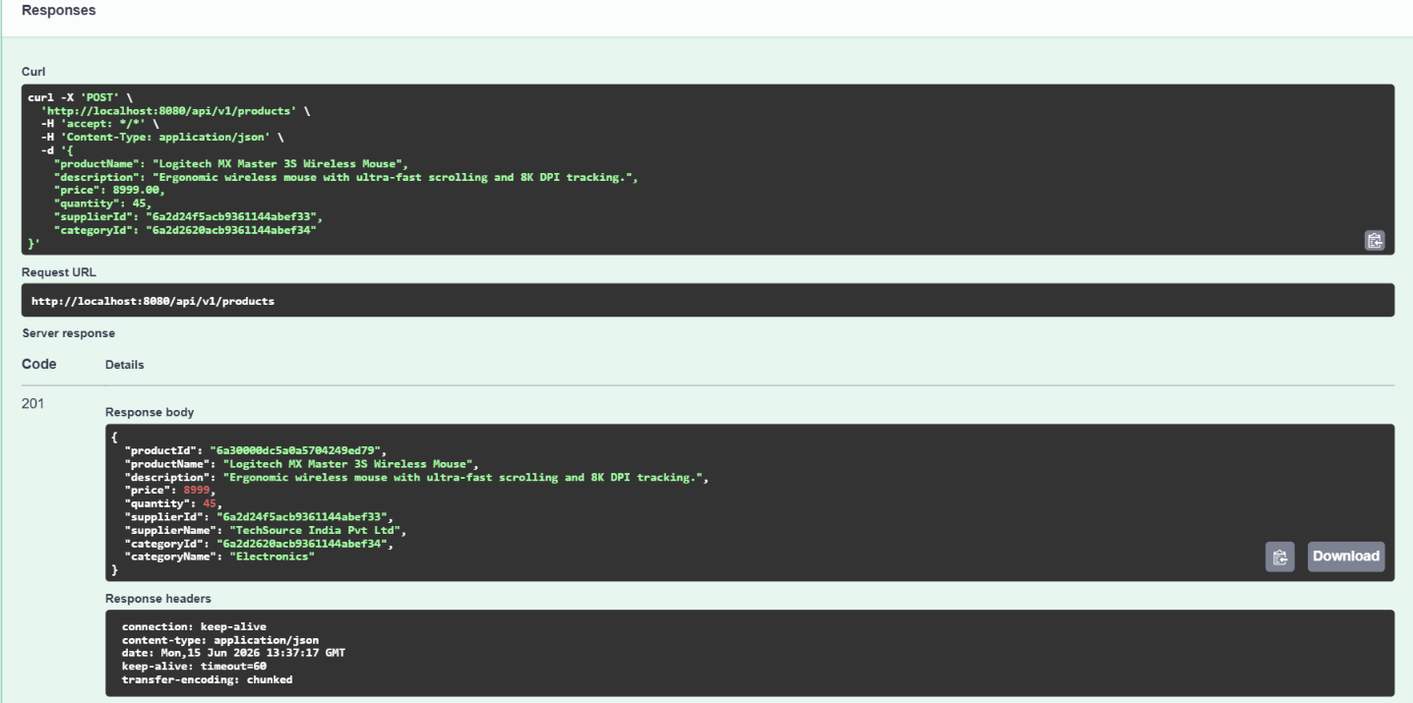

Explanation: The POST API successfully created a new product record with its associated supplier and category details, returning HTTP status code 201 (Created).

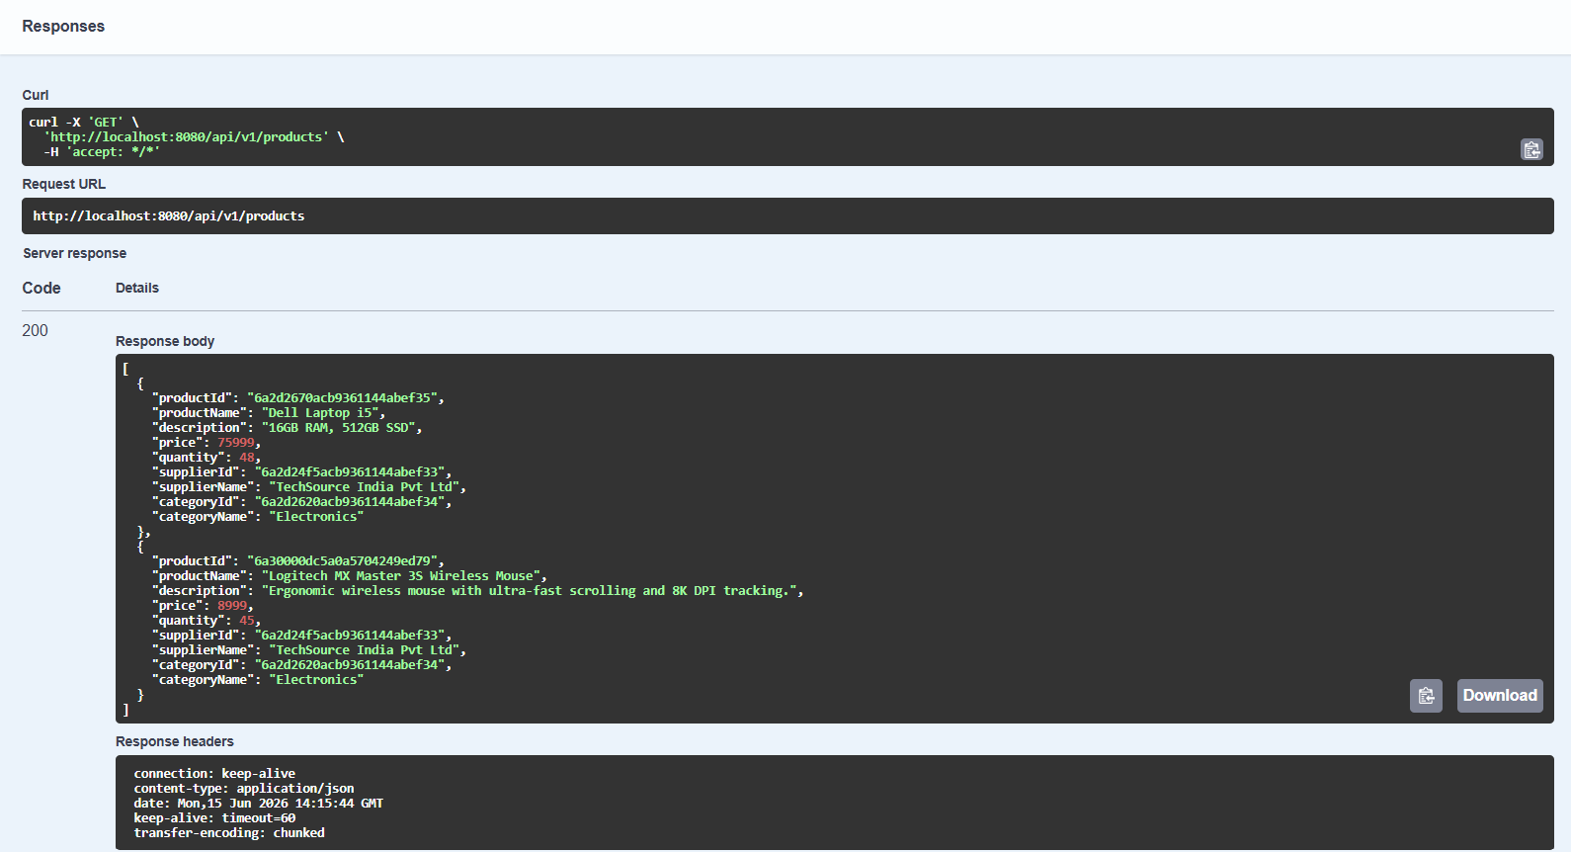

Explanation: The GET API successfully retrieved and displayed all product records along with their associated supplier and category information, returning HTTP status code 200 (OK).

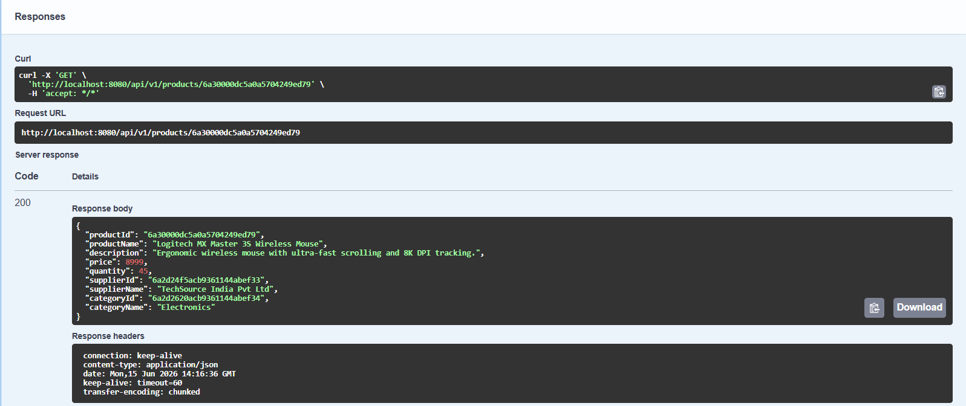

Explanation: The GET API successfully retrieved the details of a specific product using its unique product ID and returned the record with HTTP status code 200 (OK).

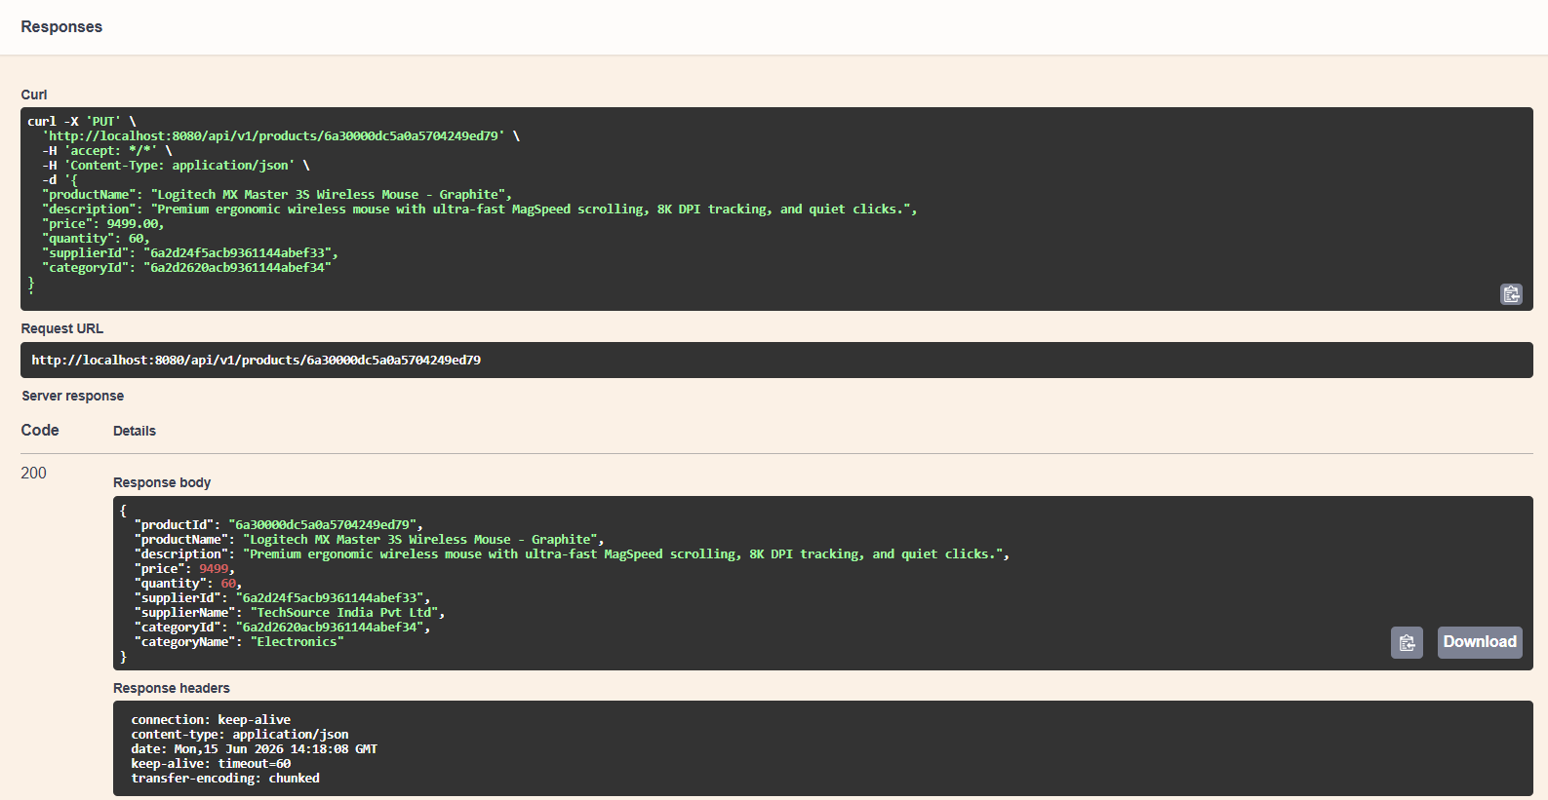

Explanation: The PUT API successfully updated the product information, including its name, description, price, and quantity, and returned the modified product record with HTTP status code 200 (OK).

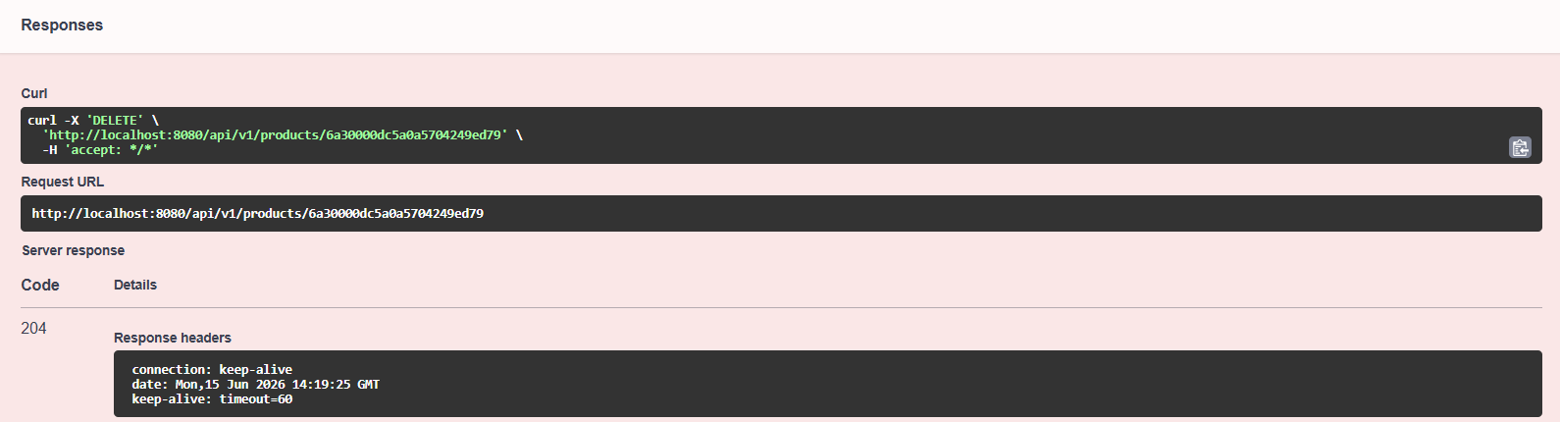

Explanation: The DELETE API successfully removed the specified product record from the database and returned HTTP status code 204 (No Content) to confirm successful deletion.

D) Orders

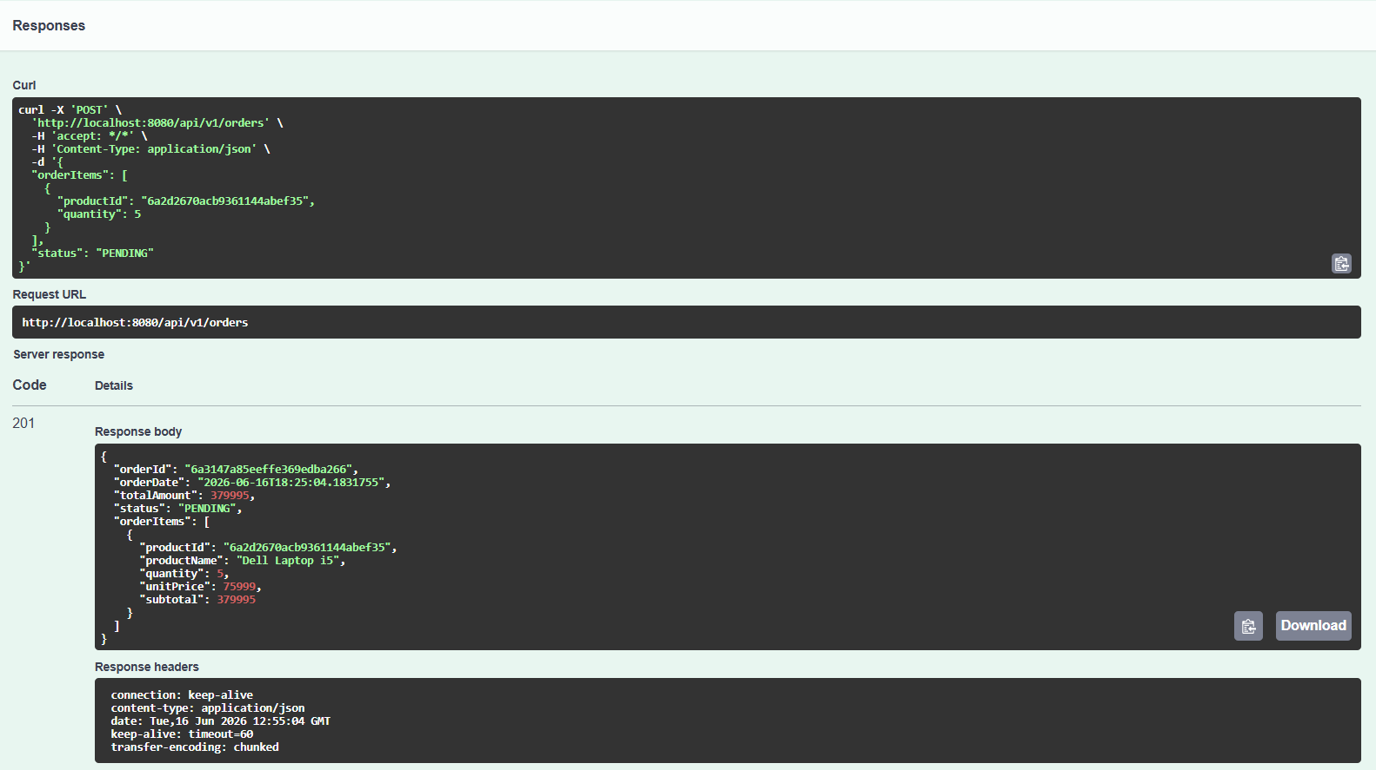

Explanation: The POST API successfully created a new order with the specified product and quantity, automatically calculating the total amount and returning HTTP status code 201 (Created).

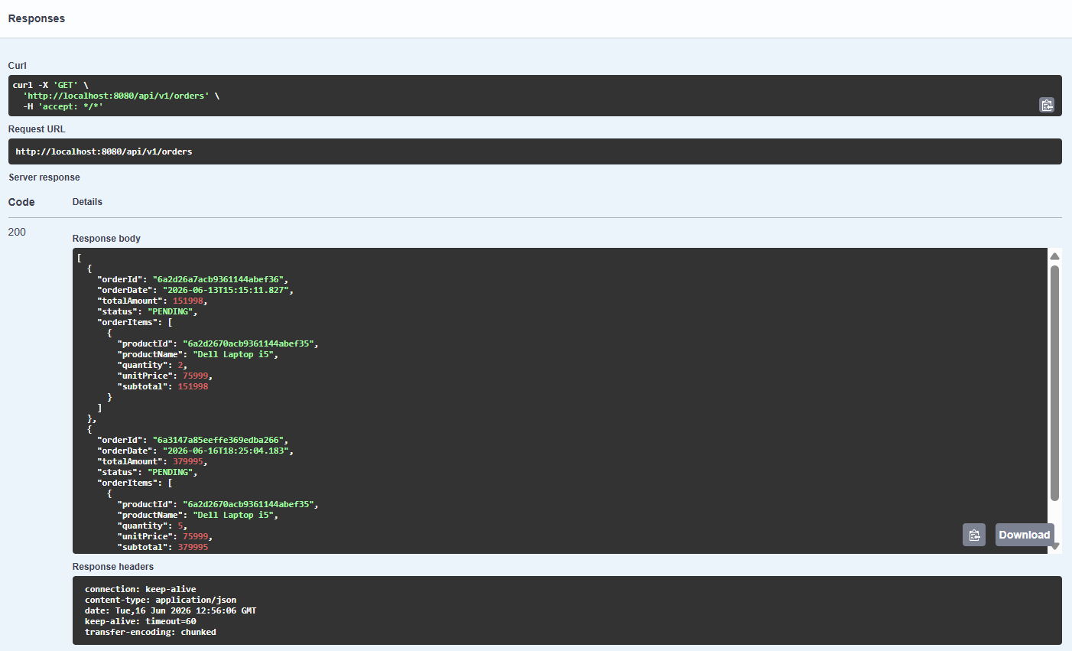

Explanation: The GET API successfully retrieved and displayed all order records along with their order items, quantities, pricing details, and current status, returning HTTP status code 200 (OK).

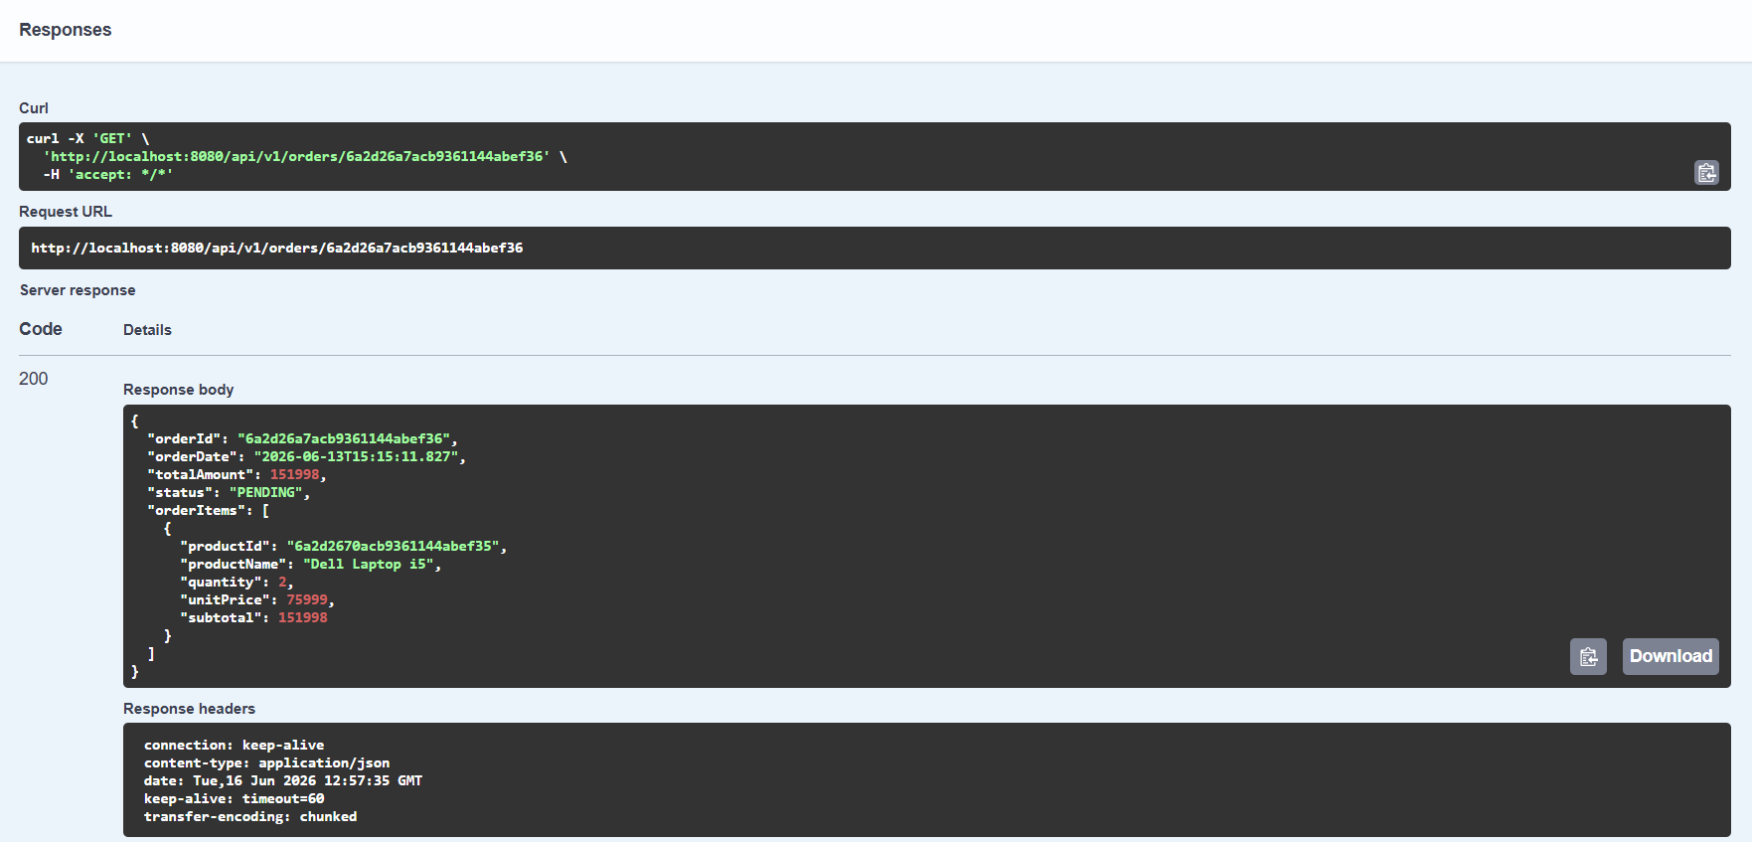

Explanation: The GET API successfully retrieved the details of a specific order, including its items, quantities, pricing information, and current status, using the unique order ID.

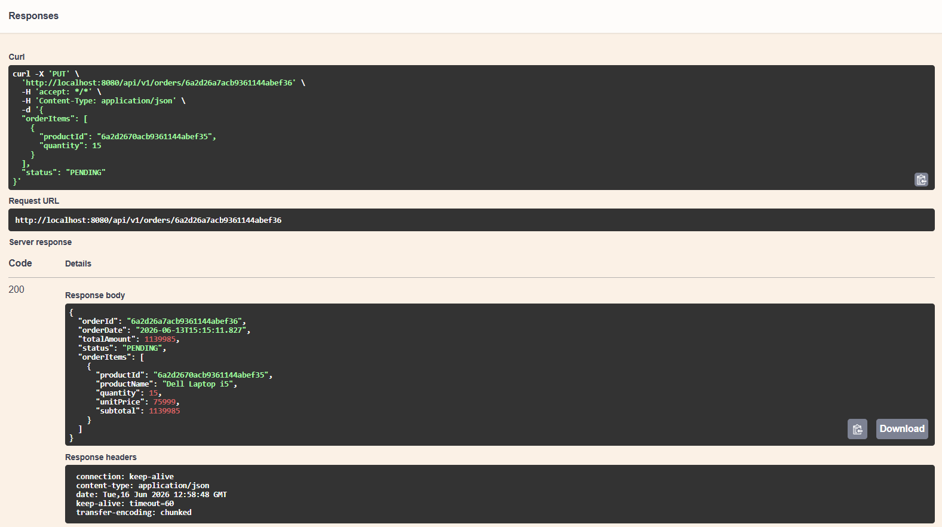

Explanation: The PUT API successfully updated the order details by modifying the product quantity, automatically recalculating the total amount, and returning the updated order record with HTTP status code 200 (OK).

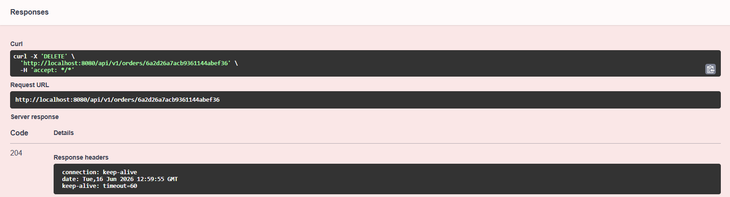

Explanation: The DELETE API successfully removed the specified order from the database and returned HTTP status code 204 (No Content) to confirm successful deletion.

10. Expected Outcome
The system will provide an efficient solution for managing inventory records, supplier information, product details, categories, and customer orders. It will demonstrate backend development concepts including REST APIs, MongoDB relationships, validation, exception handling, and API documentation.

11. Conclusion
This project provides practical experience in developing a real-world backend application using Spring Boot and MongoDB. It showcases CRUD operations, collection relationships, API development, and inventory management concepts in a structured and scalable manner.

