Name – Vyom Desai
Registration Number – 24BCE10318

1)Get Supplier By ID (GET /api/v1/suppliers/{supplierId})
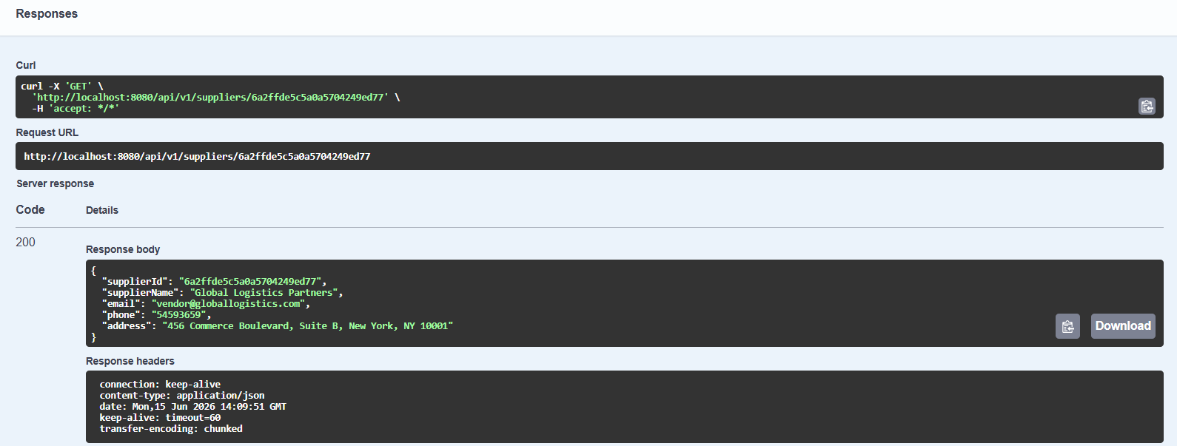

2)Delete Supplier By ID (DELETE /api/v1/suppliers/{supplierId})
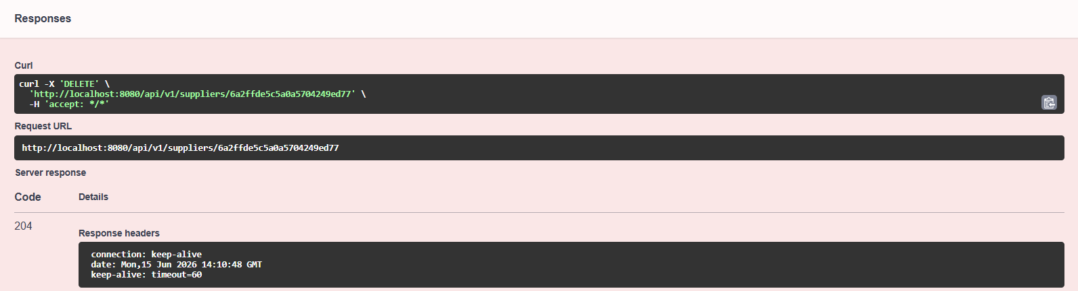

3)Get All Categories (GET /api/v1/categories)
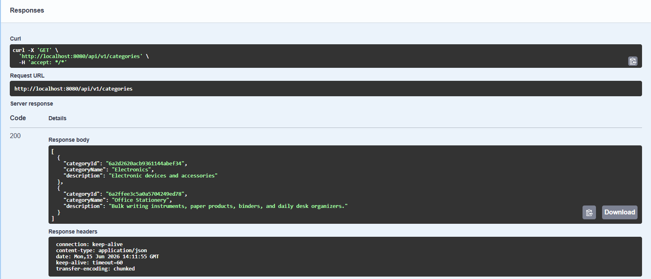

4)Update Category By ID (PUT/api/v1/categories/{categoryId})
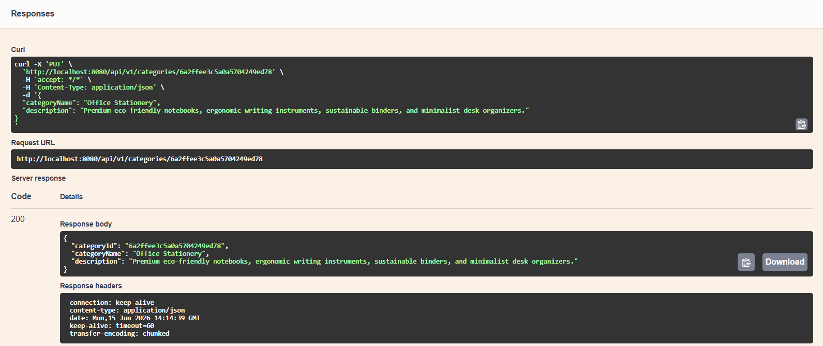

5)Delete Category By ID (DELETE/api/v1/categories/{categoryId})
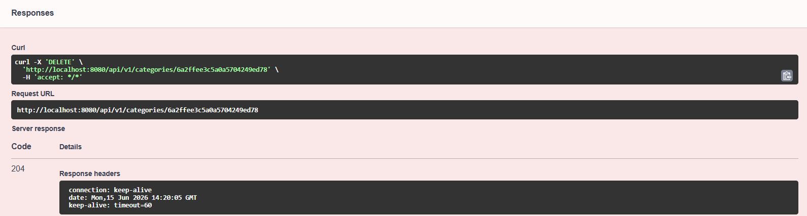
6)Get All Products (GET /api/v1/products)
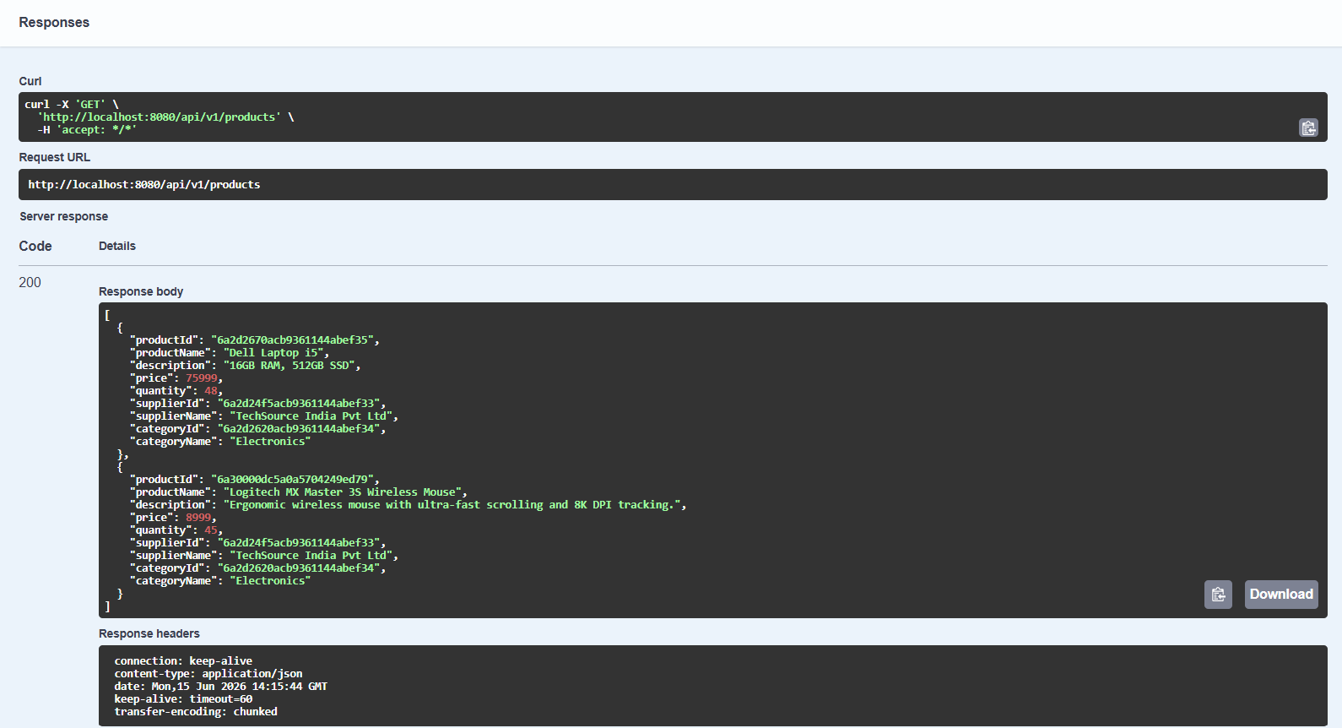

7)Get Product By ID (GET /api/v1/products/{productId)
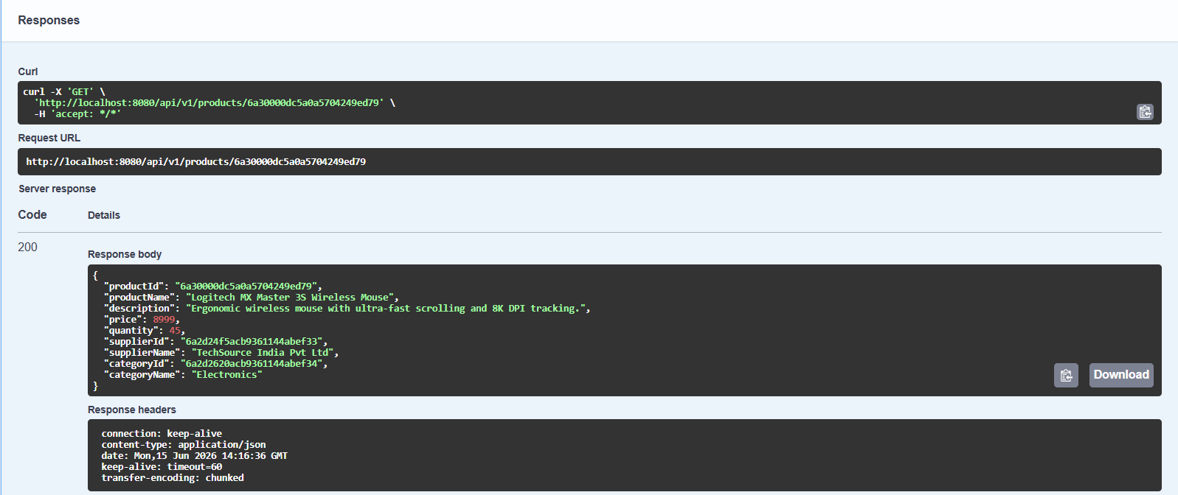

8)Update Product By ID (PUT /api/v1/products/{productId)
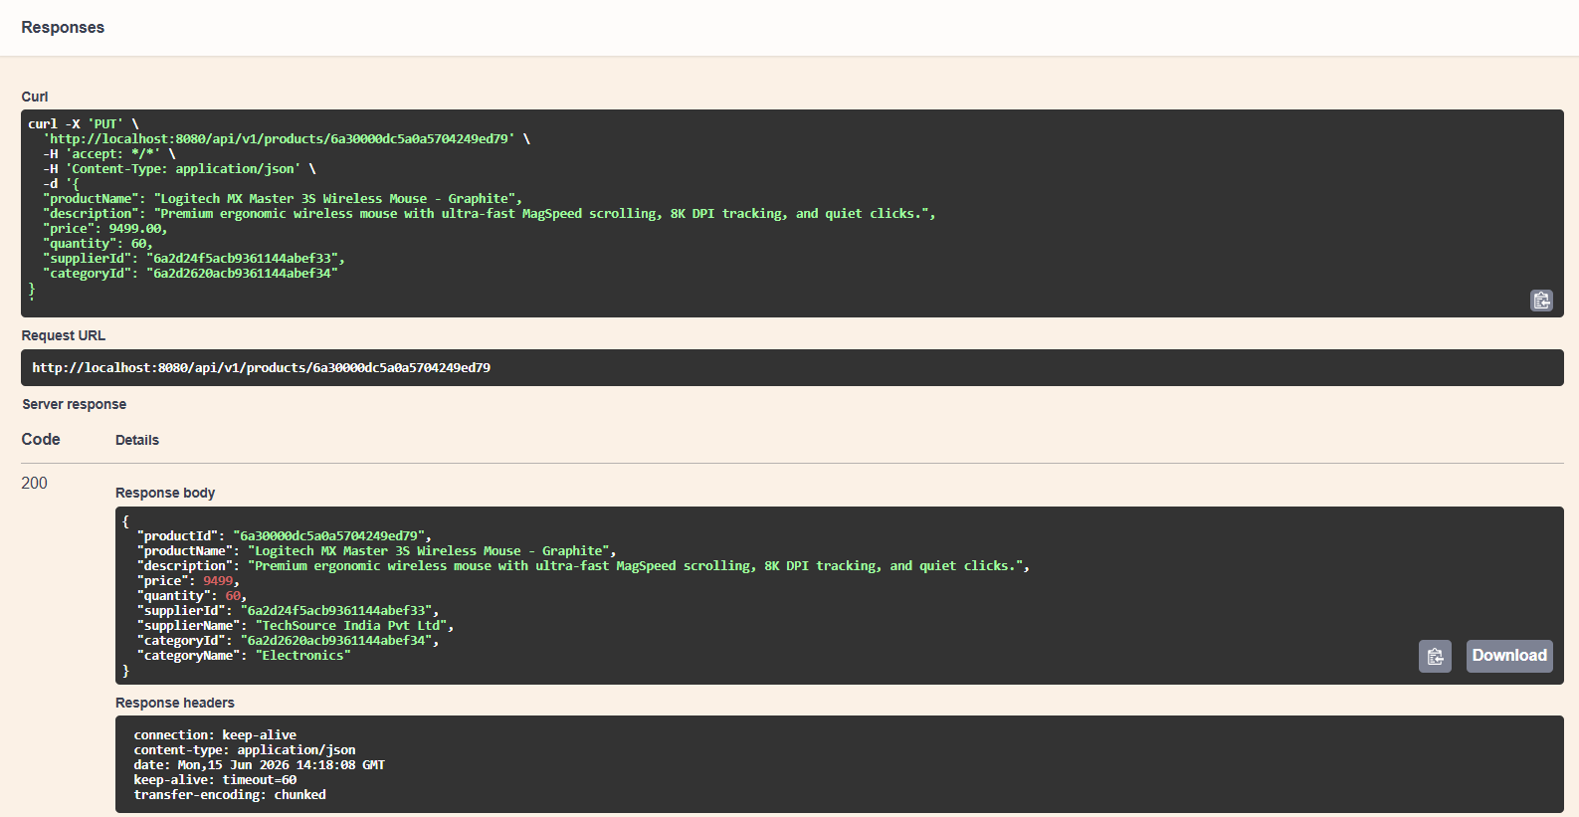

9)Delete Product By ID (DELETE /api/v1/products/{productId)
