Name – Vyom Desai
Registration Number – 24BCE10318

1) Create Supplier (POST /api/v1/suppliers)
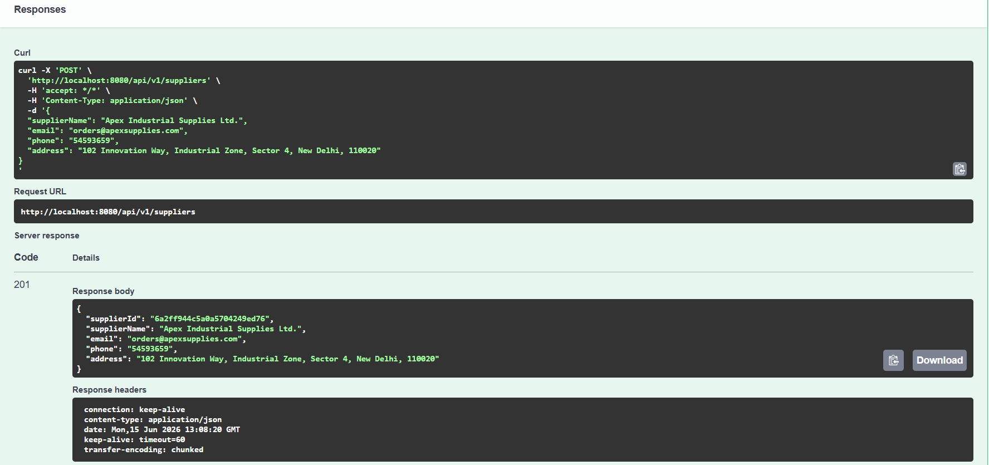

2)Get All Suppliers (GET /api/v1/suppliers)
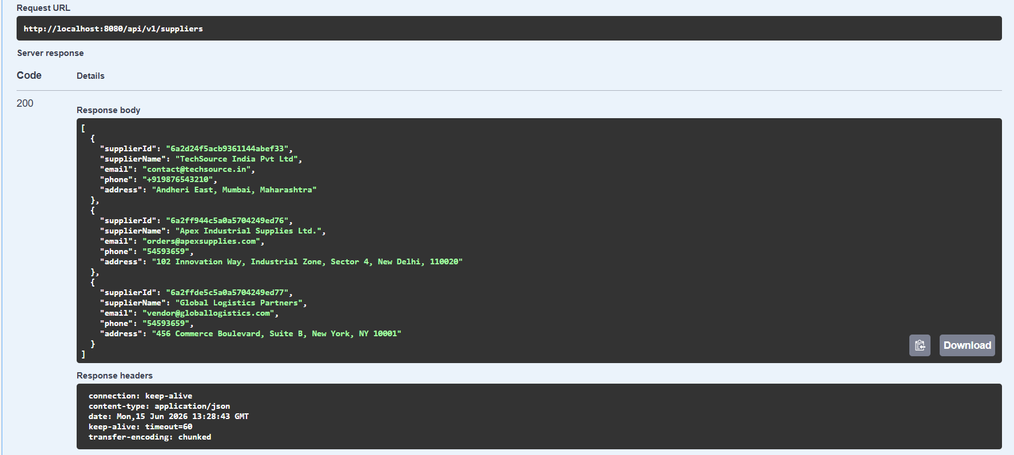

3)Create Category (POST /api/v1/categories)
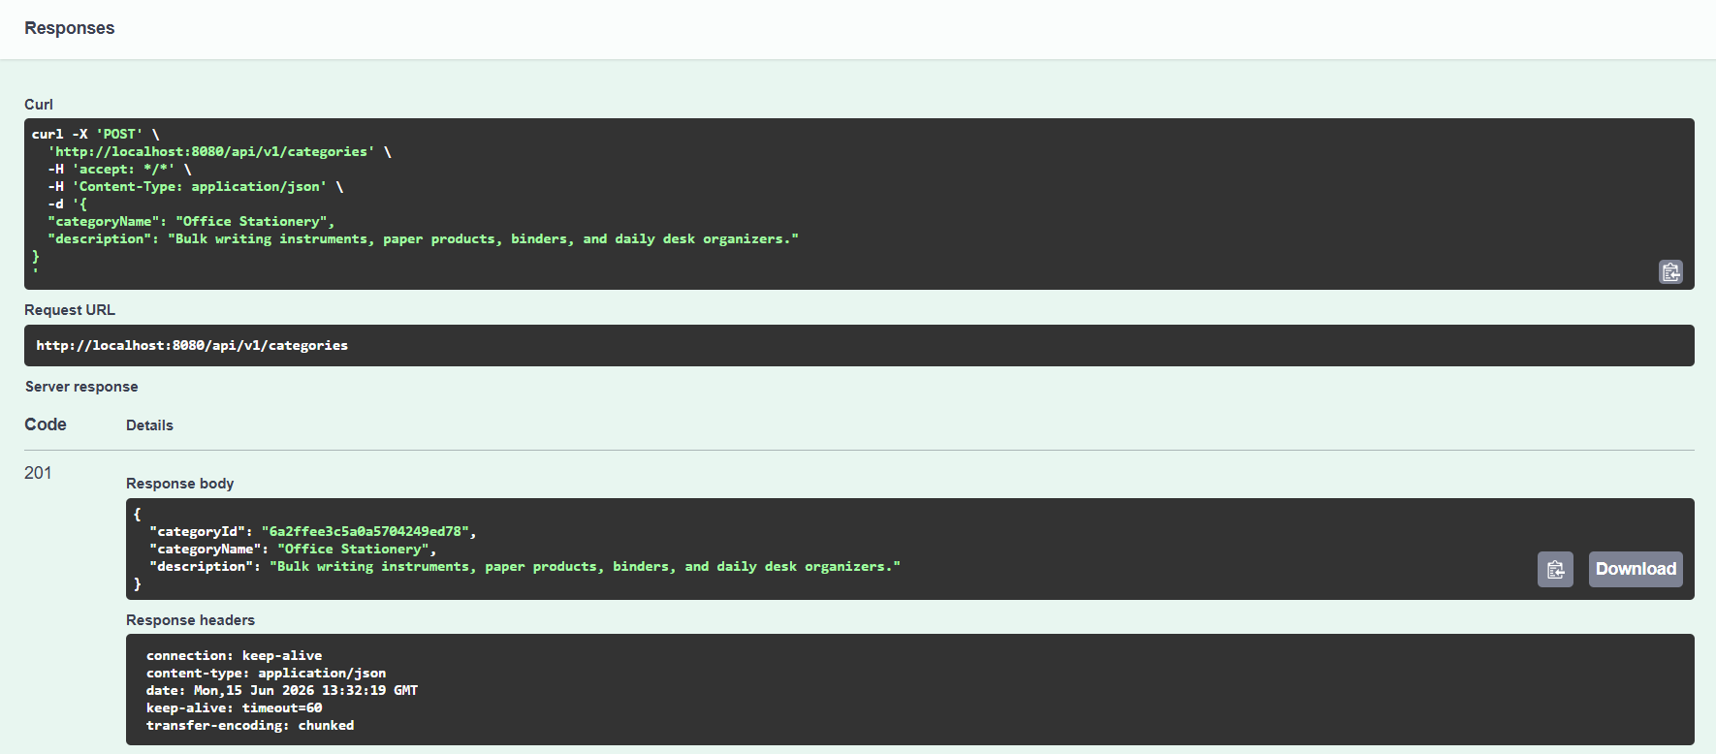

4)Get Category by ID (GET /api/v1/categories/{categoryId})
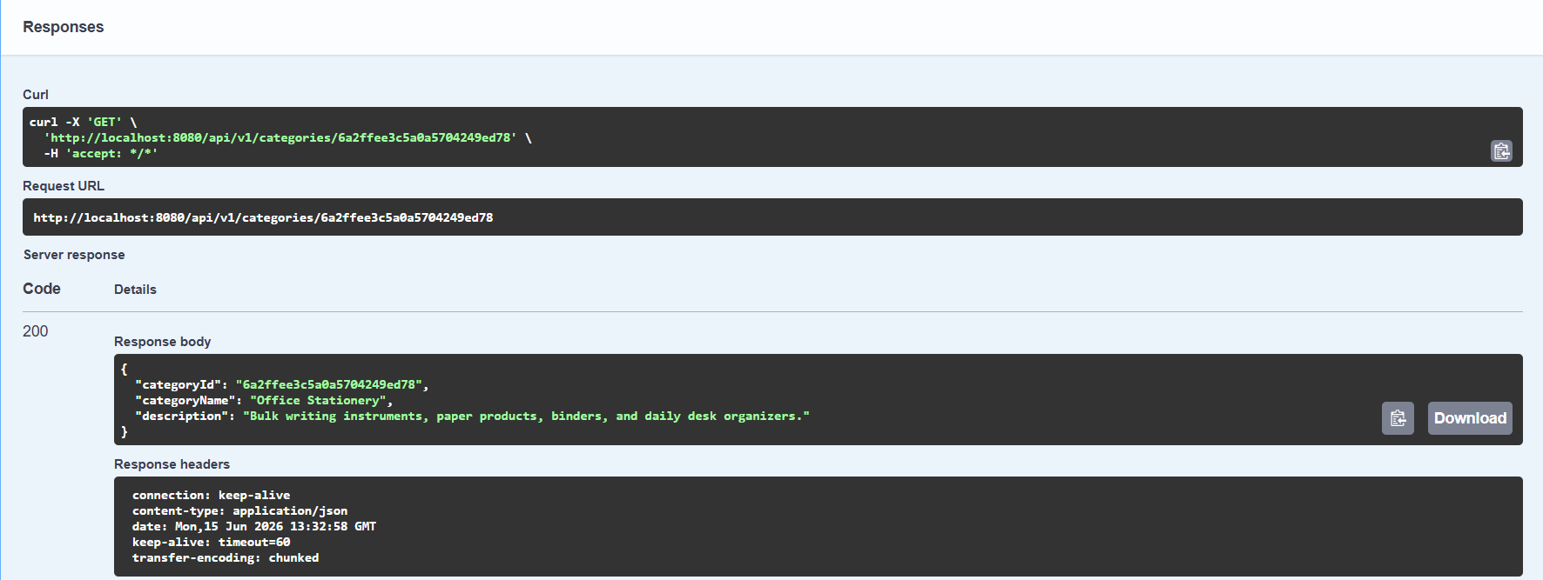

5)Create Product (POST /api/v1/products)
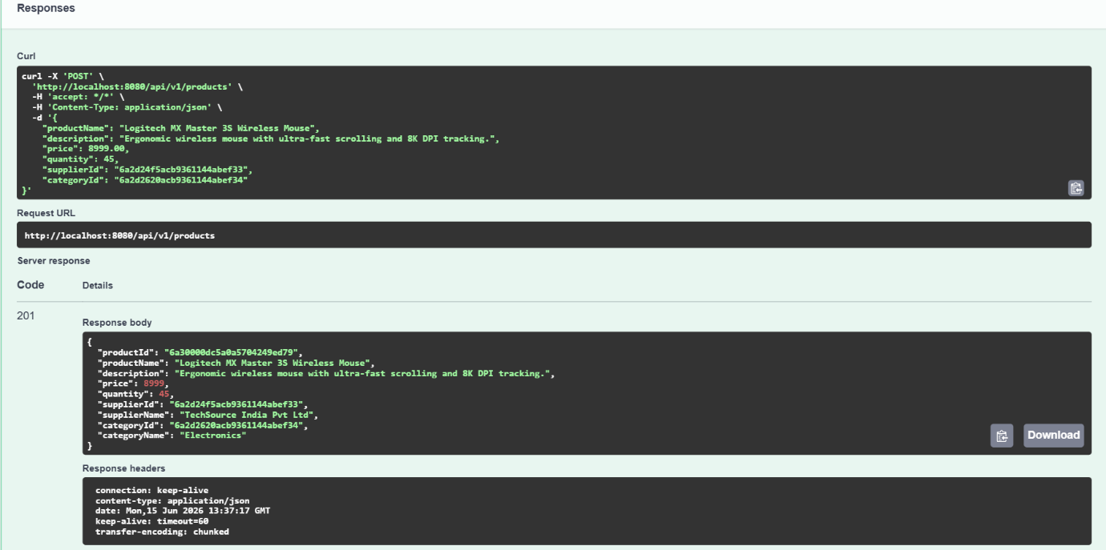

6)Update Supplier (PUT /api/v1/suppliers/{supplierId})
