CAPSTONE ASSIGNMENT 20.1 · INITIAL REPORT AND EXPLORATORY DATA ANALYSIS
NYC Food Safety Inspection Model
Predicting Serious Restaurant Inspection Failures · Summary of Findings · Vyom Rawat
UC Berkeley Professional Certificate in Machine Learning and Artificial Intelligence · October 2026

Links to the Analysis
- GitHub repository: VyomR/nyc-food-safety-inspection-eda
- Notebook 1 (cleaning, EDA, features): 01_data_cleaning_and_eda.ipynb
- Notebook 2 (baseline model): 02_baseline_model.ipynb

1. The Question
Using only information available before an inspection, can we predict which New York City restaurants will receive a serious failing score (28 points or more, the C-grade range) at their next routine health inspection? A reliable answer would let the Health Department visit the riskiest restaurants first and find unsafe kitchens sooner with the same number of inspectors.

2. Data and Cleaning
Source: DOHMH New York City Restaurant Inspection Results (NYC Open Data), snapshot of 25 October 2026: 294,406 violation records for 31,369 restaurants.
- Duplicates and placeholders: removed 217 duplicate rows and 3,917 placeholder rows dated 1900 (restaurants not yet inspected); kept 2022 onward because earlier years are thinly covered.
- Missing and invalid values: coordinates of (0, 0) and borough code “0” treated as missing and filled from other records with the same ZIP code; missing cuisine set to “Not Listed”; grade left missing because it is not issued on every inspection.
- Roll-up: violations combined into 91,745 inspections; the routine first visit of each inspection cycle is the prediction target.
- Outliers: very high scores (up to 157) are genuine, with many violations and frequent closures, so they were kept and score-history features were capped at the 99th percentile; 77 zero-score inspections with critical violations were removed as data-entry errors.
- Final dataset: 46,000 routine inspections of 22,033 restaurants with 21 features built only from earlier inspections (previous scores, pest, temperature and hygiene history, closures, time since the last visit, cuisine, borough, chain size, month).

3. Key Findings from the EDA
- Serious failures are common but the minority: 18.1% of routine inspections score 28 or more, so the target is imbalanced.
- Past behavior is the strongest signal: restaurants whose previous routine score was very high fail again 36% of the time vs 12% after an A-range score; earlier pests (23% vs 13%) and closures (32% vs 17%) also raise the risk.
- Chains fail about half as often as independent restaurants (9% vs 20%).
- Cuisine matters more than borough: Caribbean 29%, Latin American 27% and Chinese 25% vs Donuts 5% and Hamburgers 6%; Queens 22% vs Staten Island 14%.
- Typical causes: pest-friendly conditions appear in about two-thirds of serious failures, followed by food held at unsafe temperatures and evidence of mice or flies.
- Statistical tests: chi-square and Mann-Whitney tests show every relationship is significant (p < 0.001), but each is small to moderate on its own, so the model must combine several signals.
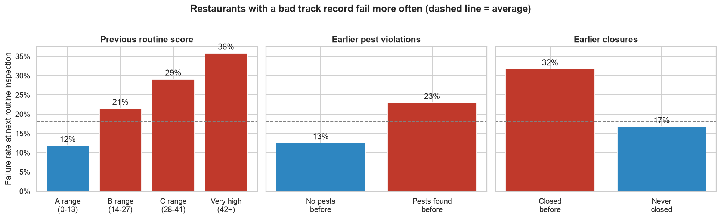
Figure 1. Failure rate at the next routine inspection, by track record (dashed line = average).
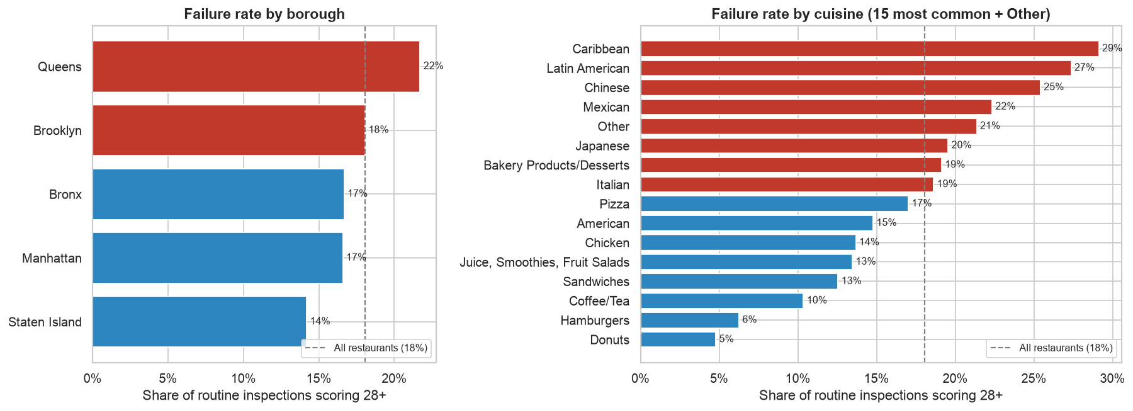
Figure 2. Serious failure rate by borough and cuisine.
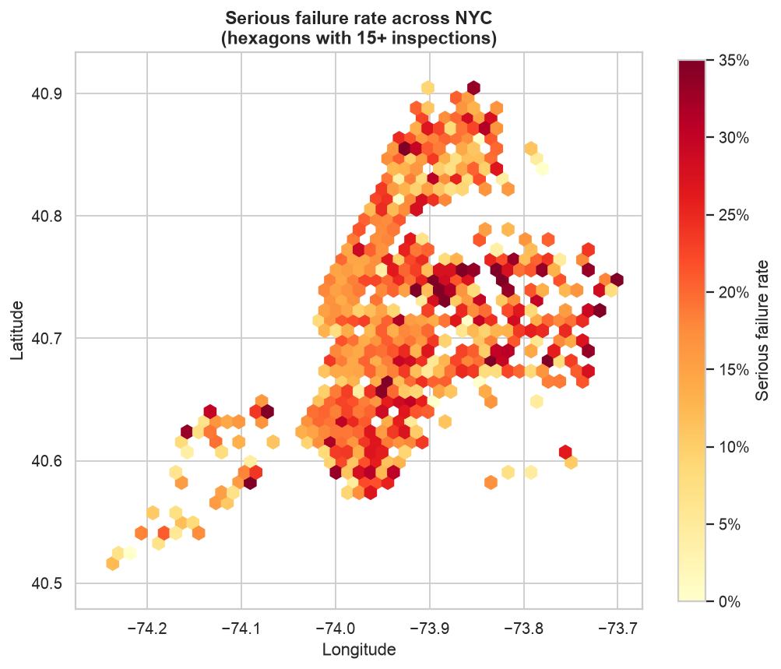
Figure 3. Serious failure rate across NYC (hexagons with 15+ inspections).

4. Baseline Model
Model: logistic regression with balanced class weights in a scikit-learn pipeline (median imputation with missing-value flags, scaling, one-hot encoding). Trained on January 2022 to April 2026 and tested on the most recent six months (April to October 2026, 9,226 inspections), so the model is always predicting the future.
Evaluation metric: PR-AUC (average precision). Only about 1 in 5 inspections fails, so accuracy is misleading: always predicting “pass” is 79% accurate on the test period but catches no failures. Inspectors would work from a ranked list, and PR-AUC measures how well true failures rise to the top of that list. It is paired with the capture rate: the share of failures found when visiting the riskiest restaurants first.
Approach | PR-AUC | ROC-AUC | Found in top 10% | Found in top 20%
Do-nothing (random order) | 0.213 | 0.50 | 10% | 20%
Rule of thumb (previous score) | 0.279 | 0.57 | 16% | 29%
Logistic regression (baseline) | 0.355 | 0.68 | 20% | 35%
Interpretation: if inspectors visit the riskiest 10% of restaurants first, 43% of those visits uncover a serious failure, versus 21% at random: about twice the hit rate. Time-ordered cross-validation on the training period gives PR-AUC 0.297 ± 0.046, and the model beats both reference approaches in every one of the 5 folds, so the gain is consistent. The strongest risk factors are a poor inspection history, earlier pests and temperature problems, summer months and certain cuisines; larger chains and long clean records lower the risk.
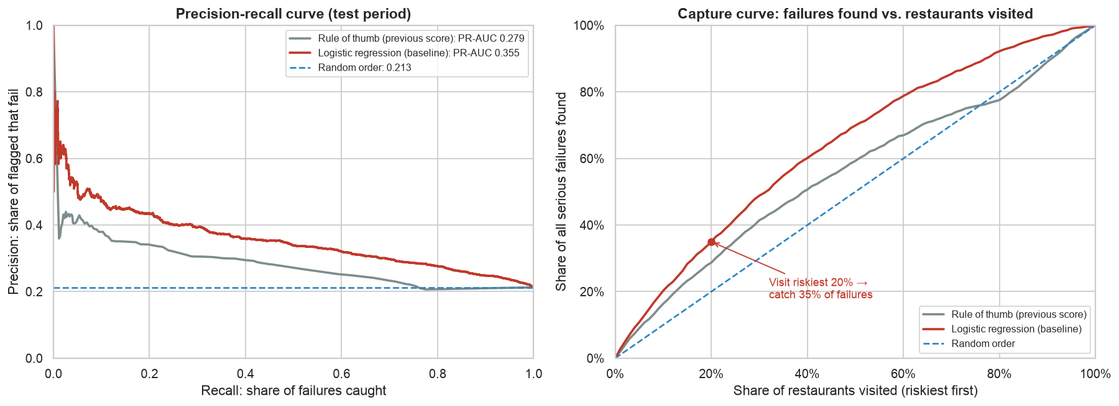
Figure 4. Precision-recall and capture curves on the test period.

5. Next Steps (Module 24)
- Compare k-nearest neighbors, decision tree, random forest and gradient boosting against this baseline, tuned with GridSearchCV and time-ordered cross-validation.
- Set the decision cut-off to match realistic inspector capacity.
- Add neighborhood failure history, nearby 311 rodent and food complaints, and score trends.
- Explain the final model and turn the results into plain-language recommendations for the Health Department.

