**New Pension Benefit Product Configuration Type**

**Basic Requirement**

1. New Benefit Type
2. Needs to be configurable under the Configure Product to Client function.
3. New Benefit needs to be selectable under the Benefit List.
4. New Benefit should be named ‘Pension Free Type’

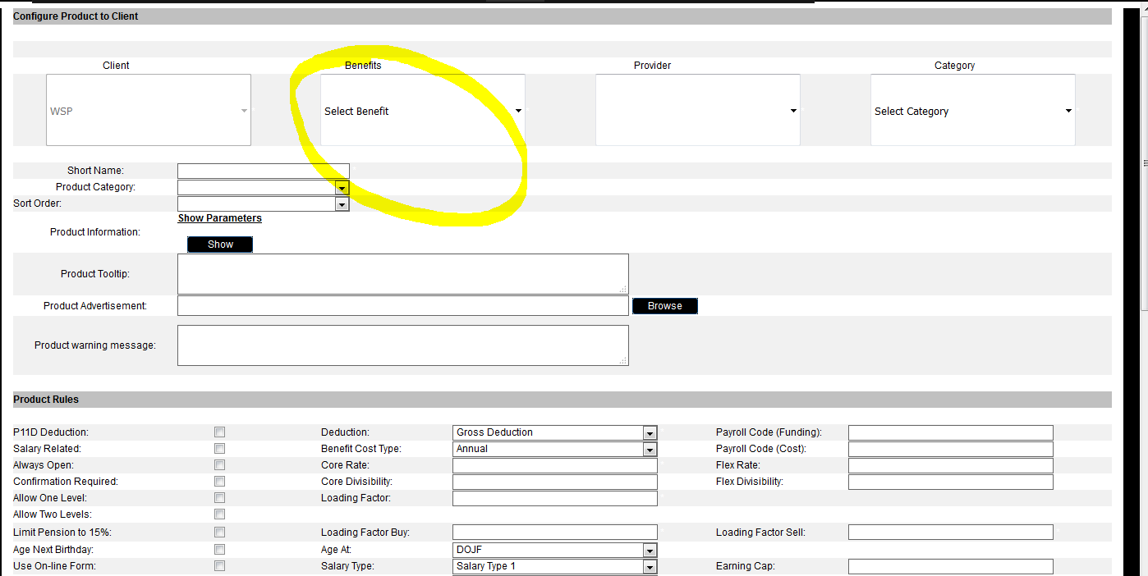

**Product configuration**

1. Selection function should show front end as follows:

This field will be set by the value input in Funding Choice 1 in the Full Import. Is fixed does not change.

This field should be calculated by the system as Salary Type set in the benefit configuration x Employer Contribution %. It is not editable

£2,500***

10%*

Employer Contribution Amount

This field should be calculated by the system as Salary Type set in the benefit configuration x Employee Contribution %. It is not editable

£2,500***

10%**

Employee Contribution Amount

This field will be set by Selection Choice 1 in the Full Import. Is editable as a free type and should allow % entries based on the configuration rules (noted below)

Under product rules we need some new configuration options that link to the new Benefit type.

On the left side there should be a new list item for ‘Use Pension Free Type’ if this is ticked the following options should appear.

1. Employee Contribution Minimum % value (This will define the minimum % that can be entered in to this field i.e. 5)
2. Employee Contribution Maximum % value value (This will define the maximum % that can be entered in to this field i.e. 100)
3. Increment % (This will define the incremental value that can be input to the field i.e. 0.00)
4. Use Matching Contribution (a tick box should show to define if required or not)
5. If the Use Matching Contribution in ticked 2 fields for ‘Min Matching Cap’ and ‘Max Matching Cap’ should appear which will allow a number to be entered to fix the level at which the macthing to choice should start and stop. i.e. min 0 max 5 so employee contribution valaues from 0 to 5 the Employee contribution value will change to match the employee contribution level but this will cease a 5 the number added to the ‘Matching Cap’

**Calculated fields will be:**

Employer Contribution Amount = Salary Type x Employer Contribution%

Employee Contribution Amount = Salary Type x Employee Contribution%

**Rate Table**

No rate table will be needed as it will use the data in the Full import to set the opening values and the free type field for Employee Contribution will be linked to the configuration field rules noted above.

**Eligibility Condition**

1. The Eligibility Condition function must be active for this benefit configuration type.

**Configure Choices**

1. Configuring choices will not be required as no rate table

**Additional requirements**

None