KERALAMMATCH
COMPLETE USER & ADMIN PANEL WEB PAGES EXPLANATION
Full Screen-by-Screen GUI Breakdown · User Flows · Admin Portals · Database & Security Architecture

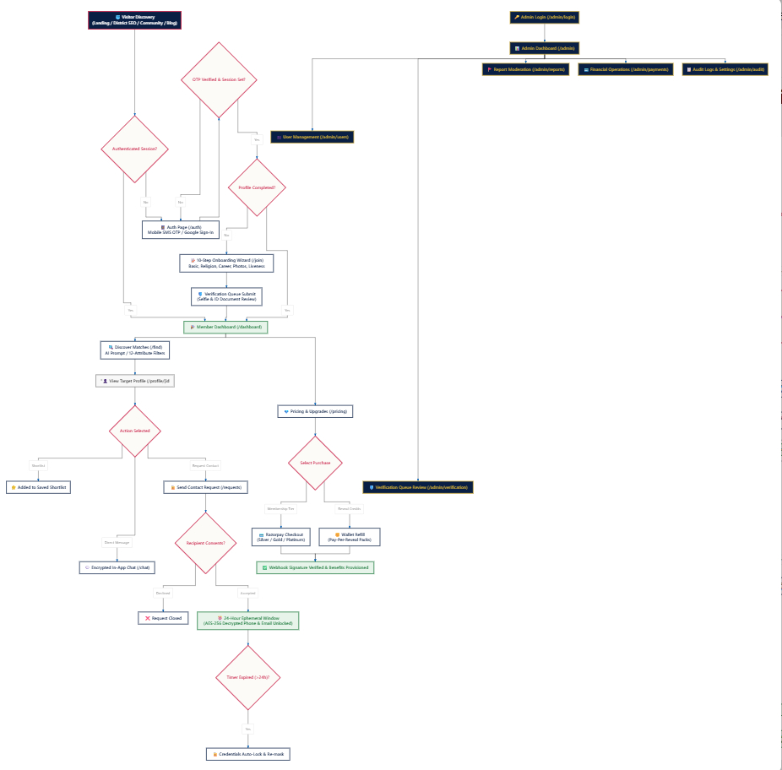
Figure 1: KeralamMatch Complete Master System & Page Architecture Flowchart

1. System Architecture & Visual Design Framework
KeralamMatch is built on Next.js 16 App Router, TypeScript strict mode, Tailwind CSS v4, and PostgreSQL with Prisma ORM v6. The web application enforces strict Clean Architecture domain separation (Presentation → Controller → Service → Repository → Database) and is styled using a tailored brand palette: Warm Ivory (#FCFBF7), Deep Navy (#0A1F44), Ruby Crimson (#C81D45), and Classic Gold (#D4AF37).

2. Complete User Panel Web Pages Explanation
This section breaks down every public and authenticated member page in the customer application.

2.1 Landing Page (`/` — `src/app/page.tsx`)
Purpose: Primary marketing and conversion gateway for prospective Kerala brides, grooms, and parents.
- Global Header (`src/components/shared/header.tsx`): KeralamMatch emblem logo, nav links (Find Matches, How It Works, Pricing, Trust & Safety, Blog), and 'Create Account' crimson CTA button.
- Hero Section: Large serif headline 'Find Your Perfect Match, the Malayali Way', subtitle, pill trust badges (Privacy First, Verified Profiles, 24/7 Support), and high-quality Kerala wedding couple portrait.
- Dark Maroon Statistics Banner: Highlighted maroon statistics bar displaying 50,000+ Happy Members, 100+ Communities, 98% Verified Profiles, and 24/7 Customer Support.
- 3-Column Feature Cards: Features highlighting: 1. 24-Hour Ephemeral Contact Reveal, 2. Multi-Layer Verification Queue (Selfie + Govt ID), 3. Encrypted In-App Messaging.
- Recent Success Stories Carousel: High-trust testimonials from couples across Kerala and GCC with marriage dates and photos.
- District & Community Footer Grid: SEO directory links covering all 13 Kerala districts and 6 major religious/community matrimonial categories.

2.2 Authentication Page (`/auth` — `src/app/auth/page.tsx`)
Purpose: Unified authentication hub supporting Indian Mobile SMS OTP and Google OAuth sign-in.
- Left Branding Showcase: Deep Maroon (#5C0A1E) background with traditional Kerala Nilavilakku lamp graphic motif, brand logo, and slogan 'Privacy First. Always. Forever.'
- Auth Card & Toggle: Pill selector toggling between 'Sign In' (existing users) and 'Create Account' (new registration).
- Mobile Number Input: Phone number input prefilled with +91 country code and client validation for 10-digit Indian mobile numbers.
- 6-Digit OTP Verification Form: Input boxes for SMS OTP entry with countdown resend timer and error feedback states.
- Google OAuth 2.0 Button: One-click authentication using Firebase Auth Google provider.
- Developer Sandbox Notice: Displays test OTP fallback (123456) when operating in test/staging environments.

2.3 10-Step Onboarding Wizard (`/join` — `src/app/join/page.tsx`)
Purpose: Comprehensive profile creation wizard capturing demographic, career, family, and partner preference details.
- Progress Header Bar: Displays current step ('Step X of 10') with circular percentage completion ring.
- Step 1 (Basic Details): First Name, Last Name, DOB, Gender, and Profile Creator (Self, Parent, Sibling).
- Step 2 (Physical Traits): Height (cm), Complexion, Body Type, and Physical Status.
- Step 3 (Religion & Caste): Religion, Caste, Sub-Caste, Mother Tongue, and Horoscope/Star requirements.
- Step 4 (Education & Career): Highest Education Level, Institution, Occupation, and Annual Income Bracket.
- Step 5 (Location Details): State, District, Current City, and Native Place.
- Step 6 (Family Background): Family Type (Joint/Nuclear), Family Status, Values, and Parents' Occupations.
- Step 7 (Lifestyle Habits): Dietary Preference (Vegetarian/Non-Veg), Smoking, and Drinking habits.
- Step 8 (Partner Preferences): Preferred Age Range, Height Range, Religion, Caste, and District Filters.
- Step 9 (Photo & Audio Upload): Cloudinary drag-and-drop photo gallery upload with watermarking and voice introduction recording.
- Step 10 (Verification Submit): Selfie liveness camera capture + Aadhaar ID upload for queue submission.

2.4 Member Dashboard (`/dashboard` — `src/app/dashboard/page.tsx`)
Purpose: Central personalized command center for registered candidates.
- Sidebar Navigation: Quick access links to Dashboard, Find Matches, Messages, Requests, Shortlists, Notifications, Settings.
- Welcome Banner: Personalized banner greeting 'Welcome back, [First Name] 👋' showing active membership tier.
- Profile Strength Ring: Circular progress widget showing profile score (0-100%) and 'Complete Profile' prompt.
- Activity Metrics Cards: Profile Views (240 views, +18% this week), Matches Found (128), and Active Requests (3).
- Curated Recommendations: 4-column grid of candidate profile cards matching user's stored partner preferences.

2.5 Find Matches & Search (`/find` — `src/app/find/page.tsx`)
Purpose: Discovery hub combining demographic dropdown filters with AI natural language query parsing.
- Navigation Category Tabs: Tabs for Find Matches, Saved Searches, Mutual Matches, and Recent Visitors.
- Quick Demographic Filters: Dropdown filters for Religion, Caste, District, Age Range, and Education Level.
- AI Smart Search Bar: Prompt box accepting plain English prompts (e.g. 'Software engineer in Ernakulam preferring vegetarian diet').
- Candidate Grid Cards: Portrait photo, Candidate Name, Age, Height, District, Profession, Match Compatibility % badge, Shortlist Heart, and 'View Profile' CTA.

2.6 Target Profile Detail (`/profile/[id]` — `src/app/profile/[id]/page.tsx`)
Purpose: In-depth candidate profile view with verified credentials, horoscope status, and 24h reveal engine.
- Hero Candidate Header: Large portrait photo with Cloudinary privacy blur for unverified guests, Name, Age, Height, Location, and 94% Match Compatibility badge.
- Primary Actions Bar: Shortlist Heart, Send Interest Star button, Send Contact Request button, and Message button.
- Information Tabs: Tabs for About Me, Lifestyle, Education & Career, Family Details, and Partner Preferences.
- Verified Details Box: Green checkmarks for Mobile Verified, Email Verified, Aadhaar Verified, Photo Verified.
- Horoscope Details Card: Star/Rasi information with 'View Full Horoscope' action.
- 24-Hour Ephemeral Reveal Card: Displays 'Send Contact Request' button, pending consent badge, or 24:00:00 live countdown timer with decrypted phone & email.

2.7 Secure Messaging (`/chat` — `src/app/chat/page.tsx`)
Purpose: End-to-end encrypted private in-app chat for mutually connected candidates.
- Conversation List (Left Pane): Active chat threads with candidate avatars, names, last message snippet, timestamp, and unread badges.
- Active Chat Window (Right Pane): Header with user avatar, name, online status, encryption lock banner ('Messages are encrypted and private'), and Block User button.
- Message Thread: Sender message bubbles in Ruby Crimson (#C81D45) right-aligned; receiver bubbles in Warm Ivory (#FCFBF7) left-aligned with double checkmarks.
- Message Input Bar: Text input with emoji picker, send CTA button, and Upstash Redis rate-limiter protection.

2.8 Contact Requests (`/requests` — `src/app/requests/page.tsx`)
Purpose: Central management hub for incoming, outgoing, active, and expired contact reveal requests.
- Filter Tabs Bar: Tabs for Received (Incoming), Sent (Outgoing), Active (24h Window), and Expired.
- Request Cards: Candidate avatar, Name, District, Requested Date, Accept button (green), Decline button (outline), Active 24h countdown badge, or Expired badge.

2.9 Notifications Hub (`/notifications` — `src/app/notifications/page.tsx`)
Purpose: Chronological alert feed tracking all member activities and account updates.
- Header & Actions: Title 'Notifications', unread count badge, and 'Mark all as read' button.
- Alert Cards List: Icon indicators by type (Heart for request, Message for chat, Shield for verification, Coins for wallet), title, description, timestamp, unread red marker.

2.10 Pricing & Monetization (`/pricing` — `src/app/pricing/page.tsx`)
Purpose: Membership plan upgrade and pay-per-reveal credit recharge portal.
- Header Banner: Title 'Choose Your Plan — Upgrade to unlock premium features'.
- Membership Plan Cards: Cards for Free, Silver (₹999/mo), Gold (₹1,999/3mo — Most Popular gold border), and Platinum (₹3,499/yr) with feature checklists.
- Pay-Per-Reveal Packs: Credit refill options: ₹99 for 1 reveal, ₹499 for 5 reveals.
- Razorpay Checkout Modal: Triggers Razorpay payment modal supporting UPI (GPay, PhonePe), Netbanking, and Debit/Credit cards.
- Payment Confirmation (`/pricing/success`, `/pricing/cancel`): Receipt confirmation and cancel redirection views.

2.11 Account Settings (`/settings` — `src/app/settings/page.tsx`)
Purpose: Member account management, password updates, and privacy controls.
- Sidebar Menu: Categories for Profile Settings, Account & Password, Privacy Settings, Notification Settings, Astro & Horoscope, Media Gallery, Deactivate Account.
- Settings Content Forms: Password change input fields, profile visibility checkboxes, phone display toggles, Sign Out button, and Delete Account modal.

2.12 Trust & Safety Center (`/trust` — `src/app/trust/page.tsx`)
Purpose: Public safety documentation, security principles, and reporting guidelines.
- Safety Hero Banner: Title 'Your Privacy & Safety Come First'.
- Safety Pillars Grid: Cards detailing Verified Profiles, Ephemeral Contact Protection, Report & Moderation, Instant Blocking.
- 24/7 Support Banner: Direct contact options to reach grievance officers and customer support.

2.13 Blog Magazine (`/blog`, `/blog/[slug]`)
Purpose: Content hub and SEO traffic magnet featuring wedding tips, traditions, and success stories.
- Category Filter Pills: Filter articles by All, Relationships, Marriage Tips, Success Stories, Lifestyle, Family.
- Article Grid (`/blog`): Article cards with thumbnail images, category tags, read time, titles, excerpts, and publication dates.
- Article Detail View (`/blog/[slug]`): Hero banner image, H1 title, author bio, rich text paragraphs, social share buttons, and related articles grid.

2.14 District & Community SEO Pages
Purpose: High-ranking landing pages capturing localized search traffic.
- 13 District Landing Pages (`/find/brides-in-[district]`): Dedicated pages for Trivandrum, Ernakulam, Kozhikode, Kottayam, etc., featuring local candidate statistics, popular towns, and district FAQs.
- 6 Community Matrimony Hubs (`/find/[community]-matrimony`): Dedicated hubs for Nair, Ezhava, Christian, Latin Catholic, Syrian Christian, and Muslim matrimony with tradition highlights.

3. Complete Admin Panel Web Pages Explanation
The Admin Portal provides centralized operations control for candidate verification, moderation, financial auditing, and content management.

3.1 Admin App Shell & Navigation Layout (`src/app/admin/layout.tsx`)
Purpose: Unified administrative layout with dark navy styling and role-based session guards.
- Dark Navy Sidebar (`#0A1F44`): Fixed left sidebar displaying KeralamMatch Admin logo, navigation menu items with Lucide icons (Dashboard, Users, Verification, Reports, Payments, Blog, FAQ, Audit, Settings).
- Active Crimson Menu Indicator (`#C81D45`): Highlighted active page item styled with ruby crimson background and white text.
- Top Search Header Bar: Universal search bar ('Search candidates, reports, payments...'), notification bell indicator, and Admin profile avatar.
- Light Canvas Content Area (`#F8FAFC`): Clean canvas designed for data tables, statistics cards, and chart visualizations.

3.2 Admin Login (`/admin/login` — `src/app/admin/login/page.tsx`)
Purpose: Secure authentication gate for administrative staff and grievance officers.
- Admin Auth Card: White elevated card with KeralamMatch logo, 'Admin Portal' title, and Kerala Nilavilakku lamp graphic motif.
- Credentials Input Form: Admin email field (`admin@keralammatch.com`), password input, 'Remember this device' checkbox, and Login button.
- Security Badge: Displays 'Protected by KeralamMatch Security Guard & Audit Logger'.

3.3 Admin Master Dashboard (`/admin` — `src/app/admin/page.tsx`)
Purpose: Executive overview of platform health, candidate growth, verifications, and financial revenue.
- 4 Top KPI Overview Cards: Total Users (25,430 +12.5%), New Registrations (1,234 +8.2%), Verified Profiles (18,765 +10.6%), Active Premium Members (2,456 +6.7%).
- Registrations Growth Chart: Visual bar chart tracking daily candidate registration trajectory across the current month.
- Verification Queue Summary Widget: Displays Pending (324), In Review (76), and Completed (1,842) verification submissions.
- Reports & Moderation Summary Widget: Displays Total Flagged Reports (156) and Resolved Reports (120).

3.4 User Management Directory (`/admin/users` — `src/app/admin/users/page.tsx`)
Purpose: Comprehensive search, filtering, and account control for all registered platform members.
- User Status Filter Tabs: Tabs for All Users, Active, Inactive, Blocked, and Premium Subscribers.
- Real-Time Search Bar: Filters candidate table instantly by name, email, phone number, or profile ID.
- User Data Table: Columns for Candidate Name & Email, Phone Number, Membership Plan, Verification Status (Verified/Pending), Account Status (Active/Banned), Joined Date, and Actions button.
- User Actions Menu: View full profile, manual verification override, password reset trigger, and account suspension/ban.

3.5 Document Verification Queue (`/admin/verification` — `src/app/admin/verification/page.tsx`)
Purpose: Review queue for candidate selfie facial liveness checks and Aadhaar/Govt ID uploads.
- Status Filter Tabs: Tabs for All, Pending, In Review, and Completed verifications.
- Verification Candidate Cards: Candidate portrait photo, Full Name, Profile ID, District, Uploaded Documents Count (e.g. 4/4 Uploaded), and 'Inspect Documents' button.
- Approval / Rejection Controls: One-click 'Approve' button (issues green verified badge to user) or 'Reject' button with rejection reason selector.

3.6 Reports & Moderation Center (`/admin/reports` — `src/app/admin/reports/page.tsx`)
Purpose: Investigation queue for handling user-flagged profiles, harassment complaints, and spam.
- Report Category Tabs: Tabs for All, Pending, In Review, and Resolved complaints.
- Reported Case Cards: Complaint Category (Inappropriate Message, Fake Profile, Harassment, Spam), Reporter Candidate Name, Target Account ID, Submission Timestamp, and Complaint Details.
- Moderation Action Buttons: 'Investigate' modal, 'Issue Warning' button, 'Dismiss Report' button, and 'Ban User' button.

3.7 Financial Revenue & Payments (`/admin/payments` — `src/app/admin/payments/page.tsx`)
Purpose: Financial analytics, transaction ledger, subscription tracking, and refund management.
- 4 Financial Metric Cards: Total Revenue (₹18.76 Lakhs), This Month Revenue (₹2.45 Lakhs), Processed Refunds (₹32.45K), Pending Payouts (₹1.28L).
- Transaction Ledger Table: Columns for User Name, Plan Name (Silver/Gold/Platinum/Wallet Refill), Amount (₹), Payment Gateway ID, Status (Success/Refunded/Failed), and Timestamp.
- Refund Action Handler: Allows authorized administrators to initiate Razorpay refunds.

3.8 Blog CMS Editor (`/admin/blog` — `src/app/admin/blog/page.tsx`)
Purpose: Content management system for creating and publishing SEO blog articles and guides.
- Header CTA: 'Add New Article' button opening rich post creation modal.
- Article Table: Columns for Article Title, Category Tag, Author Name, Status (Published/Draft), Publication Date, Edit button, and Delete button.

3.9 FAQ Content Management (`/admin/faq` — `src/app/admin/faq/page.tsx`)
Purpose: Editor for public customer support questions and matrimonial answers.
- Header CTA: 'Add New FAQ' button.
- FAQ Management Table: Columns for Question Text, Category (General, Privacy, Payments, Verification), Status (Published/Draft), Inline Edit, and Delete.

3.10 Security Audit Logs (`/admin/audit` — `src/app/admin/audit/page.tsx`)
Purpose: Immutable timeline recording every administrative action for legal compliance and security audits.
- Date Range Filter: Calendar picker filtering audit entries by date range.
- Audit Trail Ledger Table: Columns for Staff Admin Name, Action Taken (User Banned, Verification Approved, Setting Changed), Module Affected, Detail Metadata, IP Address, and Timestamp.

3.11 Platform System Settings (`/admin/settings` — `src/app/admin/settings/page.tsx`)
Purpose: Global platform configuration for business rules, contact reveal durations, and maintenance.
- Settings Category Sidebar: Categories for General Settings, Contact Reveal Rules, Email/SMS Gateway, Payment Gateways, Security Policies, System Backups.
- Configuration Form: Site Name input, Support Email, Ephemeral Reveal Duration (default 24 hours), Maintenance Mode toggle, and 'Save Settings' button.

4. Core Technical Mechanics & Operational Workflows

Consent-Based 24-Hour Ephemeral Contact Reveal
Candidate credentials (phone number and email address) are stored using AES-256-GCM field encryption at rest in PostgreSQL. When Candidate A sends a request and Candidate B accepts, the backend computes `expiresAt = now + 24 hours`. Candidate A is granted temporary decryption access displaying a live 24:00:00 countdown timer. When `now > expiresAt`, credentials automatically re-lock and API requests throw 403 ACCESS_EXPIRED_OR_LOCKED.

12-Attribute Match Score Calculation Engine
Matching engine calculates compatibility percentage (%) across 7 weighted dimensions: 1. Religion/Caste (100 pts), 2. Education/Career (100 pts), 3. Lifestyle Compatibility (100 pts), 4. Location Proximity (100 pts), 5. Family Background (100 pts), 6. Future Career/Migration Goals (100 pts), 7. Communication Style (100 pts).

Razorpay Payment Gateway & Webhook Signature Validation
Orders are initialized on the server via Razorpay Order API. Client completes payment via standard modal. Razorpay dispatches an asynchronous webhook (`payment.captured`) to `/api/payments/razorpay/webhook`. The server validates the HMAC SHA-256 signature against `RAZORPAY_WEBHOOK_SECRET` before provisioning membership tiers or wallet credits.

Admin Privacy Shield Architecture
Admin controllers and repository queries explicitly restrict administrators from viewing un-redacted private chat messages between candidates. Message queries require `senderId === session.user.id || receiverId === session.user.id`, ensuring private communications remain strictly confidential.

