KERALAMMATCH
MASTER SOFTWARE & PRODUCT DOCUMENTATION
End-to-End Customer · Admin · Architecture · Security · Payments · QA · Launch · Version 1.1 (Clean Baseline)

Item / Field | Specification Value
Project Name | KeralamMatch
Domain | https://keralammatch.com
Document Title | Master Software & Product Documentation v1.1 (Clean)
Frontend Stack | Next.js 16 App Router, TypeScript Strict Mode, Tailwind CSS v4, PWA
Backend Architecture | Clean Architecture (Presentation → API → Service → Repository → Prisma)
Database & Storage | PostgreSQL (Neon Serverless) + Prisma ORM v6
Authentication | Firebase Authentication (SMS Phone OTP + Google OAuth 2.0)
Media CDN | Cloudinary CDN (AVIF/WebP, Watermarking, Audio Introductions)
Payment Gateway | Razorpay Gateway (UPI, Netbanking, Cards, Webhook Signature Check)
Rate Limiting & Caching | Upstash Redis (Sliding-Window API Rate Limiting)
Email Service | Resend API (Branded Transactional HTML Emails)
Hosting & Deployment | Vercel Edge Network (Region: Singapore sin1)
Current Build Status | 53 Compiled Routes, 42 Prisma Models, 24/24 Unit Tests Passed, 8/8 E2E Passed

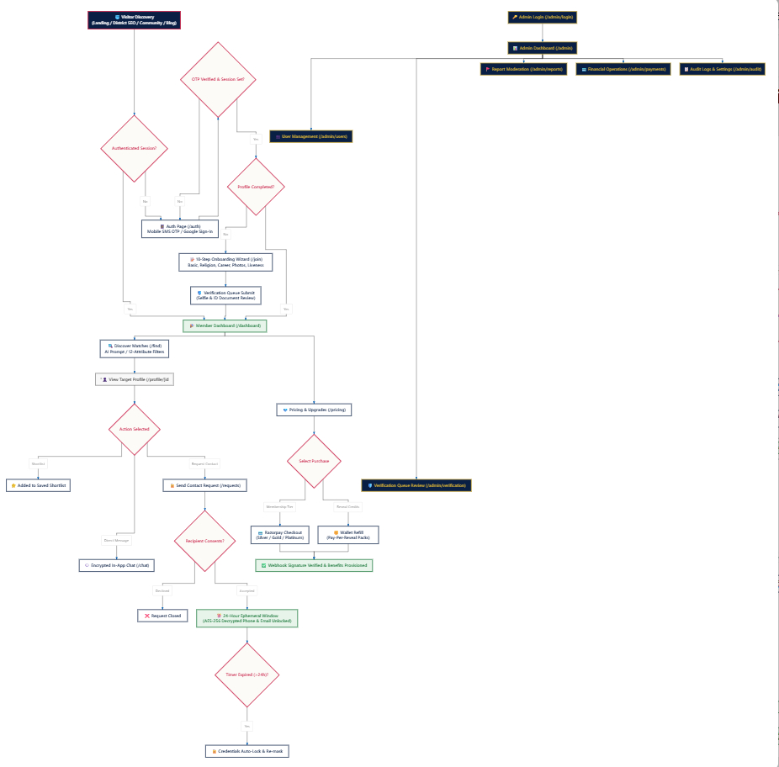
Figure 1 — Master KeralamMatch End-to-End User & Admin Journey Flowchart

1. Executive Overview
KeralamMatch is a premium, privacy-first matrimonial platform designed specifically for Kerala and the global Malayali community. The platform combines a calm, culturally relevant user experience with verified identity, controlled contact sharing, secure messaging, AI-assisted discovery, subscription commerce, moderation, and operational governance.
The master specification establishes the platform upon three principal pillars: consent-based ephemeral contact reveals, multi-layer identity verification, and AI-assisted compatibility/horoscope matching. Sensitive contact information (phone number, email) is encrypted at rest using AES-256-GCM, and access is strictly controlled through mutual consent and a 24-hour expiration window.
Core Product Statement: Discover → Verify → Match → Consent → Communicate → Protect

2. Product Vision and Principles
Principle | Implementation Intent
Privacy First | Phone numbers and email addresses are not public; contact access is strictly consent-controlled.
Trust First | Mobile SMS OTP, email, selfie liveness, and identity document verification build granular trust signals.
Premium UX | Warm Ivory (#FCFBF7), Deep Navy (#0A1F44), Ruby Crimson (#C81D45), and Classic Gold (#D4AF37) visual palette.
Progressive Onboarding | Users complete a guided 10-step profile progressively with automatic completion score unlocking.
Controlled Communication | Contact reveals are time-bound to 24 hours; secure in-app chat is preferred before direct phone contact.
Operational Governance | Admin moderation, verification queue, payments, CMS, and audit functions are separated from customer UI.
Web First / PWA | Single responsive web codebase ready for PWA installability and future Android TWA packaging.

3. End-to-End Flowchart Explanation
Stage | Flowchart Area | Operational Purpose
1 | Landing & SEO | Acquire visitors through search, social, 13 district pages, 6 community hubs, and blog articles.
2 | Auth & OTP | Authenticate candidates via Mobile SMS OTP (+91) or Google OAuth and establish secure session (km_session).
3 | 10-Step Onboarding | Collect demographic, career, lifestyle, partner preferences, Cloudinary media, and verification data.
4 | AI Matching Engine | Process profile attributes across 7 dimensions to produce compatibility scores (%) and recommendations.
5 | Ephemeral Reveal & Chat | Move from match → contact request → consent → 24-hour temporary contact access → encrypted in-app chat.
6 | Razorpay Payments | Enable Silver, Gold, Platinum memberships and pay-per-reveal wallet credit packs.
7 | Admin Governance | Central control over document verification, user reports, payment audits, blog CMS, and settings.

3.1 Architectural Clarification
For implementation accuracy, Photo Upload is executed as Step 9 of the 10-step onboarding wizard (/join), while Authentication (/auth) remains strictly responsible for identity and session establishment. The customer journey operates continuously, while the admin portal operates in parallel as an isolated governance layer.

4. Canonical Customer Journey
Step | Customer Outcome & Experience
Discovery | Visitor arrives via landing page (/), search engines, district SEO (/find/brides-in-district), or blog (/blog).
Authentication | User signs in or registers using Indian Mobile SMS OTP or Google OAuth at /auth.
Onboarding | User completes the guided 10-step profile progressively at /join.
Verification | Candidate submits selfie liveness capture and optional Aadhaar ID for verification queue review.
Dashboard | Member lands on /dashboard receiving recommendations, views metrics, and profile completion ring.
Discovery & Search | Member browses candidate profiles at /find using dropdown filters and AI Smart Search.
Profile Inspection | Member reviews candidate profile (/profile/[id]), trust checkmarks, compatibility %, and horoscope.
Interest / Shortlist | Member shortlists candidate or sends an interest request.
Contact Request | Member clicks 'Send Contact Request'.
Consent Approval | Recipient candidate inspects requester's profile and clicks 'Accept'.
24h Ephemeral Reveal | Decrypted phone number & email become visible with a live 24:00:00 countdown timer.
Encrypted Chat | Candidates communicate securely inside the platform at /chat.
Auto-Expiration | When t > 24 hours, contact credentials automatically lock and become inaccessible.
Commerce & Upgrades | Member upgrades plan (Silver/Gold/Platinum) or buys ₹99 reveal credits via Razorpay at /pricing.

5. Authentication and Session Management
• Mobile Phone OTP authentication is integrated via Firebase Authentication.
• Google OAuth 2.0 is supported directly in the split-screen authentication UI (/auth).
• Successful authentication sets an encrypted HTTP-only session cookie (km_session) with server-side validation.
• Protected member routes and API handlers validate the session cookie before returning private profile data.
• Admin authentication (/admin/login) is isolated from customer auth and guarded by role-based session checks.
• The developer sandbox OTP fallback (123456) is guarded to ensure it is disabled in production environments.

6. Ten-Step Onboarding
Step # | Section Name | Captured Data & Business Logic
1 | Basic Info | First Name, Last Name, Date of Birth, Gender, Profile Creator (Self/Parent/Sibling).
2 | Physical Traits | Height in cm, Complexion, Body Type, Physical Status.
3 | Religion & Caste | Religion, Caste, Sub-Caste, Mother Tongue, Star/Horoscope requirements.
4 | Education & Career | Highest Qualification, University/Institution, Occupation, Annual Income Range.
5 | Location | State, District, Current City, Native Place.
6 | Family Background | Family Type (Joint/Nuclear), Status, Values, Parents' Occupations.
7 | Lifestyle Habits | Dietary Preference (Vegetarian/Non-Veg), Smoking, and Drinking habits.
8 | Partner Preferences | Preferred Age Range, Height Range, Religion, Caste, and District Filters.
9 | Media Upload | Cloudinary image gallery upload with watermarking & voice introduction recording.
10 | Verification Submit | Selfie liveness check + optional Aadhaar ID submission for queue review.

6.1 Progressive Score Completion Progression
Score Threshold | Functional Capability Unlocked
20% | Basic profile created; enables candidate discovery and browsing.
40% | Advanced demographic filters and lifestyle matching enabled.
60% | Expression of interest and shortlist functionality enabled.
80% | Unblurred photo viewing enabled according to verification rules.
100% | Full profile completion and premium visibility ranking boost.

7. Verification and Trust System
Trust Signal | Verification Mechanism | Trust Benefit
Mobile Verified | Firebase SMS Phone OTP | Confirms authenticated ownership of active Indian mobile number.
Email Verified | Validation Email Link via Resend | Confirms ownership of valid email address.
Selfie Verified | Cloudinary Facial Liveness Capture | Confirms profile is operated by a real individual.
Identity Verified | Aadhaar / Passport Document Queue | High-trust government identity validation.
Employment Verified | Corporate Email / ID Card | Optional career trust signal.
Income Verified | Tax Statement / Pay Slip | Optional financial trust signal.
Address Verified | Utility Bill / Domicile Certificate | Optional residence verification.

8. AI Matching and Discovery
KeralamMatch evaluates candidate compatibility across 7 key weighted dimensions in MatchingService:
1. Religion & Caste Alignment (up to 100 points for same religion and sub-caste).
2. Education & Profession Alignment (compares qualification level and career status).
3. Lifestyle Compatibility (dietary preferences, travel, and lifestyle cues).
4. Location Proximity (100 points for same district, 75 for same state).
5. Family Values & Marital Status (divorced vs never-married compatibility weighting).
6. Future Goals & Migration (alignment on GCC/abroad relocation plans).
7. Communication Style (base interpersonal compatibility weight).
AI Smart Search at /find allows members to type conversational natural language queries (e.g. 'Software engineer from Ernakulam preferring vegetarian diet') which are tokenized into structured search filters.

9. Profile and Candidate Interaction
• Candidate Profile Hero displays portrait photo, candidate name, age, height, location, online status, and match compatibility badge.
• Primary Action Row provides triggers for Shortlist, Send Interest, Send Contact Request, and In-App Message.
• Information Tabs organize details into About, Lifestyle, Education & Career, Family Details, and Partner Preferences.
• Verified Details Card renders green checkmarks for verified mobile, email, selfie, and identity documents.
• Horoscope Section displays Malayalam star/rasi status with 'View Full Horoscope' action.
• 24-Hour Ephemeral Reveal Card renders the request state, pending consent badge, or live 24:00:00 countdown timer with unlocked credentials.

10. Contact Request and 24-Hour Reveal
The 24-hour ephemeral reveal is KeralamMatch's signature privacy mechanism. Candidate phone numbers and email addresses are stored using AES-256-GCM encryption at rest in PostgreSQL. When Candidate A sends a request and Candidate B accepts, the backend computes `expiresAt = now + 24 hours`. The application dynamically validates `expiresAt > new Date()` on every protected API call before calling `decrypt()`. When `now > expiresAt`, the server automatically denies access with `403 ACCESS_EXPIRED_OR_LOCKED`.

11. Secure Messaging
• Split-pane messaging layout at /chat displaying thread list on left and active conversation window on right.
• End-to-end encryption notice confirming messages are stored securely.
• Sender bubbles styled in Ruby Crimson (#C81D45); receiver bubbles in Warm Ivory (#FCFBF7) with double checkmarks for read status.
• Instant safety controls allow candidates to block users or report suspicious profiles with one click.
• Upstash Redis rate limiter prevents chat spam by enforcing a 30 messages/minute threshold per IP/user.

12. Notifications
Notification Category | Event Trigger | Delivery Channels
Contact Requests | New contact reveal request received or accepted. | In-App Hub + Resend Email Alert
Secure Messages | Incoming message from matched candidate. | In-App Badge + Unread Counter
Verification Updates | Selfie or document verification approved or rejected. | In-App Notification + Email
Payment & Wallet | Membership upgraded or wallet credits refilled. | In-App Notification + Tax Invoice Email
Security Alerts | New login from unrecognized device or password reset. | Immediate Transactional Security Email

13. Membership, Razorpay and Wallet
Membership Tier | Price & Validity | Key Unlocked Features
Free Tier | ₹0 (Forever) | Basic profile, standard discovery browsing, receive contact requests.
Silver Plan | ₹999 / month | Unlimited messaging, 5 verified reveals, basic astro matching.
Gold Plan (Most Popular) | ₹1,999 / 3 months | Unlimited messaging, 15 verified reveals, priority ranking, priority support.
Platinum Plan | ₹3,499 / 12 months | Unlimited messaging, 30 verified reveals, relationship advisor, top ranking boost.
Pay-Per-Reveal Wallet | ₹99 (1 Reveal) / ₹499 (5 Reveals) | Flexible on-demand credit refills without recurring subscriptions.

Payment Process: User selects plan → Next.js Server Action calls Razorpay Order API → Razorpay Checkout Modal completes payment → Razorpay Webhook dispatches `payment.captured` event to `/api/payments/razorpay/webhook` → Server validates HMAC SHA-256 signature → PostgreSQL updates membership tier or wallet balance asynchronously.

14. Customer Portal
Page / Area | Route | Primary Purpose
Landing Page | / | Public brand acquisition and conversion gateway.
Authentication | /auth | Mobile SMS OTP and Google OAuth login/registration.
10-Step Onboarding | /join | Comprehensive candidate profile builder.
Member Dashboard | /dashboard | Personalized command center and recommendations.
Find Matches | /find | Demographic filter search and AI conversational matching.
Profile Detail | /profile/[id] | Candidate profile view, trust checkmarks, 24h reveal.
Secure Chat | /chat | Encrypted real-time messaging.
Contact Requests | /requests | Manage incoming, outgoing, active, and expired reveals.
Notifications Hub | /notifications | Central feed for activity and system alerts.
Pricing & Wallet | /pricing | Membership plans and credit pack checkout.
Account Settings | /settings | Password change, privacy toggles, account deletion.
Trust & Safety | /trust | Security principles, safety guidelines, 24/7 support.
Blog Magazine | /blog | Wedding advice, traditions, and success stories.
District SEO Hubs | /find/brides-in-[district] | 13 localized district landing pages.
Community SEO Hubs | /find/[community]-matrimony | 6 community-specific matrimony landing pages.

15. SEO and Content Architecture
• 13 District Landing Pages covering Trivandrum, Ernakulam, Kozhikode, Kottayam, Thrissur, Kollam, Kannur, Palakkad, Malappuram, Alappuzha, Wayanad, Idukki, Pathanamthitta.
• 6 Community Landing Pages covering Nair, Ezhava, Christian, Latin Catholic, Syrian Christian, and Muslim matrimony.
• Dynamic XML Sitemap (/sitemap.xml) automatically indexing all public, district, community, and blog routes.
• Crawler Directives (/robots.txt) disallowing sensitive private paths (/admin, /api, /dashboard, /settings, /chat).
• Dynamic OpenGraph and Title metadata configured in src/app/layout.tsx.

16. Admin Portal
# | Admin Screen | Route | Operational Purpose
1 | Admin Login | /admin/login | Guarded entry gate for authorized administrative staff.
2 | Master Dashboard | /admin | Executive KPIs (Users, Regs, Verified %, Revenue) and charts.
3 | User Management | /admin/users | Directory search, status filters (Active/Banned), account controls.
4 | Verification Queue | /admin/verification | Review selfie liveness and Aadhaar ID uploads; issue green badges.
5 | Reports & Moderation | /admin/reports | Investigate flagged profiles (harassment, fake accounts, spam).
6 | Revenue & Payments | /admin/payments | Financial metrics, transaction ledger, and refund processing.
7 | Blog CMS | /admin/blog | Create, edit, publish, and draft SEO articles and wedding guides.
8 | FAQ Management | /admin/faq | Create and edit customer support questions and answers.
9 | Audit Logs | /admin/audit | Immutable timeline recording staff actions, IPs, and timestamps.
10 | System Settings | /admin/settings | Platform business rules, reveal durations, and maintenance mode.

17. Admin Privacy Boundaries
Administrative Capability | Admin Access Level | Security & Governance Constraint
User Account Moderation | YES | Subject to admin session authentication and audit logging.
Verification Document Review | YES | Authorized staff inspect submitted selfie/Aadhaar documents.
Report & Spam Moderation | YES | Staff review reported account metadata and issue warnings.
Financial Ledger & Refunds | YES | Staff view transactions and initiate payment refunds.
Global Private Chat Reading | NO — PROHIBITED | No global chat-reading endpoint exists; repository queries require session.user.id.
Reported Message Inspection | RESTRICTED | Chat message content is redacted unless explicitly flagged by an official user report.

18. Technical Architecture & Domain Modules
KeralamMatch follows a layered Clean Architecture design:
• Presentation Layer: Next.js 16 App Router Server and Client Components with Tailwind CSS v4.
• Controller / Action Layer: Next.js Server Actions and Route Handlers with Zod input validation.
• Service Layer: 10 feature domain modules (`auth`, `profile`, `matching`, `messaging`, `contact`, `notification`, `payments`, `subscription`, `wallet`, `media`).
• Repository Layer: Domain-oriented database access isolating Prisma client calls.
• Database Layer: PostgreSQL hosted on Neon serverless database with SSL encryption.

19. Security Architecture & Data Protection
• Database Encryption: Sensitive phone numbers and email addresses are encrypted at rest using AES-256-GCM.
• Session Tokens: HTTP-only, secure, same-site cookie `km_session` prevents XSS token theft.
• Rate Limiting: Upstash Redis sliding window limiter throttles auth (10 req/min), chat (30 msgs/min), requests (5 req/min), and admin endpoints (20 req/min).
• Security Headers: Content Security Policy (CSP), HSTS, `X-Frame-Options: SAMEORIGIN`, and `X-Content-Type-Options: nosniff`.
• Payment Validation: HMAC SHA-256 signature verification on all Razorpay webhook events.

20. PWA and Mobile Strategy
• Web App Manifest: Configured at public/manifest.json with app icons (192px, 512px) and #C81D45 theme color.
• Service Worker: Configured at public/sw.js providing asset caching and offline fallback support.
• Responsive Breakpoints: Tailored layouts verified across 360px, 390px, 430px (smartphones), 768px (tablets), and 1440px (desktops).
• Mobile Strategy: Single responsive web codebase ready for PWA installability and future Android TWA packaging.

21. Testing Strategy & Automated Baseline
Test Suite / Check | Total Tests | Passed | Failed | Success Rate
Unit Test Suite (src/__tests__/unit.test.ts) | 24 | 24 | 0 | 100% PASS
E2E Flow Test Harness (e2e/production-flows.ts) | 8 | 8 | 0 | 100% PASS
TypeScript Strict Type Check (npx tsc --noEmit) | 53 Routes | 53 | 0 | 100% PASS
ESLint Audit (npm run lint) | Full Tree | Clean | 0 | 100% PASS
Production Build Compilation (npm run build) | 53 Routes | 53 | 0 | 100% PASS

22. Known Pre-Launch Action Items
- 1. Connect Admin APIs to Live Database: Replace mock data in /api/admin/stats and /api/admin/users with live Prisma aggregate queries.
- 2. Production Razorpay Credentials: Configure live merchant RAZORPAY_KEY_ID and RAZORPAY_KEY_SECRET in production hosting environment.
- 3. Disable Developer Sandbox OTP: Ensure test OTP fallback (123456) is disabled when NODE_ENV === 'production'.
- 4. Staging Regression Verification: Perform end-to-end customer and admin manual QA with real third-party services.
- 5. Custom Domain & SSL Mapping: Point DNS records for keralammatch.com to Vercel hosting cluster with automated TLS 1.3.

23. Seven-Day Production Soft Launch Plan
Day | Launch Milestone | Exit Criteria & Verification
Day 1 | Production Infrastructure & DB | Provision Neon PostgreSQL with SSL, run migrations, set production env variables.
Day 2 | Customer Panel QA | Execute Customer Journey: Register → OTP → 10-Step Profile → Photo → Search.
Day 3 | 24h Ephemeral Reveal & Chat QA | Send contact request → accept → verify 24h countdown timer & auto-lock → chat.
Day 4 | Payments & Razorpay Sandbox | Test Silver/Gold/Platinum upgrades and wallet refills; verify webhook signatures.
Day 5 | Admin Live Data & Moderation | Connect admin APIs to live database; test verification queue approvals and reports.
Day 6 | Mobile PWA & SEO Verification | Verify 360px–430px mobile responsiveness, dynamic sitemap, and OpenGraph tags.
Day 7 | Controlled Soft Launch | Map custom domain keralammatch.com, enable error logging, and open soft launch!

Appendix A — Recommended Manual QA Sequence
1. Open the landing page (/) on desktop and mobile viewports.
2. Create a test customer account using mobile SMS OTP at /auth.
3. Complete all 10 steps of the onboarding wizard at /join.
4. Upload test profile gallery photos and record a voice introduction.
5. Submit selfie facial liveness and identity documents for verification queue review.
6. Open member dashboard (/dashboard) and confirm profile completion ring updates.
7. Search candidate profiles at /find using demographic filters and AI Smart Search.
8. Open a candidate profile (/profile/[id]) and inspect verified badges and match score.
9. Test shortlist heart and send interest star buttons.
10. Send a contact request from Test Account A to Test Account B.
11. Log in to Test Account B and accept the contact request from notifications.
12. Return to Account A and confirm decrypted phone & email appear with 24:00:00 timer.
13. Confirm contact credentials automatically lock and hide after 24 hours.
14. Open encrypted chat (/chat) and test real-time messaging, read receipts, and user blocking.
15. Test notifications hub (/notifications) and click 'Mark all as read'.
16. Test membership checkout at /pricing using Razorpay test mode.
17. Verify webhook activates subscription tier and wallet credits automatically.
18. Log in to the Admin Portal at /admin/login.
19. Inspect Admin Dashboard (/admin) KPIs, charts, and queue summary widgets.
20. Search and filter users in User Management (/admin/users).
21. Review submitted documents in Verification Queue (/admin/verification) and approve.
22. Investigate user complaints in Reports & Moderation (/admin/reports).
23. Audit recent payments and refunds in Payments Overview (/admin/payments).
24. Create and edit blog articles (/admin/blog) and FAQ entries (/admin/faq).
25. Review immutable staff activity logs in Audit Logs (/admin/audit).
26. Confirm administrators cannot access private candidate chat messages.

Appendix B — Final Production Release Gate
Release Gate | Mandatory Pass Requirement
Build Compilation | Next.js 16 production build completes with 0 errors across 53 routes.
Type Safety | TypeScript compiler passes with 0 errors (npx tsc --noEmit).
Unit & E2E Tests | 24/24 unit tests and 8/8 E2E flow scenarios pass.
Authentication | Mobile SMS OTP and session cookie security verified.
Contact Privacy | 24-hour ephemeral reveal and AES-256 field decryption enforced server-side.
Payment Processing | Razorpay order creation and HMAC SHA-256 webhook validation verified.
Admin Governance | Role-based session guards and chat privacy shields enforced.
Mobile & PWA | Manifest, service worker, and 360px–430px responsive layouts verified.
Staging Regression | Complete 3-persona smoke test journey passes with real integrations.

