KERALAMMATCH
MASTER SOFTWARE SPECIFICATION & GUI COMPONENT DOCUMENTATION
Detailed End-to-End User & Admin Portals Breakdown · Version 1.0

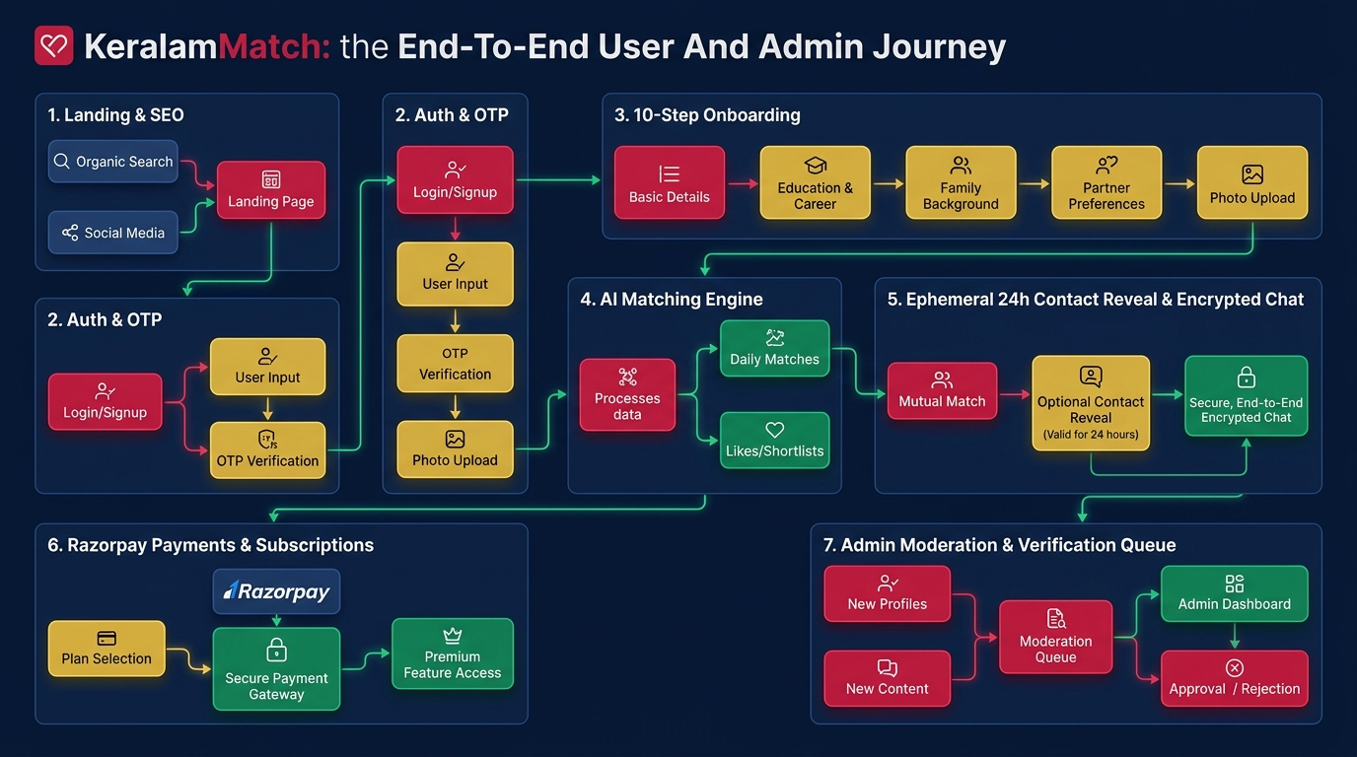
Figure 1: KeralamMatch End-to-End User & Admin Journey Flowchart

1. Executive Overview & Core Product Architecture
KeralamMatch is Kerala's premier privacy-first, verified matrimonial platform tailored for the global Malayali community. The software combines modern web design aesthetics (Warm Ivory #FCFBF7, Deep Navy #0A1F44, Crimson Red #C81D45, and Classic Gold #D4AF37) with Clean Architecture software design patterns, serverless PostgreSQL data storage, and strict privacy controls.

Core Architectural Pillars
- Consent-Based Ephemeral 24-Hour Contact Reveals: Candidate phone numbers and email credentials are encrypted at rest with AES-256-GCM. Unlocking credentials requires mutual consent and auto-expires after exactly 24 hours.
- Multi-Layer Identity Verification Queue: Every profile undergoes Mobile SMS OTP verification, selfie liveness checks, and document review (Aadhaar / Passport) before receiving green verified badges.
- AI-Assisted Compatibility & Horoscope Matching: The matching engine calculates compatibility percentages based on 12 candidate parameters including education, profession, district, lifestyle, and horoscope alignment.
- Admin Privacy Shield & Role Governance: Administrators have access to moderation tools but are restricted from viewing un-redacted private chat messages without explicit user authorization and audit logging.

2. Detailed User Portal Pages & GUI Breakdown
The User Portal consists of 14 core interactive routes designed for smooth navigation, candidate discovery, and privacy-first communication.

2.1 Landing Page (`/`)
• Header & Brand Navigation: Displays KeralamMatch SVG Emblem Logo, navigation links (Home, Find Matches, How It Works, Pricing, Trust & Safety, Blog), and 'Create Account' crimson CTA button.
• Hero Banner: Large serif headline 'Find Your Perfect Match, the Malayali Way.', subtitle, pill badges (Privacy First, Verified Profiles, 24/7 Support, 100% Secure), primary crimson CTA, and authentic Kerala couple hero portrait.
• Dark Maroon Stat Bar: Highlighted maroon statistics banner displaying 50,000+ Happy Members, 100+ Communities, 98% Verified Profiles, and 24/7 Support.
• 3-Column Feature Cards: Cards detailing Ephemeral 24-Hour Reveal, Multi-Layer Verification Queue, and Encrypted In-App Messaging.
• District & Community Footer Grid: SEO quick links covering 13 Kerala districts and major communities.

2.2 Authentication Page (`/auth`)
• Split-Screen Layout: Left: Deep maroon panel (#5C0A1E) with brand logo, traditional Nilavilakku lamp vector graphic, and slogan 'Privacy First. Always. Forever.'; Right: Interactive Auth Card.
• Login / Sign Up Toggle: Pill toggle switching between existing account login and new candidate registration.
• Mobile OTP Input: Indian phone number (+91) input field connected to Firebase Auth SMS OTP delivery.
• Google OAuth Button: One-click Google Account authentication button.
• Sandbox Fallback Notice: Developer fallback prompt accepting test OTP (123456) when operating in test mode.

2.3 10-Step Onboarding Wizard (`/join`)
• Progress Header: Displays 'Step X of 10' progress counter and completion percentage ring bar.
• Step 1: Basic Info: First name, last name, DOB, gender, profile owner (Self, Parent, Sibling).
• Step 2: Physical Attributes: Height in cm, complexion, body type, physical status.
• Step 3: Religion & Caste: Religion, caste, sub-caste, mother tongue, star/horoscope requirement.
• Step 4: Education & Profession: Highest qualification, institution, occupation, annual income range.
• Step 5: Location Details: State, district, current city, native place.
• Step 6: Family Details: Family type (Joint/Nuclear), status, values, father/mother occupation.
• Step 7: Lifestyle: Dietary preference (Veg/Non-Veg), smoking, drinking habits.
• Step 8: Partner Preferences: Preferred age range, height, religion, caste, district preferences.
• Step 9: Media Upload: Cloudinary image dropzone for candidate photo gallery and voice introduction recording.
• Step 10: Verification Submission: Selfie liveness upload + optional Aadhaar ID submission for queue review.

2.4 Member Dashboard (`/dashboard`)
• Left Navigation Sidebar: Quick links to Dashboard, Find Matches, My Matches, Messages, Requests, Shortlisted, Notifications, Settings.
• Welcome Banner: Personalized greeting 'Welcome back, [firstName] 👋' displaying active user status.
• Profile Completion Widget: Circular progress ring displaying completion % and 'Update Now' CTA.
• Profile Views Card: Displays 240 profile views, +18% growth badge, and view details button.
• Recommended Candidates Grid: 4-column candidate cards with photo portrait, age, district, shortlist heart, and view profile CTA.

2.5 Find Matches & Discovery (`/find`)
• Category Navigation Tabs: Tabs for Find, Matches, Search, and Saved Searches.
• Quick Filter Bar: Dropdown selectors for Religion, Caste, District, Age Range, and 'More Filters' button.
• AI Smart Search Prompt: Natural language text input (e.g. 'Software engineer from Ernakulam preferring vegetarian diet') powering AI query parsing.
• Candidate Cards Grid: Candidate portrait image, age, height, district, religion/caste, match compatibility % badge, shortlist heart, and 'View Profile' button.

2.6 Target Profile Detail (`/profile/[id]`)
• Hero Profile Header Card: Large portrait photo, candidate name, age, height, location, online status ('Last seen recently'), and match score badge (94% Match).
• Action Buttons Row: Shortlist heart, Send Interest star button, Send Contact Request button, and Message button.
• Section Navigation Tabs: Tabs for About, Lifestyle, Education, Career, Family, and Partner Preference.
• Personal Attributes Grid: Spacious 2-column table displaying education, profession, mother tongue, marital status, district, and religion/caste.
• Verified Details Card: Checkmarked list: Mobile Verified, Email Verified, Aadhaar Verified, Photo Verified.
• Horoscope Card: Horoscope requirement status and 'View Horoscope' action button.
• Ephemeral 24h Contact Reveal Box: Displays 'Send Contact Request' button, pending consent badge, or 24h countdown timer with revealed phone & email credentials.

2.7 Secure Messaging (`/chat`)
• Split-Pane Chat Layout: Left: Active conversation list with candidate avatars, names, last message snippet, timestamp, and unread count badges.
• Chat Window Header: Displays candidate avatar, name, online badge, and encryption banner 'Messages are encrypted and private'.
• Message Bubbles: Sender messages styled in crimson (#C81D45) right-aligned; receiver messages styled in warm white (#FCFBF7) left-aligned with double checkmarks for read status.
• Input Bar: Message text input with send icon CTA and block user option.

2.8 Contact Requests (`/requests`)
• Filter Tabs: Tabs for Received (Incoming), Sent (Outgoing), Active (24h reveals), and Expired.
• Request Cards List: Candidate avatar, name, district, requested date, Accept button (green), Decline button (outline), Active 24h countdown badge, or Expired status.

2.9 Notifications (`/notifications`)
• Header Bar: Title 'Notifications', unread counter, and 'Mark all as read' button.
• Notification List Items: Icon indicator by alert type (Heart for request, Message for chat, Shield for verification, Coins for wallet), title, message description, timestamp, and unread red dot.

2.10 Pricing & Subscriptions (`/pricing`)
• Header Section: Title 'Choose Your Plan — Upgrade to unlock premium features'.
• Membership Plan Cards: Cards for Free, Silver, Gold (Most Popular gold border), and Platinum with pricing, feature checklists, and 'Choose Plan' buttons.
• Pay-Per-Reveal Credit Packs: Wallet credit recharge options (₹99 for 1 reveal, ₹499 for 5 reveals).
• Razorpay Payment Modal: Triggers native Razorpay checkout modal supporting UPI, Cards, and Netbanking.

2.11 Settings (`/settings`)
• Sidebar Category Menu: Links for Profile Settings, Account & Password, Privacy Settings, Notification Settings, Astro & Horoscope, Photos & Media, Deactivate Account.
• Right Content Panel: Forms for password change, privacy checkboxes, Sign Out button, and Delete Account confirmation modal.

2.12 Trust & Safety (`/trust`)
• Safety Hero Banner: Title 'Your Safety Comes First' and privacy vision.
• Safety Pillars Grid: Cards for Verified Profiles, Contact Reveal Protection, Report & Moderation, Instant Blocking.
• 24/7 Support Banner: Direct link to customer support and FAQ center.

2.13 Blog System (`/blog`, `/blog/[slug]`)
• Category Filter Pills: Filter articles by All, Relationships, Marriage Tips, Success Stories, Lifestyle, Family.
• Article Grid: Thumbnail image, category badge, read time, title, excerpt, and publish date.
• Article Detail Page: Full-width hero header, author info, rich text body content, and social share buttons.

2.14 District & Community SEO Pages
• District Landing Pages (`/find/brides-in-[district]`): SEO header for 13 Kerala districts, verified candidate count (12,856), popular towns list, community breakdown, and FAQs.
• Community Landing Pages (`/find/[community]-matrimony`): SEO header for Nair, Ezhava, Christian, Latin Catholic, Syrian Christian, and Muslim matrimony with tradition highlights.

3. Detailed Admin Portal & Governance Breakdown
The Admin Portal is accessible via `/admin` and provides central control over candidate verification, report moderation, payments, content, and system audit logs.

Admin App Shell (`src/app/admin/layout.tsx`)
- Dark Navy Sidebar (`#0A1F44`): Fixed left sidebar with KeralamMatch Admin logo emblem and navigation menu items.
- Active Indicator (`#C81D45`): Highlighted active page item styled in vibrant crimson red.
- Top Header Bar: White header featuring quick search input ('Search candidates, reports...'), notification bell, and Admin profile avatar.
- Light Content Canvas (`#F8FAFC`): Spacious clean canvas for rendering analytical dashboards and data tables.

3.1 Admin Login (`/admin/login`)
• Admin Auth Card: Centered white card with KeralamMatch logo, 'Admin Portal' crimson title, and Nilavilakku lamp graphic motif.
• Credentials Input: Email input (admin@keralammatch.com), password input, 'Remember me' checkbox, and Login button.

3.2 Admin Dashboard (`/admin`)
• 4 KPI Overview Cards: Total Users (25,430 +12.5%), New Registrations (1,234 +8.2%), Verified Profiles (18,765 +10.6%), Active Premium (2,456 +6.7%).
• Registrations Chart Card: Visual bar graphic displaying daily candidate registration trajectory over the current month.
• Verification Queue Summary Box: Displays Pending (324), In Review (76), and Completed (1,842) document verifications.
• Reports Summary Box: Displays Total Reports (156) and Resolved Reports (120).

3.3 User Management (`/admin/users`)
• User Filter Tabs: Tabs for All Users, Active, Inactive, Blocked, and Premium.
• Search Input Bar: Real-time search filtering users by name, email, or contact number.
• User Data Table: Columns for User Name & Email, Contact Number, Account Status (Active/Inactive), Verification Status (Verified/Pending), Joined Date, and Edit Actions.

3.4 Verification Queue (`/admin/verification`)
• Verification Status Tabs: Tabs for All, Pending, In Review, and Completed.
• Document Review Cards: Candidate name, Profile ID, District, Documents Uploaded count (e.g. 4/4 Uploaded), View documents button, and Review/Approve buttons.

3.5 Reports & Moderation (`/admin/reports`)
• Report Category Tabs: Tabs for All, Pending, In Review, and Resolved.
• Report Action Items: Displays report reason (Inappropriate Message, Fake Profile, Harassment, Spam), Reporter Name, Target User ID, Time, Review button, and Ban User button.

3.6 Payments Overview (`/admin/payments`)
• Financial Metric Cards: Total Revenue (₹18.76L), This Month (₹2.45L), Refunds (₹32.45K), Pending Payouts (₹1.28L).
• Recent Transactions Table: Columns for User Name, Plan Name, Amount, Payment ID, Status (Success/Refunded), and Date.

3.7 Blog CMS (`/admin/blog`)
• Header CTA: 'Add New Article' button triggering post creation editor.
• Article Table: Columns for Article Title, Category, Status (Published/Draft), Published Date, Edit, and Delete actions.

3.8 FAQ Management (`/admin/faq`)
• Header CTA: 'Add New FAQ' button for adding new customer questions.
• FAQ Table: Columns for Question, Category, Status, Edit, and Delete actions.

3.9 Audit Logs (`/admin/audit`)
• Audit Trail Table: Timeline table displaying Admin Name, Action Taken, Module (Verification, Users, Reports, Payments), Details, and Timestamp.

3.10 Admin Settings (`/admin/settings`)
• Category Sidebar: Settings categories for General, Site, Email, SMS, Payment, Security, Notification, Backup.
• Configuration Form: Input fields for Site Name, Support Email, Contact Number, and 'Save Changes' button.

4. Technical Mechanics & Underlying Software Flow
- AES-256 Field Encryption Engine: Sensitive user fields (phone number, email address) are encrypted at rest using AES-256-GCM before database insertion. The secret key is stored securely in environment config.
- 24-Hour Ephemeral Contact Reveal Logic: When a contact request is accepted, the system sets `expiresAt = now + 24 hours`. API endpoints calculate remaining time dynamically and mask credentials automatically when `now > expiresAt`.
- Razorpay Order Creation & Webhooks: Subscription and credit refill orders are initiated on the backend via Razorpay API. Upon payment success, Razorpay webhooks verify payment signatures and activate user benefits asynchronously.
- Admin Privacy Shield Enforcement: Admin controllers explicitly redact private candidate message text from moderation views unless an official report audit flag is active.

