KeralamMatch
End-to-End System Flowchart & Architecture Documentation
Platform Specification & Technology Roadmap — Version 1.0

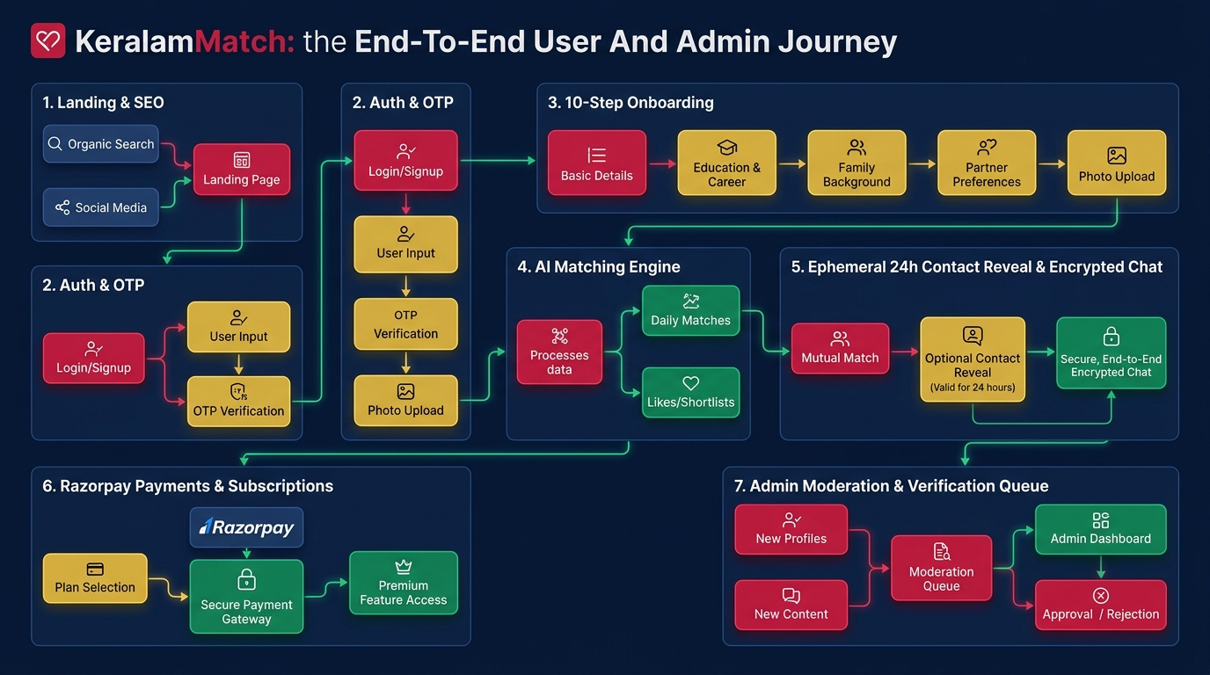
Figure 1: KeralamMatch End-to-End User and Admin Journey Flowchart Diagram

1. Executive Summary & Vision
KeralamMatch is Kerala's premier privacy-first, verified matrimonial platform designed for the global Malayali community. Unlike traditional matrimonial portals that publicly expose candidate phone numbers, photos, and personal details to search engines or anonymous web crawlers, KeralamMatch enforces consent-based 24-hour ephemeral contact reveals, AES-256-GCM database field encryption, multi-layer identity verification, and AI-assisted attribute compatibility matching.

2. Platforms & Technology Stack (Used Now)
Domain / Layer | Platform / Tech Used | Responsibility & Function
Frontend Framework | Next.js 16 (App Router) + React 19 | Server/client rendering, SSG for 53 routes, Turbopack build engine
Programming Language | TypeScript (Strict Mode) | End-to-end type safety, controller schemas, and repository interfaces
Design System & UI | Tailwind CSS v4 + Lucide Icons | Custom design system tokens (#0A1F44, #C81D45, #D4AF37, #FCFBF7)
Database Layer | Neon PostgreSQL + Prisma ORM v6 | Serverless PostgreSQL with SSL encryption, migrations, and model relations
Data Security | AES-256-GCM Field Encryption | Encrypts phone numbers & email addresses at rest before DB insertion
Authentication | Firebase Auth (SMS OTP + Google) | Mobile OTP verification & encrypted session cookie (km_session) generation
Media Cloud Storage | Cloudinary CDN | AVIF/WebP image optimization, photo watermarking, liveness uploads, voice intro
Payment Gateway | Razorpay API + Webhooks | UPI, Cards, Netbanking checkout for Silver/Gold/Platinum plans & credit refills
Email Infrastructure | Resend API | Transactional HTML emails for OTP, requests, acceptances, and receipts
Security & Caching | Upstash Redis + Security CSP | Throttling Auth/Chat APIs, rate-limiting, HSTS, and CSP header injection
Analytics | Google Analytics 4 + Clarity | Traffic metrics, event tracking, and user session recording

3. Future Platforms & Integration Roadmap (Going to be Used)
- Native Mobile Apps (React Native / Expo): Native apps for Apple App Store & Google Play Store featuring FaceID/Biometrics login and camera verification.
- DigiLocker Govt Verification (SurePass / Cashfree API): Automated 5-second instant Aadhaar, Passport, and PAN verification to issue green verified badges.
- WhatsApp Business API (Twilio / Meta WhatsApp API): Deliver instant WhatsApp alerts for incoming contact requests, chat messages, and 24h reveal expiry warnings.
- AI Vector Matcher Engine (OpenAI Embeddings + Pinecone): Hyper-personalized semantic candidate matching based on vector embeddings and Porutham (horoscope matching).
- In-App Virtual Video Dates (Agora.io / Daily.co WebRTC SDK): Encrypted 1-on-1 virtual video dating directly inside the platform without disclosing personal phone numbers.
- Push Notification Service (Firebase Cloud Messaging (FCM)): Real-time web push and mobile push notifications for instant candidate activity alerts.

4. End-to-End User & Admin Flow Stages
• Stage 1: Entry & SEO: Visitors arrive via main Landing Page (/), District SEO (/find/brides-in-district), Community pages (/find/nair-matrimony), or Blog (/blog). Unauthenticated visitors view masked profiles with blurred photos.
• Stage 2: Auth & 10-Step Onboarding: User logs in via Mobile OTP (/auth), receives km_session cookie, and completes 10 onboarding steps (/join): Basic Details, Physical Attributes, Religion/Caste, Education, Location, Family, Lifestyle, Partner Preferences, Cloudinary Photos, and Liveness Check.
• Stage 3: Discovery & AI Matching: Member views Dashboard (/dashboard) and searches candidate profiles (/find) using quick filters or AI prompts. System calculates Compatibility Score (%) across 12 key attributes.
• Stage 4: Ephemeral 24-Hour Contact Reveal: Candidate A requests contact (/requests). Candidate B receives notification and approves. System unlocks decrypted phone & email for exactly 24 hours (expiresAt = now + 24h). Credentials auto-lock after 24h.
• Stage 5: Secure Messaging & Monetization: Matched candidates chat in real-time (/chat). Users upgrade membership plans (Silver/Gold/Platinum) or buy ₹99 reveal credits via Razorpay modal (/pricing).
• Stage 6: Governance & Admin Portal: Admins authenticate (/admin/login) and manage Dashboard stats (/admin), User Management (/admin/users), Verification Queue approvals (/admin/verification), Report Moderation (/admin/reports), Payments (/admin/payments), Blog CMS (/admin/blog), FAQ (/admin/faq), Audit Logs (/admin/audit), and System Settings (/admin/settings).

