KERALAMMATCH
COMPLETE SYSTEM FLOWCHARTS & ARCHITECTURE SPECIFICATION
All 4 Core System Flowcharts: Master Journey · Ephemeral Reveal · Razorpay Webhooks · Admin Governance

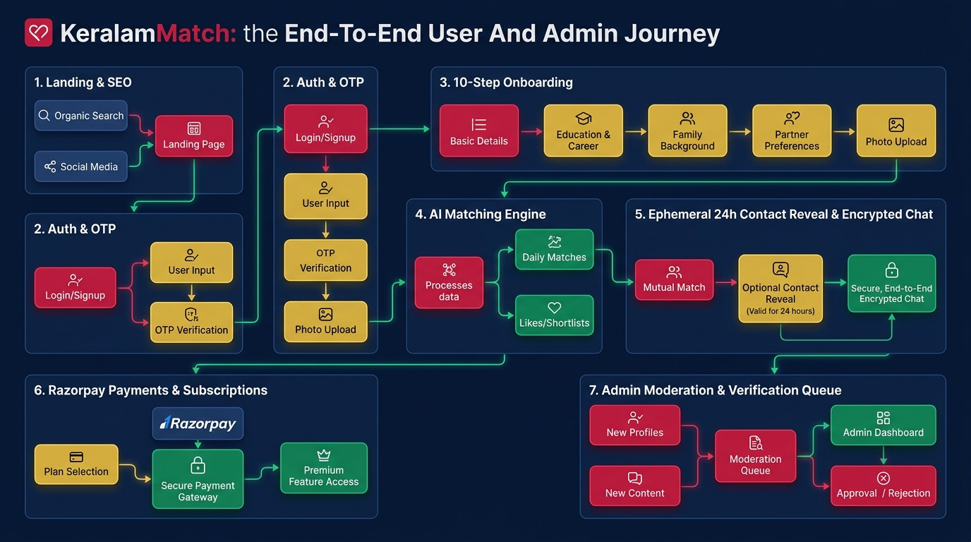

1. Master End-to-End User & Admin Journey Flowchart
```mermaid
flowchart TD
%% Styling Configuration
classDef startEnd fill:#0A1F44,color:#FFFFFF,stroke:#C81D45,stroke-width:2px;
classDef process fill:#FFFFFF,color:#0A1F44,stroke:#0A1F44,stroke-width:1.5px;
classDef decision fill:#FCFBF7,color:#C81D45,stroke:#C81D45,stroke-width:2px;
classDef admin fill:#0A1F44,color:#D4AF37,stroke:#D4AF37,stroke-width:1.5px;
classDef success fill:#E6F4EA,color:#137333,stroke:#137333,stroke-width:1.5px;
%% Entry Points & Public Discovery
A["🌐 Visitor Discovery<br/>(Landing / District SEO / Community / Blog)"]:::startEnd --> B{"Authenticated Session?"}:::decision
%% Authentication & Onboarding
B -- No --> C["📱 Auth Page (/auth)<br/>Mobile SMS OTP / Google Sign-In"]:::process
C --> D{"OTP Verified & Session Set?"}:::decision
D -- No --> C
D -- Yes --> E{"Profile Completed?"}:::decision
%% Onboarding Path
E -- No --> F["📝 10-Step Onboarding Wizard (/join)<br/>Basic, Religion, Career, Photos, Liveness"]:::process
F --> G["🛡️ Verification Queue Submit<br/>(Selfie & ID Document Review)"]:::process
G --> H["🎉 Member Dashboard (/dashboard)"]:::success
E -- Yes --> H
B -- Yes --> H
%% Core Member Discovery & Matching
H --> I["🔍 Discover Matches (/find)<br/>AI Prompt / 12-Attribute Filters"]:::process
I --> J["👤 View Target Profile (/profile/[id])"]:::process
J --> K{"Action Selected"}:::decision
K -- Shortlist --> L["⭐ Added to Saved Shortlist"]:::process
K -- Direct Message --> M["💬 Encrypted In-App Chat (/chat)"]:::process
K -- Request Contact --> N["🔒 Send Contact Request (/requests)"]:::process
%% 24-Hour Ephemeral Reveal Lifecycle
N --> O{"Recipient Consents?"}:::decision
O -- Declined --> P["❌ Request Closed"]:::process
O -- Accepted --> Q["⏰ 24-Hour Ephemeral Window<br/>(AES-256 Decrypted Phone & Email Unlocked)"]:::success
Q --> Q1{"Timer Expired (>24h)?"}:::decision
Q1 -- Yes --> Q2["🔒 Credentials Auto-Lock & Re-mask"]:::process
%% Monetization & Payments
H --> R["💎 Pricing & Upgrades (/pricing)"]:::process
R --> S{"Select Purchase"}:::decision
S -- Membership Tier --> T["💳 Razorpay Checkout<br/>(Silver / Gold / Platinum)"]:::process
S -- Reveal Credits --> U["🪙 Wallet Refill<br/>(Pay-Per-Reveal Packs)"]:::process
T & U --> V["✅ Webhook Signature Verified & Benefits Provisioned"]:::success
%% Admin Portal Suite
W["🔑 Admin Login (/admin/login)"]:::admin --> X["📊 Admin Dashboard (/admin)"]:::admin
X --> Y1["👥 User Management (/admin/users)"]:::admin
X --> Y2["🛡️ Verification Queue Review (/admin/verification)"]:::admin
X --> Y3["🚩 Report Moderation (/admin/reports)"]:::admin
X --> Y4["💳 Financial Operations (/admin/payments)"]:::admin
X --> Y5["📋 Audit Logs & Settings (/admin/audit)"]:::admin
```

Operational Flow Breakdown:
- Visitor Discovery: Organic visitors discover KeralamMatch via landing page (/), 13 district SEO pages, or 6 community hubs.
- Authentication & Onboarding: Mobile SMS OTP (+91) or Google OAuth sets HTTP-only session cookie (km_session), leading to 10-step onboarding (/join).
- Matching & Profile Viewing: Algorithmic 12-attribute compatibility scoring (%) on /find and rich profile view on /profile/[id].
- Action Choices: Shortlist profile, initiate encrypted in-app chat (/chat), or request 24h contact reveal (/requests).
- Monetization & Upgrades: Silver, Gold, Platinum plans and pay-per-reveal credit packs via Razorpay checkout (/pricing).
- Admin Operations: Central governance covering user management, verification queue, report moderation, and audit logs.

2. The 24-Hour Ephemeral Contact Reveal Flowchart
```mermaid
sequenceDiagram
autonumber
actor UserA as Candidate A (Requester)
participant System as KeralamMatch Backend
actor UserB as Candidate B (Recipient)
participant DB as PostgreSQL Database
UserA->>System: Clicks "Send Contact Request"
System->>DB: Creates ContactRequest (status: PENDING)
System->>UserB: Sends In-App Notification & Resend Email
UserB->>System: Inspects Candidate A Profile & Clicks "Accept"
System->>DB: Sets status = ACCEPTED, expiresAt = now + 24h
System->>UserA: Notifies "Request Accepted! 24h Window Active"
UserA->>System: Opens Profile B (/profile/[id])
System->>DB: Checks active reveal (now < expiresAt)
System->>UserA: Decrypts AES-256 Phone & Email + Displays 24:00:00 Countdown
Note over UserA,UserB: Exactly 24 Hours Pass (now > expiresAt)
UserA->>System: Requests Profile B contact details
System-->>UserA: 403 Forbidden: ACCESS_EXPIRED_OR_LOCKED (Auto-locked)
```

Operational Flow Breakdown:
- Step 1: Request Initiation: Candidate A clicks 'Send Contact Request' on Profile B. Status set to PENDING.
- Step 2: Notification & Consent: Candidate B receives real-time in-app alert and transactional email with profile snippet.
- Step 3: Mutual Consent Approval: Candidate B clicks 'Accept'. Backend sets expiresAt = now + 24 hours.
- Step 4: Decrypted Unlocking: Candidate A views Profile B. AES-256 decrypted phone & email are displayed with live countdown timer.
- Step 5: Automatic Re-Locking: When now > expiresAt, credentials auto-lock and throw 403 ACCESS_EXPIRED_OR_LOCKED.

3. Razorpay Payment & Webhook Architecture Flowchart
```mermaid
sequenceDiagram
autonumber
actor User as Member
participant Client as Next.js 16 Client
participant Server as Next.js Server Action
participant RZP as Razorpay Gateway API
participant Webhook as Webhook Route Handler (/api/payments/razorpay/webhook)
participant DB as PostgreSQL Database
User->>Client: Selects Silver / Gold / Platinum / Credit Pack
Client->>Server: Calls checkoutSubscriptionAction(planId)
Server->>RZP: Creates Order (Amount, INR, Receipt ID)
RZP-->>Server: Returns Order ID (rzp_order_...)
Server-->>Client: Initializes Razorpay Standard Modal
User->>RZP: Completes Payment (UPI / Netbanking / Card)
RZP-->>Client: Triggers onSuccess callback
RZP->>Webhook: Dispatches Webhook Event (payment.captured)
Webhook->>Webhook: Validates HMAC SHA-256 Webhook Signature
Webhook->>DB: Activates Subscription / Credits Wallet Balance
Client->>User: Redirects to /pricing/success with Unlocked Features
```

Operational Flow Breakdown:
- Step 1: Plan Selection: User selects Silver/Gold/Platinum tier or ₹99 reveal credit pack on /pricing.
- Step 2: Order Creation: Next.js Server Action calls Razorpay Order API and returns rzp_order_id.
- Step 3: Client Checkout: Standard Razorpay modal opens supporting UPI (GPay/PhonePe), Netbanking, and Cards.
- Step 4: Webhook Event Dispatch: Razorpay fires asynchronous webhook event (payment.captured) to /api/payments/razorpay/webhook.
- Step 5: Signature Validation & Provisioning: Server validates HMAC SHA-256 signature, updates database status, and provisions membership tier / wallet balance.

4. Admin Governance & Verification Flowchart
```mermaid
flowchart LR
classDef admin fill:#0A1F44,color:#D4AF37,stroke:#D4AF37,stroke-width:1.5px;
classDef process fill:#FFFFFF,color:#0A1F44,stroke:#0A1F44,stroke-width:1.5px;
classDef badge fill:#E6F4EA,color:#137333,stroke:#137333,stroke-width:1.5px;
A["🔐 Admin Login (/admin/login)"]:::admin --> B["📊 Dashboard Overview (/admin)"]:::admin
B --> C1["🛡️ Verification Queue (/admin/verification)"]:::admin
C1 --> C1A["Inspect Selfie Liveness & Aadhaar ID"]:::process
C1A --> C1B["Approve ──► Green Verified Badge Issued"]:::badge
C1A --> C1C["Reject ──► Re-upload Prompt Sent"]:::process
B --> C2["🚩 Report Moderation (/admin/reports)"]:::admin
C2 --> C2A["Review Reported Accounts & Flags"]:::process
C2A --> C2B["Dismiss / Issue Warning / Suspend User"]:::process
B --> C3["💳 Revenue & Payments (/admin/payments)"]:::admin
C3 --> C3A["Audit Ledger, Subscriptions & Refunds"]:::process
B --> C4["📋 Audit Logs (/admin/audit)"]:::admin
C4 --> C4A["Immutable Timeline of All Staff Actions"]:::process
```

Operational Flow Breakdown:
- Admin Authentication: Guarded login at /admin/login redirects authorized staff to dark navy layout (/admin).
- Verification Queue Review: Inspect candidate selfie liveness and Aadhaar ID uploads; issue green verified badges.
- Report Moderation: Review flagged accounts (harassment, fake profiles, spam) and issue warnings or instant account bans.
- Financial Oversight: Audit total revenue, recent transactions, subscription renewals, and process refunds.
- Audit Trail: Immutable logging of every admin action with timestamp, admin ID, and IP address.

