**Water quality analysis**

Phase 4: Development Part 2

Using Visualization Libraries for Water Quality Analysis

In this guide, we will explore how to leverage powerful visualization libraries such as Matplotlib and Seaborn to enhance water quality analysis. From creating histograms to scatter plots and correlation matrices, these techniques will provide insight, uncover patterns, and aid in decision-making for water quality improvement.

Introduction

Visualizing water quality data is crucial for understanding complex patterns and trends. By utilizing modern visualization libraries, we can transform raw data into insightful visuals, enabling us to make data-driven decisions to improve water quality and create a sustainable environment.

Overview of Visualization Libraries

Matplotlib and Seaborn are powerful Python libraries provide a wide range of visualizations. Matplotlib

offers extensive customization options, while Seaborn that provides easy-to-use high-level interfaces, making it simple to create impactful charts and plots for water quality analysis.

# Creating Histograms for Water Quality Analysis

## Identifying Data Distribution

Histograms allow us to understand the distribution of water quality parameters. By plotting the frequency of different values, we can identify outliers, assess normality, and detect potential issues affecting water quality.

## Uncovering Patterns

Histograms help us visualize the concentration levels of specific parameters, such as pH or dissolved oxygen. This enables us to identify patterns, such as diurnal variations, seasonal trends, and potential pollution sources.

## Comparing Multiple Samples

By overlaying histograms of different samples, we can compare water quality parameters and assess variations across different locations, time periods, or experimental conditions.

# Creating Scatter Plots for Water Quality Analysis

Scatter plots are valuable tools for visualizing relationships between two variables. In water

quality analysis, scatter plots allow us to explore correlations, identify anomalies, and detect potential

trends that may impact the overall water quality.

### Correlation Analysis:

Scatter plots help us identify and evaluate the correlation between different water quality parameters, such as temperature and dissolved oxygen levels, enabling the identification of potential dependencies.

### Outlier Detection:

Scatter plots allow us to visually identify outliers or abnormal observations that may indicate underlying issues affecting water quality, such as pollution events or equipment malfunctions.

### Pattern Recognition:

By visualizing scatter plots over time, we can detect recurring patterns or trends, such as seasonal variations or long-term changes, providing insights into the overall dynamics of water quality.

# Creating Correlation Matrices for Water Quality Analysis

Correlation matrices reveal the strength and direction of relationships between multiple

variables. In water quality analysis, these matrices enable us to identify significant correlations,

pinpoint potential contributors to water quality issues, and prioritize mitigation efforts.

"Correlation matrices are like treasure maps, guiding us towards understanding the complex web of

relationships between various water quality parameters."

* Identify major influencing factors
* Highlight parameter interactions
* Pinpoint potential sources of contamination

# Benefits of Data Visualization in Water Quality Analysis

**Enhanced Data-Driven Decision Effective**

**Understanding Making Communication**

Data visualization provide a Visualizing water quality data Well-designed visualizations

clear and concise enables evidence-based simply the communication

representation of water decision making, allowing of complex data, facilitating

quality information making it stakeholders to prioritize engagement with

easier to grasp complex the actions, allocate resources stakeholders and promoting

relationships and patterns. effectively, and implement a shared understanding of

targeted interventions. water quality challenges and

solutions.

Regression analysis in water quality assessment is a powerful tool that helps us understand the relationships between different variables. In the context of water quality, regression can be applied to analyze how various factors influence water characteristics. Let's dive into a few key points:

1. **Correlation between Variable:**

Regression allows us to examine the correlation between different parameters in water quality. For instance, you might be interested in understanding how the concentration of a particular pollutant correlates with factors like temperature, pH, or dissolved oxygen.

**2. Predictive Modeling:**

Regression models can be used to predict the values of one variable based on the values of others. This predictive capability is valuable in water quality management, where understanding how changes in one parameter might affect another can be crucial.

**3. Identifying Trends:**

Regression analysis helps identify trends over time. This is essential in monitoring water quality, especially in areas prone to pollution or where human activities may impact the environment. Recognizing trends can aid in developing strategies for sustainable water management.

**4. Quality Assurance:**

By employing regression analysis, you can assess the reliability and accuracy of water quality data. This is crucial for quality assurance in environmental monitoring programs. Detecting patterns and relationships in data helps ensure that measurements are consistent and reliable.

**5. Multiple Regression:**

In water quality analysis, it's often necessary to consider multiple variables simultaneously. Multiple regression enables the examination of how several factors influence a particular water quality parameter. This is more realistic than looking at isolated relationships.

**6. Spatial Analysis:**

Regression can also be applied to understand spatial variations in water quality. By considering geographical factors, you can assess how water quality changes across different locations, helping target areas that may need specific attention or interventions.

**7. Policy and Decision Making:**

The insights gained from regression analysis contribute to informed decision-making in water resource management and environmental policy. Understanding the relationships between different variables allows policymakers to implement effective measures to safeguard water quality.

Remember, regression analysis is a statistical tool, and the choice of the regression model depends on the nature of the data and the relationships you're trying to explore. Always consider the specific context of your water quality analysis when applying regression techniques.

Representation of Linear Regression using scatterplot:

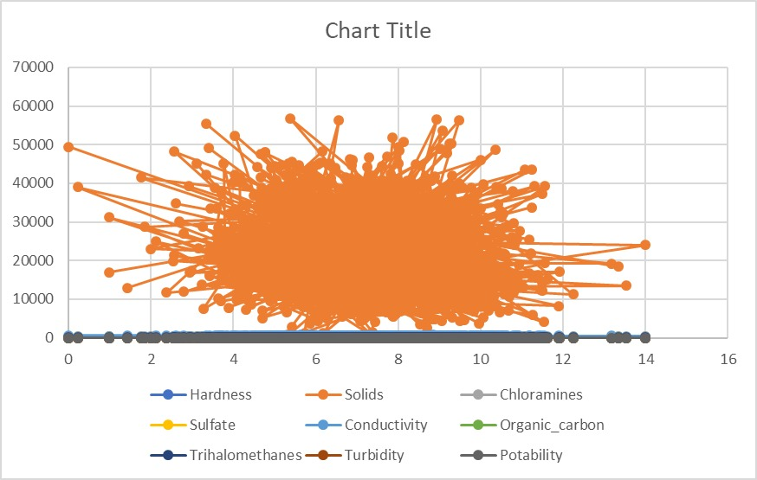

Conclusion:

Using powerful visualization libraries like Matplotlib and Seaborn can unlock the full potential of water

quality data analysis. By harnessing the insights gained from histograms, scatter plots, and correlation

matrices, we can make informed decisions and take proactive steps to protect and improve our

water resources.