ATOMS-NUMERICALS(2)
1.Write two important limitations of Rutherford model which could not explain the observed features of atomic spectra. How were these explained in Bohr’s model of hydrogen atom?
2. A hydrogen atom initially in the ground state absorbs a photon which excites it to the n = 4 level. Estimate the frequency of the photon.
3. State Bohr’s quantization condition of angular momentum. Calculate the shortest wavelength of the Brackett series and state to which region of the electromagnetic spectrum it belongs.
4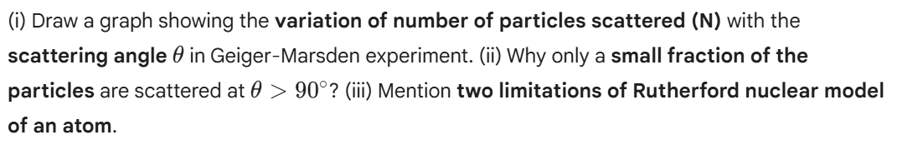
5.
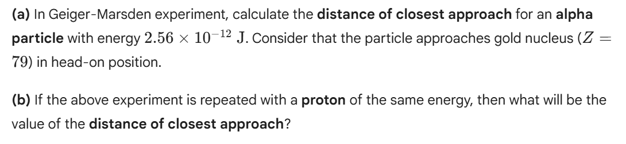

6. Show that the radius of the orbit in hydrogen atom varies as n^2, where n is the principal quantum number of the atom.
7.

