Keeping It On The DL

Govindankutty, Karsten, McCann, Rasch

EV Emissions calculator

Contents

Introduction 2

Problem Definition 2

Problem Statement 2

Definition 2

Survey 2

Renewable Energy Growth 2

Levelized Vehicle Lifecycle Emissions and Cost 3

Clustering Algorithms 5

Proposed Method 5

Intuition 5

Innovation 5

Description 6

Experiments/Evaluation 8

Distribution of Team Member Effort 8

Testbed/DOE 8

Observations 13

Conclusion 13

References 14

Appendix 16

Appendix A: Gantt Chart 16

# Introduction

With the emergence of fully electric vehicles (EVs), and the continuing growth of hybrid electric vehicles, the automobile market places has never been more complex. Consumers have myriad of choices, but few ways to compare directly across technologies; they are literally attempting to compare apples to oranges. While EVs do not create pollution while driving, the source of their electricity may, or may not, create more emissions in the long run than some gas power cars. As pollution/emissions and environmental impact rushes to the forefront of public policy and concerns, a method to observe the real impact of vehicle ownership across the life of the product is necessary.

# Problem Definition

## Problem Statement

To educate consumers on the effective environmental and financial impact of their vehicle use.

## Definition

Consumers do not have easy access to the data regarding the entire environmental and fiscal impact of their vehicle purchases. This tool provides a single source, with easy to interpret visualizations to provide consumers with all the information they need to decide on a purchase.

# Survey

## Renewable Energy Growth

1. *Renewable Electricity Futures for the United States* [1]
   1. Main Idea: Discusses future of renewable electricity in US with nearly 80% coming from renewable sources by 2050
   2. Potential: Explores usage of flexible conventional generation, grid storage, new transmission, more responsive loads and changes.
   3. Shortcoming: No cost-benefit analysis to evaluate relative impacts of renewable generation.
2. *Analysis of renewable energy development to power generation in the United States* [2]
3. Main Idea: Discusses the potential of each state to generate significant power from at least one renewable energy source based on the landscape and climate.
4. Potential: Uses dynamics model to understand the impact of variability and cost for renewables generation.
5. Short Comings: Only provides a cumulative result on how each renewable resource would contribute to power generation in each state; not a thorough analysis.
6. *Wind and Solar Power in the United States: Status and Prospects* [3]
7. Main Idea: Discusses growth in the contribution of wind and solar energy to power generation
8. Potential: Analyses cost levied by the consumers when using solar energy for power generation and discusses subsidies and policies like selling power back to the grid.
9. Shortcomings: No discussion about changes in installation and storage of power at the grid for efficient use.

## Levelized Vehicle Lifecycle Emissions and Cost

1. *Comparative economic and environmental analysis of conventional, hybrid and electric vehicles - the case study of Greece* [4]
2. Main Idea: Evaluation of the economic and environmental impact of conventional, hybrid, and electric vehicles.
3. Potential: Basis for normalizing indicators, weighting for the impact of different greenhouse gases.
4. Shortcomings: No accounting for localized utility energy, No data for specific car models.
5. *Lifecycle cost assessment and carbon dioxide emissions of diesel, natural gas, hybrid electric, fuel cell hybrid and electric transit buses* [5]
6. Main Idea: Examines the lifecycle costs and CO2 emissions for different types of city bus technologies.
7. Potential: Data on “well-to-tank” emissions, assumptions for expected price depreciation for purchasing, energy, and battery.
8. Shortcomings: Specific to buses.
9. *Current and Future United States Light-Duty Vehicle Pathways: Cradle-to-Grave Lifecycle Greenhouse Gas Emissions and Economic Assessment* [6]
10. Main Idea: Compares 7 types of vehicles on the main components of lifecycle: emissions and cost.
11. Potential: Metric and calculation for LCDs.
12. Shortcomings: No regional data.
13. *Conventional, hybrid, plug-in hybrid or electric vehicles? State-based comparative carbon and energy footprint analysis in the United* [7]
14. Main Idea: Compares different types of vehicles on their GHG emissions and energy consumptions based on the State.
15. Potential: Regional data comparison.
16. Shortcomings: No vehicle specific or cost information.
17. *Can EV (electric vehicles) address Ireland’s CO2 emissions from transport?* [8]
18. Main Idea: Discuss how EV effective emissions are dependent on grid fuel sources. Increase in renewable penetration from 15% to 40% could reduce emissions from ~520g/kWh to ~330g/kWh
19. Potential: Shows true value of EVs increases over time
20. Shortcomings: Ireland is much smaller than the US. Only looks at CO2. Limited number of vehicles analyzed.

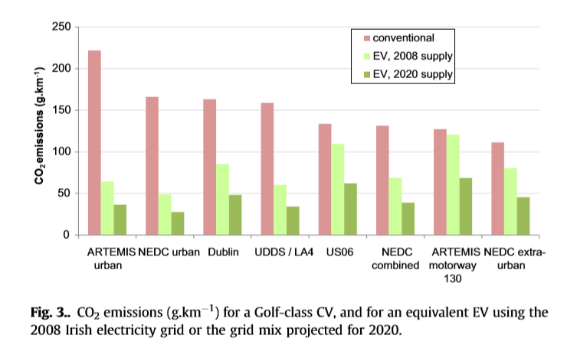

**Figure 1.** Example figure from the article above.

1. *Assessing CO2 emissions of electric vehicles in Germany in 2030* [9]
2. Main Idea: EVs are not always “greener” to operate than conventional technologies based on the grid. EV emissions highly dependent on energy mix
3. Potential: Shows flaws in idea that EVs are greener, not always the case.
4. Shortcomings: Used a model of the grid, many assumptions go into this. Does not give a real ideal of what an individual consumers vehicle will emit.
5. *Vehicle emissions and consumer information in car advertisements* [10]
6. Main Idea: Advertising is piecemeal at best in terms of emissions information for consumers.
7. Potential: Illustrates the issue we are trying to solve
8. Shortcomings: Only points out shortcomings, does not provide a solution
9. *The adoption of cleaner vehicles in the UK: exploring the consumer attitude-action gap* [11]
10. Main Idea: Public opinion is generally in favor of EV and low emission vehicles, however purchasing trends do not exactly correlate
11. Potential: Details that consumers have low knowledge of the actual emissions each vehicle emits. Further identifies “hot spots” that influence adoption of low carbon products
12. Shortcomings: Only points out shortcomings, does not provide a solution

## Clustering Algorithms

1. *What to Do When K-Means Clustering Fails: A Simple yet Principled Alternative Algorithm* [12]
2. Main Idea: Discusses an alternative solution to K-means using a nonparametric Bayesian Dirilecht process mixture model (MAP-DP).
3. Potential: If the data cannot be adequately modeled using K-means, this is a potential back-up algorithm.
4. Shortcomings: MAP-DP is not good for high dimensional data, but the data we plot can be chosen base on this limitation.
5. *Electric Vehicle Driver Clustering using Statistical Model and Machine Learning* [13]
6. Main Idea: Leverages a K-means clustering model for an EV application.
7. Potential: Example of clustered data in the desired domain space.
8. Shortcomings: No mention of emissions or cost.
9. *Data Clustering: A Review* [14]
10. Main Idea: Presents on overview of clustering algorithms for pattern recognition applications.
11. Potential: Useful for implementation of our model.
12. Shortcomings: Clustered data is for a different application.
13. *Missing value estimation methods for DNA microarrays* [15]
14. Main Idea: Addresses missing data problem in K-means clustering.
15. Potential: Provides method addressing missing data in clustering problems.
16. Shortcomings: Potential to introduce bias in the added missing values.

# Proposed Method

## Intuition

The current practice is to compare non-standard efficiency ratings across different technologies. There are no widely accepted standards currently available for emissions/mile for vehicles in the US that include the impact of electricity used for charging.

## Innovation

* Our approach creates an effective emissions per mile metric that normalizes emissions and cost between different types of vehicles.
* Using the consumer’s geographic location, this innovative approach allows personalized results that reflect the local fuel prices, energy prices, and mix of utility electric generation.
* The tool interactively informs consumers of a vehicle’s environmental and financial cost.
* A clustering algorithm groups different vehicles into categories with similar environmental impact or financial cost to aid the consumer in benchmarking their choice against the rest of the market.

## Description

The tool can be broken down into the front end and back end as visualized in Figure 1.

In the back end, a Python script is run which connects to various APIs to collect the necessary data from The U.S. Energy Information Administration for electricity data and from the Department of Energy’s Office of Energy Efficiency and Renewable Energy for vehicle data. The data is then standardized, cleaned, and combined into a single JSON per state and saved. This data can then be fed into the website for calculation.

The front end is framed by an HTML script which lays out the website pages, text, links, and cards (locations for visualizations). A CSS script is used to style the page.

Figure 1 Code Structure

However, the valuable part of this project is in the interactive module of the front end; the JavaScript. This allows the user to interact with the webpage, selecting the state and vehicles they are interested in exploring. The data is then parsed using asynchronous JQuery commands and summarized in 3 plots, by the included JavaScript file:

1. Power Generation Sources Line Plot
   1. Power Generation data is displayed in a line plot, showing the break down of power sources in the state and their corresponding emissions. The state with non-renewable source as their primary source of electricity would have more average emissions/kwhr.

This is the primary source of emissions for an EV.

1. Total Vehicle Emissions Bar Graph
   1. Up to 3 vehicles can be selected, and their corresponding emissions/mile are displayed in a bar chart.
   2. For traditional vehicles, the emissions are directly displayed from data.
   3. For EVs and hybrids, emissions are calculated based on the energy mix, and vehicle efficiency (kWh/mile).
2. Lifecycle Emissions and Fuel Cost Clustered Scatter Plot
   1. Plot uses the selected state and Vehicle 1 from the bar graph dropdowns to aggregate all vehicle data of the same class and year and produces a scatter plot for lifecycle emissions and fuel cost.
   2. Data is clustered into three groups using a K-means algorithm that initially, randomly selects three points on the graph, classifies a color for each datapoint, generates a new centroid mean and iterates 20 times to obtain 3 colored clusters of data.
   3. The clusters are colored based on the lifecycle emissions and fuel cost, where green has the lowest emissions and fuel cost and red has the highest emissions and cost. These colors visually aid the user to more easily interpret the lowest emission and fuel cost vehicles.
   4. This plot translates fuel economy data of vehicles into dollars/mile which aides the user in benchmarking their choice against the rest of the market.

# Experiments/Evaluation

## Distribution of Team Member Effort

All team members have contributed a similar amount of effort per the schedule of work. See Appendix A for the Gantt Chart of the breakdown of work.

## Testbed/DOE

Our testbed is the website itself that the JavaScript code runs on.

**Experiment 1: Car Comparison**

The first experiment used the tool to evaluate three cars of the same class. This is representative of a user using the tool to evaluate three similar vehicles. For this experiment, a state with low Effective Emissions was chosen. As can be seen in the plot, California (CA) has little to no coal power generation.

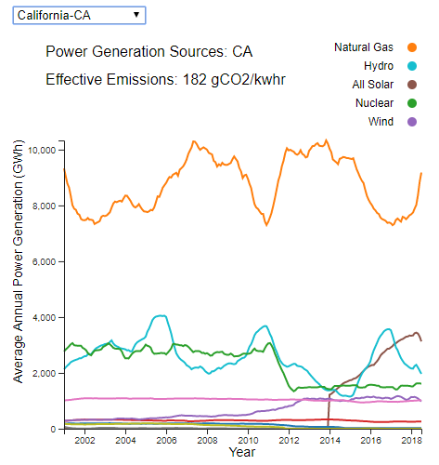

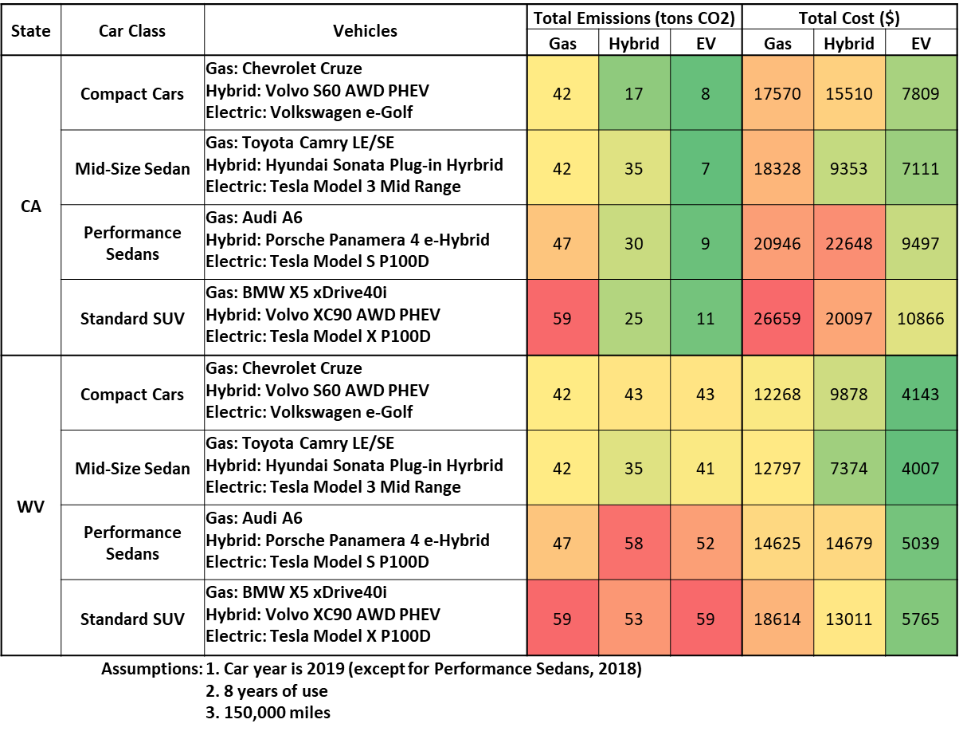

**Experiment 2: Class Comparison**

The second experiment used the tool to expand the car search to vehicles of different classes. This is representative of a user who wants to understand the difference in emissions and fuel cost between choosing a Compact Car or an SUV. Again, California was used as the basis for emissions. It can be seen from the table that electric vehicles offer greatly improved emissions and fuel cost over the gas vehicles in California.



**Experiment 3: State Comparison**

The third experiment used the tool to show the difference between two states. This is representative of a user who may be moving to a new state and wants to know how their vehicle purchasing decision may change when the local power generation, fuel prices, and electricity prices change. This time a high emissions state was chosen for the comparison. West Virginia (WV) gets nearly all its generation from Coal, so the effective emissions are high. This fact makes the electric and hybrid vehicles equivalent and sometimes worse compared to the gas vehicles on emissions. Additionally, in the state comparison, the difference in local fuel and electricity prices can be seen between California and West Virginia, where the price of electricity is ~50% less and gas is ~33% less.

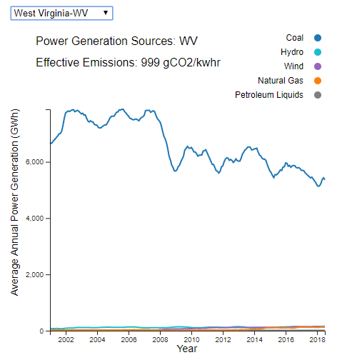



**Experiment 4: Case Study**

The fourth experiment outlined a case study of a user stepping through each part of the tool and potential inferences they may have along the way. Again, the experiment was performed for both California and West Virginia using the Compact Cars class.

First, the user would select their state. A user in California may find themselves proud of their state for the lack of coal generation and appreciate the recent spike in solar energy. A user in West Virgina may be worried about the lack of diversity in generation and reliance on coal.



Next, the user would move to the second plot and select three vehicles from the compact car class with different powertrain types to understand the emissions impact using their local state power generation. A user in California would likely be compelled to purchase a hybrid or electric vehicle due to the significant emissions reduction; however, a user in West Virginia would see no benefit to driving a hybrid or electric vehicle due to the state’s high effective emissions.

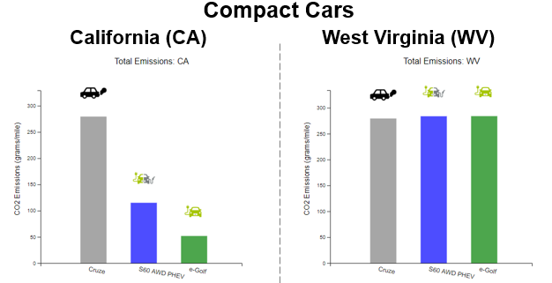

Last, the user could view how their selections compare to other cars in the Compact Car class. For ease of understanding, colored circles representative of the vehicle type were added to the graph to show how the three vehicles compare. A user in California would see that the e-Golf is the best option for both lifetime emissions and fuel cost, and they would likely feel encouraged about their purchase. A user in West Virginia would find that while the e-Golf is the best vehicle for lifetime fuel cost, there are other vehicles with lower emissions and still good fuel cost. They could move their mouse over the other points, and a tool-tip would inform the user about the potentially better option. The user could then change their purchasing decision based on the new knowledge.

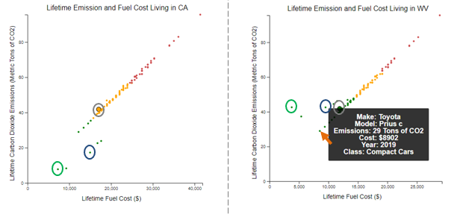

## Observations

* The state-to-state variation in power generation and effective emissions can vary greatly.
* State effective emissions have a significant impact to lifetime emissions for electric and hybrid vehicles.
* Public policy and societal trends are clearly seen in the power generation data. For example, California, a state that promotes clean energy, has low effective emissions; whereas, West Virginia, a state known for supporting the coal industry, is completely reliant on the source.
* Electric vehicles had a lower fuel cost overall for any state; however, there were a few states where the power generation made the emissions worse than gas or hybrid vehicles.
* For gas vehicles, there is a linear trend between emissions and fuel cost.
* In general, states showed an increase in generation from renewable sources since 2002.
* Low emissions natural gas has played an important role in supplementing high emission coal generation.

# Conclusion

Consumers now have a single tool to determine the financial and environmental impacts of their vehicle choices. The true emissions of electric vehicles are unknown to the public and hard to understand. By converting all emissions from traditional internal combustion, hybrid electric, and fully electric vehicles into an effective gCO2/mile metric, based on the user’s location, this tool represents a major step in bringing information to the consumer. Our experiments showed that while EVs are cheaper across the board due to their high efficiency and low cost of electricity, there are times when they can create higher emissions due to high-polluting electric grids, though usually they are the cleanest option. Finally, clustering of vehicle data presents an easily understandable visualization of similar cars to further assist consumer choice.

# References

|  |  |
| --- | --- |
| [1] | T. M. Mai, M. Hand, S. F. Baldwin, R. H. Wiser, G. L. Brinkman, P. Denholm, D. J. Arent, G. Porro, D. Sandor, D. J. Hostick, M. Milligan, E. A. DeMeo and M. Bazilian, "Renewable Electricity Futures for the United States," *IEEE Transactions on Sustainable Energy,* vol. 5, no. 2, pp. 372-378, 2014. |
| [2] | K.-F. V. Wong and A. Aslani, "Analysis of renewable energy development to power generation in the United States," *Renewable Energy,* vol. 63, pp. 153-161, 2014. |
| [3] | M. B. McElroy and X. Chen, "Wind and Solar Power in the United States: Status and Prospects," *CSEE JOURNAL OF POWER AND ENERGY SYSTEMS,* vol. 3, no. 1, pp. 1-6, 2017. |
| [4] | E. A. Nanaki and C. J. Koroneos, "Comparative economic and environmental analysis of conventional, hybrid and electric vehicles - the case study of Greece," *Journal of Cleaner Production - Elsevier,* pp. 261-266, 2013. |
| [5] | T. Lipman and A. Lajunen, "Lifecycle cost assessment and carbon dioxide emissions of diesel, natural gas, hybrid electric, fuel cell hybrid and electric transit buses," *Energy - Elsevier,* pp. 329-342, 2016. |
| [6] | A. Elgowainy, J. Han, J. Ward, F. Joseck, D. Gohlke, A. Lindauer, T. Ramsden, M. Biddy, M. Alexander, S. Barnhart, I. Sutherland, L. Verduzco and T. J. Wallington, "Current and Future United States Light-Duty Vehicle Pathways: Cradle-to-Grave Lifecycle Greenhouse Gas Emissions and Economic Assessment," *Environmental Science & Technology,* pp. 2392-2399, 2018. |
| [7] | N. C. Onat, M. Kucukvar and O. Tatari, "Conventional, hybrid, plug-in hybrid or electric vehicles? State-based comparative carbon and energy footprint analysis in the United States," *Applied Energy,* pp. 36-49, 2015. |
| [8] | W. J. Smith, "Can EV (electric vehicles) address Ireland's CO2 emissions from transport?," *Energy,* vol. 35, pp. 4514-4521, 2010. |
| [9] | P. Jochem, S. Babrowski and W. Fichtner, "Assessing CO2 emissions of electric vehicles in Germany in 2030," *Transportation Research,* vol. 78, no. A, pp. 68-83, 2014. |
| [10] | N. Wilson, A. Maher, G. Thomson and M. Keall, "Vehicle emissions and consumer information in car advertisements," *Environmental Health,* pp. 7-14, 2008. |
| [11] | B. Lane and S. Potter, "The adoption of cleaner vehicles in the UK: exploring the ocnsumer attitude-action gap," *Journal of Cleaner Production,* vol. 15, pp. 1085-1092, 2007. |
| [12] | Y. A. B. F. L. M. Raykov, "What to Do When K-Means Clustering Fails: A SImple yet Principled Alternative Algorithm," *PLOS ONE,* p. 28, 2016. |
| [13] | Y. W. B. C. C.-C. G. R. Xiong, "Electric Vehicle Driver CLustering using Statistical Model andf Machine Learning," p. 5, 2018. |
| [14] | A. M. M. F. P. Jain, "Data CLustering: A Review," *IEEE,* p. 50, 1996. |
| [15] | O. C. M. S. G. B. P. H. T. T. R. B. D. A. R. Troyanskaya, "Missing Value Estimation Methods for DNA Microarrays," *Bioinformatics,* p. 6, 2001. |

# Appendix

## Appendix A: Gantt Chart

