PROGRAM: 1
DATE: 14/03/2018
AIM: Simple Servlet Program to Print Environment Variables.
PROGRAM:
import java.io.*;
import javax.servlet.*;
import javax.servlet.http.*;
import java.lang.String.*;
public class EnvVariable extends HttpServlet
{
public void doGet(HttpServletRequest req, HttpServletResponse res)throws ServletException, IOException
{
res.setContentType("text/plain");
PrintWriter out = res.getWriter();
String str=req.getServerName();//server name
out.println("server name : "+str);
String str1=getServletContext().getServerInfo();//server software
out.println("server software : "+str1);
String str2=req.getProtocol();//server protocol
out.println("server protocol :"+str2);
int port=req.getServerPort();//server port
out.println("server port :"+port);
String str3=req.getMethod();//request method
out.println("request method :"+str3);
String str4=req.getPathInfo();//path info
out.println("path info :"+str4);
String str5=req.getPathTranslated();//path transilated
out.println("path transilated :"+str5);
String str6=req.getServletPath();//script name
out.println("script name :"+str6);
String str7=getServletContext().getRealPath("/");//document root
out.println("document root :"+str7);
String str8=req.getQueryString();//queury string
out.println("queury string :"+str8);
}
}

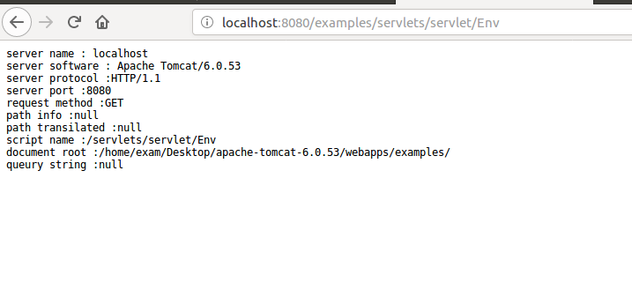
OUTPUT:

PROGRAM: 2
DATE: 15/03/2018
AIM: Program to Display Cookie – ID
PROGRAM:import java.io.*;
import javax.servlet.*;
import javax.servlet.http.*;
public class SampleCookie extends HttpServlet
{
public void doGet(HttpServletRequest request,HttpServletResponse response)throws IOException, ServletException
{ response.setContentType("text/html");
PrintWriter out = response.getWriter();
int flag=0;
Cookie[] cookies = request.getCookies();
if(cookies!=null)
{
for (int i = 0; i < cookies.length; i++)
{ Cookie c = cookies[i];
String name = c.getName();
if(name.equals("visited"))
{ flag=1;
out.println("You are an old visitor");
break;
}
}
}
if(flag==0||cookies==null)
{
out.println("You are a new visitor");
Cookie c = new Cookie("visited","1");
response.addCookie(c);
}
}
}

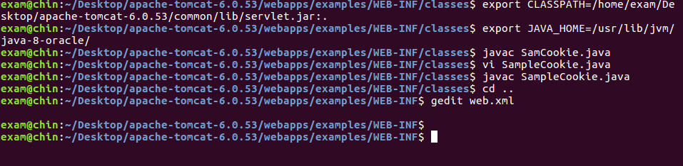
OUTPUT:
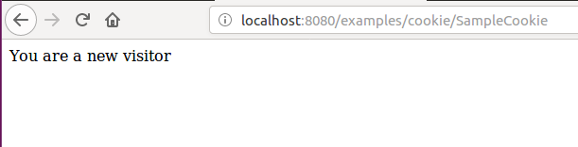

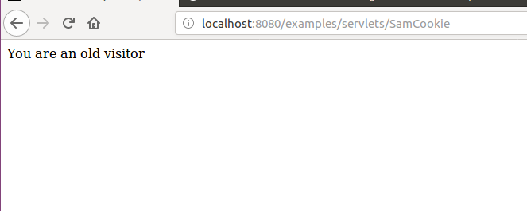

PROGRAM: 3
DATE: 13/05/2018
AIM: Program to Implement RMI.
PROGRAM:
/Hello.java
//interface which declares the remote methods.
import java.rmi.*;
public interface Hello extends Remote
{ String sayHello() throws RemoteException;
}
//HelloImpl.java
//implementation class which implements the methods specified in the interface(Hello)
import java.rmi.*;
import java.rmi.server.*;
public class HelloImpl extends UnicastRemoteObject implements Hello
{ public HelloImpl() throws RemoteException
{ super();
}
public String sayHello()
{
return "Hello World !";
}
}

HelloServer.java
//Server program whcih binds the object in the rmiregistry service running at the server side. The name given to the object is MyObject.
import java.rmi.*;
public class HelloServer
{ public static void main(String args[])
{ try{
HelloImpl hello=new HelloImpl();
Naming.rebind("rmi://localhost/MyObject",hello);
System.out.println("bound to registry");
}catch(Exception e){e.printStackTrace();}
}
}

HelloClient.java
//Client program which looksup in the rmiregistry service at the server for the object.The object is looked by name.
import java.rmi.*;
public class HelloClient
{
public static void main(String args[])throws RemoteException,java.net.MalformedURLException
{
try{
Hello ref=(Hello)Naming.lookup("rmi://localhost/MyObject");
String ret=ref.sayHello();
System.out.println(ret);
}
catch(Exception e){ e.printStackTrace(); }
}
}

OUTPUT:
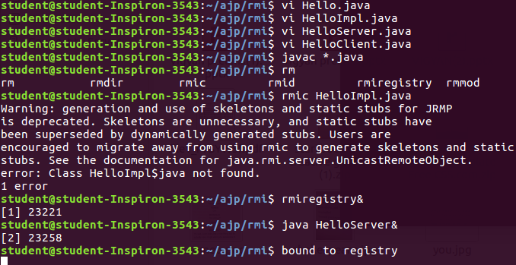
Open a new terminal ,
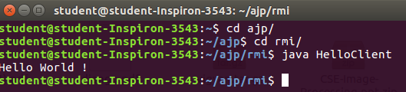

\

PROGRAM: 4
DATE: 14/05/2018
AIM: Program to Implement Client Server Communication Using RMI

PROGRAM:
Reg.java
import java.rmi.*;
class Reg
{
public static void main(String args[])
{
try{
CalcImpl obj= new CalcImpl();
Naming.rebind("calc",obj);
System.out.println("Bound");
}catch(Exception e){e.printStackTrace();}
}
}

Calc.java
import java.rmi.*;
public interface Calc extends Remote
{
int add(int a,int b) throws RemoteException;
int sub(int a,int b) throws RemoteException;
int mul(int a,int b) throws RemoteException;
int div(int a,int b) throws RemoteException;
}

CalcImpl.java
import java.rmi.*;
import java.rmi.server.*;
public class CalcImpl extends UnicastRemoteObject implements Calc
{
public CalcImpl()throws RemoteException{super();}
public int add(int a, int b) throws RemoteException
{
return a+b;
}
public int sub(int a, int b) throws RemoteException
{
return a-b;
}
public int mul(int a, int b) throws RemoteException
{
return a*b;
}
public int div(int a, int b) throws RemoteException
{
return a/b;
}
}

Client.java
import java.rmi.*;
import java.io.*;
class Client
{
public static void main(String args[])
{
try{
Calc obj=(Calc)Naming.lookup("rmi://localhost/calc");
BufferedReader kb=new BufferedReader(new
InputStreamReader(System.in));
System.out.println("\nEnter two numbers : ");
int x = Integer.parseInt(kb.readLine());
int y = Integer.parseInt(kb.readLine());
System.out.println("\nOperation");
System.out.println("1.Add");
System.out.println("2.Subtract");
System.out.println("3.Multiply");
System.out.println("4.Divide");
System.out.print("ENTER YOUR CHOICE : ");
int ch = Integer.parseInt(kb.readLine());
System.out.println("\nNumbers are : X = "+x+", Y = "+y);
switch(ch)
{
case 1:
{int res1=obj.add(x,y);
System.out.println("\tSUM = "+res1);
break;
}
case 2:
{
int res2=obj.sub(x,y);
System.out.println("\tDIFF = "+res2);
break;
}
case 3:
{
int res3=obj.mul(x,y);
System.out.println("\tMUL = "+res3);
break;
}
case 4:
{
int res4=obj.div(x,y);
System.out.println("\tDIV = "+res4);
break;
}
default:
{
System.out.println("\tWRONG CHOICE !!!");
break;
}
}
}catch(Exception e){e.printStackTrace();}
}
}

OUTPUT:
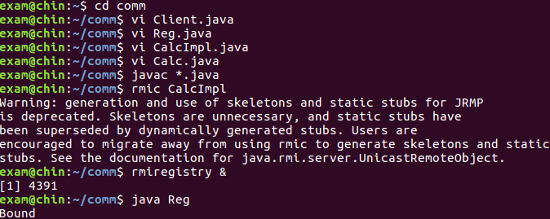
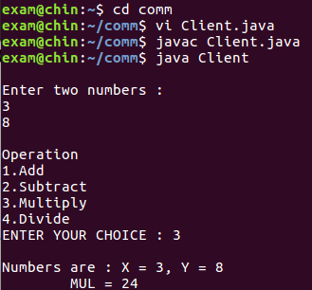

PROGRAM: 5
DATE: 20/05/2018
AIM: Program to Implement Client Server Chat Application Using RMI
PROGRAM:
reg.java
import java.rmi.*;
public class reg
{
public static void main(String args[])
{
try
{
chatimpl ob=new chatimpl();
Naming.rebind("hello",ob);
System.out.println("class is registered");
}
catch(Exception e) { e.printStackTrace(); }
}
}

chatprg.java
import java.rmi.*;
public interface chatprg extends Remote
{
public String message(String str)throws RemoteException;
}

chatclient.java
import java.rmi.*;
import java.io.*;
public class chatclient
{
public static void main(String args[])
{
String msg="";
String retmsg="";
try
{
BufferedReader dis=new BufferedReader(new InputStreamReader(System.in));
chatprg ob =(chatprg)Naming.lookup("rmi://localhost/hello");
while(true)
{
System.out.println();
System.out.println("me(client)\t:");
msg=dis.readLine();
retmsg=ob.message(msg);
System.out.println("friend(server)\t:"+retmsg);
}
}
catch(Exception e) { }
}
}

chatimpl.java
import java.rmi.*;
import java.rmi.server.*;
import java.io.*;
public class chatimpl extends UnicastRemoteObject implements chatprg
{
public chatimpl()throws RemoteException { }
public String message(String str)throws RemoteException
{
BufferedReader dis=new BufferedReader(new InputStreamReader(System.in));
String msg1="";
try
{
System.out.println("friend(client)\t:"+str);
System.out.println("me(server)\t:");
msg1=dis.readLine();
}
catch(Exception e)
{
e.printStackTrace();
}
return msg1;
}}

OUTPUT:
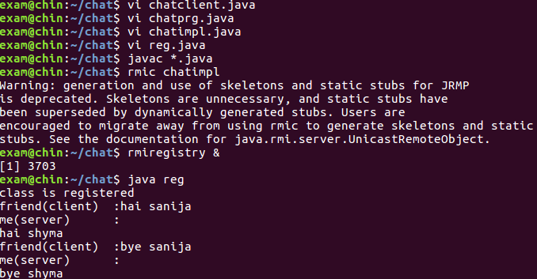

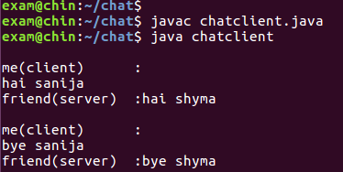

PROGRAM: 6
DATE: 21/05/2018
AIM: Implementation of CORBA.
PROGRAM:
Hello.idl
module Helloapp
{
interface Hello
{
string reverse(in string msg1);
string Uppercase(in string msg1);
string lower(in string msg1);
string length(in string msg1);
};
};
Helloimpl.java
import Helloapp.*;
import org.omg.CosNaming.*;
//import org.omg.CosNaming.NamingContextPackage;
import org.omg.CORBA.*;
import org.omg.PortableServer.*;
import org.omg.PortableServer.POA.*;
import java.util.*;
class Helloimpl extends _HelloImplBase
{
public String reverse(String msg1)
{
String reverseString = new StringBuffer(msg1).reverse().toString();
return reverseString;
}
public String Uppercase(String msg1)
{
msg1=msg1.toUpperCase();
return msg1;
}
public String lower(String msg1)
{
msg1=msg1.toLowerCase();
return msg1;
}
public String length(String msg1)
{
int l=msg1.length();
String len=Integer.toString(l);
return len;
}
}

HelloServer.java
import Helloapp.*;
import org.omg.CosNaming.*;
import org.omg.CORBA.*;
public class HelloServer
{ public static void main(String args[])
{
try
{ ORB orb=ORB.init(args,null);
Hello helloimpl=new Helloimpl();
orb.connect(helloimpl);
NameComponent name=new NameComponent("Hello"," ");
NameComponent comp[]={name};
org.omg.CORBA.Object name_service_obj=orb.resolve_initial_references("NameService");
NamingContext naming_Service=NamingContextHelper.narrow(name_service_obj);
naming_Service.rebind(comp,helloimpl);
java.lang.Object obj=new java.lang.Object();
synchronized(obj)
{ obj.wait();
}
}catch(Exception e){ }
}
}
HelloClient.java
import Helloapp.*;
import org.omg.CosNaming.*;
import org.omg.CORBA.*;
import java.io.*;
public class HelloClient
{ public static void main(String args[])
{ BufferedReader dis=new BufferedReader(new InputStreamReader(System.in));
try
{ ORB orb=ORB.init(args,null);
org.omg.CORBA.Object objref=orb.resolve_initial_references("NameService");
NamingContext naming_service=NamingContextHelper.narrow(objref);
NameComponent ac=new NameComponent("Hello"," ");
NameComponent arr[]={ac};
org.omg.CORBA.Object ref=naming_service.resolve(arr);
Hello href=HelloHelper.narrow(ref);
System.out.print("enter string\t:");
String st=dis.readLine();
int flag=0;
int choice;
while(true)
{ System.out.println("\t1.reverse");
System.out.println("\t2.Uppercase");
System.out.println("\t3.Lowercase");
System.out.println("\t4.length");
System.out.println("\t5.exit");
System.out.print("\tenter your choice\t:");
choice=Integer.parseInt(dis.readLine());
switch(choice)
{ case 1:
System.out.println("reverse is\t:"+href.reverse(st));
break;
case 2:
System.out.println("Uppercase is\t:"+href.Uppercase(st));
break;
case 3:
System.out.println("Lowercase is\t:"+href.lower(st));
break;
case 4:
System.out.println("Length \t:"+href.length(st));
break;
default:
flag=1;
System.exit(0);
break;
}
}
}
catch(Exception e) { }
}
}
OUTPUT:
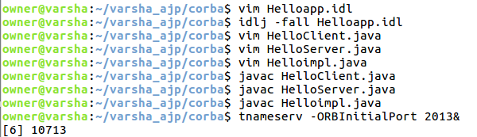

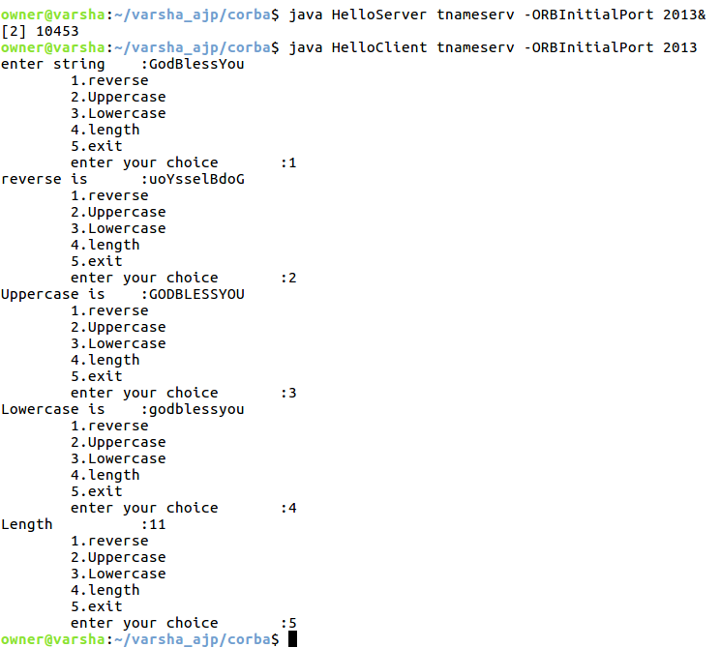
Open a new terminal,

PROGRAM: 7
DATE: 27/05/2018
AIM: Listing Objects Using JNDI

PROGRAM:
import java.util.Properties;
import javax.naming.*;
public class Lookup
{
public static void main(String[] args)
{
String name = " ";
if (args.length > 0)
name = args[0];
try
{
// Create a Properties object and set properties appropriately
Properties props = new Properties();
props.put(Context.INITIAL_CONTEXT_FACTORY,"com.sun.jndi.fscontext.RefFSContextFactory");
props.put(Context.PROVIDER_URL, "file:///home/user/Desktop");
// Create the initial context from the properties we just created
Context initialContext = new InitialContext(props);
// Look up the object
Object obj = initialContext.lookup(name);
if (name.equals(" "))
System.out.println("Looked up the initial context");
else
System.out.println(name + " is bound to: " + obj);
}
catch (NamingException nnfe)
{
System.out.println("Encountered a naming exception");
}
}
}

OUTPUT:

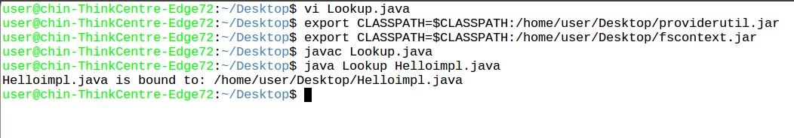

PROGRAM: 8
DATE: 28/05/2018
AIM: Directory Searching Using JNDI
PROGRAM:
import java.util.Properties;
import javax.naming.*;
import java.io.*;
import java.lang.Runtime;
public class Listing
{ public static void main(String[] args)throws IOException
{ String dname="/home/owner";
String tname="",fname="";
int ch;
BufferedReader buf=new BufferedReader(new InputStreamReader(System.in));
try
{
// Create a Properties object and set properties appropriately
Properties props = new Properties();
props.put(Context.INITIAL_CONTEXT_FACTORY,"com.sun.jndi.fscontext.RefFSContextFactory");
props.put(Context.PROVIDER_URL, "file:///home/owner/Desktop/varsha");
// Create the initial context from the properties we just created
Context initCont = new InitialContext(props);
while(true)
{
Process proc=Runtime.getRuntime().exec("clear");
System.out.println("\t\t M E N U \n");
System.out.println("\t1.List Contents of Directory");
System.out.println("\t2.Create a directory");
System.out.println("\t3.Delete a directory");
System.out.println("\t4.Create a file");
System.out.println("\t5.Remove a file");
System.out.println("");
System.out.print("\tENTER YOUR CHOICE: ");
ch=Integer.parseInt(buf.readLine());
switch(ch)
{ case 1:
//System.out.println("Enter the name of the directory");
//tname=buf.readLine();
NamingEnumeration enm=initCont.list("");
while(enm.hasMore())
{
NameClassPair ncPair=(NameClassPair)enm.next();
System.out.println(ncPair.getName()+""+ncPair.getClassName());
}
break;
/*case 2:
System.out.print("Enter the directory name to change :");
tname=buf.readLine();
Object obj=initCont.lookup(tname);
initCont=(Context)initCont.lookup(tname);
System.out.println("Present working directory " +obj);
break;*/
case 2:
System.out.println("");
System.out.print("Enter name of the directory to create : ");
tname=buf.readLine();
initCont.createSubcontext(tname);
System.out.println("Created Directory....: "+tname);
break;
case 3:
System.out.println("");
System.out.print("Enter name of the directory to delete : ");
tname=buf.readLine();
initCont.destroySubcontext(tname);
System.out.println("Deleted Directory ...:"+tname);
break;
case 4:
System.out.println("Sorry...Creating File Not Working.......");
/*System.out.print("Enter name of the file to Create : ");
tname=buf.readLine();
fname=dname+tname;
java.io.File newfile = new java.io.File(fname);
initCont.bind(fname, newfile);*/
break;
case 5:
System.out.println("");
System.out.print("Enter name of the file to delete : ");
tname=buf.readLine();
initCont.unbind(tname);
break;
default:
System.out.println("Wrong Choice.........");
}
}
}
catch (NamingException nnfe) {
System.out.println("Encountered a naming exception");
}
}
}

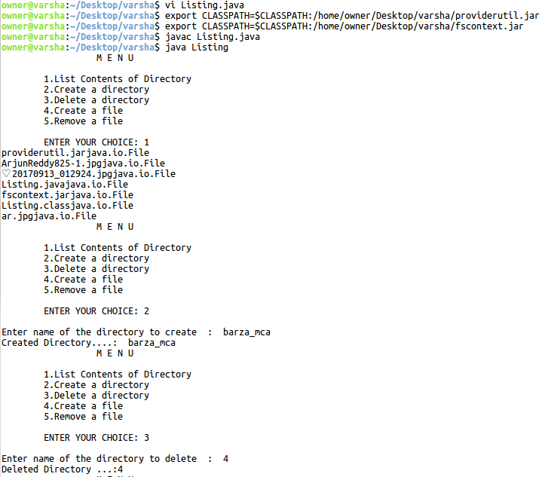
OUTPUT:

PROGRAM: 9
DATE: 04/06/2018
AIM: Display a Message Using JSP
PROGRAM:
<HTML><HEAD>
<TITLE>JSP Expressions</TITLE>
<META NAME="author" CONTENT="Marty Hall">
<META NAME="keywords"
CONTENT="JSP,expressions,JavaServer,Pages,servlets">
<META NAME="description"
CONTENT="A quick example of JSP expressions.">
<LINK REL=STYLESHEET HREF="JSPStyles.css"
TYPE="text/css">
</HEAD>
<BODY>
<H2>JSP Expressions</H2>
<UL>
<LI>Current time: <%= new java.util.Date() %>
<LI>Your hostname: <%= request.getRemoteHost() %>
<LI>Your session ID: <%= session.getId() %>
<LI>The <CODE>testParam</CODE> form parameter:
<%= request.getParameter("testParam") %>
</UL></BODY></HTML>

OUTPUT
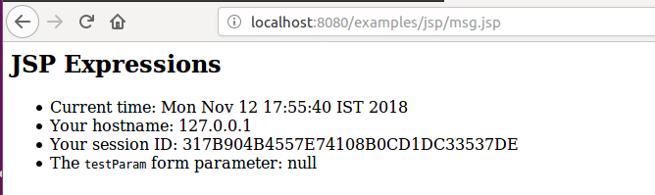
PROGRAM: 10
DATE: 05/06/2018
AIM: Implementing Entity Bean
PROGRAM:
index.html
<!DOCTYPE html>
<html>
<body>
<form action="AddServlet" method="post">
Enter 1st number :<input type="text" name="t1"><br>
Enter 2nd number :<input type="text" name="t2"><br>
<input type="submit">
</form>
</body>
</html>
AddServlet.java
import MyBean.AddEjb;
import java.io.IOException;
import java.io.PrintWriter;
import javax.ejb.EJB;
import javax.servlet.annotation.WebServlet;
import javax.servlet.http.HttpServlet;
import javax.servlet.http.HttpServletRequest;
import javax.servlet.http.HttpServletResponse;
@WebServlet(urlPatterns = {"/AddServlet"})
public class AddServlet extends HttpServlet
{
@EJB
AddEjb obj;
public void doPost(HttpServletRequest req,HttpServletResponse res) throws IOException
{
PrintWriter out = res.getWriter();
int i = Integer.parseInt(req.getParameter("t1"));
int j = Integer.parseInt(req.getParameter("t2"));
obj.setI(i);
obj.setJ(j);
obj.add();
int k = obj.getK();
out.println("Addition using EJB is : "+k);
}
}
AddEjb.java
package MyBean;
import javax.ejb.Stateless;
@Stateless
public class AddEjb
{
private int i,j,k;
public int getI() {
return i;
}
public void setI(int i) {
this.i = i;
}
public int getJ() {
return j;
}
public void setJ(int j) {
this.j = j;
}
public int getK() {
return k;
}
public void setK(int k) {
this.k = k;
}
public void add(){
k = i+j;
}
}

OUTPUT:
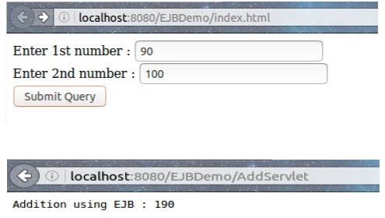

PROGRAM: 11
DATE: 11/06/2018
AIM: Implement Session Bean
PROGRAM:
index.html
<!DOCTYPE html>
<html>
<body>
<form action="AddServlet" method="post">
Enter 1st number :<input type="text" name="t1"><br>
Enter 2nd number :<input type="text" name="t2"><br>
<input type="submit">
</form>
</body>
</html>
AddServlet.java
import MyBean.AddEjb;
import java.io.IOException;
import java.io.PrintWriter;
import javax.ejb.EJB;
import javax.servlet.annotation.WebServlet;
import javax.servlet.http.HttpServlet;
import javax.servlet.http.HttpServletRequest;
import javax.servlet.http.HttpServletResponse;
@WebServlet(urlPatterns = {"/AddServlet"})
public class AddServlet extends HttpServlet
{
@EJB
AddEjb obj;
public void doPost(HttpServletRequest req,HttpServletResponse res) throws IOException
{
PrintWriter out = res.getWriter();
int i = Integer.parseInt(req.getParameter("t1"));
int j = Integer.parseInt(req.getParameter("t2"));
obj.setI(i);
obj.setJ(j);
obj.add();
int k = obj.getK();
out.println("Addition using EJB is : "+k);
}
}
AddEjb.java
package MyBean;
import javax.ejb.Stateless;
@Stateless
public class AddEjb
{
private int i,j,k;
public int getI() {
return i;
}
public void setI(int i) {
this.i = i;
}
public int getJ() {
return j;
}
public void setJ(int j) {
this.j = j;
}
public int getK() {
return k;
}
public void setK(int k) {
this.k = k;
}
public void add(){
k = i+j;
}
}

OUTPUT:

PROGRAM: 12
DATE: 12/06/2018
AIM: Implement Database Connection Using JSP.
PROGRAM:
index.html
<body>
<form action="db.jsp" method="post">
User name :<input type="text" name="usr" /><br>
password :<input type="password" name="pwd" /><br>
<input type="submit" />
</form>
</body>

db.jsp
<%@ page import ="java.sql.*" %>
<%@ page import ="javax.sql.*" %>
<%
String username=request.getParameter("usr");
session.putValue("username",username);
String pswd=request.getParameter("pwd");
Class.forName("com.mysql.jdbc.Driver");
java.sql.Connection
con=DriverManager.getConnection("jdbc:mysql://localhost/stud","root","mysql");
Statement st= con.createStatement();
ResultSet rs=st.executeQuery("select * from login where username='"+username+"'");
if(rs.next())
{
if(rs.getString(2).equals(pswd))
{
out.println("WELCOME "+username);
}
else
{
out.println("Invalid password try again");
}}
%>

OUTPUT:
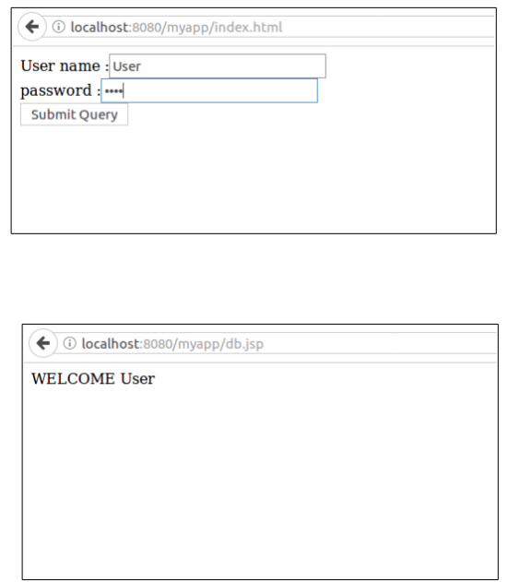

SP&CD

PROGRAM: 1

Lex Program
DATE:13/03/2018

PROGRAM:

%{
#include <stdio.h>
#include <stdlib.h>
%}
%option noyywrap
%%
[ \t] ;
[0-9]+\.[0-9]+ { printf("%s Floating Point Number \n", yytext); }
[0-9]+ { printf("%s Found an integer\n",yytext); }
[a-zA-Z0-9]+ { printf("%s Found a string \n",yytext); }
%%
main() {
// lex through the input:
yylex();
}

OUTPUT:
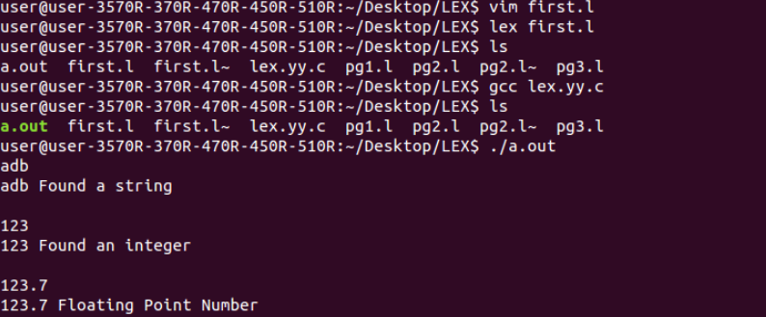

PROGRAM: 2
DATE:13/03/2018

PROGRAM:

%{
#include <stdio.h>
#include <stdlib.h>
%}
%option noyywrap
letter [a-zA-Z]
d
[0-9]+
w
[ \t]
f
{d}(\.{d})?(E[+\-]?{d})?
id
{letter}({letter}|{d})*
%%
{w} {}
"+" { printf("%s is an add \n", yytext); }
"-" { printf("%s is an minus \n", yytext); }
"*" { printf("%s is an multiply \n", yytext); }
"/" { printf("%s is an div \n", yytext); }
{d} { printf("%s is an Integer \n", yytext); }
{f} { printf("%s is a floating point number\n", yytext); }
{id} { printf("%s is an identifier\n", yytext); }
.
{ printf("%s is an invalid character\n", yytext);}
%%
main()
{
yylex();
}

OUTPUT:

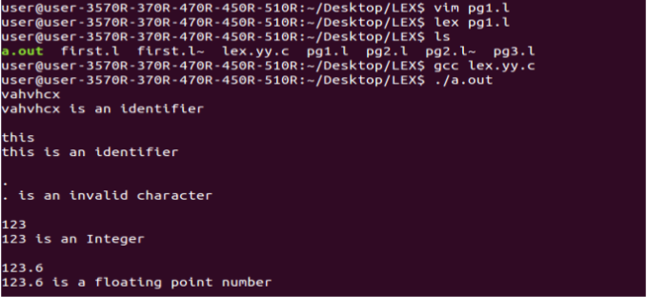

PROGRAM 3
DATE:14/03/2018

PROGRAM :

%{
int charcount=0,linecount=0;
%}
%option noyywrap
%%
\n linecount++;
. charcount++;
%%
int main()
{
yylex();
printf("There were %d characters in %d lines\n",
charcount,linecount);
return 0;
}

OUTPUT :

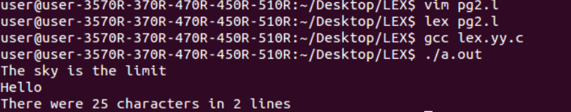

PROGRAM 4
DATE:15/03/2018
PROGRAM :

%{
#include <stdio.h>
#include <stdlib.h>
%}
%option noyywrap
letter [a-zA-Z]
string ({letter})*
%%
{letter}
{ printf("%s is a character\n", yytext); }

{ printf("%s is an invalid character\n", yytext);}
%%
main()
{
yylex();
}

OUTPUT:

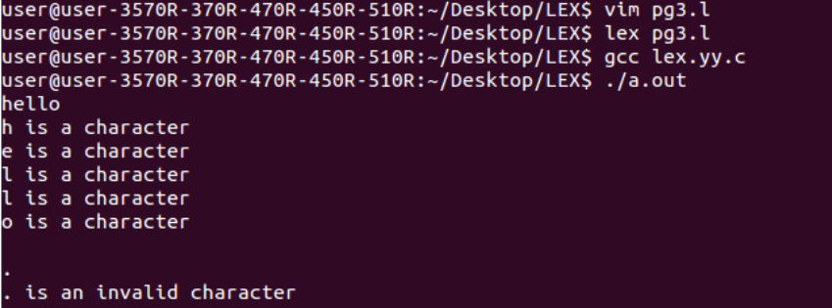

WEB TECHNOLOGY

PROGRAM: 1
DATE: 13/03/2018
AIM: Create an HTML page containing header, aside, main, nav and footer elements with layout
PROGRAM:
<!DOCTYPE html>
<html>
<head>
<style>
div.container {
width: 100%;
border: 1px solid grey;
}
header, footer {
padding: 1em;
color: white;
background-color: black;
clear: left;
text-align: center;
}
nav {
float: left;
max-width: 160px;
margin: 0;
padding: 1em;
}
nav ul {
list-style-type: none;
padding: 0;
}
nav ul a {
text-decoration: none;
}
article {
margin-left: 170px;
border-left: 1px solid gray;
padding: 1em;
overflow: hidden;
}
</style>
</head>
<body><div class="container">
<header>
<h1>Into the Wild</h1>
</header>
<aside>
<nav>
<ul>
<li><a href="https://andreasmoser.blog/2011/03/26/into-the-wild/">BOOK
REVIEW</a></li>
<li><a href="https://www.commonsensemedia.org/movie-reviews/into-the-
wild">RATING</a></li>
</ul>
</nav>
</aside>
<main>
<article>
<h1>Into the Wild-Review</h1>
<p>There is plenty of sorrow to be found in “Into the Wild,” Sean Penn’s adaptation of the
nonfiction bestseller by Jon Krakauer. The story begins with an unhappy family, proceeds
through a series of encounters with the lonely and the lost, and ends in a senseless, premature
death. But though the film’s structure may be tragic, its spirit is anything but. It is infused
with an expansive, almost giddy sense of possibility, and it communicates a pure, unaffected
delight in open spaces, fresh air and bright sunshine.
</p>
</article>
</main>
<footer> @chintech</footer>
</div>
</body>
</html>

OUTPUT:
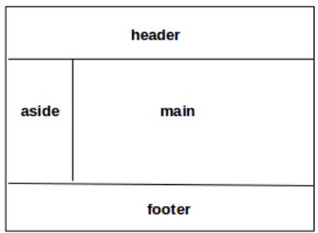

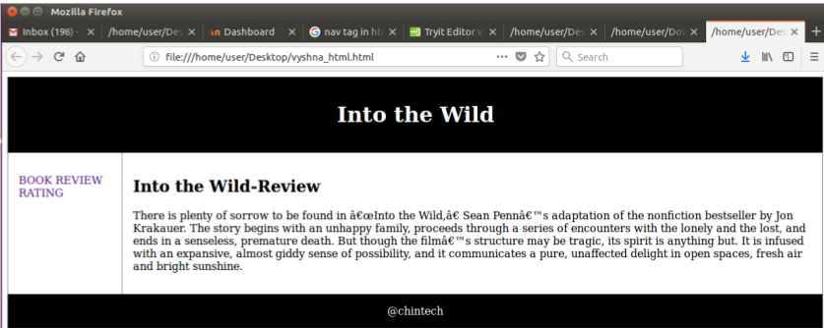

PROGRAM: 2
DATE: 14/03/2018
AIM: Draw a rectangle and circle in HTML page using canvas.
PROGRAM:
<!DOCTYPE html>
<html>
<body>
<canvas id="CANVAS" width="500" height="300" style="border:3px solid #76967E;">
</canvas>
<script>
var a=document.getElementById("CANVAS");
var b=a.getContext("2d");
b.beginPath();
b.arc(130,100,50,0,3*Math.PI);
b.stroke();
var c=document.getElementById("CANVAS");
var context=c.getContext("2d");
context.rect(188, 50, 200, 100);
context.fillStyle = 'pink';
context.fill();
context.lineWidth = 7;
context.strokeStyle = 'black';
context.stroke();
</script>
</body>
</html>
OUTPUT:
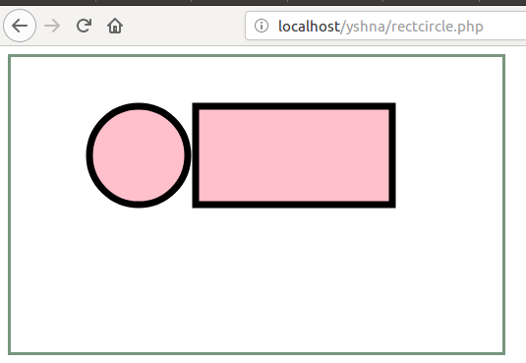

PROGRAM: 3
DATE: 15/03/2018
AIM: Create a student registration form with layout.
PROGRAM:
<!DOCTYPE HTML>
<html>
<head>
<script type="text/javascript" src="validate.js"></script>
</head>
<body>
<form action="#" name="StudentRegistration" onSubmit="return(validate());">
<table cellpadding="2" width="20%" bgcolor="gray" align="center"
cellspacing="2">
<tr>
<td colspan=2>
<center><font size=4><b>Student Registration Form</b></font></center>
</td>
</tr>
<tr>
<td>Name</td>
<td><input type=text name=textnames id="textname" size="30"></td>
</tr>
<tr>
<td>Father Name</td>
<td><input type="text" name="fathername" id="fathername"size="30"></td>
</tr>
<tr>
<td> Address</td>
<td><input type="text" name="personaladdress"
id="personaladdress" size="30"></td>
</tr>
<tr>
<td>Gender</td>
<td><input type="radio" name="Gender" value="male" size="10">Male
<input type="radio" name="Gender" value="Female" size="10">Female</td>
</tr>
<tr>
<td>Course</td>
<td><select name="Course">
<option value="-1" selected>select..</option>
<option value="BBA">BBA</option>
<option value="MCA">MCA</option>
<option value="MBA">MBA</option>
<option value="BCA">BCA</option>
</select></td>
</tr>
<tr>
<td>District</td>
<td><select name="District"><option value="-1" selected>select..</option>
<option value="KANNUR">KANNUR</option>
<option value="KOZHIKODE">KOZHIKODE</option>
<option value="KASARGOD">KASARGOD</option>
<option value="WAYANAD">WAYANAD</option>
</select></td>
</tr>
<tr>
<td>State</td>
<td><select Name="State">
<option value="-1" selected>select..</option>
<option value="kerala">KERALA</option>
<option value="tamilnadu">TAMILNADU</option>
<option value="karnataka">KARNATAKA</option>
<option value="goa">GOA</option>
</select></td>
</tr>
<tr><td>PinCode</td>
<td><input type="text" name="pincode" id="pincode" size="30"></td>
</tr>
<tr>
<td>EmailId</td><td><input type="email" name="emailid" id="emailid" size="30"></td>
</tr>
<tr><td>DOB</td>
<td><input type="text" name="dob" id="dob" size="30"></td>
</tr>
<tr>
<td>MobileNo</td>
<td><input type="text" name="mobileno" id="mobileno" size="30"></td>
</tr>
<tr>
<td><input type="reset"></td>
<td colspan="2"><input type="submit" value="Submit Form" /></td>
</tr>
</table>
</form>
</body>
</html>

OUTPUT:
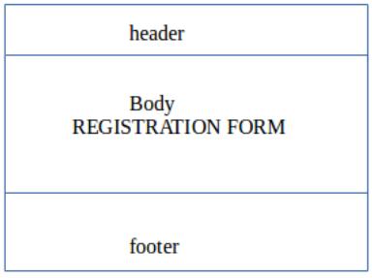

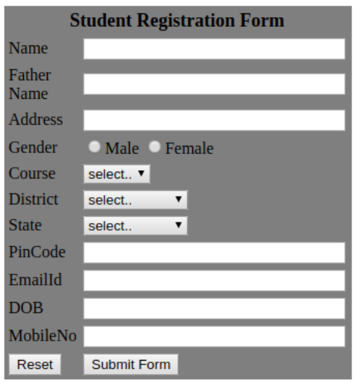

PROGRAM: 4
DATE: 18/05/2018
AIM: Create a JS program to find the factorial of a number

PROGRAM:
<!doctype html>
<html>
<head>
<script>
function findfactorial()
{
var i, n, fact;
fact=1;
n=Number(document.getElementById("NUMBER").value);
for(i=1; i<=n; i++)
{
fact= fact*i;
}
document.getElementById("FACTORIAL").value= fact;
}
</script>
</head>
<body>
<center>
<br><br>
<font size=30 color="black"><b>FACTORIAL</b></font>
<br><br><br>
<table bgcolor="pink">
<tr>
<td>
<font size=3 color="black">
ENTER A NUMBER:
</td>
<td><br><input id="NUMBER">
<br><br>
</td>
</tr>
<tr>
<td><button onclick="findfactorial()">FIND FACTORIAL</button></td>
<td><input id="FACTORIAL"></td>
</tr>
</table>
</center>
</font>
</body>
</html>

OUTPUT:
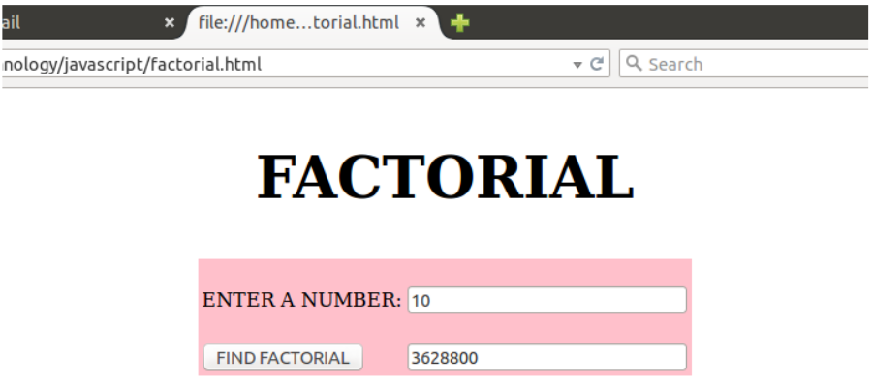

PROGRAM: 5
DATE: 19/05/2018
AIM: Create a JS program to find the largest of the 3 numbers provided by the user
PROGRAM:
<!doctype html>
<html>
<head>
<script>
function findlargest()
{
var num1,num2,num3,largest;
num1=Number(document.getElementById("NUMBER1").value);
num2=Number(document.getElementById("NUMBER2").value);
num3=Number(document.getElementById("NUMBER3").value);
if(num1>num2)
largest=num1;
else
largest=num2;
if(num3>largest)
largest=num3;
document.getElementById("largest").value= largest;
}
</script></head>
<body bgcolor="black">
<CENTER>
<br><font color="white" size=10>
<b>LARGEST OF 3 NUMBERS</b>
<br><hr>
</font>
<font size=4 color="black">
<table bgcolor=grey>
<tr><td>ENTER FIRST NUMBER </td>
<td>:<input id="NUMBER1" type="text"></td>
</tr>
<tr>
<td>ENTER SECOND NUMBER </td>
<td>:<input id="NUMBER2" type="text"></td>
</tr>
<tr>
<td>ENTER THIRD NUMBER </td>
<td>:<input id="NUMBER3" type="text"></td>
</tr>
<tr><td></td></tr>
<td align=center><button onclick="findlargest()">FIND LARGEST</button></td>
<td><input id="largest" type="text"></td>
</tr>
</font></table></body>
</html>

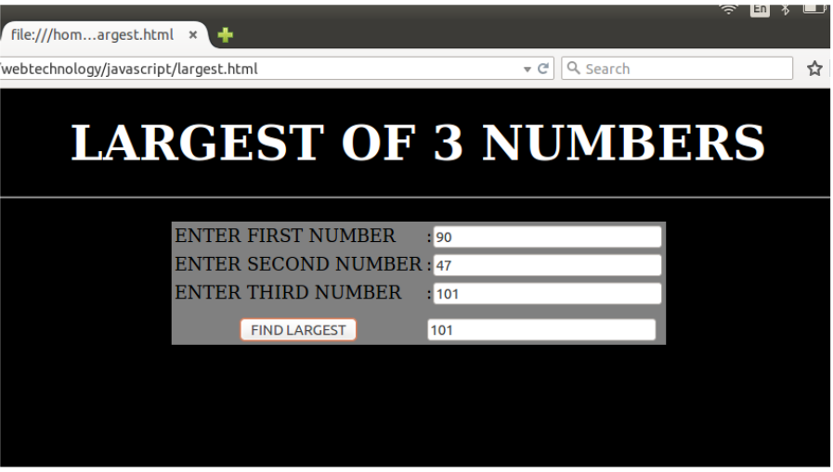
OUTPUT:

PROGRAM: 6
DATE: 19/05/2018
AIM: Create a simple JavaScript calculator program.
PROGRAM:
<!doctype html>
<html>
<head>
<style>
body {
background-color:#abf;
margin: 0px auto;
}
button{
background-color: #aff;
width: 130px;
height: 60px;
font-size: 20px;
border: 1px solid #097C9B;
}
input{
font-size: 20px;
}
</style>
<script type="text/javascript">
function add()
{
var n1=Number(document.getElementById("tb1").value);
var n2=Number(document.getElementById("tb2").value);
var res=n1+n2;
document.getElementById("answer").value= res;
}
function sub()
{
var n1=Number(document.getElementById("tb1").value);
var n2=Number(document.getElementById("tb2").value);
var res=n1-n2;
document.getElementById("answer").value= res;
}function mul()
{
var n1=Number(document.getElementById("tb1").value);
var n2=Number(document.getElementById("tb2").value);
var res=n1*n2;
document.getElementById("answer").value= res;
}
function div()
{
var n1=Number(document.getElementById("tb1").value);
var n2=Number(document.getElementById("tb2").value);
var res=n1/n2;
document.getElementById("answer").value= res;
}
</script>
</head>
<body align=center>
<h1> CALCULATOR</h1>
<br><br>
n1: <input type="textbox" id=tb1><br><br>
n2: <input type="textbox" id=tb2><br><br>
&nbsp;&nbsp;&nbsp;&nbsp;&nbsp;&nbsp;<input type="textbox" id=answer disabled>
<br><br><br>
<button onclick="add()" >ADD</button>
<button onclick="sub()">SUBTRACT</button>
<button onclick="mul()">MULTIPLY</button>
<button onclick="div()">DIVIDE</button>
</body>
</html>

OUTPUT:
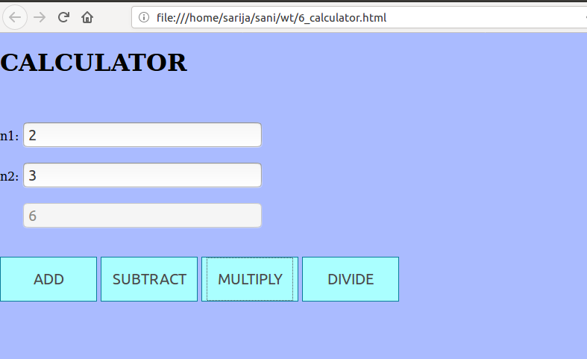

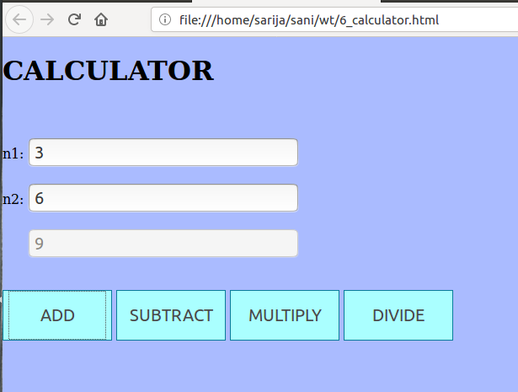

PROGRAM: 7
DATE: 20/05/2018
AIM Write a JavaScript program to roll a dice and calculate frequency of individual numbers entered
PROGRAM:

<html><style>
table
{ border:1px solid;
background : #87CEFA;
}
tr,td,th
{ border:1px solid;
padding:10px;
}
</style>
<script type="text/javascript" >
var o=0,t=0,th=0,f=0,fv=0,s=0;
function roll()
{ var number = Math.floor(Math.random() * 7);
if(number==0)
{ var number = Math.floor(Math.random() * 7);
}
alert("Number on rolled dice: "+number);
if(number==1)
{ o++;
}
else if(number==2)
{ t++;
}
else if(number==3)
{ th++;
}
else if(number==4)
{ f++;
}
else if(number==5)
{ fv++;
}
else
{ s++;
}
document.getElementById('o').innerHTML=o;
document.getElementById('t').innerHTML=t;
document.getElementById('th').innerHTML=th;
document.getElementById('f').innerHTML=f;
document.getElementById('fv').innerHTML=fv;
document.getElementById('s').innerHTML=s;
}
</script><center>
<h2>ROLLING THE DICE</h2>
<table>
<tr><th>Number on the Dice</th><th>Frequency</th></tr>
<tr>
<td>1</td>
<td><label id="o"></label><br></td></tr>
<tr>
<td>2</td>
<td><label id="t"></label><br></td></tr>
<tr>
<td>3</td>
<td><label id="th"></label><br></td></tr>
<tr>
<td>4</td><td><label id="f"></label><br></td></tr>
<tr>
<td>5</td><td><label id="fv"></label><br></td></tr>
<tr><td>6</td><td><label id="s"></label><br></td></tr>
</table><br>
<input type="button" value="Roll dice" onclick="roll();"/>
</html>

OUTPUT:
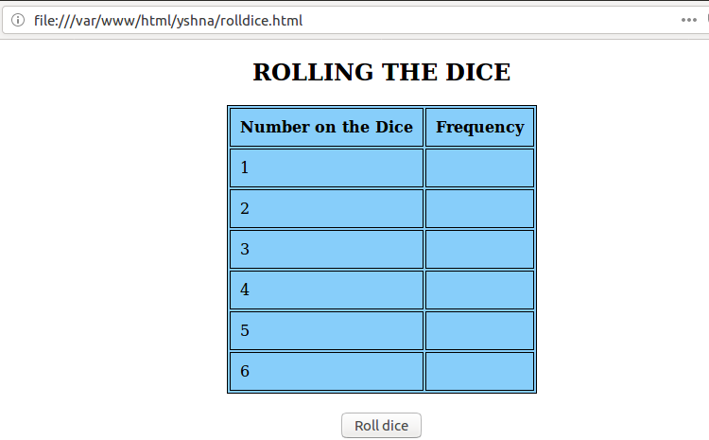

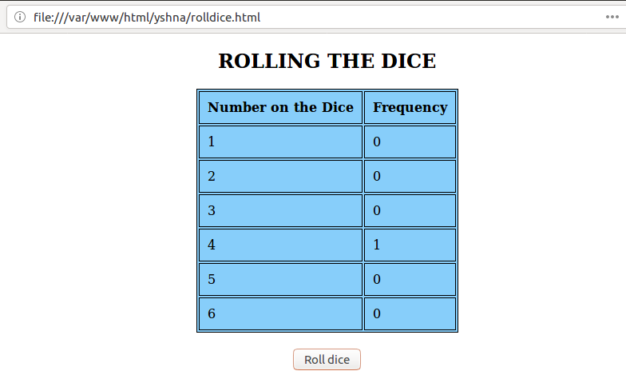

PROGRAM: 8
DATE: 21/05/2018
AIM: Write a jQuery program to copy the permanent address in correspondance address section
PROGRAM:
<!DOCTYPE html>
<html>
<head>
<script>
function myFunction() {
document.getElementById("myForm").reset();
}
</script>
<script src="https://ajax.googleapis.com/ajax/libs/jquery/3.2.1/jquery.min.js"></script>
<script>
$(document).ready(function() {
$('#check').click(function() {
var f1=$('#id1').val();
$('#id8').val(f1);
var f2=$('#id2').val();
$('#id9').val(f2);
var f3=$('#id3').val();
$('#id10').val(f3);
var f4=$('#id4').val();
$('#id11').val(f4);
var f5=$('#id5').val();
$('#id12').val(f5);
var f6=$('#id6').val();
$('#id13').val(f6);
var f7=$('#id7').val();
$('#id14').val(f7);
});
});
</script>
</head>
<body bgcolor=pink><section><h2> <i>permanent Address</h2>
<form id="myForm">
<label >First Name</label>
<input type="text" id="id1" name="name" /><br>
<label >House Name</label>
<input type="text" id="id2" name="name" /><br>
<label >Street Name</label>
<input type="text" id="id3" name="name" /><br>
<label >Post Office</label>
<input type="text" id="id4" name="name" /><br>
<label >City</label>
<input type="text" id="id5" name="name" /><br>
<label >State</label>
<input type="text" id="id6" name="name" /><br>
<label >PIN</label>
<input type="text" id="id7" name="name" /><br>
<br><br>
<label><b>Autofill</b></label>
<input type="checkbox" id="check">
<hr/>
</section>
<section>
<h2>Correspondance Address</h2>
<label >First Name</label>
<input type="text" id="id8" name="name" /><br>
<label >House Name</label>
<input type="text" id="id9" name="name" /><br>
<label >Street Name</label>
<input type="text" id="id10" name="name" /><br>
<label >Post Office</label>
<input type="text" id="id11" name="name" /><br>
<label >City</label>
<input type="text" id="id12" name="name" /><br>
<label >State</label>
<input type="text" id="id13" name="name" /><br>
<label >PIN</label>
<input type="text" id="id14" name="name" /><br>
<button type="reset" class="cancelbtn">Reset</button><br></section>
</form>
</body>
</html>

OUTPUT:

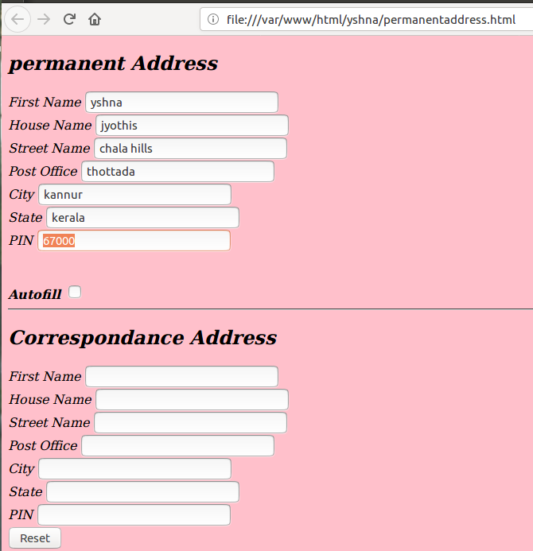

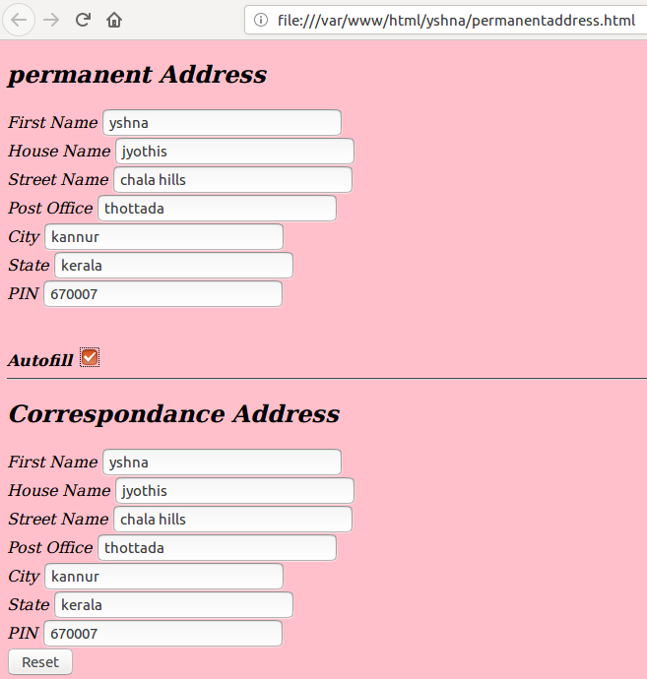

PROGRAM: 9
DATE: 21/05/2018
AIM: Write a jQuery program to remove all paragraph from the page.
PROGRAM:
<!DOCTYPE html>
<html>
<head>
<script src="https://ajax.googleapis.com/ajax/libs/jquery/3.2.1/jquery.min.js"></script>
<script>
$(document).ready(function(){
$("button").click(function(){
$("p").hide();
});
});
</script>
</head>
<body>
<center>
<b>
<H1><p>OTHELO</p></h1>
</b>
<p>Othello begins in the city of Venice, at night. Iago, an ensign in the Venetian army, is bitter about being passed over for lieutenant in favor of Cassio. Iago tells Roderigo that he serves Othello, the Moor who is the army's general, only in order to serve himself. Iago knows that Desdemona, the daughter of nobleman Brabantio, has run off to marry Othello. He also knows that Roderigo lusts after Desdemona, so Iago manipulates him into alerting Venice. Iago's duplicity arises even in the first scene.
</p>
<p>
Learning of his daughter's elopement, Brabantio panics, and calls for people to try and find Desdemona. Iago joins Othello, and tells him about Roderigo's betrayal of the news of his marriage to Brabantio. Cassio comes at last, as do Roderigo and Brabantio; Brabantio is very angry, swearing to the men assembled that Othello must have bewitched his daughter. Brabantio's grievance is denied, and Desdemona will indeed stay with Othello. However, Othello is called away to Cyprus, to defend it from an invasion of Turks. </p>
<button style = "color : red">Remove paragraphs</button>
</center></body></html>

OUTPUT:
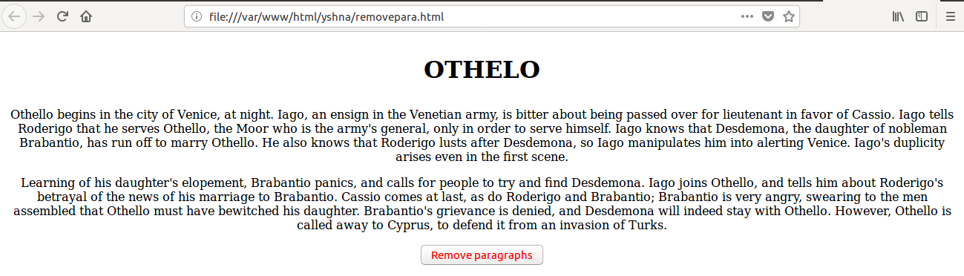

PROGRAM: 10
DATE: 22/05/2018
AIM: Write a jQuery program to give a zoom effect to all images in the HTML page
PROGRAM:
<!DOCTYPE html>
<html>
<head>
<script src="https://ajax.googleapis.com/ajax/libs/jquery/3.2.1/jquery.min.js" type="text/javascript"></script>
<title>ZOOM EFFECTS</title>
</head>
<body>
<script type="text/javascript">
$(document).ready(function () {
$('#img').width(200);
$('#img').mouseover(function () {
$(this).css("cursor", "pointer");
$(this).animate({ width: "500px" ,height : "500px"}, 'slow');
});
$('#img').mouseout(function () {
$(this).animate({ width: "200px", height : "200px" }, 'slow');
});
});
</script>
<div>
<h1>ZOOM EFFECTS</h1>
<br><a><img src="weather.jpg" alt="weather" id="img" width="364"height="619"/></a>
</div>
</body>
</html>

OUTPUT:
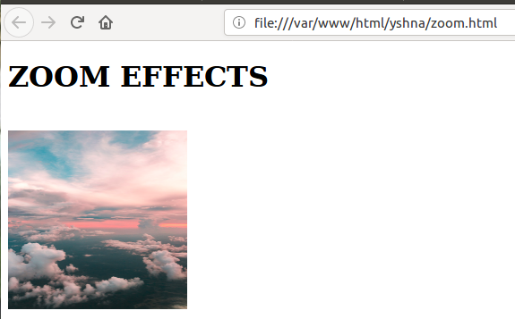

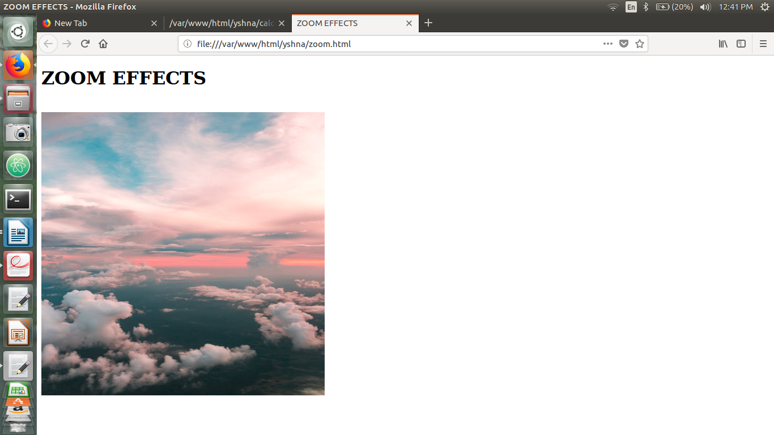

PROGRAM: 11
DATE: 26/05/2018
AIM: Create a program using associative array
PROGRAM:
<html>
<body bgcolor=#E6E6FA>
<CENTER>
<img src="superheroes.jpg" height="200" width="700">
<br><FONT size=6><U>JUSTICE LEAGUE</U></font><br>
<br>Batman
<br>Superman
<br>Wonder Woman<br>
<br>
<br><br><FONT size=6><U>AVENGERS</U></font><br>
<br>Captain America
<br>Iron Man
<br>Spider Man
<br>Widow<br>
<br><form action="" method="post">
<label><i>Please enter your Super Hero name:</i></label>
<input type="text" name="Name" value='<?php echo $name; ?>'/><br><br><br>
<input name="form" type="submit" value="Submit"/><br><br>
</form>
<?php
$name= $_POST['Name'];
$justice = array("Bruce Wayne" => "Batman", "Clark Kent" => "Superman", "Princess Diana" =>
"Wonder Woman", "Steve" => "Captain America", "Tony Stark" => "Ironman", "Peter Parker" =>
"Spiderman","Romonov" => "Widow");
foreach($justice as $key => $value)
{
if($name == $value)
{
echo "The real name is ". $key."</br>";
}
}
?>
</center>
</body>
</html>

OUTPUT:
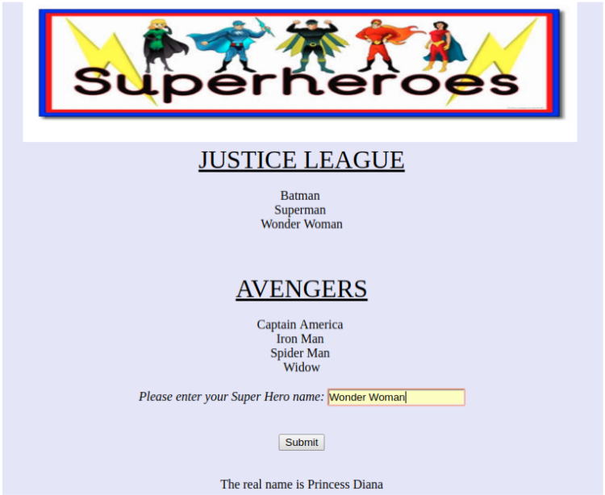

PROGRAM: 12
DATE: 26/05/2018
AIM: Create a PHP database connectivity program
PROGRAM:
login.php
<?php
session_start();
?>
<!DOCTYPE html>
<html>
<head>
<title> Login Form</title>
</head><body>
<form method="post" action="validate_login.php" >
Name: <input type="text" name="users_email" id="users_name"><br><br><br>
Password: <input name="users_pass" type="password" id="users_pass"></input>
<input type="submit" value="Submit"/>
</form></body></html>

validate.php
<?php
// Grab User submitted information
$email = $_POST["users_email"];
$pass =$_POST["users_pass"];
$username = "root";
$password = "passw0rd";
$hostname = "localhost:3306";
// Connect to the database
$con = mysqli_connect($hostname, $username, $password,"examples");
if(! $con)
{ die('Connection Failed'.mysql_error()); }
// Select the database to use - mysql_select_db("examples");
$result = mysqli_query($con,"SELECT users_email, users_pass FROM users WHERE users_email = '$email'");
$row = mysqli_fetch_array($result,MYSQLI_ASSOC);
//echo $row["users_email"];
//echo $row["users_pass"];
if($row["users_email"]==$email && $row["users_pass"]==$pass)
echo"You are valid user.";
else
echo"Sorry,";
?>

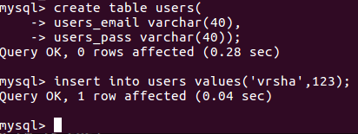
OUTPUT:
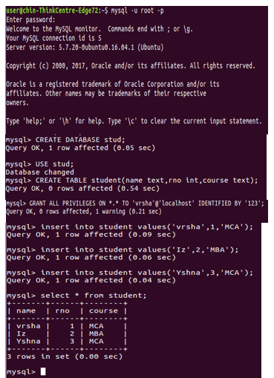

PROGRAM: 13
DATE: 28/05/2018
AIM: Create login module using session.
PROGRAM:
log1.php
<?php session_start();
if(isset($_POST['Submit'])){
$logins = array(yshna => yshna, ysh => ysh);
$Username = isset($_POST['Username']) ? $_POST['Username'] : '';
$Password = isset($_POST['Password']) ? $_POST['Password'] : '';
if (isset($logins[$Username]) && $logins[$Username] == $Password){
$_SESSION['UserData']['Username']=$logins[$Username];
header("location:ind.php");
exit;
} else {
$msg="<span style='color:red'><marquee>Invalid Login Details</marquee></span>";
}}
?>
<body bgcolor="powderblue">
<form action="" method="post" name="Login_Form"><fieldset><fieldset>
<table width="400" border="0" align="center" cellpadding="5" cellspacing="1" class="Table">
<?php if(isset($msg)){?>
<tr><td colspan="2" align="center" valign="top"><?php echo $msg;?></td>
</tr>
<?php } ?>
<tr><td colspan="2" align="left" valign="top" color="red"><h3>Login</h3></td>
</tr>
<tr><td align="right" valign="top">Username</td>
<td><input name="Username" type="text" class="Input"></td>
</tr>
<tr><td align="right">Password</td>
<td><input name="Password" type="password" class="Input"></td></tr>
<tr><td> </td>
<td><input name="Submit" type="submit" value="Login" class="Button3"></td>
</tr>
</table>
</form></fieldset></fieldset>
ind.php
<body bgcolor="pink">
<?php session_start(); /* Starts the session */
if(!isset($_SESSION['UserData']['Username'])){
header("location:log1.php");
exit;
}
?><fieldset>
<img src="https://encrypted-tbn0.gstatic.com/images?
q=tbn:ANd9GcR06hl9Izd_ASUUa_bNLdQvAHicfBT0STDXzlfVnpeRHLIp9Fwe"><font
color="red">WELCOME JISMAYA </marquee><center><a
href="logo.php">logout</a></fieldset></body>
logo.php
<?php session_start(); /* Starts the session */session_destroy(); /* Destroy started session
*/header("location:log1.php"); /* Redirect to login page */exit;
?>
OUTPUT:
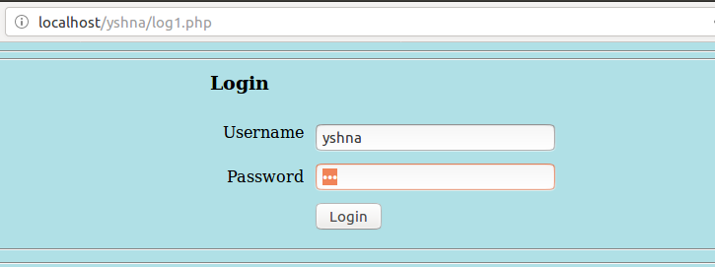
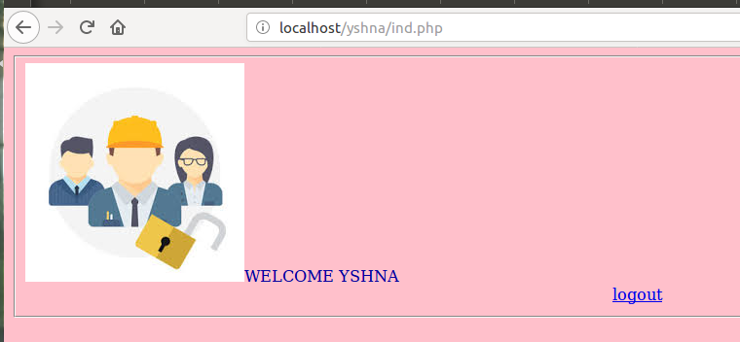

PROGRAM: 14
DATE: 29/05/2018
AIM: Create PHP program to demonstrate opening, closing and reading file.
PROGRAM:
File.txt
hello yshna!!

filereading.php
<?php
$file=fopen("File.txt","r");
echo fread($file,filesize("File.txt"));
fclose($file);
?>
OUTPUT:
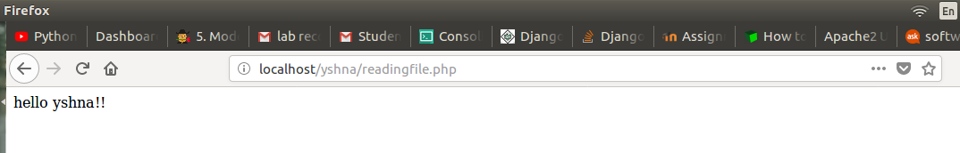

PROGRAM: 15
DATE: 03/06/2018
AIM: Write a program to destroy a PHP session.
PROGRAM:
<?php
session_start();
?>
<!DOCTYPE html>
<html><body><br><br>
<?php
session_name('testing') ;
session_start() ;
$_SESSION['name'] = 'YSHNA' ;
echo "Session variable " , $_SESSION['name'] , " is set !!";
echo "<br><br>";
session_unset();
session_destroy();
echo "<br><br>";
echo "Bye..Session variable is removed and destroyed !!" ;
?>
</body>
</html>

OUTPUT:

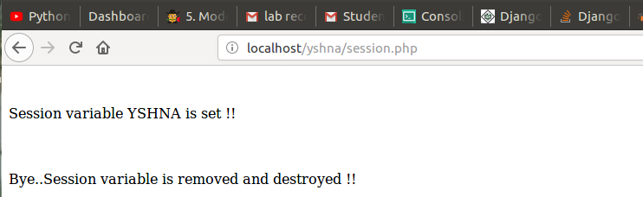

PROGRAM: 16
DATE: 26/05/2018
AIM: Write a PHP program to find a String inside a paragraph.
PROGRAM:
<?php
$a="mirror mirror on the wall, was I always meant to fall.";
echo $a."<br>"."<br>";
$str1=$_POST["t1"];
$count =0;
$para=explode(" ",$a);
if($para!=false)
{
foreach ($para as $paras)
{
if($paras==$str1)
{
$count++;
}
} echo $str1." APPEARS ".$count." TIMES";
}
else
{
echo "SORRY NOT FOUND...";
}
?>
<html>
<body><br>
<form name="f1" method="POST">
<br><B>
ENTER YOUR WORD : <input type="text" name="t1" placeholder="Enter Something">
</form></body>
</html>
OUTPUT:
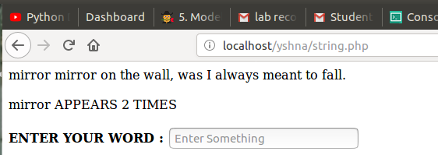

PROGRAM: 17
DATE: 05/06/2018
AIM: Create a menu driven program for string operation. User must be able to select a string function as option to perform string operation.
PROGRAM:
16_FindString.html
<html>
<head>
<title>String Operations in php</title>
</head> <body>
<form name="demo" method="POST" action="string.php">
ENTER A STRING : <input type="text" name="string" placeholder="Enter a string"/><br>
<b>SELECT A STRING OPERATION:</b><br>
<select name="ch">
<option value="1" selected>SELECT</option>
<option value="len">Length</option>
<option value="rev">Reverse</option>
<option value="up">Upper Case</option>
<option value="low">Lower Case</option>
<option value="enc">Encrypt</option>
<option value="count">Count Words</option>
</select>
<input type="submit" value="SUBMIT"/>
</form>
</body> </html>

string.php
<?php
$str = $_POST['string'];
$ch = $_POST['ch'];
if($ch=='len')
{ echo"Length of string is :".strlen($str);
}
else if($ch=='rev')
{ echo"Reverse of string is :".strrev($str);
}
else if($ch=='up')
{ echo"String in uppercase :".strtoupper($str);
}
else if($ch=='low')
{ echo"String in lowercase :".strtolower($str);
}
else if($ch=='enc')
{ echo"Encrypted String is : ".md5($str);
}
else if($ch=='count')
{ echo"Number of words in String : ".str_word_count($str);
} ?>

OUTPUT:
Put both the files in .html and .php files in /var/www/html folder and from the browser type localhost/program.html

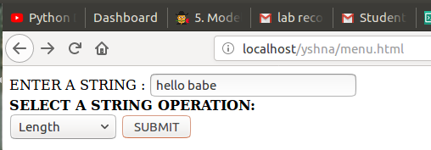

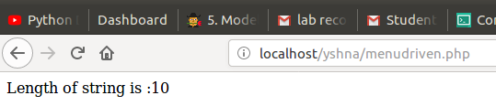

PROGRAM: 18
DATE: 10/06/2018
AIM: Create an XML file containing data of restaurant menu. Use XSLT for styling the
PROGRAM:
food.xsl
<?xml version="1.0" encoding="UTF-8"?>
<xsl:stylesheet version="1.0" xmlns:xsl="http://www.w3.org/1999/XSL/Transform">
<xsl:template match="/">
<html><body>
<h1><center>RESTAURANT DESSERT MENU</center></h1>
<table border="1" align="center" cellpadding="15">
<tr bgcolor="DodgerBlue">
<th>N A M E </th>
<th>P R I C E</th>
</tr>
<xsl:for-each select="restaurant-menu/food">
<tr>
<td><xsl:value-of select="name"/></td>
<td><xsl:value-of select="price"/></td>
</tr>
</xsl:for-each>
</table></body></html>
</xsl:template>
</xsl:stylesheet>
restaurannt.xml
<?xml version="1.0" encoding="UTF-8"?>
<?xml-stylesheet href="food.xsl" type="text/xsl"?>
<restaurant-menu>
<food>
<name>FISH TIKKA</name>
<price>$15.95</price>
</food>
<food>
<name>VANILLA GELATO</name>
<price>$25.00</price>
</food>
<food>
<name>GRILL FISH</name>
<price>$12.80</price>
</food>
<food>
<name>PEPPER MUTTON</name>
<price>$10.87</price>
</food>
<food>
<name>PECAN PIE</name>
<price>$25.75</price>
</food>
<food>
<name>GARLIC VEG </name>
<price>$65.50</price>
</food>
<food>
<name>CARROT CAKE</name>
<price>$35.50</price>
</food>
<food>
<name>C0RN FRIED FISH</name>
<price>$20.61</price>
</food>
<food>
<name>MUSHROOM 65</name>
<price>$35.50</price>
</food>
</restaurant-menu>
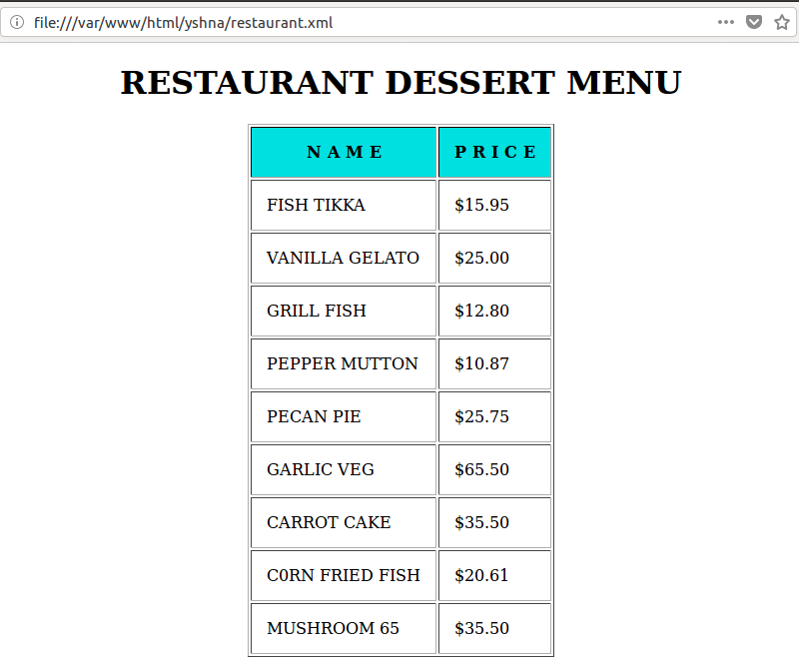
OUTPUT:

PROGRAM: 19

DATE: 11/06/2018
AIM: Create a JSON file containing 10 movie records
PROGRAM:
{
"record" : [
{
"Rank":"1",
"Movie":"3 IDIOTS",
"Distributor":"Sony Pictures",
"Genre":"comedy",
"MPAA":"PG",
},
{
"Rank":"2",
"Movie":"1971",
"Distributor":"Paramount Pictures",
"Genre":"Adventure",
"MPAA":"PG-13",
},
{
"Rank":"3",
"Movie":"DILWALE",
"Distributor":"Sony Pictures",
"Genre":"Romantic",
"MPAA":"PG-13",
},
{
"Rank":"4",
"Movie":"THE SHAWSHANK REDEMPTION",
"Distributor":"Paramount Pictures",
"Genre":"Action",
"MPAA":"PG-13",
},
{
"Rank":"5",
"Movie":"INTO THE WILD",
"Distributor":"Buena Vista",
"Genre":"Adventure",
"MPAA":"G",
},
{
"Rank":"6",
"Movie":"KAHANI",
"Distributor":"Warner bros.",
"Genre":"Action",
"MPAA":"PG-13",
},
{
"Rank":"7",
"Movie":"THE PURSUIT OF HAPPINESS",
"Distributor":"20th Century Fox",
"Genre":"Adventure",
"MPAA":"G",
},
{"Rank":"8",
"Movie":"SHOLAY",
"Distributor":"Universal",
"Genre":"Musical",
"MPAA":"PG-13",
},
{
"Rank":"9",
"Movie":"THE PURSUIT OF HAPPINESS",
"Distributor":"Universal",
"Genre":"Adventure",
"MPAA":"PG-13",
},
{
"Rank":"10",
"Movie":"CHAK DE INDIA",
"Distributor":"ForSearchLight",
"Genre":"Adventure",
"MPAA":"PG-13",
}
]
}

