**Name: VYSHNAV SURESH**

**Roll No:56**

**Batch:B**

**Date:25/03/2022**

**ADVANCED DATABASE MANAGEMENT SYSTEM LAB**

**Experiment No.: 1**

**Aim**

To study various DDL commands – CREATE

**Question**

Create the following Tables

#### Table 1: DEPOSIT

ACTNO VARCHAR2(5) PRIMARY KEY, FIRST LETTER MUST START WITH ‘D’ CNAME VARCHAR2(15) FOREIGN KEY REFERENCES CUSTOMER

BNAME VARCHAR2(20) FOREIGN KEY REFERENCES BRANCH AMOUNT NUMBER (8,2) NOT NULL, CANNOT BE 0

ADATE DATE

#### Table 2: BRANCH

BNAME VARCHAR2(20) PRIMARY KEY

CITY VARCHAR2(30) NOT NULL , any one of NAGPUR, DELHI, BANGALORE, BOMBAY

#### Table 3: CUSTOMER

CNAME VARCHAR2(15) PRIMARY KEY CITY VARCHAR2(20) NOT NULL ,

#### Table 4: BORROW

LOANNO VARCHAR2(8) PRIMARY KEY / FIRST LETTER MUST START WITH ‘L’ CNAME VARCHAR2(15) FOREIGN KEY REFERENCES CUSTOMER

BNAME VARCHAR2(20) FOREIGN KEY REFERENCES BRANCH AMOUNT NUMBER(8,2) NOT NULL, CANNOT BE 0

**Procedure**

Create the following Tables

#### Table 1: DEPOSIT

CREATE TABLE DEPOSIT (ACTNO VARCHAR(5) CHECK (ACTNO LIKE 'D%') PRIMARY KEY ,CNAME

VARCHAR(15) REFERENCES CUSTOMER(CNAME) ,BNAME VARCHAR(20) REFERENCES

BRANCH(BNAME),AMOUNT FLOAT(8) CHECK (AMOUNT>0) NOT NULL, ADATE DATE);

ADATE DATE

#### Table 2: BRANCH

CREATE TABLE BRANCH (BNAME VARCHAR(20) PRIMARY KEY,CITY VARCHAR(30) CHECK (CITY IN

('NAGPUR','DELHI','BANGALORE','BOMBAY')) NOT NULL);

#### Table 3: CUSTOMER

CREATE TABLE CUSTOMER (CNAME VARCHAR(15) PRIMARY KEY ,CITY VARCHAR(20) NOT NULL );

#### Table 4: BORROW

CREATE TABLE BORROW (LOANNO VARCHAR(8) CHECK (LOANNO LIKE 'L%') PRIMARY KEY,CNAME

VARCHAR(15) REFERENCES CUSTOMER(CNAME) ,BNAME VARCHAR(20) REFERENCES

BRANCH(BNAME),AMOUNT FLOAT(8) CHECK (AMOUNT>0) NOT NULL);

**Inserting data**

#### Table 1: DEPOSIT

INSERT INTO DEPOSIT VALUES('D100','ANIL','VRCE',1000.00,'2008-11-11');

INSERT INTO DEPOSIT VALUES('D101','SUNIL','ANJNI',500.00,'1996-01-04');

INSERT INTO DEPOSIT VALUES('D102','MEHUL','KAROLBAGH',3500.00,'1995-11-17');

INSERT INTO DEPOSIT VALUES('D104','MADHURI','CHANDNI',1200.00,'1995-12-17');

INSERT INTO DEPOSIT VALUES('D105','PRAMOD','MG ROAD',3000.00,'1996-03-27');

INSERT INTO DEPOSIT VALUES('D106','SANDIP','ANDHERI',2000.00,'1996-03-31');

INSERT INTO DEPOSIT VALUES('D107','SHIVANI','VIRAR',1000.00,'1995-06-05');

INSERT INTO DEPOSIT VALUES('D108','KRANTI','NEHRU PLACE',5000.00,'1995-07-02');

INSERT INTO DEPOSIT VALUES('D109','MINU','POWAI',7000.00,'1995-10-08');

#### Table 2: BRANCH

INSERT INTO BRANCH VALUES('VRCE','NAGPUR');

INSERT INTO BRANCH VALUES('AJNI','NAGPUR');

INSERT INTO BRANCH VALUES('KAROLBAGH','DELHI');

INSERT INTO BRANCH VALUES('CHANDNI','DELHI');

INSERT INTO BRANCH VALUES('DHARAMPETH','NAGPUR');

INSERT INTO BRANCH VALUES('MG ROAD','BANGALORE');

INSERT INTO BRANCH VALUES('ANDHERI','BOMBAY');

INSERT INTO BRANCH VALUES('NEHRU PALACE','DELHI');

INSERT INTO BRANCH VALUES('POWAI','BOMBAY');

#### Table 3: CUSTOMER

INSERT INTO CUSTOMER VALUES('ANIL','CALCUTTA');

INSERT INTO CUSTOMER VALUES('SUNIL','DELHI');

INSERT INTO CUSTOMER VALUES('MEHUL','BARODA');

INSERT INTO CUSTOMER VALUES('MANDAR','PATNA');

INSERT INTO CUSTOMER VALUES('MADHURI','NAGPUR');

INSERT INTO CUSTOMER VALUES('PRAMOD', 'NAGPUR');

INSERT INTO CUSTOMER VALUES('SANDIP','SURAT');

INSERT INTO CUSTOMER VALUES('SHIVANI','BOMBAY');

INSERT INTO CUSTOMER VALUES('KRANTI','BOMBAY');

INSERT INTO CUSTOMER VALUES('NAREN','BOMBAY');

#### Table 4: BORROW

INSERT INTO BORROW VALUES('L201','ANIL','VRCE',1000.00);

INSERT INTO BORROW VALUES('L206','MEHUL','AJNI',5000.00);

INSERT INTO BORROW VALUES('L311','SUNIL','DHARAMPETH',3000.00);

INSERT INTO BORROW VALUES('L321','MADHURI','ANDHERI',2000.00);

INSERT INTO BORROW VALUES('L371','PRAMOD','VIRAR',8000.00);

INSERT INTO BORROW VALUES('L481','KRANTI','NEHRU PLACE',3000.00);

**Output Screenshot**

SELECT * FROM DEPOSIT;

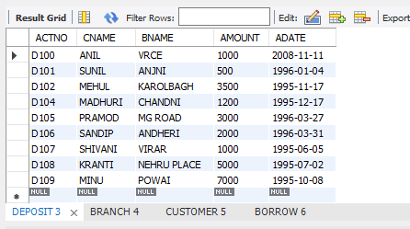

SELECT * FROM BRANCH;

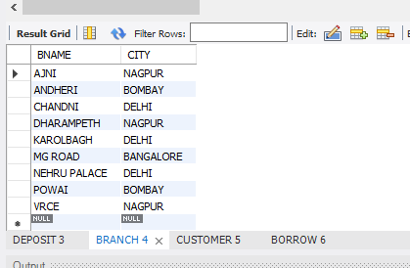

SELECT * FROM BRANCH;

SELECT * FROM CUSTOMER;

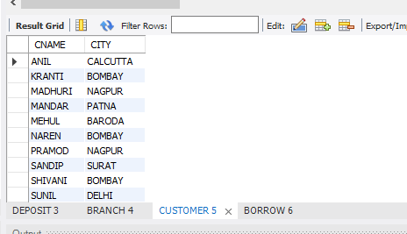

SELECT * FROM BORROW;

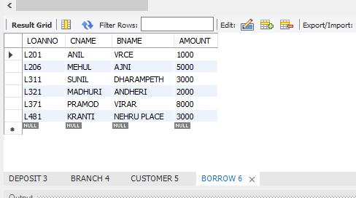

**Name: VYSHNAV SURESH**

**Roll No:56**

**Batch:B**

**Date:25/03/2022**

**ADVANCED DATABASE MANAGEMENT SYSTEM LAB**

**Experiment No.: 2**

**Aim**

To familiarize with selecting data from single table

**Question**

1. List all data from table deposite

2. List all data from borrow

3. List all data from customer

4. List all data from branch

5. Give account no and amount of deposite

6. Give customer name and account no of depositors

7. Give name of customers

8. Give name of branches

9. Give name of borrows

10. Give names of customer living in city Nagpur

11. Give names of depositors having amount greater than 4000

12. Give account date of Anil

13. Give name of all branches located in Bombay

14. Give name of borrower having loan number l205

15. Give names of depositors having account at VRCE

16. Give names of all branched located in city Delhi

17. Give name of the customers who opened account date ‘1-12-96’

18. Give account no and deposit amount of customers having account opened between dates  ‘1-12-96’ and ‘1-5-96’

19. Give name of the city where branch KAROLBAGH is located

20. Give details of customer ANIL

**Procedure**

SELECT*FROM DEPOSIT;

SELECT*FROM BORROW;

SELECT*FROM CUSTOMER;

SELECT*FROM BRANCH;

SELECT ACTNO,AMOUNT FROM DEPOSIT;

SELECT CNAME,ACTNO FROM DEPOSIT;

SELECT CNAME FROM CUSTOMER;

SELECT BNAME FROM BRANCH;

SELECT CNAME FROM BORROW;

SELECT CNAME FROM CUSTOMER WHERE CITY='NAGPUR';

SELECT CNAME from DEPOSIT where AMOUNT>4000;

SELECT ADATE FROM DEPOSIT where CNAME='ANIL';

SELECT BNAME from BRANCH where CITY='Bombay';

SELECT * from BORROW;

SELECT CNAME from BORROW where LOANNO='L205';

SELECT CNAME from DEPOSIT WHERE BNAME='VRCE';

SELECT BNAME from BRANCH WHERE CITY='Delhi';

SELECT CNAME from DEPOSIT WHERE ADATE='1996-12-1';

SELECT ACTNO,AMOUNT from DEPOSIT WHERE ADATE BETWEEN '1996-12-1'  AND '1996-05-1';

SELECT CITY from BRANCH WHERE BNAME='KAROLBAGH';

# SELECT * from customer join borrow on customer.cname=borrow.cname join deposit on  deposit.cname=borrow.cname WHERE customer.cname='ANIL';

**Output Screenshot**

SELECT * FROM DEPOSIT;

SELECT * FROM BRANCH;



SELECT * FROM CUSTOMER;



SELECT * FROM BORROW;



SELECT ACTNO,AMOUNT FROM DEPOSIT;

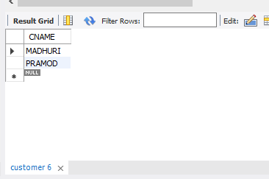

SELECT CNAME,ACTNO FROM DEPOSIT;

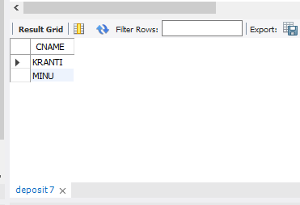

SELECT ADATE FROM DEPOSIT where CNAME='ANIL';

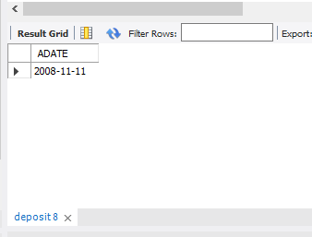

SELECT BNAME from BRANCH where CITY='Bombay';

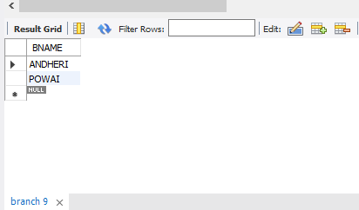

SELECT * from BORROW;

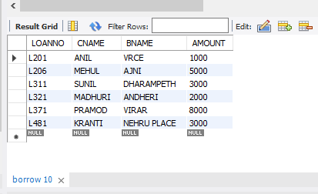

SELECT CNAME from BORROW where LOANNO='L205';

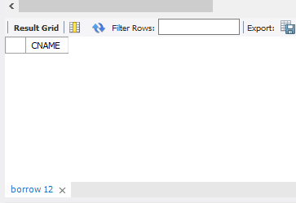

SELECT CNAME from DEPOSIT WHERE BNAME='VRCE';

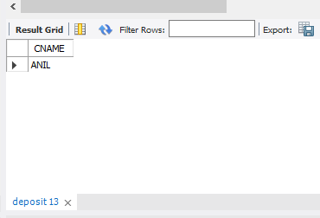

SELECT BNAME from BRANCH WHERE CITY='Delhi';

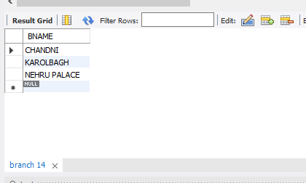

SELECT CNAME from DEPOSIT WHERE ADATE='1996-12-1';

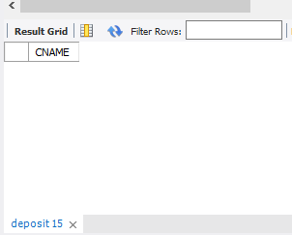

SELECT ACTNO,AMOUNT from DEPOSIT WHERE ADATE BETWEEN '1996-12-1'  AND '1996-05-1';

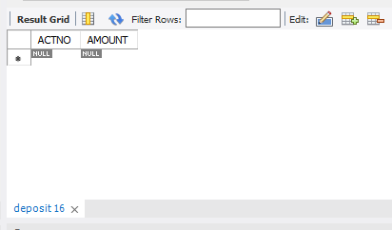

SELECT CITY from BRANCH WHERE BNAME='KAROLBAGH';

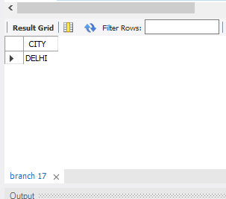

# SELECT * from customer join borrow on customer.cname=borrow.cname join deposit on  deposit.cname=borrow.cname WHERE customer.cname='ANIL';

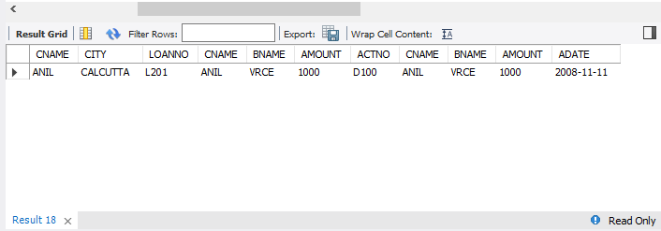

**Name: VYSHNAV SURESH**

**Roll No:56**

**Batch:B**

**Date:25/03/2022**

**ADVANCED DATABASE MANAGEMENT SYSTEM LAB**

**Experiment No.: 3**

**Aim**

To familiarize DDL Commands- ALTER,DROP,TRUNCATE,RENAME

**Question**

1.Create a table emp with attributes empno number(4)as primary key, ename char(10),hiredate,  salary, commission.

insert 5 rows of data

|  |  |  |  |  |
| --- | --- | --- | --- | --- |
| 101 | Ramesh | 17-Jan  1980 | 5000 |  |
| 102 | Ajay | 05-Jul  1985 | 5000 | 500 |
| 103 | Ravi | 12-Aug  1981 | 1500 |  |
| 104 | Nikesh | 03-Mar  1983 | 3000 | 700 |
| 105 | Ravi | 05-jul  1985 | 3000 |  |

2.Modifying the structure of tables

a.Add new columns: sal number(7,2)

b.Dropping a column from a table: sal

c.Modifying existing column :ename varchar2(15)

d.Renaming the tables: emp to emp1

e.truncating the tables:emp1

f.Destroying tables:emp

3.Create a table stud with sname varchar2(20) primary key , rollno number(10) not null,dob  date not null

4.Create a table student as regno number (6), mark number (3) check constraint (mark >=0 and  mark

<=100));

In table student add check constraint(length(regno<=4))

5.Create a table cust with(custid number(6) constraint unique, name char(10) 6. Refer the table “stud” in table “ student”

**Procedure**

**Create table emp:**

create table emp( empno INT primary KEY , ename char(10),hiredate DATE, salary INT,commision INT);

INSERT INTO emp values(101,'Ramesh','1980-01-17',5000,0);

INSERT INTO emp values(102,'Ajay','1985-07-05',5000,500);

INSERT INTO emp values(103,'Ravi','1981-08-12',1500,0);

INSERT INTO emp values(104,'Nikesh','1983-03-03',3000,700);

INSERT INTO emp values(105,'Ravi','1985-07-05',3000,0);

Table emp:

select * from emp;

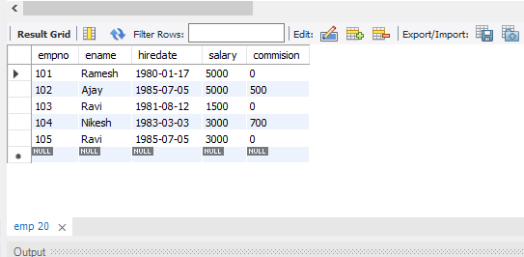

ALTER TABLE emp ADD sal int;

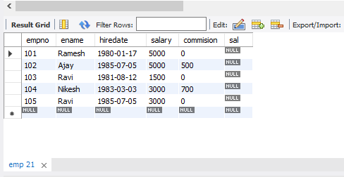

ALTER TABLE emp DROP COLUMN sal;

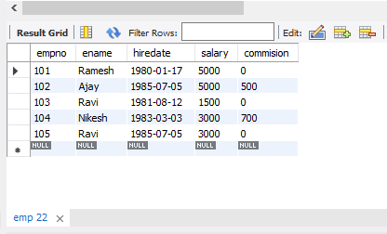

ALTER TABLE emp MODIFY ename VARCHAR(15);

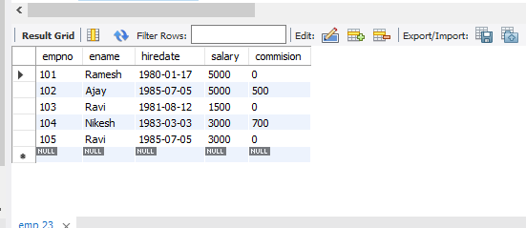

RENAME table emp to emp1;

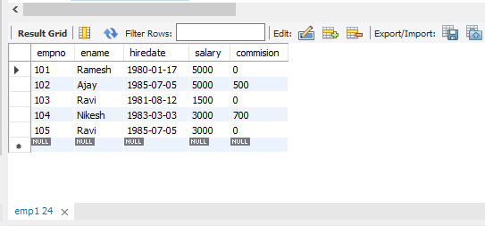

TRUNCATE TABLE emp1;

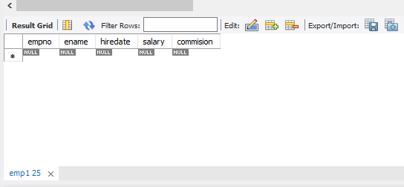

DROP TABLE emp1;



CREATE TABLE stud(sname varchar(20) PRIMARY KEY, rollno int NOT NULL, dob date  NOT NULL);

SELECT * FROM stud;

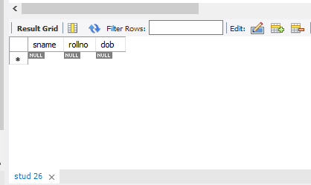

Create table student (regno int, mark int(3) constraint b check (mark >=0 and mark <=100)); SELECT * from STUDENT;

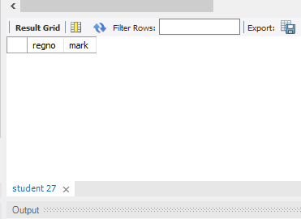

Alter table student add regno check (length(regno<=4));

CREATE TABLE cust(custid number(6) UNIQUE, name char(10));

 CREATE TABLE emp(EMPNO INT(4) PRIMARY KEY,

-> ENAME CHAR(10),

-> HIREDATE DATE,

-> SALARY INT(5),

-> COMMISSION INT(5));

Query OK, 0 rows affected, 3 warnings (0.04 sec)