**Name: VYSHNAV SURESH**

**Roll No:56**

**Batch: RMCA**

**Date:03-06-2022**

**ADVANCED DBMS LAB**

**Experiment No.: 8**

**Aim**

 Create database Practice CRUD operations

**Procedure**

1. Create database and use database

**use crud_operations**

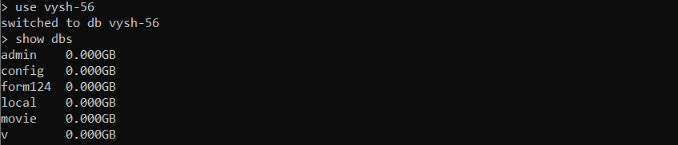

1. Display all database

**show dbs**



1. Create table and insert value into the table

**db.users.insertOne( { name:"sure",age:26,status:"pending" } )**

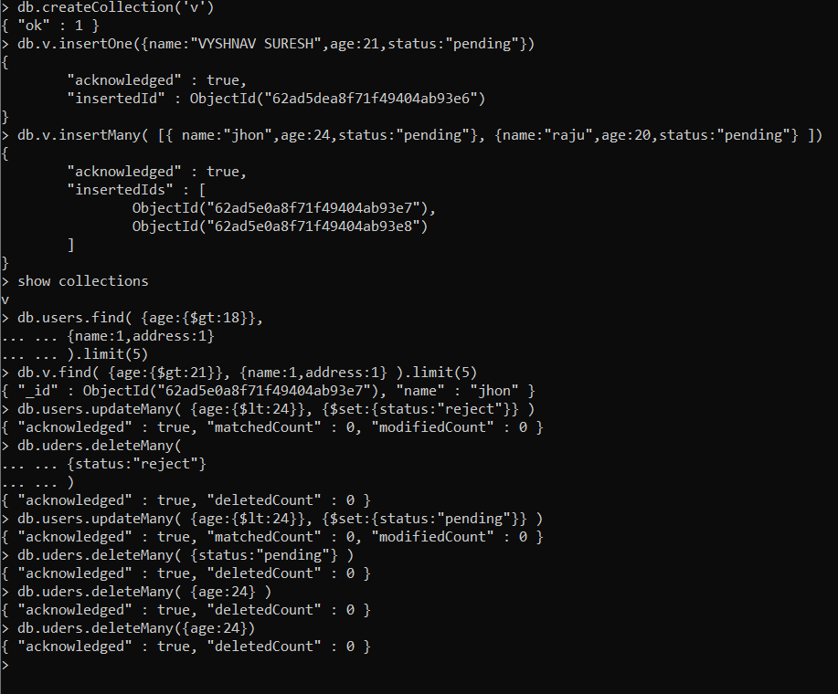

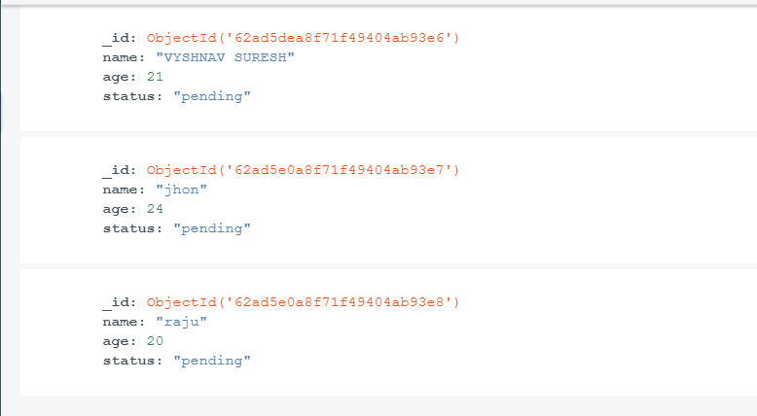

1. Insert many values into the table.

**db.users.insertMany( [{ name:"sam",age:24,status:"pending"}, {name:"ram",age:20,status:"pending"} ])**





1. Display tables

**show collections**



1. Find particular table Datas.

**db.users.find( {age:{$gt:18}},**

**... {name:1,address:1}**

**... ).limit(5)**



1. Modify existing operation in a collection

**db.users.updateMany( {age:{$lt:24}}, {$set:{status:"pending"}} )**



1. Remove documents from a collection

