|  |
| --- |
| **Name: VYSHNAV SURESH**  **Roll No:56**  **Batch: B**  **Date:26/03/2022** |

**ADVANCED DATABASE MANAGEMENT SYSTEM LAB**

**Experiment No.: 1**

**Aim**

To study various DDL commands – CREATE

# Question

Create the following Tables

## Table 1: DEPOSIT

ACTNO VARCHAR2(5) PRIMARY KEY, FIRST LETTER MUST START WITH ‘D’

CNAME VARCHAR2(15) FOREIGN KEY REFERENCES CUSTOMER

BNAME VARCHAR2(20) FOREIGN KEY REFERENCES BRANCH

AMOUNT NUMBER (8,2) NOT NULL, CANNOT BE 0 ADATE DATE

## Table 2: BRANCH

BNAME VARCHAR2(20) PRIMARY KEY

CITY VARCHAR2(30) NOT NULL , any one of NAGPUR, DELHI, BANGALORE,

BOMBAY

## Table 3: CUSTOMER

CNAME VARCHAR2(15) PRIMARY KEY

CITY VARCHAR2(20) NOT NULL ,

## Table 4: BORROW

LOANNO VARCHAR2(8) PRIMARY KEY / FIRST LETTER MUST START WITH ‘L’

CNAME VARCHAR2(15) FOREIGN KEY REFERENCES CUSTOMER

BNAME VARCHAR2(20) FOREIGN KEY REFERENCES BRANCH

AMOUNT NUMBER(8,2) NOT NULL, CANNOT BE 0

# Procedure

## Creating tables

### Table 1: DEPOSIT

CREATE TABLE DEPOSIT (ACTNO VARCHAR(5) CHECK (ACTNO LIKE 'D%') PRIMARY

KEY ,CNAME VARCHAR(15) REFERENCES CUSTOMER(CNAME),BNAME

VARCHAR(20) REFERENCES BRANCH(BNAME),AMOUNT FLOAT(8) CHECK (AMOUNT>0) NOT NULL, ADATE DATE);

### Table 2: BRANCH

CREATE TABLE BRANCH(BNAME VARCHAR(20) PRIMARY KEY,CITY VARCHAR(30) CHECK (CITY IN ('NAGPUR','DELHI','BANGALORE','BOMBAY')) NOT NULL);

### Table 3: CUSTOMER

CREATE TABLE CUSTOMER (CNAME VARCHAR(15) PRIMARY KEY ,CITY

VARCHAR(20) NOT NULL );

### Table 4: BORROW

CREATE TABLE BORROW (LOANNO VARCHAR(8) CHECK (LOANNO LIKE 'L%') PRIMARY

KEY,CNAME VARCHAR(15) REFERENCES CUSTOMER(CNAME),BNAME VARCHAR(20) REFERENCES BRANCH(BNAME),AMOUNT FLOAT(8) CHECK (AMOUNT>0) NOT NULL);

## Inserting Values

### Table 1: DEPOSIT

INSERT INTO DEPOSIT VALUES('D100','ANIL','VRCE',1000.00,'200811-11');

INSERT INTO DEPOSIT VALUES('D101','SUNIL','ANJNI',500.00,'199601-04');

INSERT INTO DEPOSIT

VALUES('D102','MEHUL','KAROLBAGH',3500.00,'1995-11-17');

INSERT INTO DEPOSIT

VALUES('D104','MADHURI','CHANDNI',1200.00,'1995-12-17');

INSERT INTO DEPOSIT VALUES('D105','PRAMOD','MG

ROAD',3000.00,'1996-03-27');

INSERT INTO DEPOSIT

VALUES('D106','SANDIP','ANDHERI',2000.00,'1996-03-31');

INSERT INTO DEPOSIT

VALUES('D107','SHIVANI','VIRAR',1000.00,'1995-06-05');

INSERT INTO DEPOSIT VALUES('D108','KRANTI','NEHRU

PLACE',5000.00,'1995-07-02');

INSERT INTO DEPOSIT

VALUES('D109','MINU','POWAI',7000.00,'1995-10-08');

### Table 2: BRANCH

INSERT INTO BRANCH VALUES('VRCE','NAGPUR');

INSERT INTO BRANCH VALUES('AJNI','NAGPUR');

INSERT INTO BRANCH VALUES('KAROLBAGH','DELHI');

INSERT INTO BRANCH VALUES('CHANDNI','DELHI');

INSERT INTO BRANCH VALUES('DHARAMPETH','NAGPUR');

INSERT INTO BRANCH VALUES('MG ROAD','BANGALORE');

INSERT INTO BRANCH VALUES('ANDHERI','BOMBAY');

INSERT INTO BRANCH VALUES('NEHRU PALACE','DELHI');

INSERT INTO BRANCH VALUES('POWAI','BOMBAY');

### Table 3: CUSTOMER

INSERT INTO CUSTOMER VALUES('ANIL','CALCUTTA');

INSERT INTO CUSTOMER VALUES('SUNIL','DELHI');

INSERT INTO CUSTOMER VALUES('MEHUL','BARODA');

INSERT INTO CUSTOMER VALUES('MANDAR','PATNA');

INSERT INTO CUSTOMER VALUES('MADHURI','NAGPUR');

INSERT INTO CUSTOMER VALUES('PRAMOD', 'NAGPUR');

INSERT INTO CUSTOMER VALUES('SANDIP','SURAT');

INSERT INTO CUSTOMER VALUES('SHIVANI','BOMBAY');

INSERT INTO CUSTOMER VALUES('KRANTI','BOMBAY');

INSERT INTO CUSTOMER VALUES('NAREN','BOMBAY');

### Table 4: BORROW

INSERT INTO BORROW VALUES('L201','ANIL','VRCE',1000.00);

INSERT INTO BORROW VALUES('L206','MEHUL','AJNI',5000.00);

INSERT INTO BORROW

VALUES('L311','SUNIL','DHARAMPETH',3000.00);

INSERT INTO BORROW

VALUES('L321','MADHURI','ANDHERI',2000.00);

INSERT INTO BORROW VALUES('L371','PRAMOD','VIRAR',8000.00);

INSERT INTO BORROW VALUES('L481','KRANTI','NEHRU

PLACE',3000.00);

**Output Screenshots**

SELECT * FROM DEPOSIT;

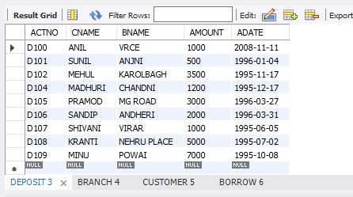

### SELECT * FROM BRANCH;

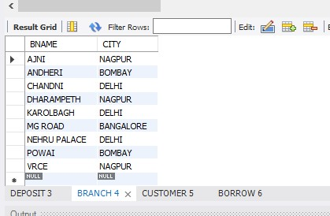

### SELECT * FROM CUSTOMER;

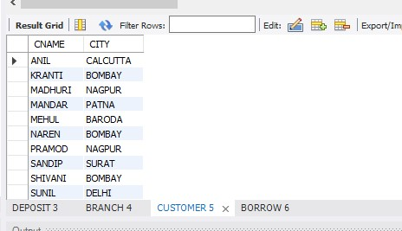

### SELECT * FROM BORROW;

