|  |
| --- |
| Name: VYSHNAV SURESH  Roll No: 56  Batch: B  Date: 08-04-2022 |

ADVANCED ADBMS LAB

Experiment No.: 2

Aim

To familiarize with selecting data from single table

Questions

1. List all data from table deposite
2. List all data from borrow
3. List all data from customer
4. List all data from branch
5. Give account no and amount of deposite
6. Give customer name and account no of depositors
7. Give name of customers
8. Give name of branches
9. Give name of borrows
10. Give names of customer living in city Nagpur
11. Give names of depositors having amount greater than 4000
12. Give account date of Anil
13. Give name of all branches located in Bombay
14. Give name of borrower having loan number l205
15. Give names of depositors having account at VRCE
16. Give names of all branched located in city Delhi
17. Give name of the customers who opened account date ‘1-12-96’
18. Give account no and deposit amount of customers having account opened between dates ‘1-12-96’ and ‘1-5-96’
19. Give name of the city where branch KAROLBAGH is located
20. Give details of customer ANIL

Procedure

# SELECT*FROM DEPOSIT;

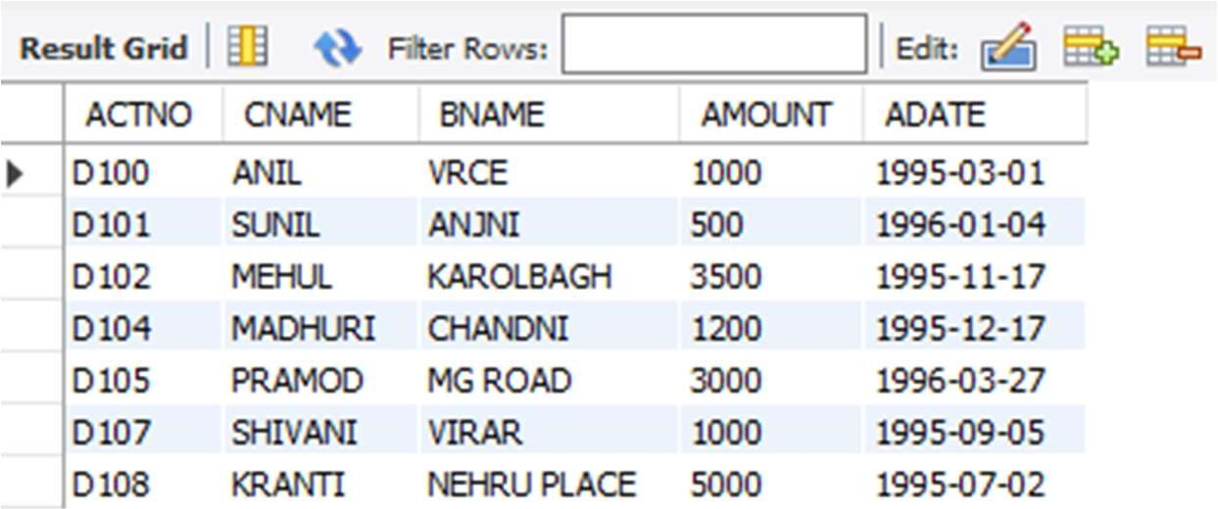

# SELECT*FROM BORROW;

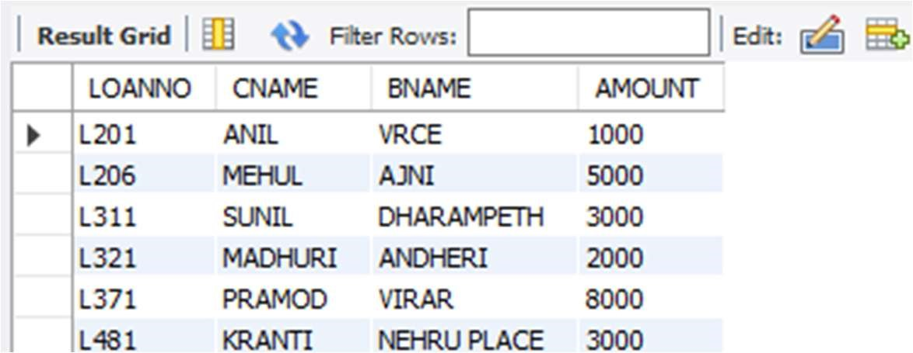

# SELECT*FROM CUSTOMER;

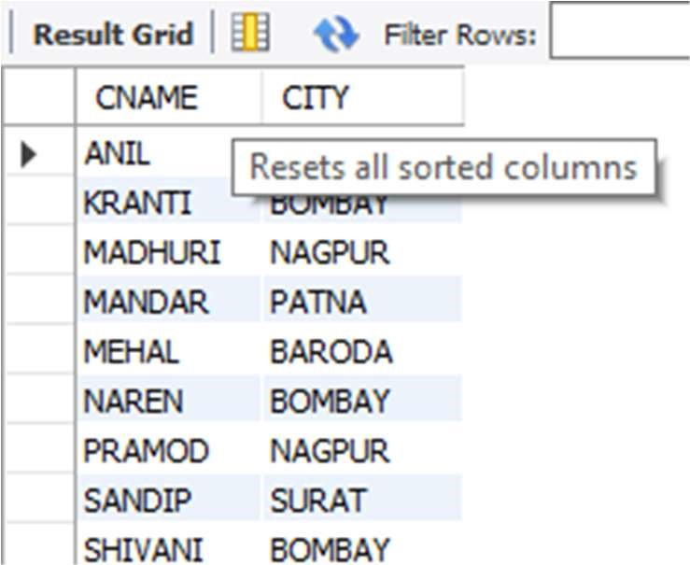

# SELECT*FROM BRANCH;

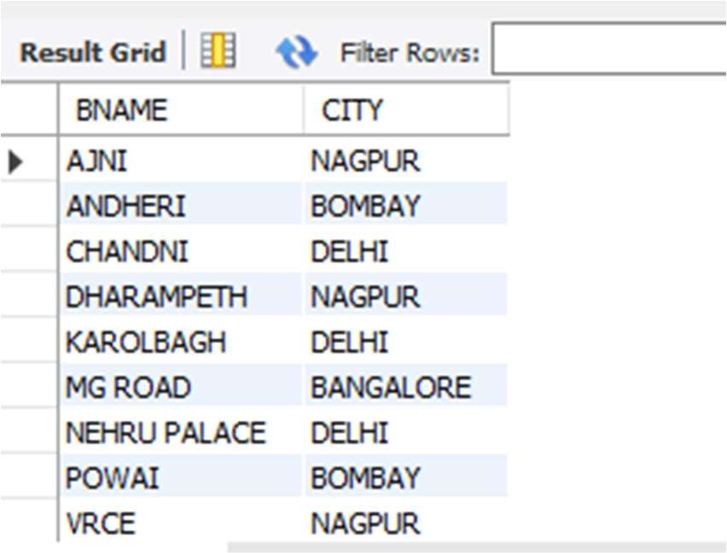

# SELECT ACTNO,AMOUNT FROM DEPOSIT;

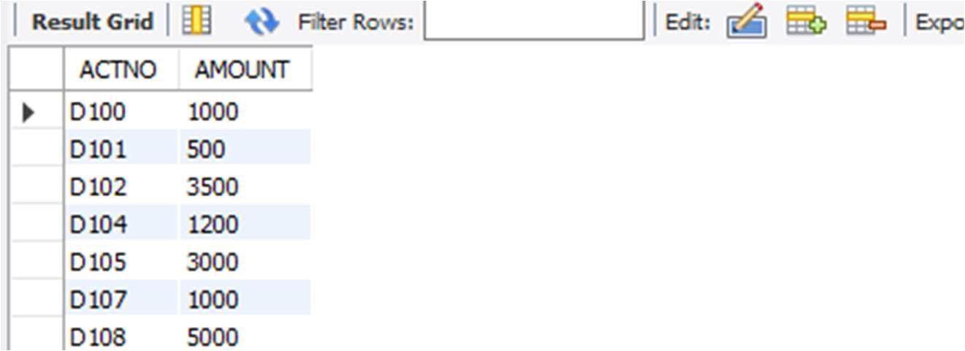

# SELECT CNAME,ACTNO FROM DEPOSIT;

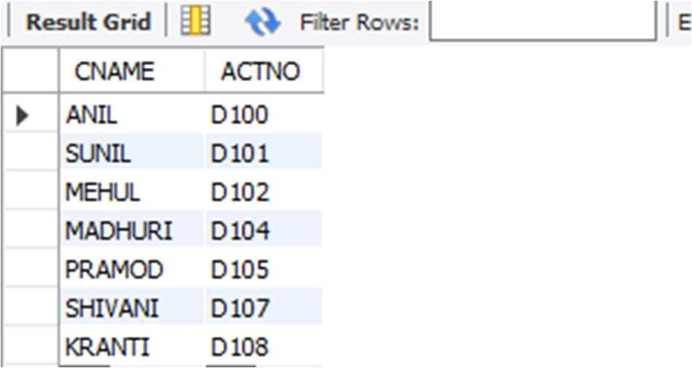

# SELECT CNAME FROM CUSTOMER;

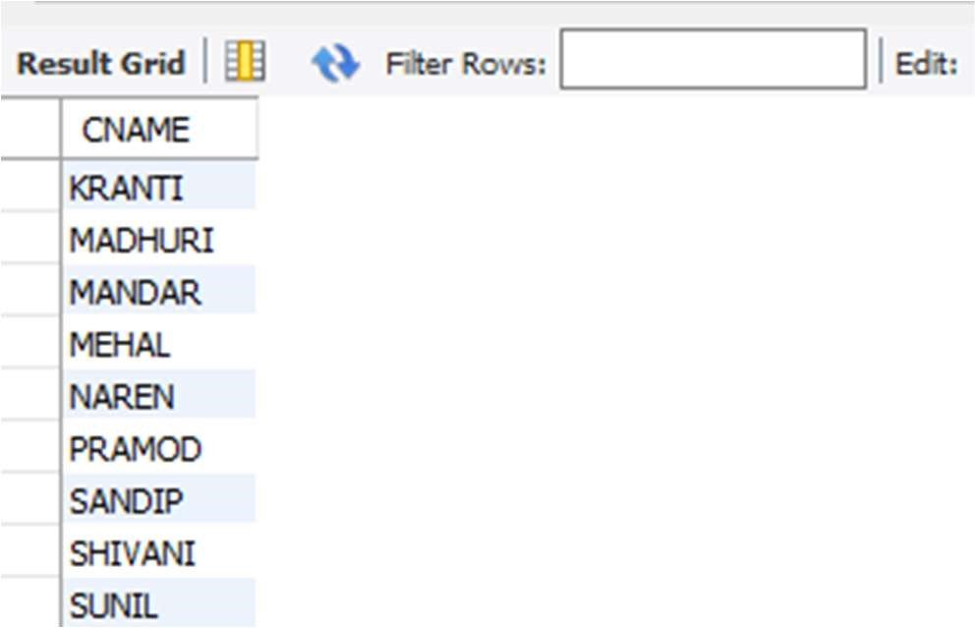

# SELECT BNAME FROM BRANCH;

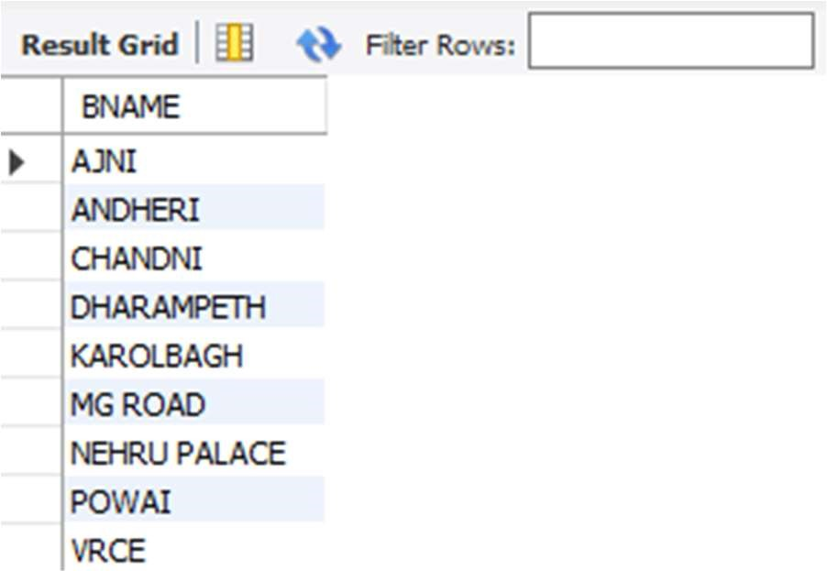

# SELECT CNAME FROM BORROW;

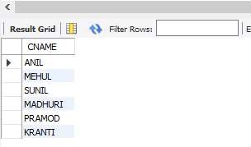

# SELECT CNAME FROM CUSTOMER WHERE CITY='NAGPUR';

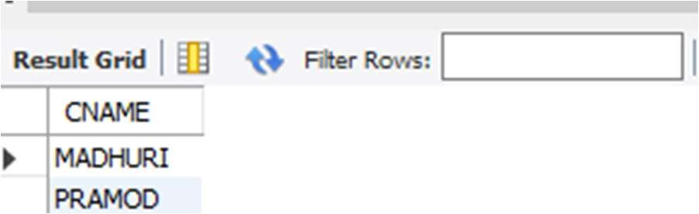

# SELECT CNAME from DEPOSIT where AMOUNT>4000;

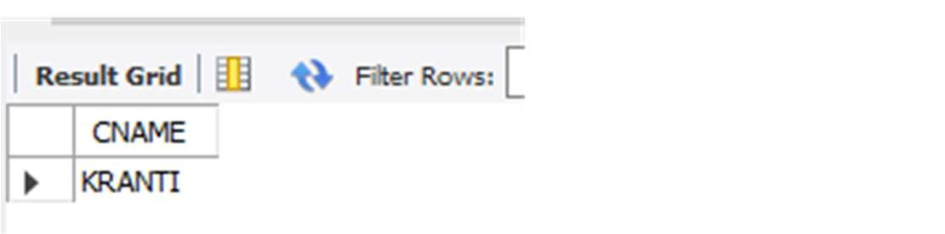

# SELECT ADATE FROM DEPOSIT where CNAME='ANIL';

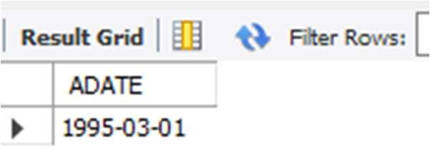

# SELECT BNAME from BRANCH where CITY='Bombay';

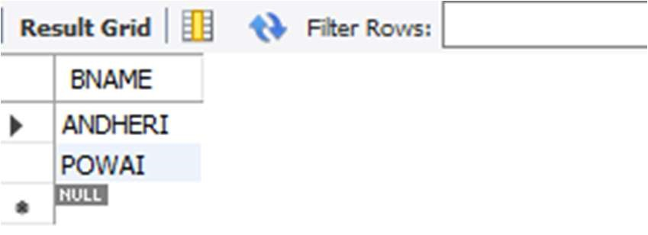

# SELECT CNAME from BORROW where LOANNO='L205';

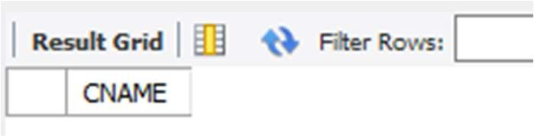

# SELECT CNAME from DEPOSIT WHERE BNAME='VRCE';

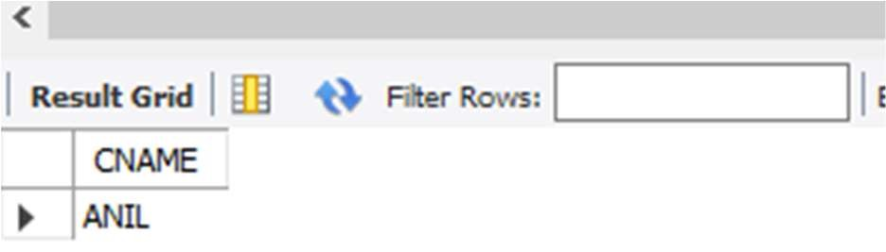

# SELECT BNAME from BRANCH WHERE CITY='Delhi';

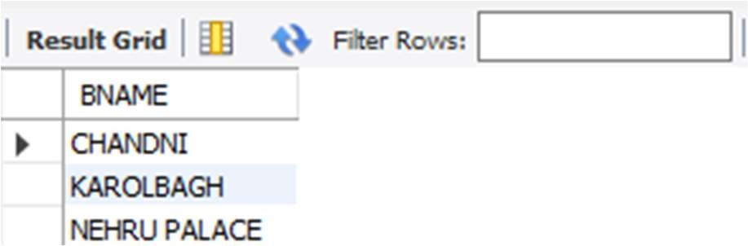

# SELECT CNAME from DEPOSIT WHERE ADATE='1996-12-1';

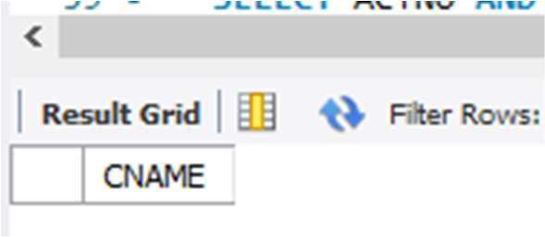

# SELECT ACTNO,AMOUNT from DEPOSIT WHERE ADATE BETWEEN '1996-12-1' AND '1996-05-1';

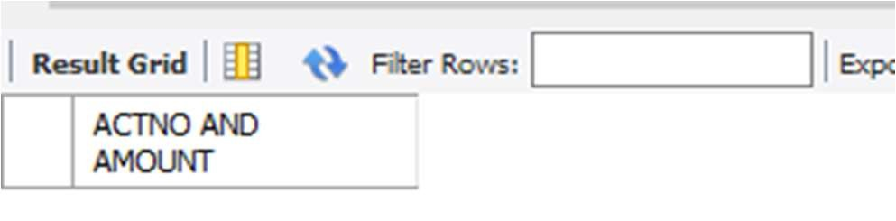

# SELECT CITY from BRANCH WHERE BNAME='KAROLBAGH';

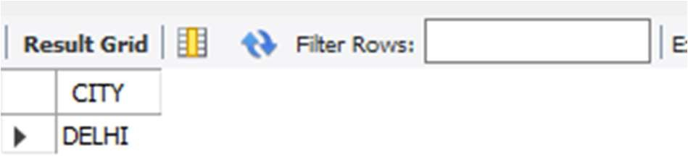

20. SELECT * from customer join borrow on customer.cname=borrow.cname join deposit on deposit.cname=borrow.cname WHERE customer.cname='ANIL';

