|  |
| --- |
| **Name:** **VYSHNAV** **SURESH**  **Roll** **No:** **56**  **Batch:** **B**  **Date: 08/04/2022** |

**ADVANCED DATABASE MANAGEMENT STYSTEM LAB**

**Experiment No.: 3**

# Aim

To Familiarize DDL Commands- ALTER, DROP, TRUNCATE, RENAME.

1.Create a table emp with attributes empno number(4)as primary key, ename char(10),hiredate, salary, commission insert 5 rows of data

|  |  |  |  |  |
| --- | --- | --- | --- | --- |
| 101 | Ramesh | 17-Jan  1980 | 5000 |  |
| 102 | Ajay | 05-Jul 1985 | 5000 | 500 |
| 103 | Ravi | 12-Aug  1981 | 1500 |  |
| 104 | Nikesh | 03-Mar 1983 | 3000 | 700 |
| 105 | Ravi | 05-jul 1985 | 3000 |  |

2.Modifying the structure of tables

1. Add new columns: sal number (7,2)
2. Dropping a column from a table: sal
3. Modifying existing column:ename varchar2(15)
4. Renaming the tables: emp to emp1
5. Truncating the tables: emp1
6. Destroying tables:emp

3.Create a table stud with sname varchar2(20) primary key, rollno number (10) not null,dob date not null

4.Create a table student as regno number (6), mark number (3) check constraint (mark >=0 and mark

<=100));

5.Create a table cust with (custid number (6) constraint unique, name char(10))

# Procedure

SQL Commands

CREATE DATABASE EMPLOYEE;

USE EMPLOYEE;

CREATE TABLE EMP (EMPNO int(4) PRIMARY KEY,ENAME char(10), HIREDATE date, SALARY int(5),COMMISSION int(5));

INSERT INTO emp(EMPNO, ENAME,HIREDATE,SALARY,COMMISSION) VALUES (101,'RAMESH','1980-0117',5000,0),(102,'AJAY','1985-07-05',5000,500), (103,'RAVI','1981-08-12',1500,0),(104,'Nikesh','1983-0303',3000,700), (105,'Ravi','1985-07-05',3000,0);

# Output Screenshot

1.

SELECT *FROM EMP;

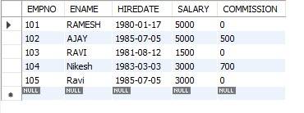

2.

a.

ALTER TABLE emp ADD sal int;

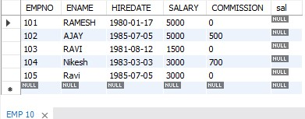

b.

ALTER TABLE emp DROP COLUMN sal;

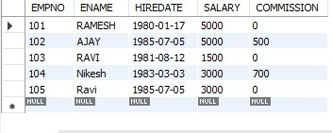 c.

ALTER TABLE emp MODIFY ename VARCHAR (15);

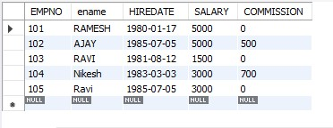 d.

RENAME table emp to emp1;

SELECT *FROM emp1;

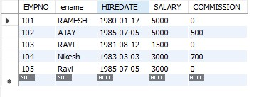 e.

TRUNCATE TABLE emp1;

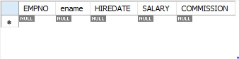

f.

DROP TABLE emp1;

SELECT *FROM emp1;



3.

CREATE TABLE stud (sname varchar (20) PRIMARY KEY, rollno int NOT NULL, dob date NOT NULL);



4.

Create table student (regno int, mark int(3) constraint b check (mark >=0 and mark <=100)); SELECT * from

STUDENT;



5.

CREATE TABLE cust(custid int(6) UNIQUE, name char(10)); select *from cust;

