**Name: VYSHNAV SURESH**

**Roll No: 56**

**Batch: B**

**Date: 03-06-2022**

**ADVANCED DBMS LAB**

**Experiment No.: 8**

**AIM**

Build sample collections/documents to perform query operations in MongoDB.

**COMMANDS AND OUTPUT**

1. **Create a database.**

* use <database_name>



1. **Check the database list.**

* show dbs

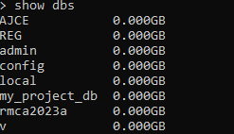

1. **Create a collection.**

* db.createCollection(name)



1. **Insert a value into a collection.**

* db.collection_name.insert({document})



1. **Insert many values into a collection.**

* db.collection_name.insertMany({documents})

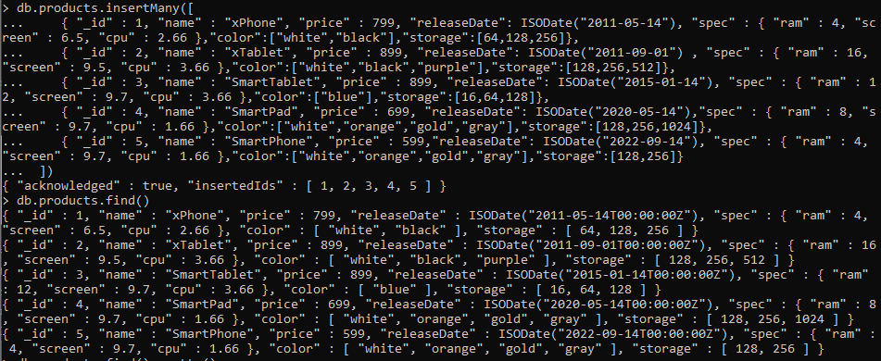

1. **Display the contents in a collection.**

* db.collection_name.find()



1. **Display the contents in a collection in a formatted way.**

* db.collection_name.find().pretty()

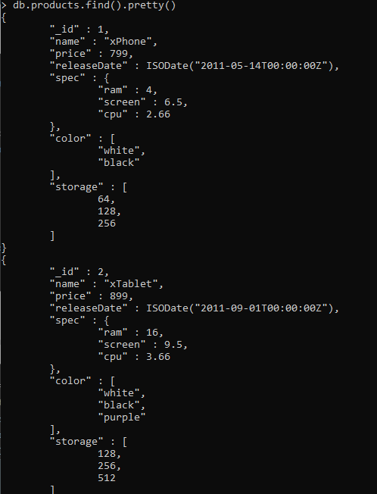

1. **Update a collection.**

* Db.collection_name.update(Selection_criteria, Updated_data)

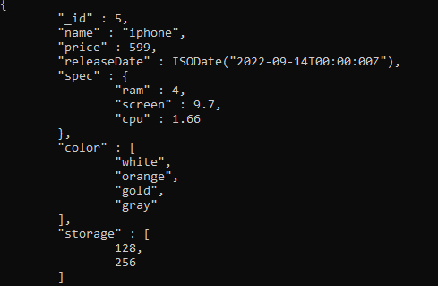

1. **Delete from a collection.**

* Db.collection_name.remove(Deletion_criteria)



