**Name: vyshnav suresh**

**Roll No:56**

**Batch:b**

**Date:**

**NETWORKING & SYSTEM ADMINISTRATION LAB**

**Experiment No.: 1**

**Aim**

Install the latest version of Ubuntu on an Oracle VM VirtualBox.

**Procedure**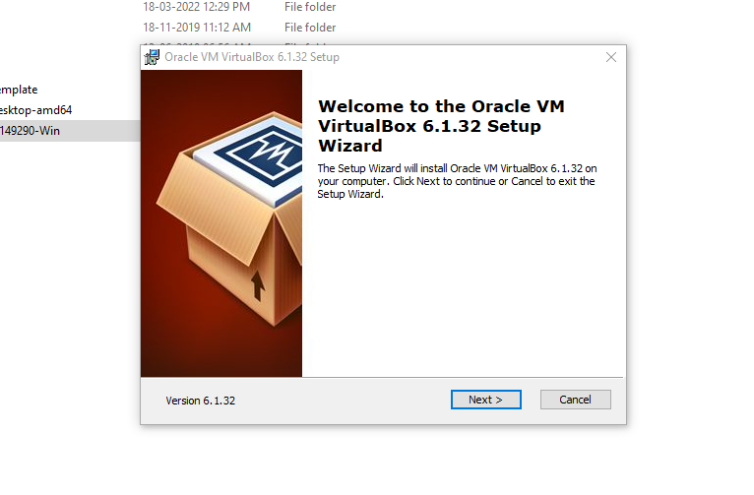

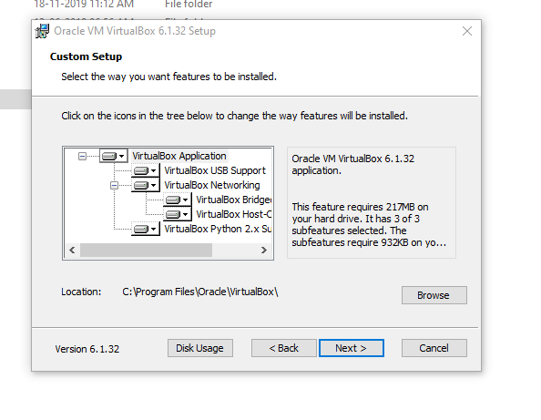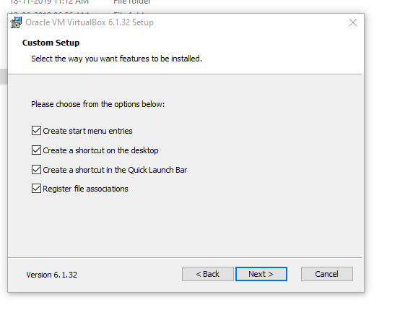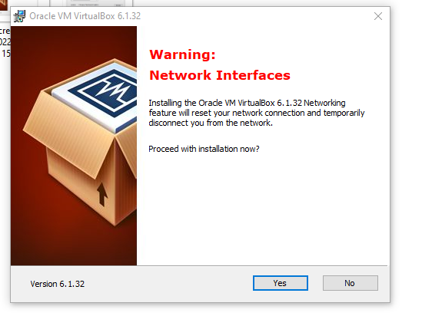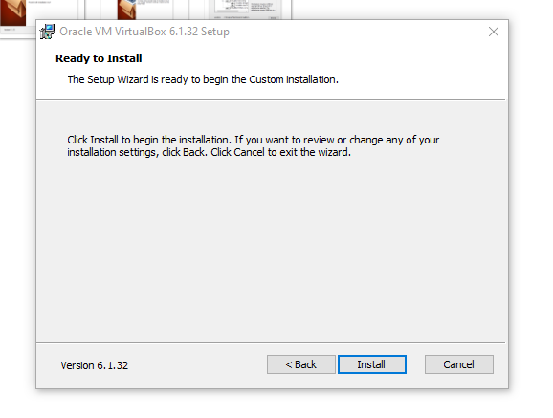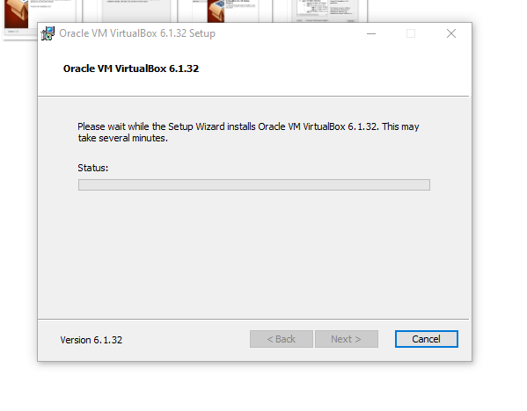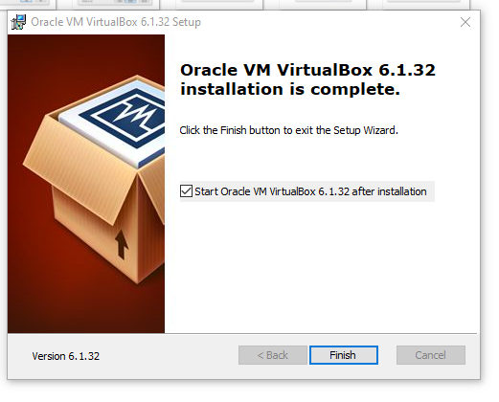

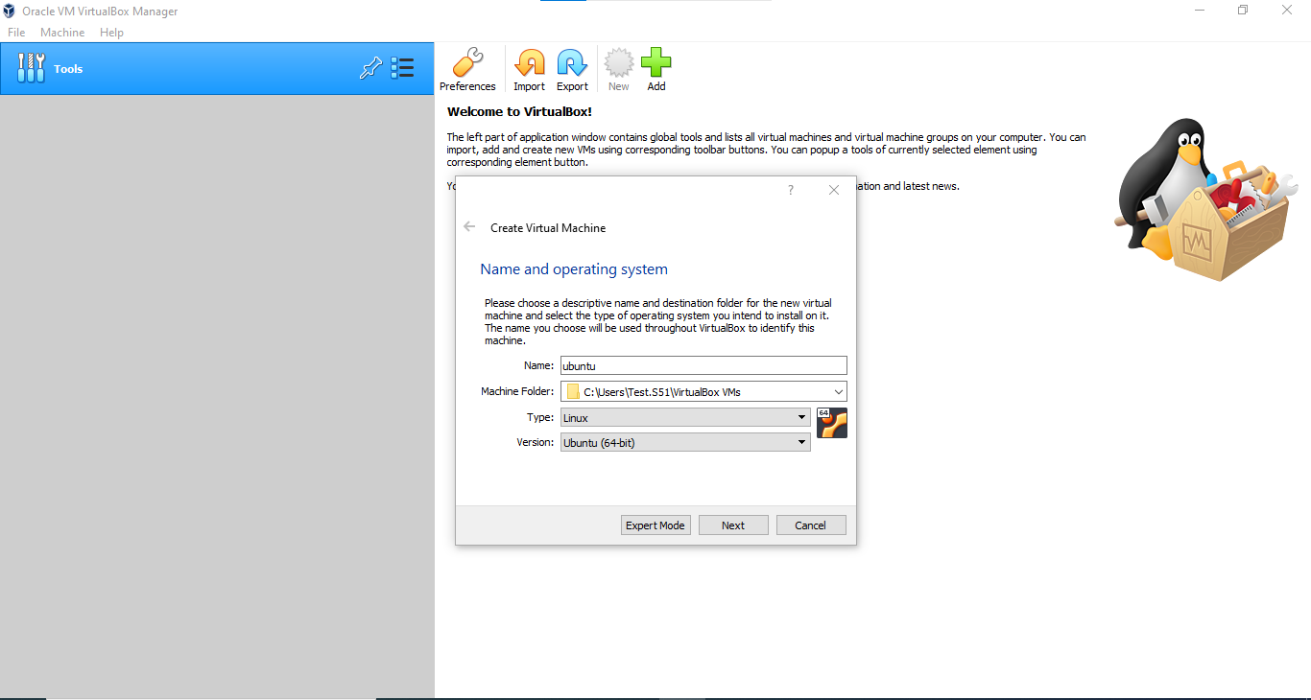

### Create Virtual Machine

Click 'New' button to open a dialog. 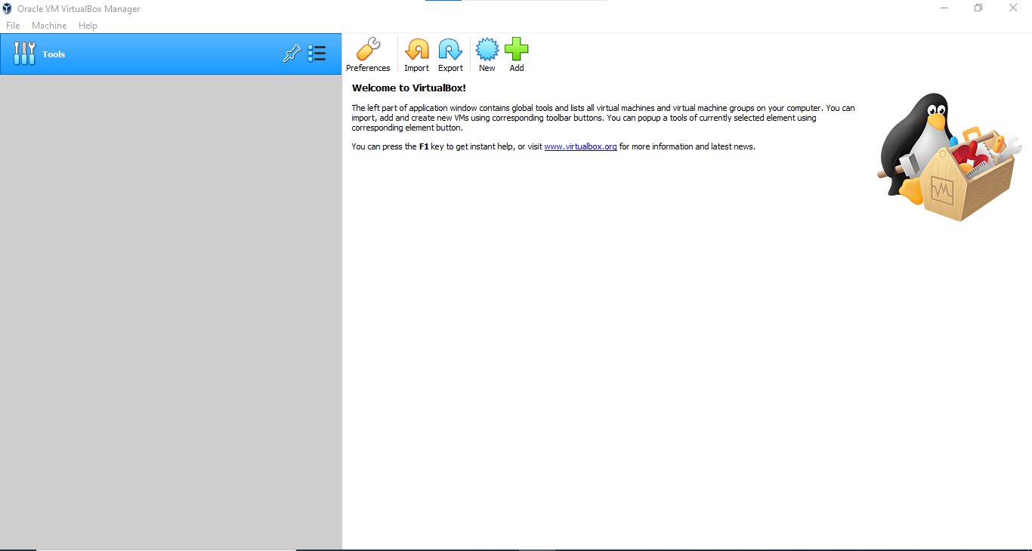



Type a name for the new virtual machine. Since I am planning to install Ubuntu 14.04, I'll enter 'ubuntu1404'. Note that VirtualBox automatically changes 'Type' to Linux and 'Version' to 'Ubuntu (64 bit)'. These two options are exactly what we need.

The memory size depends on your host machine memory size. In my case, I have 12GB physical RAM. I like to allocate as much as possible for Ubuntu but leave some for my Windows host machine. I pick 8192 MB for my Ubuntu. Note that VirtualBox will create a [swap](https://help.ubuntu.com/community/SwapFaq) partition with the same amount space as base memeory you have entered here. So later when you are selecting the size of the virtual hard drive, make sure it is large enough since the [hard drive](https://help.ubuntu.com/community/DiskSpace) will be splitted into root (/)and swap partitions. The root partition contains by default all your system files, program settings and documents.

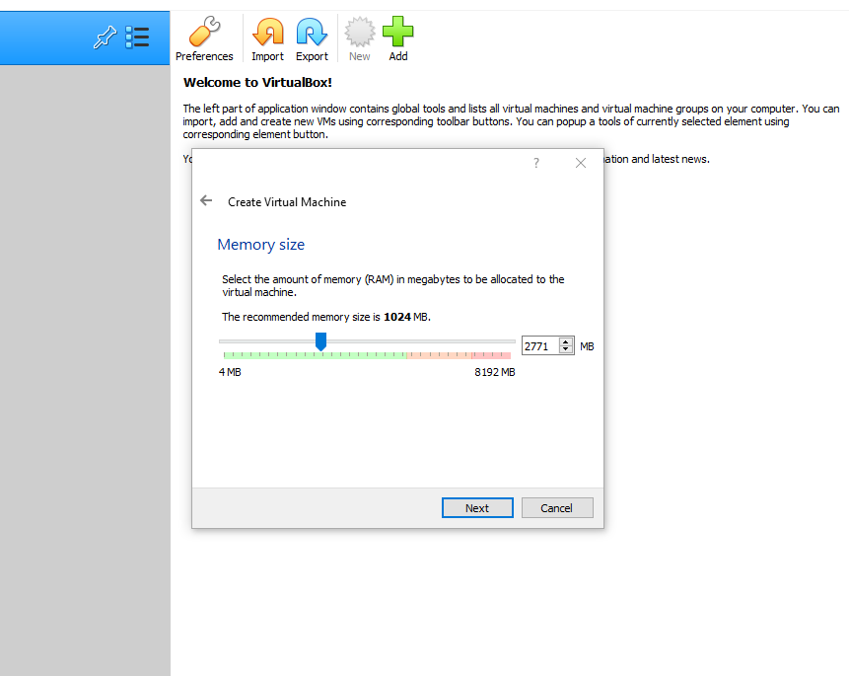

Accept the default 'Create a virtual hard drive now' and click 'Create' button.

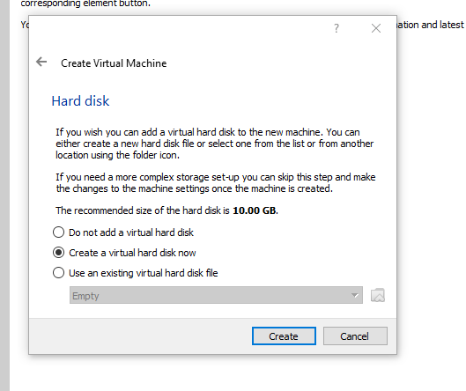

Continue to accept the default 'VDI' drive file type and click 'Next' button.

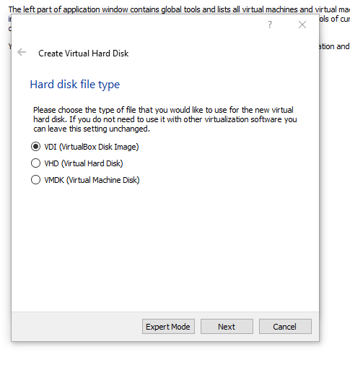

Change the storage type from the default 'Dynamically allocated' to 'Fixed size' to increase performance.

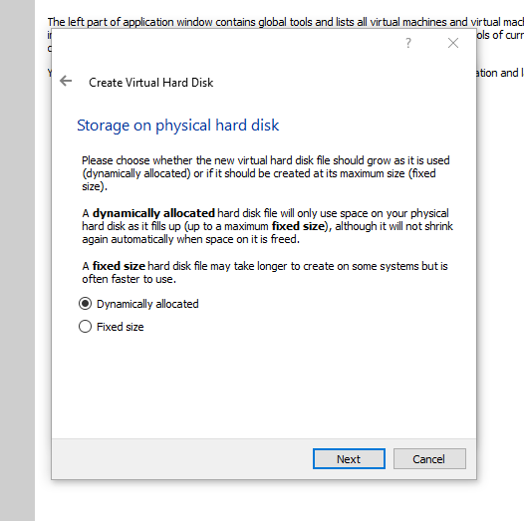

For the virtual hard drive space, the default value is 8GB which is too little for RNA-Seq analysis. I'll pick 100GB since I have plenty of space in my hard disk. You want to choose a good size for your RNA-Seq analysis. If you realize the drive space is not large enough, you'll need to go over these steps again to create another virtual machine.

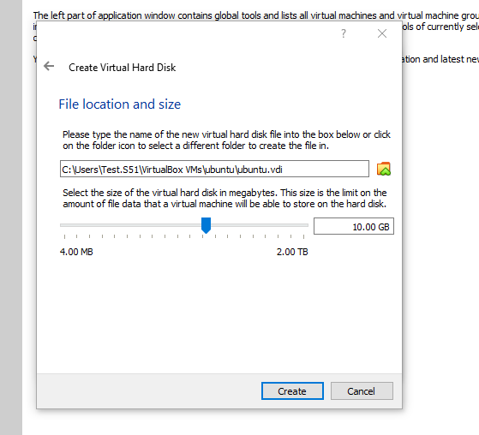

Click 'Create' button and VirtualBox will generate Ubuntu virtual machine. [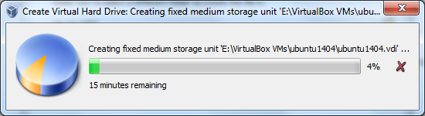](https://brb.nci.nih.gov/seqtools/images/ubuntu/image012.png)

Now the virtual machine is created. We are ready to install Ubuntu in this virtual machine. Select your new virtual machine and click 'Settings' button. Click on 'Storage' category and then 'Empty' under Controller:IDE. Click "CD/DVD" icon on right hand side and select the ubuntu ISO file to mount.

Note that if you have not downloaded 64-bit Ubuntu ISO file, you can check out [this page](https://brb.nci.nih.gov/seqtools/index.html#requirement) for more information. When downloading Ubuntu ISO file, make sure to selecte 64-bit version. Also make sure the **VT-x/Virtualization Technology** has been enabled in your computer's [BIOS/Basic Input Output System](http://en.wikipedia.org/wiki/BIOS).

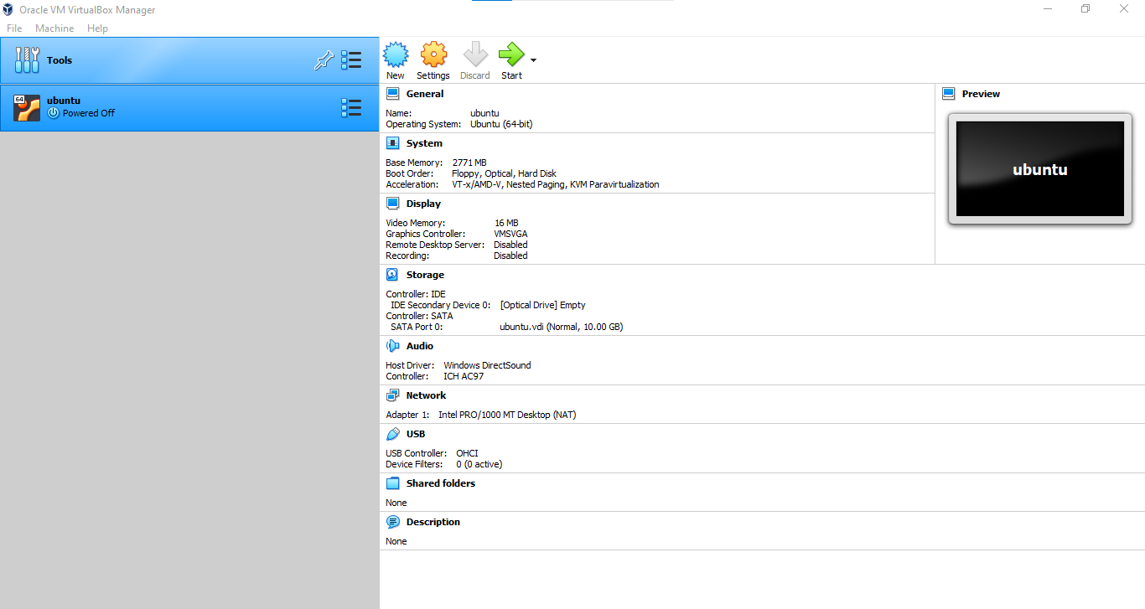

[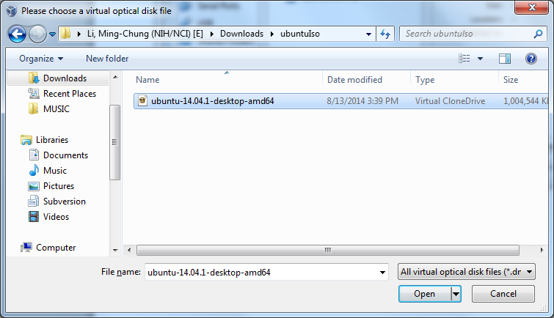](https://brb.nci.nih.gov/seqtools/images/ubuntu/image015.png)

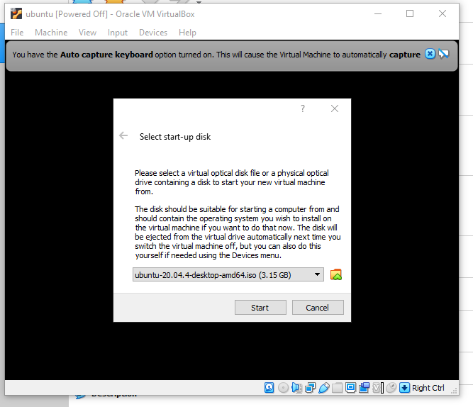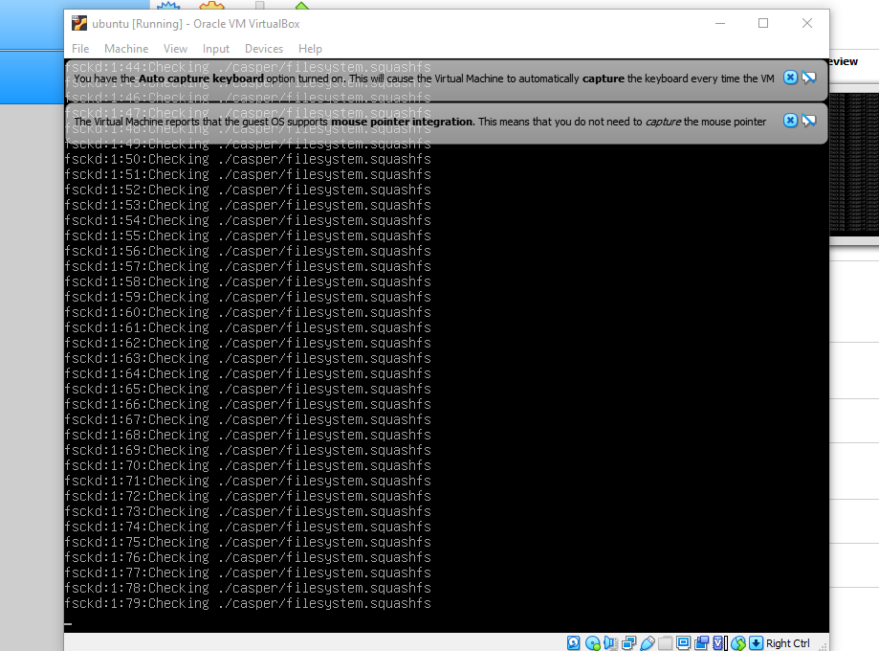

Since Tophat program can take an advantage of multiple processors/threads, it is a good idea to specify a large number of processors in virtual machine (default value is 1). You can change this number by clicking on 'System' category. In this case, I change the number of CPUs to 4 since 4 is the largest value shown on the green bar in my case. Now you can click 'OK' button to continue.

VirtualBox may pop up a message about 'Auto capture keyboard' option. Read the message there and check 'Do not show this message again' option before clicking OK.

### Install Ubuntu

Back to Oracle VM VirtualBox Manager, click on the new Ubuntu virtual machine and hit 'Start' button. Now you shall see a 'Welcome' screen. Click 'Install Ubuntu' button. Note that the installation process may differ a little bit from version to version. The screenshots here are based on Ubuntu

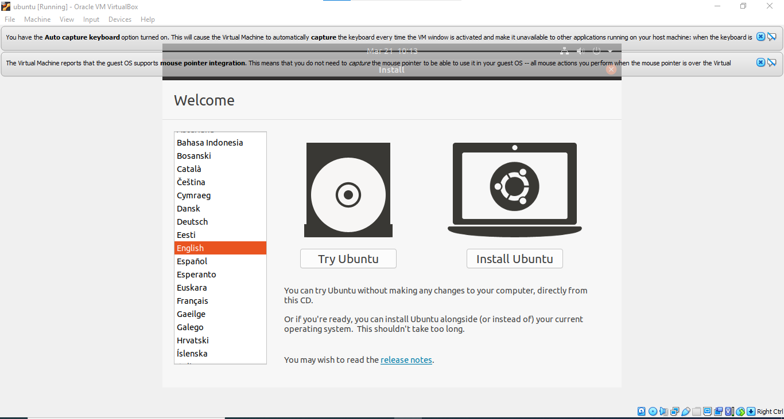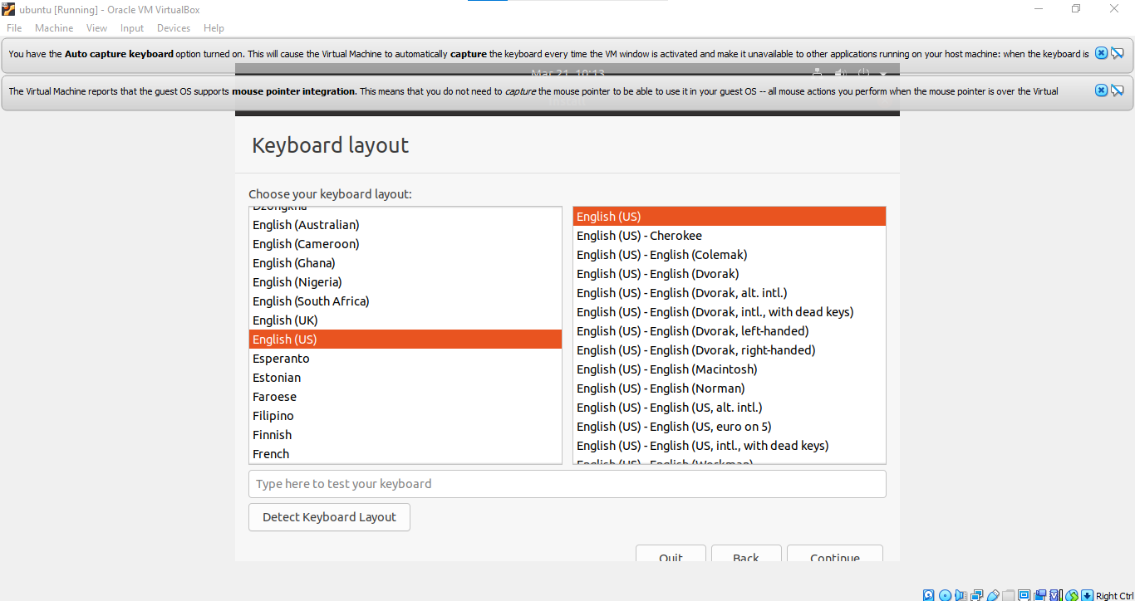

Select thekeyboard layout and language.

Click 'Continue' button.

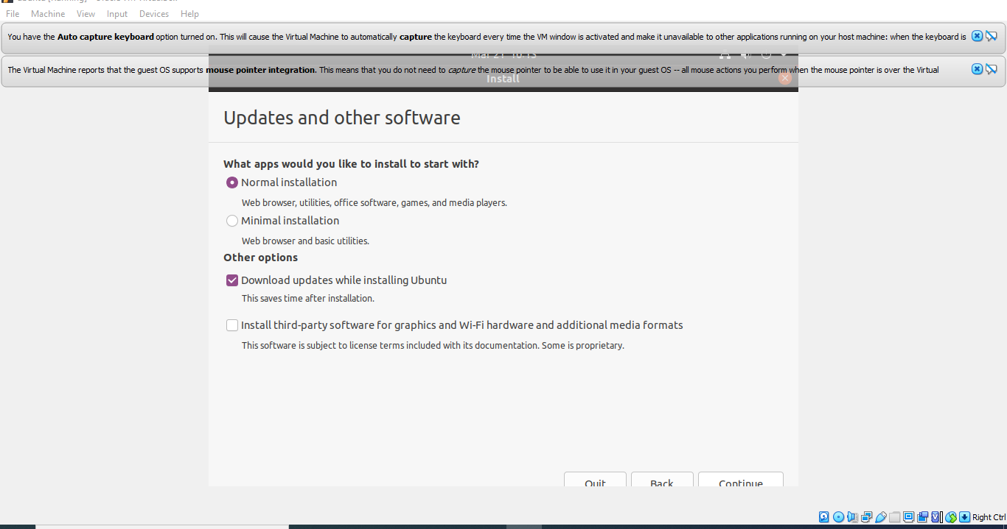

Click 'Continue' button.

Make sure 'Erase disk and install Ubuntu' option is selected and click 'Install Now' button.

Ubuntu will ask you a few questions. If the default is good, click 'Continue' button.

In 'Who are you?' dialog, enter your preferred name, username and password. **Note that this user will have root/sudo privilege**. Click 'Continue' button.

The installation will continue until it is finished.

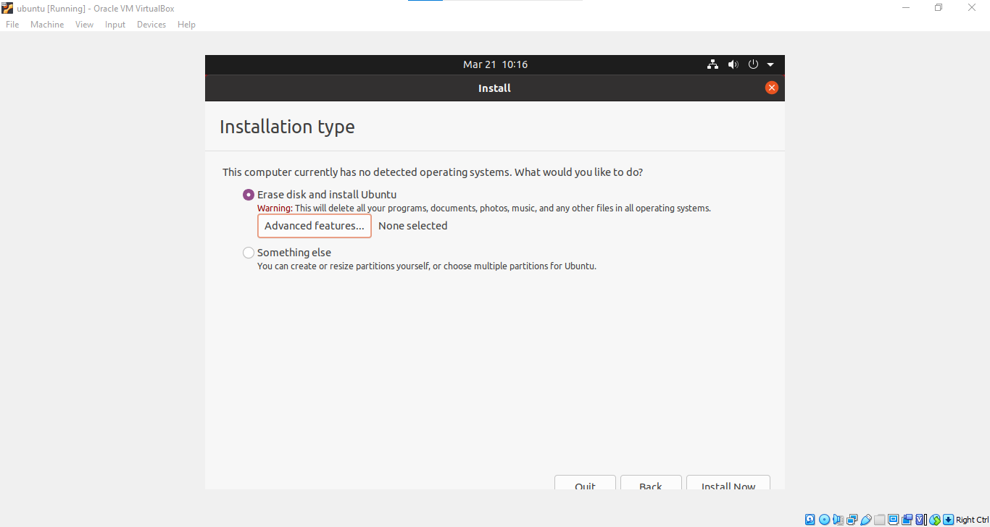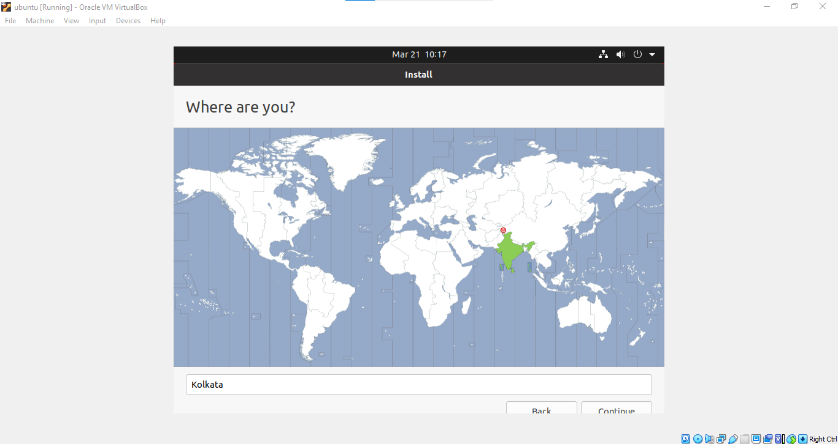

Click 'Continue' button.

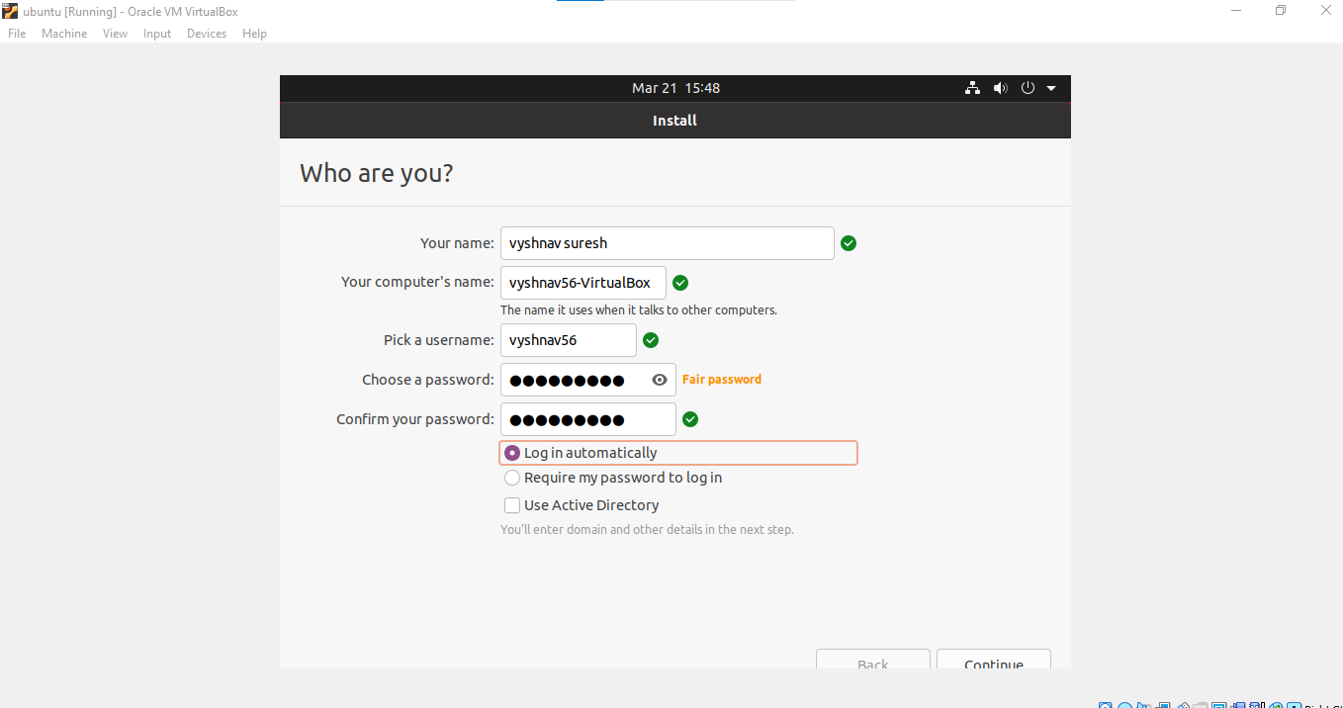

Fill the necessary fields.

Click 'Continue' button.

After installation is complete, click 'Restart Now' button. When you see a screen with a black background saying 'Please remove installation media and close the tray (if any) then press ENTER:', just follow it. 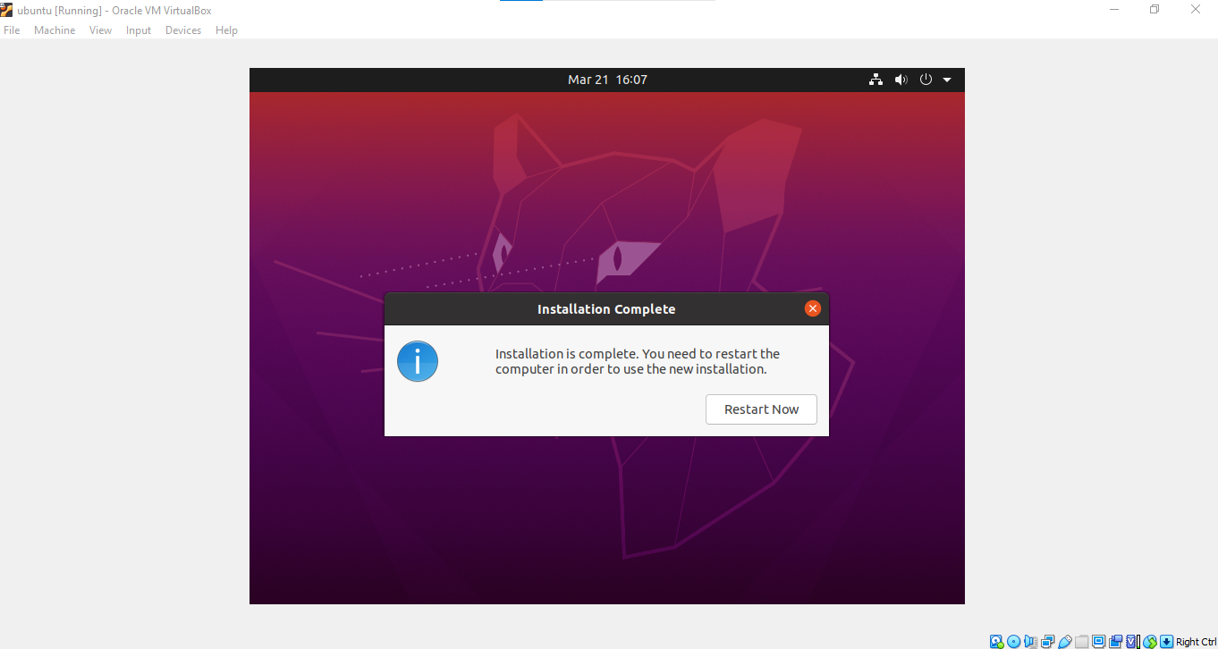

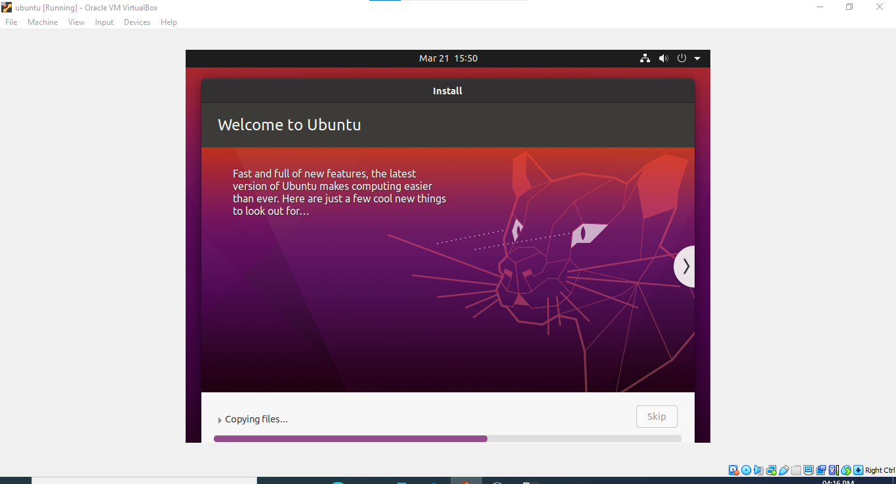

Enter the password you have chosen and press 'Enter'. 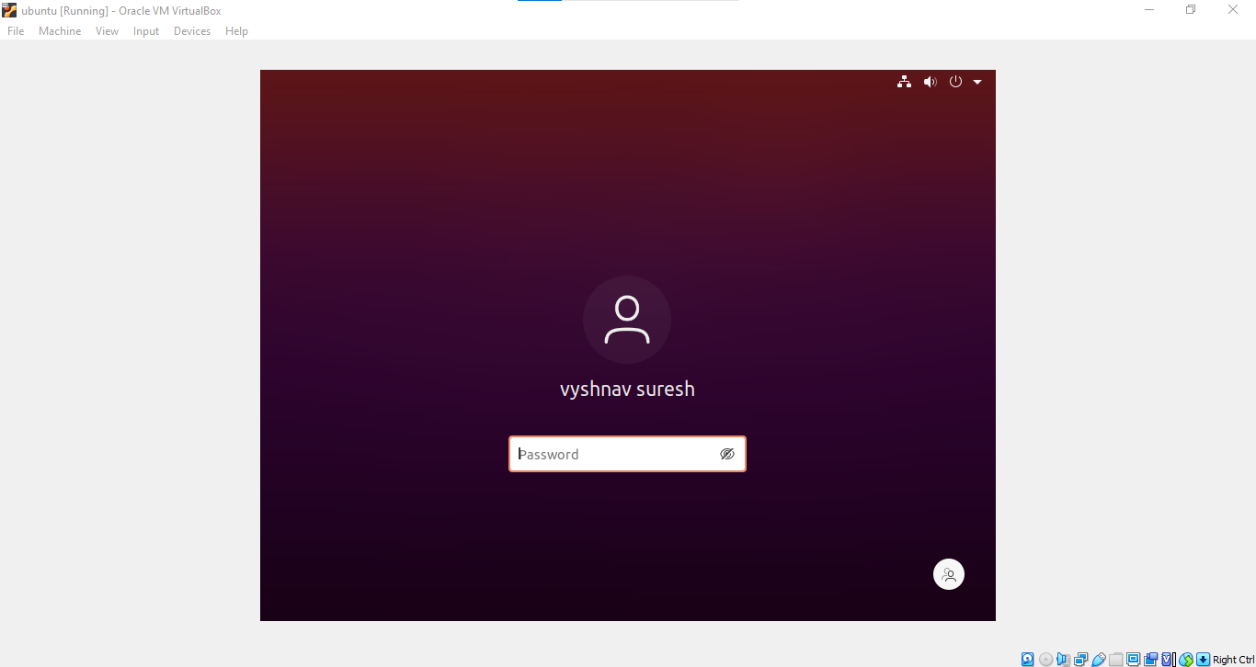

The Ubuntu Desktop OS is ready. You may find the desktop screen is too small. Don't worry. You can solve this easily with "VirtualBox Guest Additions".

