20MCA136 – NETWORKING & SYSTEM ADMINISTRATION LAB Dept. of Computer Applications

|  |
| --- |
| **Name: VYSHNAV SURESH**  **Roll No: 56**  **Batch: B**  **Date: 09-05-2022** |

**NETWORKING & SYSTEM ADMINISTRATION LAB**

**Experiment No.: 14**

**Aim**

Write a shell script to check whether a number is greater than, less than or equal to another number entered.

**Program**

echo "Enter a number to get checked" read a

echo "Enter the number be get checked with" read b if [ $a -gt $b ]

then

echo "The number isgreater" elif [ $a -lt $b ] then

echo "It is smaller"

else

echo "it is equal to the number" fi

**OUTPUT**

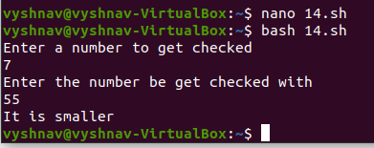

Amal Jyothi College of Engineering, Kanjirappally