20MCA136 – NETWORKING & SYSTEM ADMINISTRATION LAB Dept. of Computer Applications

|  |
| --- |
| **Name: VYSHNAV SURESH**  **Roll No: 56**  **Batch: B**  **Date: 09-05-2022** |

**NETWORKING & SYSTEM ADMINISTRATION LAB**

**Experiment No.: 16**

**Aim**

Write a shell script to find sum, average and product of 4 integers.

# Program

num=()

echo “Enter 4 integers” read num[0]

read num[1]

read num[2]

read num[3]

s=0

prod=1

avg=0 for((i=0;i<4;i++))

do

s=$(( s+num[i] ))

prod=$(( prod*num[i] ))

done avg=$(( s/4 ))

echo "sum of 4 numbers is: $s"

echo "average of 4 numbers is: $avg"

echo "product of 4 numbers is : $prod"

Amal Jyothi College of Engineering, Kanjirappally

20MCA136 – NETWORKING & SYSTEM ADMINISTRATION LAB Dept. of Computer Applications

**Output screenshot**



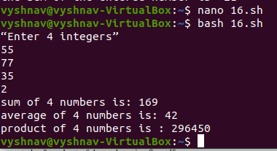

Amal Jyothi College of Engineering, Kanjirappally