20MCA136 – NETWORKING & SYSTEM ADMINISTRATION LAB Dept. of Computer Applications

|  |
| --- |
| **Name: VYSHNAV SURESH**  **Roll No: 56**  **Batch: B**  **Date: 12-05-2022** |

**NETWORKING & SYSTEM ADMINISTRATION LAB**

**Experiment No.: 19**

**Aim**

Write a shell script to find the sum of digits of a number entered.

# Program

echo -e "enter the number" read n

sum=0 a=$n while(($n>0)) do

x=`expr $n % 10` sum=`expr $sum + $x`

n=`expr $n / 10`

done

echo "the sum of $a is $sum"

# Output screenshot

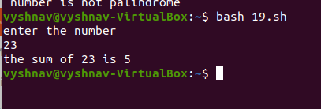

Amal Jyothi College of Engineering, Kanjirappally