20MCA136 – NETWORKING & SYSTEM ADMINISTRATION LAB Dept. of Computer Applications

|  |
| --- |
| **Name: VYSHNAV SURESH**  **Roll No: 56**  **Batch: B**  **Date: 12-05-2022** |

**NETWORKING & SYSTEM ADMINISTRATION LAB**

**Experiment No.: 20**

**Aim**

Write a shell script to find the average of the numbers entered in a command line.

# Program

echo "Enter size" read N i=1 sum=0

echo "Enter Numbers" while [ $i -le $N ] do

read num

sum=$((sum + num))

i=$((i + 1))

done

avg=$(echo "scale=3; $sum / $N "| bc -l)

echo "the average is"$avg

# Output screenshot

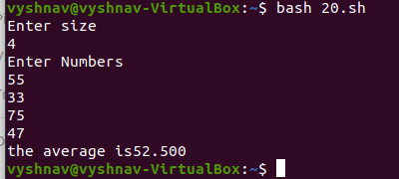

Amal Jyothi College of Engineering, Kanjirappally