20MCA136 – NETWORKING & SYSTEM ADMINISTRATION LAB Dept. of Computer Applications

|  |
| --- |
| **Name: VYSHNAV SURESH**  **Roll No: 56**  **Batch: B**  **Date: 05-05-2022** |

**NETWORKING & SYSTEM ADMINISTRATION LAB**

**Experiment No.: 8**

**Aim**

Write a shell script to enter basic details.

# Program

echo " hello world this is my new program"

# Output Screenshot

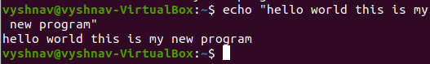

Amal Jyothi College of Engineering, Kanjirappally