**Name: Vyshnav suresh**

**Roll No:56**

**Batch:RMCA(B)**

**Date:26/03/2021**

**NETWORKING & SYSTEM ADMINISTRATION LAB**

**Experiment No.: 3**

**Aim**

Familiarization of Linux commands.

**Procedure**

1. **$cut -d ‘ ‘ –(f1/f2) filename.txt :** This command is used to display a particular column on behalf of space delimiter.

**Output:**

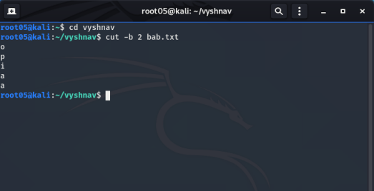

1. **$cut -b (number) filename.txt :** This command is used to display the particular column

**Output:**

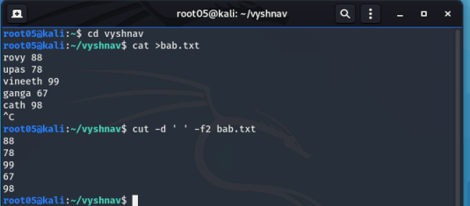

1. **10 $cut –complement -c (number) filename.txt:** This command is used to display all columns except the column specified in the column.

**Output:**

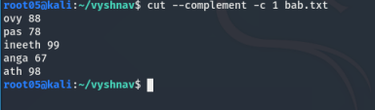

1. **$paste filename1.txt filename2.txt:** it is used to append contents of two files in column order.

**Output:**

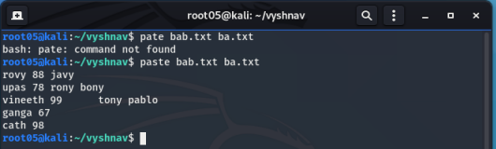

1. **$paste filename1.txt filename2.txt > filename3.txt:** It is used to append content of two files in column order and paste into another file

**Output:**

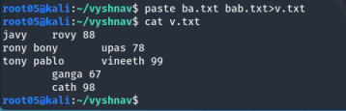

1. **$paste -d ‘-’ filename1.txt filename2.txt:** It is used to append contents of two files in column order seperated by hyphen delimiter

**Output:**

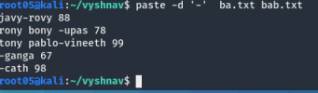

1. **$paste -d ‘--’ filename1.txt filename2.txt fielname3.txt:** This command is used to display 10 lines from bottom

**Output:**



1. **$paste -s ba.txt bab.txt** This command is used append contents in two files in row order

**Output:**

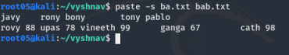

1. **$ more filename1.txt:** This command is used to view the text files in the command prompt, displaying one screen at a time in case the file is large.

**B KEY** -To move up.

**ENTER KEY -**Move down line by line.

**SPACEBAR KE –** Move page by page.

**Output:**

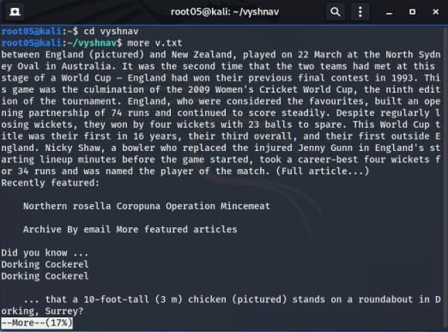

1. **$more -s filename.txt:** This command is used to squeeze multiple blank lines into one single blank line.

**Output:**

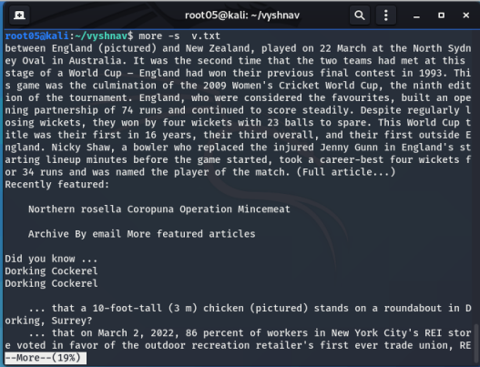

1. **$more -number filename.txt:**This command helps to specify number of lines to be displayed on screen.

**Output:**

