**Program no:1**

**Aim: Matrix operations**

**Source Code:**

**1.**

from random import seed

from random import randint

from matplotlib import pyplot

seed(1)

x = ['red', 'green', 'blue']

y = [randint(0, 100), randint(0, 100), randint(0, 100)]

pyplot.bar(x, y)

pyplot.show()

**Output:**

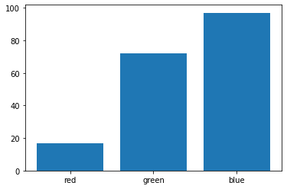

**2.**

from numpy import sin

from matplotlib import pyplot

x = [x*0.1 for x in range(100)]

y = sin(x)

pyplot.plot(x, y)

pyplot.show()

**Output:**

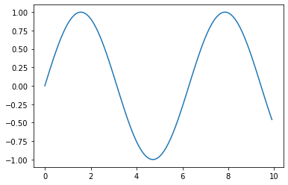

**3.**

from numpy.random import seed

from numpy.random import randn

from matplotlib import pyplot

seed(1)

x = randn(1000)

pyplot.hist(x)

pyplot.show()

**Output:**

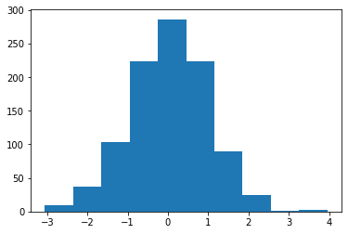

**4.**

from numpy.random import seed

from numpy.random import randn

from matplotlib import pyplot

seed(1)

x = 20 * randn(1000) + 100

y = x + (10 * randn(1000) + 50)

pyplot.scatter(x, y)

pyplot.show()

**Output:**

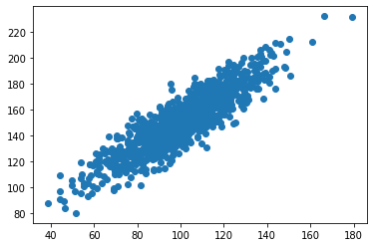

**5.**

import pandas as p

index = pd.RangeIndex(start=10, stop=30, step=2, name="data")

print("RangeIndex...\n",index)

print("\nRangeIndex start value...\n",index.start)

print("\nRangeIndex stop value...\n",index.stop)

print("\nRangeIndex step value...\n",index.step)

**Output:**

RangeIndex...

RangeIndex(start=10, stop=30, step=2, name='data')

RangeIndex start value...

10

RangeIndex stop value...

30

RangeIndex step value...

2

**6.**

import pandas as p

iris['Sepal_Length'].head()

iris[0:5]

| **Output:** | **Sepal_Length** | **Sepal_Width** | **Petal_Length** | **Petal_Width** | **Class** |
| --- | --- | --- | --- | --- | --- |
| **0** | 5.1 | 3.5 | 1.4 | 0.2 | Iris-setosa |
| **1** | 4.9 | 3.0 | 1.4 | 0.2 | Iris-setosa |
| **2** | 4.7 | 3.2 | 1.3 | 0.2 | Iris-setosa |
| **3** | 4.6 | 3.1 | 1.5 | 0.2 | Iris-setosa |
| **4** | 5.0 | 3.6 | 1.4 | 0.2 | Iris-setosa |

|  |  |  |  |  |  |
| --- | --- | --- | --- | --- | --- |
| **7.** |  |  |  |  |  |

import pandas as pd

iris.loc[0:10, ['Sepal_Length', 'Petal_Length']]

iris.loc[0, ['Sepal_Length', 'Petal_Length']]

iris.loc[0, 'Petal_Length']

iris['Petal_Length'].head()

iris.Sepal_Length.head()

iris.loc[0]

**Output:**

Sepal_Length 5.1 Sepal_Width 3.5 Petal_Length 1.4 Petal_Width 0.2 Class Iris-setosa Name: 0, dtype: object

**8.**

import pandas as p

iris.iloc[0:3, 0:4]

iris.iat[0,0]

**Output:**

5.1

**9.**

X = [[12,7,3],

    [4 ,5,6],

    [7 ,8,9]]

Y = [[5,8,1],

    [6,7,3],

    [4,5,9]]

result = [[0,0,0],

         [0,0,0],

         [0,0,0]]

for i in range(len(X)):

   for j in range(len(X[0])):

       result[i][j] = X[i][j] + Y[i][j]

for r in result:

   print(r)

**Output:**

[17, 15, 4]

[10, 12, 9]

[11, 13, 18]

**10.**

X = [[12,7,3],

    [4 ,5,6],

    [7 ,8,9]]

Y = [[5,8,1,2],

    [6,7,3,0],

    [4,5,9,1]]

result = [[0,0,0,0],

         [0,0,0,0],

         [0,0,0,0]]

for i in range(len(X)):

   for j in range(len(Y[0])):

       for k in range(len(Y)):

           result[i][j] += X[i][k] * Y[k][j]

for r in result:

   print(r)

**Output:**

[114, 160, 60, 27]

[74, 97, 73, 14]

[119, 157, 112, 23]

**11.**

import numpy as np

arr = np.array([[32, 22, 11],

                [12, 5, 2],

                [21, 32, 7]])

print("Numpy Matrix =")

print(arr)

determinant = np.linalg.det(arr)

print("\nThe Determinant of 3 * 3 Matrix =")

print(int(determinant))

**Output:**

Numpy Matrix =

[[32 22 11]

[12 5 2]

[21 32 7]]

The Determinant of 3 * 3 Matrix =

1216