Aim :familiarization of Linux commands

Procedure:

1. pwd Command
The pwd command is used to display the location of the current working directory.
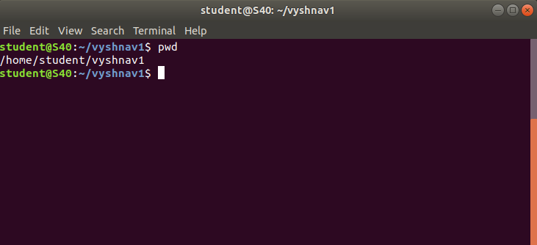

2. mkdir Command
The mkdir command is used to create a new directory under any directory.

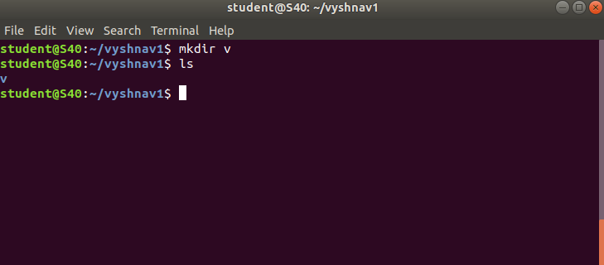

3. ls Command
The ls command is used to display a list of content of a directory.

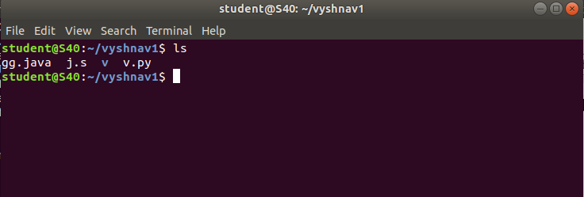

4. ls -a
The (ls -a) command will enlist the whole list of the current directory including the hidden files.

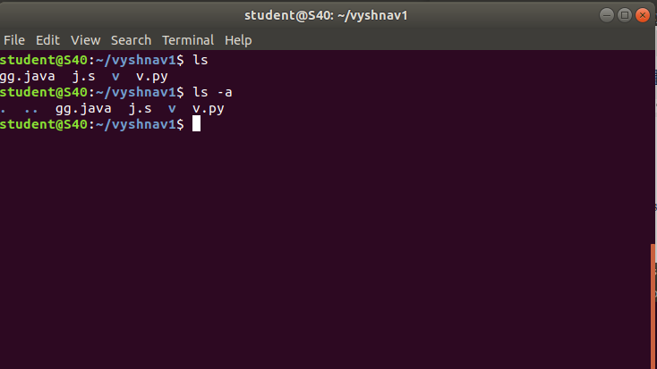
5.ls -t
display the directories in last modified order
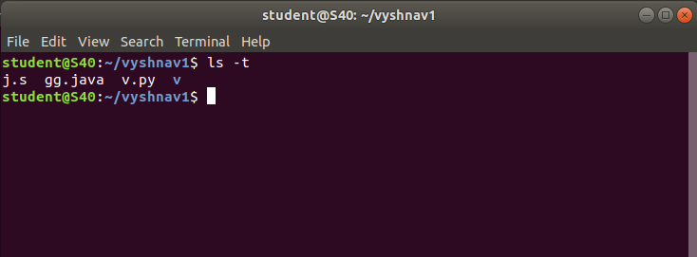

6.ls -r -R
option will list very long listing directory trees. See an example of the output of the command.
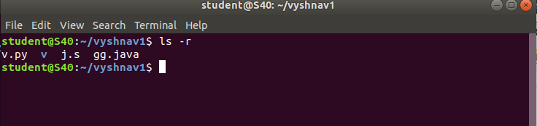
7. ls -al
this command display the files and directory with permissions
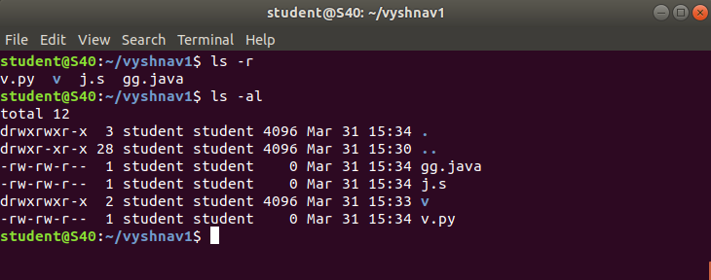

8. cd Command
The cd command is used to change the current directory.
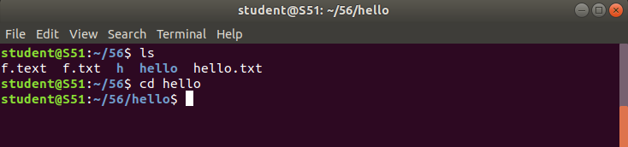

9.cd .. Command
represent the parent directory or the directory immediately above the
current one.
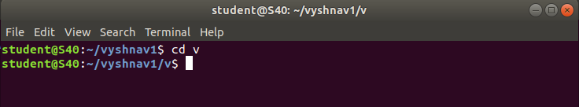

10. cd – Command
This command change our current working directory has been changed to its previous directory
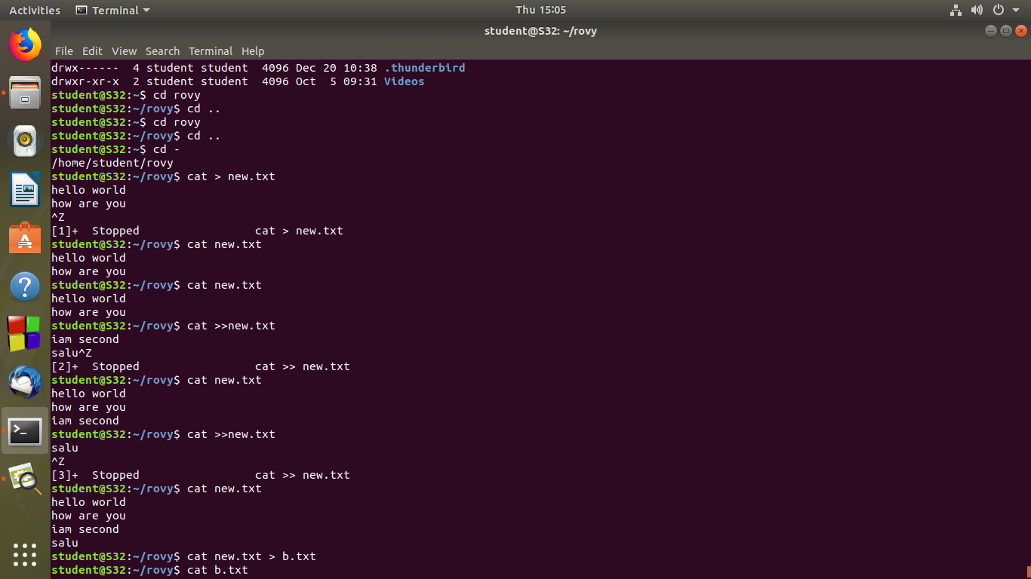
11. cat Command
The cat command is a multi-purpose utility in the Linux system. It can be used to create a file, display content of the file, copy the content of one file to another file, and more.
- $ cat file_name.txt
Which display the content in the file.
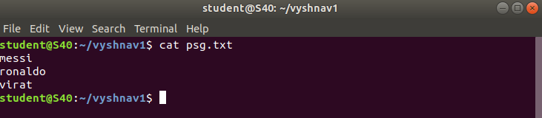

- $ cat > file_name.txt
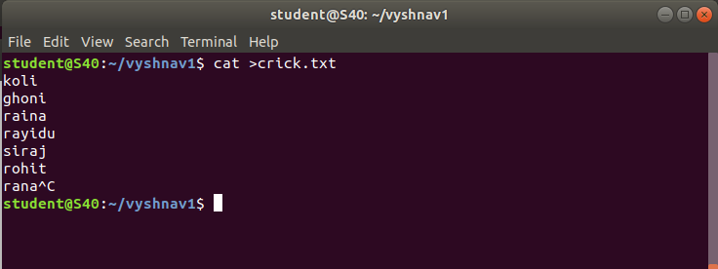
Allow to create a new file and add new elements

- $ cat >> file_name.txt
Allow to append new contents
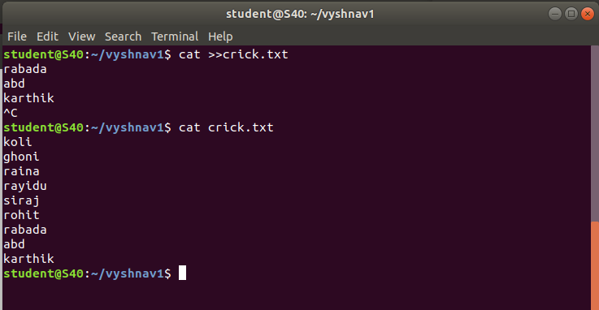
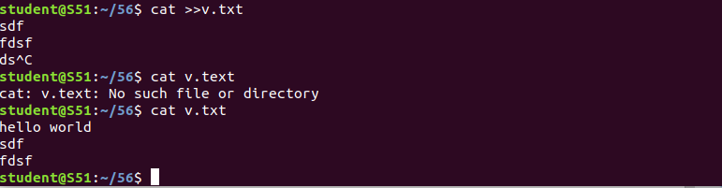

- $ cat file_name.txt > file2_name.txt
Which copy the contents of first file and paste on the second file
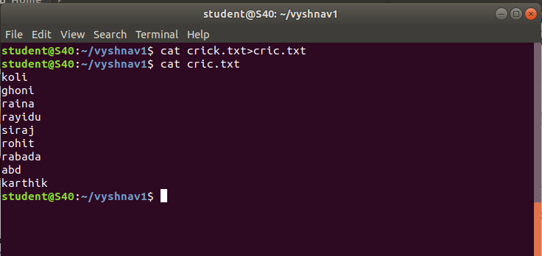
$ cat -n putiing

