Tables
FHIR Job run:
Having the task order of execution as below
Raw – Bronze – Silver -Silver-SCD2 -Gold

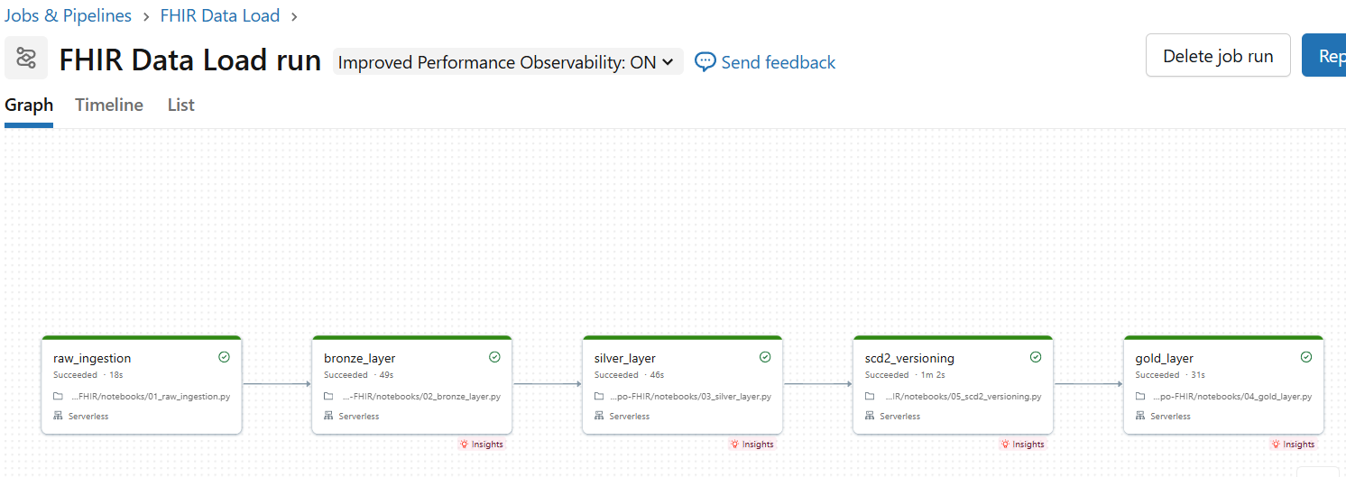

Audit Table -Pipeline.audit_log table load for all the stages

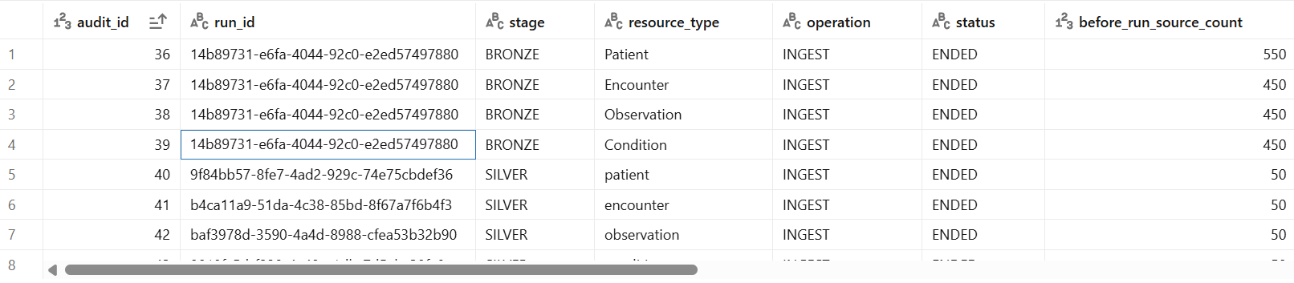
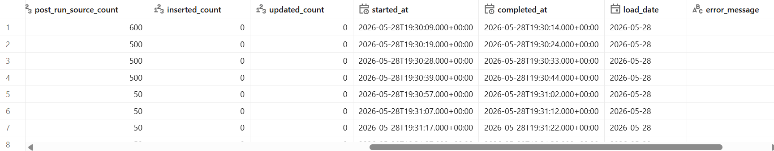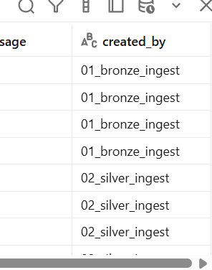

SCD 2 updates Sample:
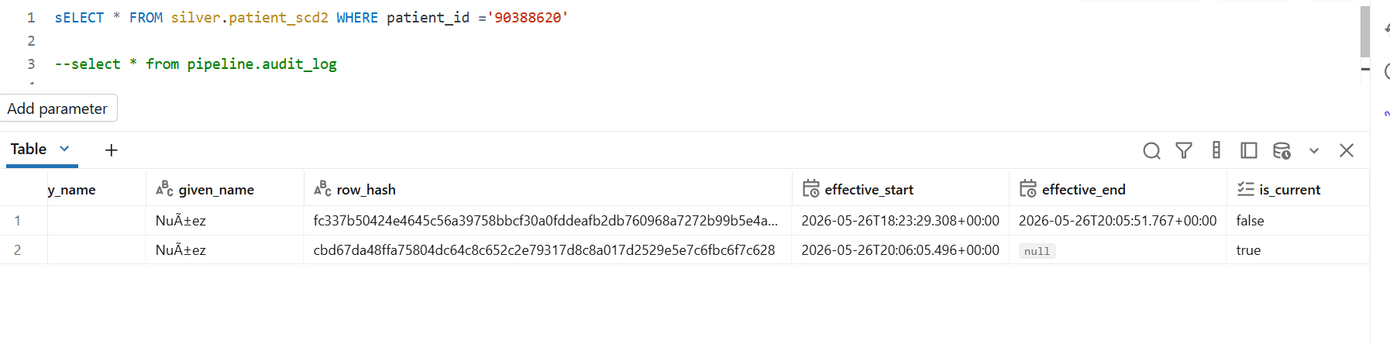

Table relationships

An observation is assosiated with Patient on patient_id, Encounter on encounter_id
An encounter is assosiated with Patient on patient_id
A condition table is assosiated with Patient on patient_id, Encounter on encounter_id

Sample Power BI report
