Assignment-11.2
Name : Vyshnavi Mashetti
Roll No: 2303A51205
Batch : 04

Task Description -1 – (Stack Using AI Guidance)
• Task: With the help of AI, design and implement a Stack data
structure supporting basic stack operations.
Expected Output:
• A Python Stack class supporting push, pop, peek, and empty-
check operations with proper documentation.

Prompt:
Generate a Python class to implement a Stack with push, pop, peek, and is_empty methods.Include proper comments and example usage.

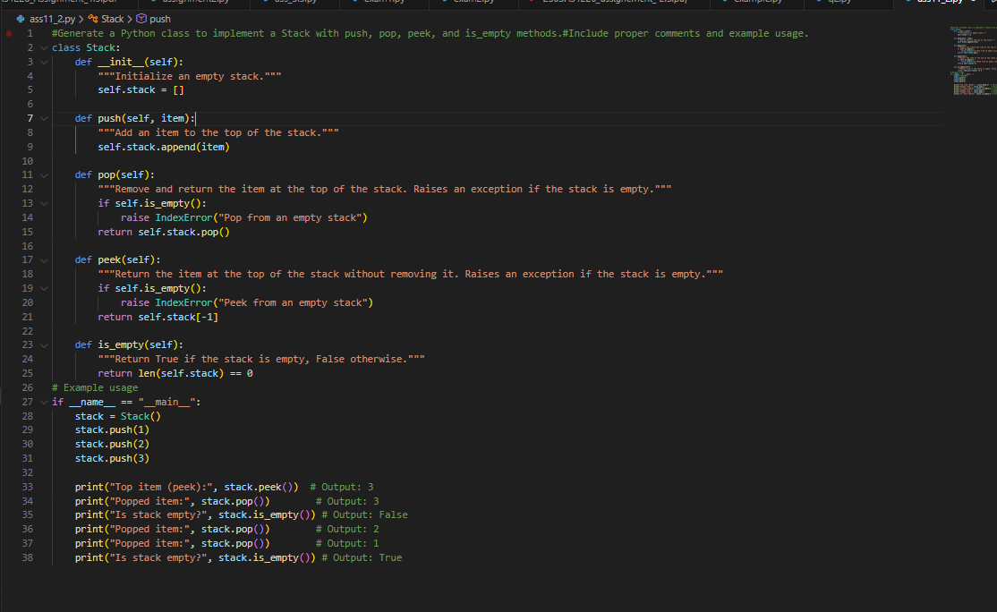

OUTPUT:

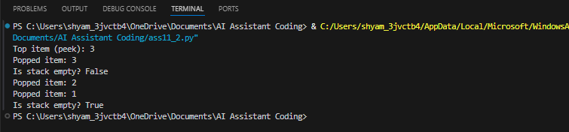

Code Explanation:

This program implements a Stack using a Python list. The push() method adds elements to the top, pop() removes the top element, peek() shows the top element without removing it, and is_empty() checks if the stack is empty. The example demonstrates that the stack follows the LIFO (Last In First Out) principle.

Task Description -2 – (Queue Design)
• Task:Use AI assistance to create a Queue data structure
following FIFO principles
Expected Output:
• A complete Queue implementation including enqueue, dequeue,
front element access, and size calculation

Prompt:

Create a Python Queue class following FIFO with enqueue, dequeue, front, size, and is_empty methods including comments, example usage, and time complexity.

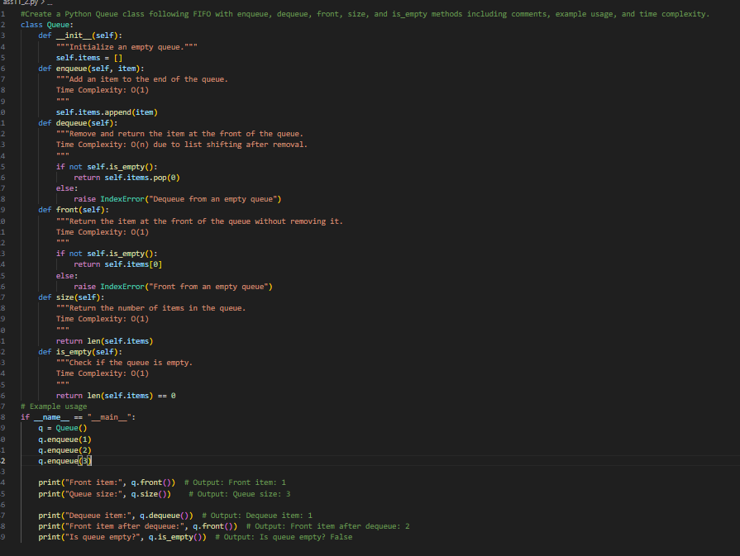

OUTPUT:

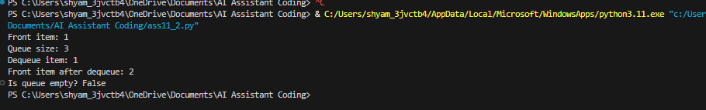

Code Explanation:

This program implements a Queue using a Python list following the FIFO (First In First Out) principle. The enqueue() method adds elements to the end of the queue, while dequeue() removes elements from the front. The front() method returns the first element without removing it, size() returns the total number of elements, and is_empty() checks whether the queue is empty. The example shows that the first inserted element is removed first, confirming FIFO behavior.

Task Description -3 –(Singly Linked List Construction)
• Task: Utilize AI to build a singly linked list supporting insertion
and traversal.
Expected Output:
• Correctly functioning linked list with node creation, insertion
logic, and display functionality.

Prompt:
Implement a Singly Linked List in Python with Node class, insert_at_end, and display methods including comments and example usage.

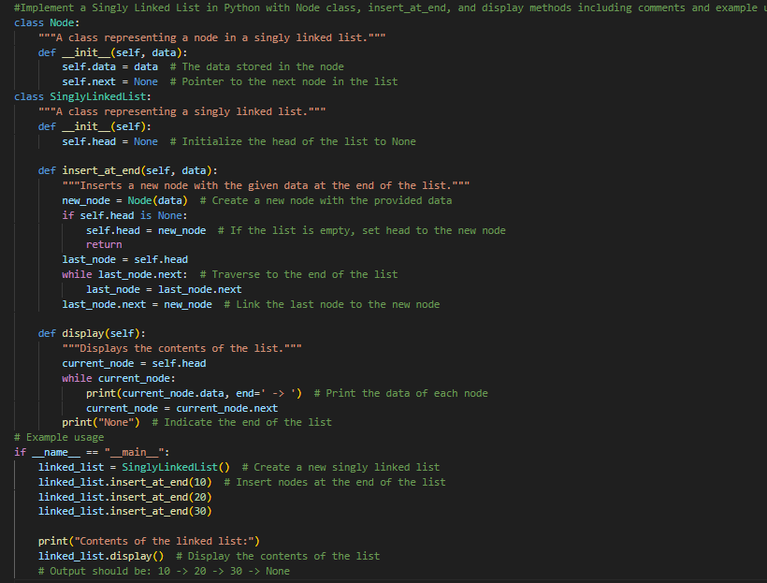

OUTPUT:

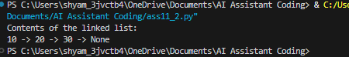

Code Explanation:

This program implements a Singly Linked List using a Node class and a SinglyLinkedList class. The Node class stores the data and a reference (next) to the next node. The insert_at_end() method adds a new node at the end by traversing the list until the last node and linking the new node. The display() method prints each node’s data followed by None, showing the end of the list. The example demonstrates inserting elements (10, 20, 30) and displaying them in order.

Task Description -4 – (Binary Search Tree Operations)
• Task: Implement a Binary Search Tree with AI support focusing
on insertion and traversal.
Expected Output:
• BST program with correct node insertion and in-order traversal

Prompt:

Develop a Binary Search Tree in Python with insert and inorder traversal methods including comments, example usage, and time complexity.

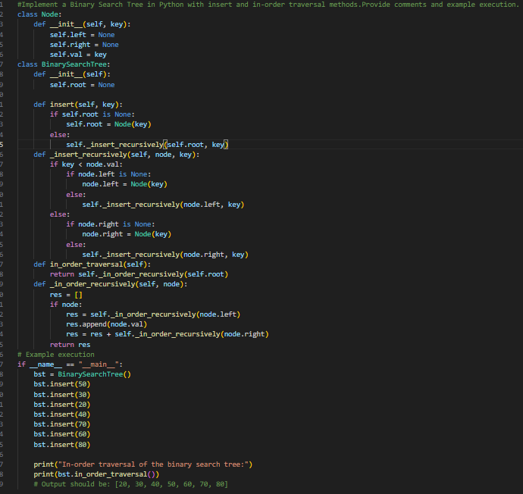
OUTPUT:

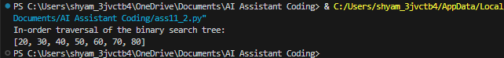

Code Explanation:
This program implements a Binary Search Tree (BST) using a Node class and a BinarySearchTree class. The insert() method adds elements according to the BST property (left child < parent < right child) using recursion. The in_order_traversal() method visits nodes in left-root-right order, which returns the elements in sorted order. The example inserts multiple values and prints them in ascending order, confirming correct BST behavior.

Task Description -5 – (Hash Table Implementation)
• Task: Create a hash table using AI with collision handling
Expected Output:
• Hash table supporting insert, search, and delete using chaining
or open

Prompt:
Create a Hash Table in Python using chaining for collision handling with insert, search, and delete methods including comments and example usage.

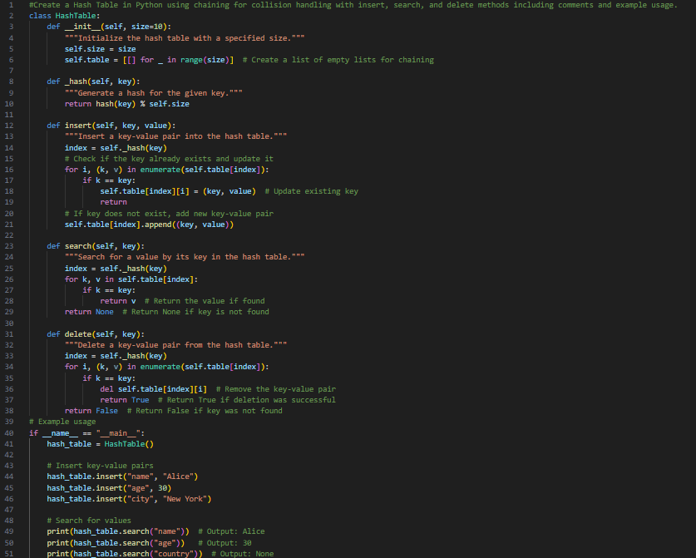

OUTPUT:

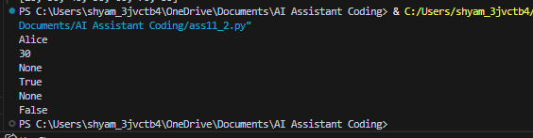

Code Explanation:
This program implements a Hash Table using chaining for collision handling. The _hash() method generates an index using Python’s built-in hash() function. The insert() method adds key-value pairs and updates the value if the key already exists. The search() method looks for a key in the corresponding bucket and returns its value, while the delete() method removes the key-value pair if found. Chaining is implemented using a list of lists, allowing multiple elements to be stored at the same index in case of collisions.

