ASSIGNMENT 9.5
Name: Vyshnavi Mashetti
Roll Number: 2303A51205
Batch - 04
AI Assisted Coding
Problem 1: String Utilities Function
Consider the following Python function:
def reverse_string(text):
return text[::-1]
Task:
1. Write documentation in:
o (a) Docstring
o (b) Inline comments
o (c) Google-style documentation
2. Compare the three documentation styles.
3. Recommend the most suitable style for a utility-based string
library.
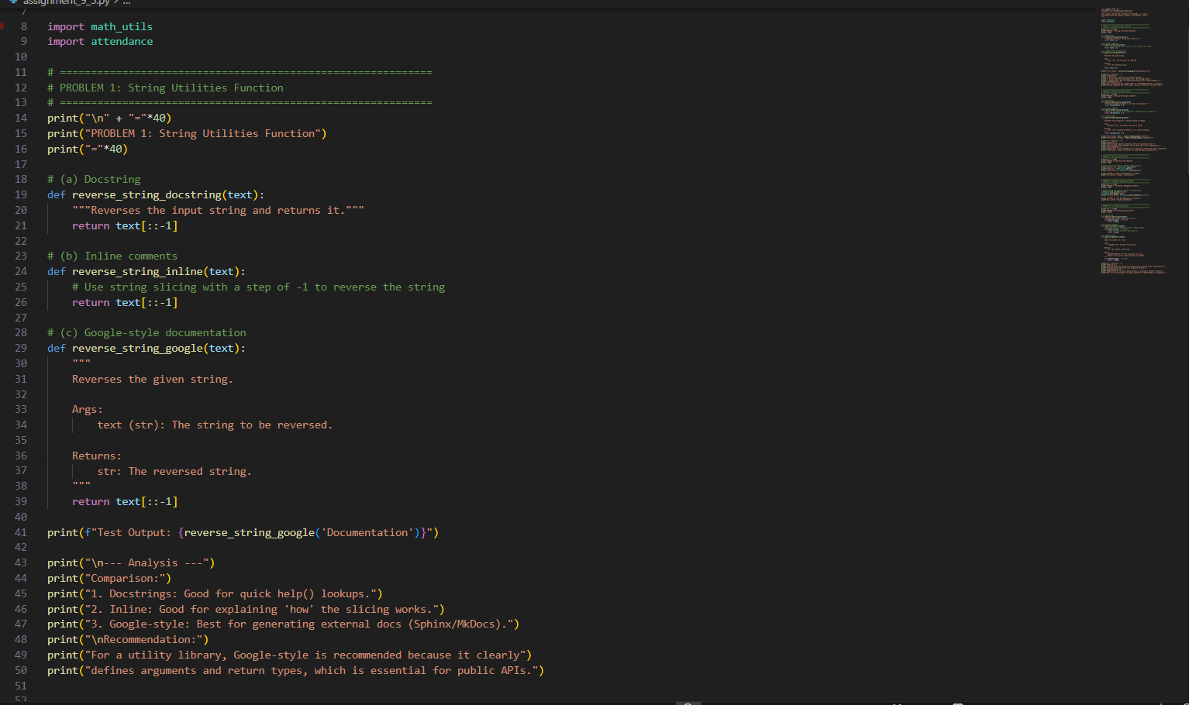
Output:
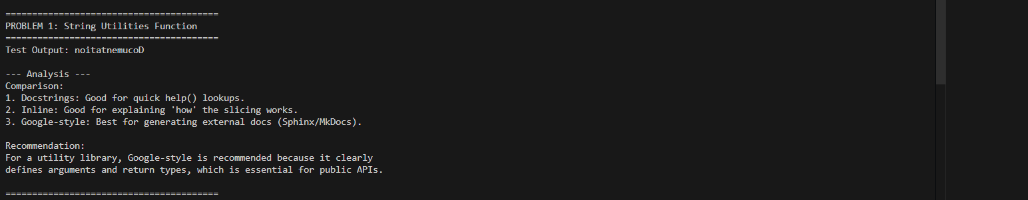
Justification:
- Docstring:
  - Provides a short explanation of what the function does.
  - Useful for quick references via help() in Python.
  - Limitation: Does not specify arguments or return types explicitly.
- Inline comments:
  - Explain the logic step by step inside the function.
  - Helps beginners understand how string slicing works ([::-1]).
  - Limitation: Comments are only useful in the code editor; they don’t help automated documentation tools.
- Google-style documentation:
  - Specifies the function purpose, arguments, return type, and description.
  - Can be automatically parsed by documentation tools like Sphinx or MkDocs.
  - Best choice for utility libraries or APIs, as it makes usage very clear to other developers.
Recommendation: Google-style is preferred because it clearly defines what input the function expects and what output it produces, which is critical for external developers or automated documentation.

Problem 2: Password Strength Checker
Consider the function:
def check_strength(password):
return len(password) >= 8
Task:
1. Document the function using docstring, inline comments, and
Google style.
2. Compare documentation styles for security-related code.
3. Recommend the most appropriate style.
Input:
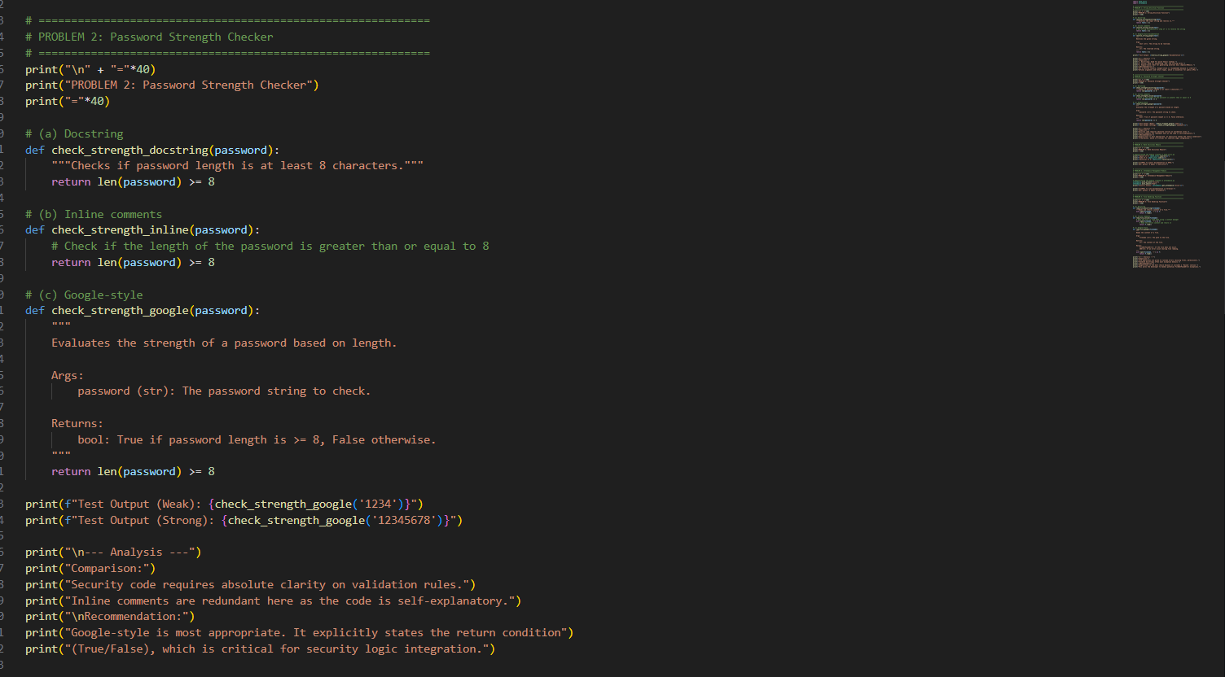
Output:
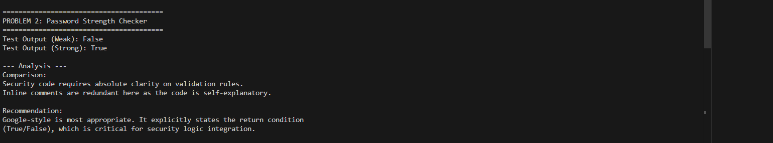
Justification:
- Docstring:
  - Simple description of the function purpose (“checks if password length is >= 8”).
  - Easy for help() lookup.
- Inline comments:
  - Explain the comparison operation (len(password) >= 8).
  - Useful for beginners but redundant for experienced programmers since the code is straightforward.
- Google-style documentation:
  - Clearly specifies:
    - Argument: password (string)
    - Return type: Boolean
    - Condition for True/False
  - Critical in security-sensitive code, where clarity avoids misinterpretation.
Recommendation: Google-style is best. In security applications, explicit argument and return specifications help prevent logic errors and ensure correct integration with other modules.
Problem 3: Math Utilities Module
Task:
1. Create a module math_utils.py with functions:
o square(n)
o cube(n)
o factorial(n)
2. Generate docstrings automatically using AI tools.
3. Export documentation as an HTML file.
Input:
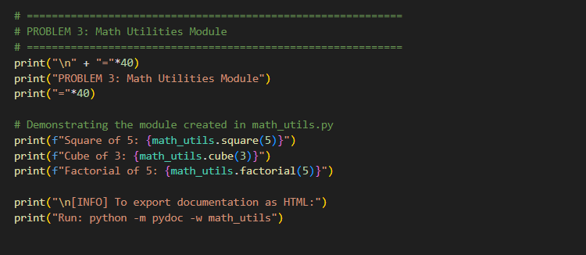
Output:
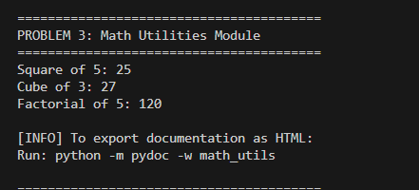

Justification:
- Demonstrates usage of a custom module (math_utils) with functions like square(), cube(), factorial().
- Documenting the module allows other developers to understand how to use the functions without reading the source code.
- Generating HTML documentation with pydoc ensures the module can be published for external use.
Recommendation: Use Google-style or standard docstrings for modules to make them easily documentable. This allows consistent API documentation and easier code maintenance.
Problem 4: Attendance Management Module
Task:
1. Create a module attendance.py with functions:
o mark_present(student)
o mark_absent(student)
o get_attendance(student)
2. Add proper docstrings.
3. Generate and view documentation in terminal and browse
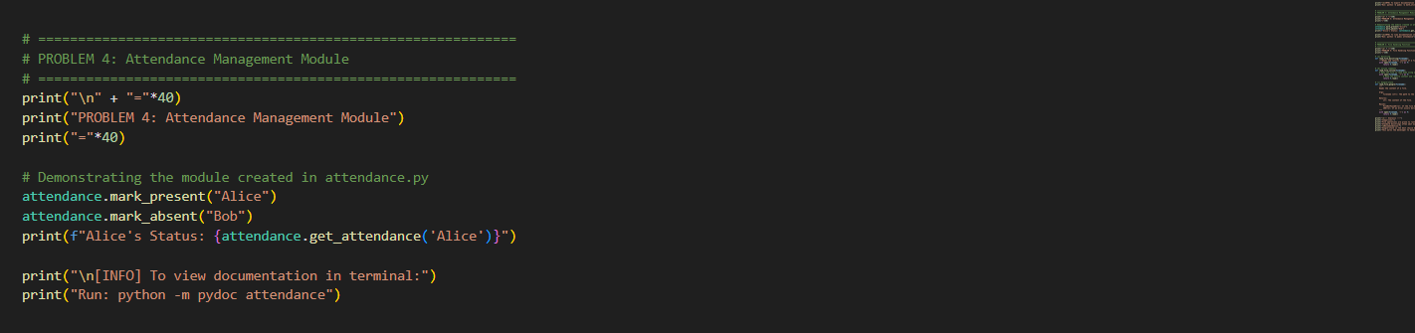
Output:
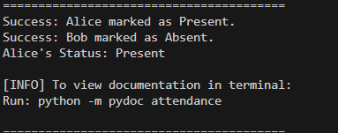

Justification:
- Demonstrates the module (attendance) for marking attendance.
- Provides a clear example of how functions like mark_present(), mark_absent(), and get_attendance() can be used.
- Terminal documentation (python -m pydoc attendance) gives quick access to usage instructions without opening the code.
Recommendation: Google-style documentation is preferred for modules because it helps other developers understand functions, arguments, and expected results clearly. Inline comments are insufficient for API-level understanding.
Problem 5: File Handling Function
Consider the function:
def read_file(filename):
with open(filename, 'r') as f:
return f.read()
Task:
1. Write documentation using all three formats.
2. Identify which style best explains exception handling.
3. Justify your recommendation.
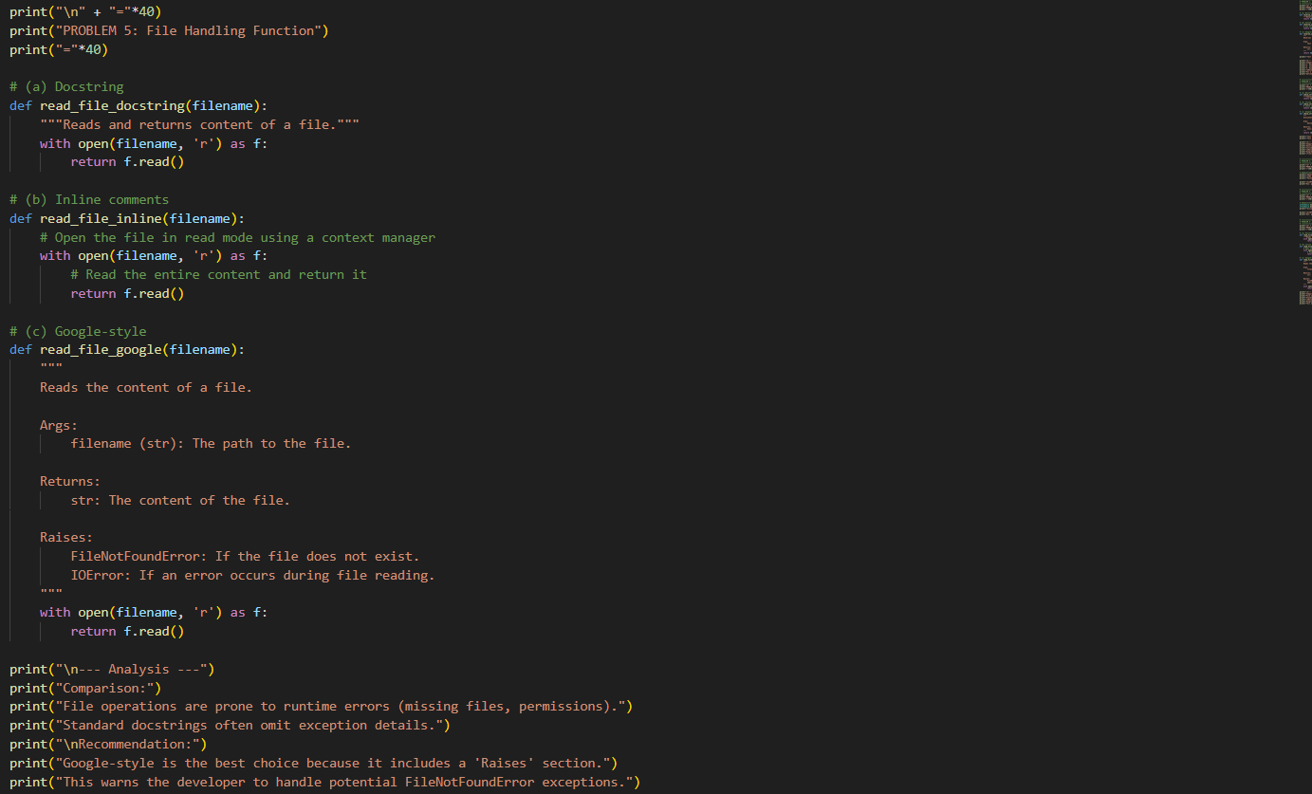
Output:
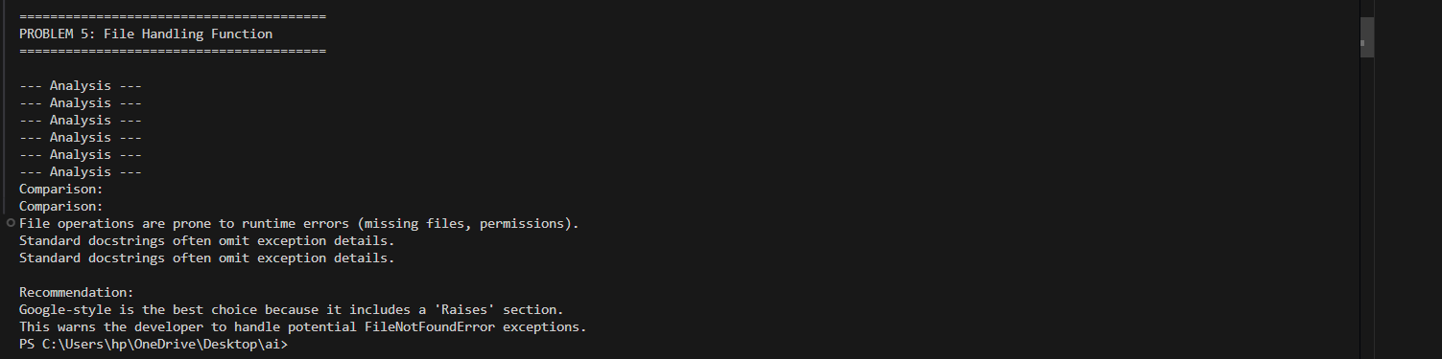
Justification:
- Docstring:
  - Provides a simple explanation (“reads and returns file content”).
  - Limited because it does not mention possible exceptions like FileNotFoundError.
- Inline comments:
  - Explain each step of opening and reading the file.
  - Useful for beginners but verbose for experienced developers.
- Google-style documentation:
  - Includes:
    - Arguments (filename)
    - Return type (str)
    - Potential exceptions (FileNotFoundError, IOError)
  - Essential for file operations, where errors are common.
  - Helps other developers anticipate and handle exceptions properly.
Recommendation: Google-style is the best choice for robust, production-ready file handling functions, because it communicates all necessary details to users, including exceptions.

