AI ASSISTANT CODING

ASSIGNMENT-2.2

Name: Vyshnavi Mashetti
Ht.no: 2303A51205
Batch: 04

Task 1: Cleaning Sensor Data
❖ Scenario:
❖ You are cleaning IoT sensor data where negative values are invalid.
❖ Task:
Use Gemini in Collab to generate a function that filters out all negative
numbers from a list.
❖ Expected Output:
➢ Before/after list
➢ Screenshot of Collab execution

Prompt: generate a function that filters out all negative
numbers from a list

Code:
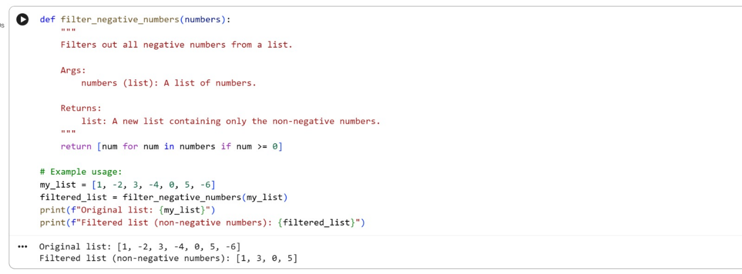

Output:

Explanation:
This Python code defines a function filter_negative_numbers that takes a list of numbers as input. It then iterates through the input list and returns a new list containing only the numbers that are greater than or equal to zero, effectively filtering out any negative values.

Task 2: String Character Analysis
❖ Scenario:
You are building a text-analysis feature.
❖ Task:
Use Gemini to generate a Python function that counts vowels, consonants,
and digits in a string.
❖ Expected Output:
➢ Working function
➢ Sample inputs and outputs

Prompt: Generate a Python function that counts vowels, consonants,
and digits in a string.
Code:
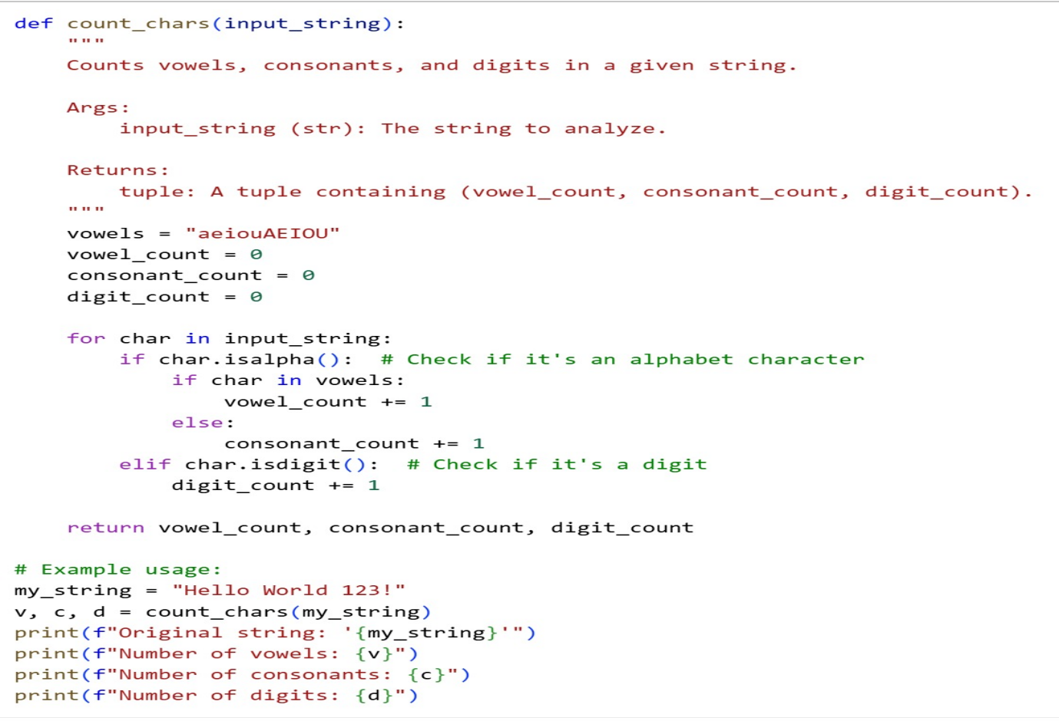

Output:
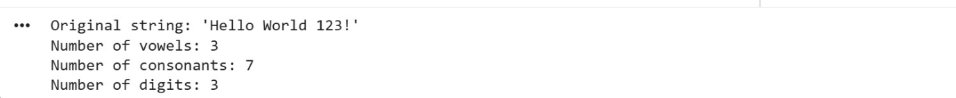

Explanation:
This code defines a function count_chars that takes a string as input. It initializes counters for vowels, consonants, and digits. It then iterates through each character in the string, checking if it's an alphabet character (and then if it's a vowel or a consonant) or a digit, incrementing the appropriate counter. Finally, it returns the total counts of vowels, consonants, and digits.

Task 3: Palindrome Check – Tool Comparison
❖ Scenario:
You must decide which AI tool is clearer for string logic.
❖ Task:
Generate a palindrome-checking function using Gemini and Copilot, then
compare the results.
❖ Expected Output:
➢ Side-by-side code comparison
➢ Observations on clarity and structure

Prompt :
Gemini prompt: Generate a palindrome-checking function

Code :
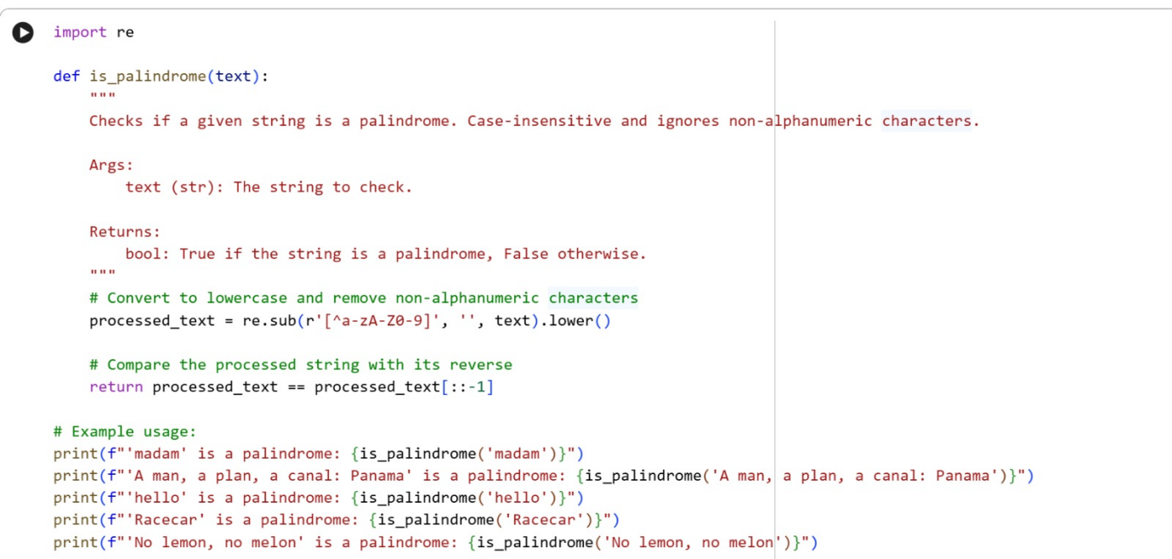

Output :
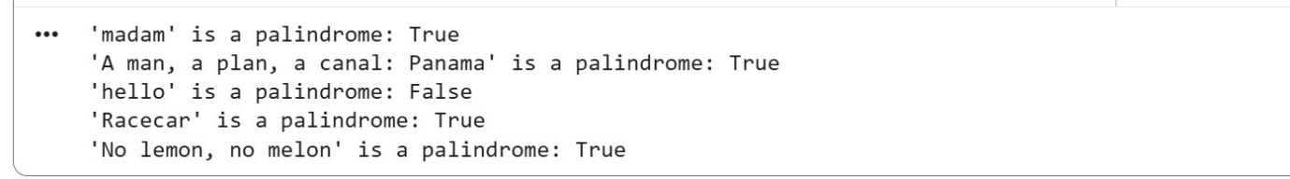

Gemini Explanation: This code defines a Python function is_palindrome that determines if a given string is a palindrome. It first cleans the input string by converting it to lowercase and removing all non-alphanumeric characters using regular expressions. Then, it checks if the cleaned string is equal to its reversed counterpart. If they are the same, the function returns True, indicating it's a palindrome; otherwise, it returns False

Copilot prompt: Generate a palindrome-checking function

Code :
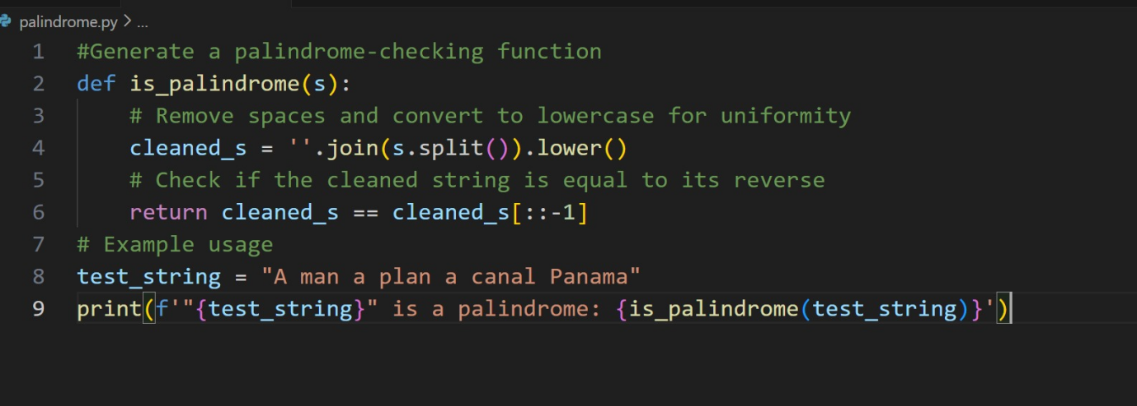

Output :
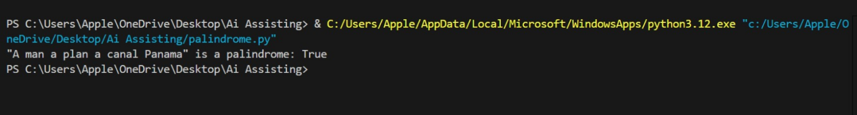
Copilot Explanation:
This function checks if a string is a palindrome by first removing spaces and converting all characters to lowercase for consistency. It then compares the cleaned string with its reversed version (cleaned_s[::-1]). If both are equal, the function returns True, meaning the string is a palindrome. For example, "A man a plan a canal Panama" evaluates to True because it reads the same backward and forward.
Key Differences Between the Two Codes:
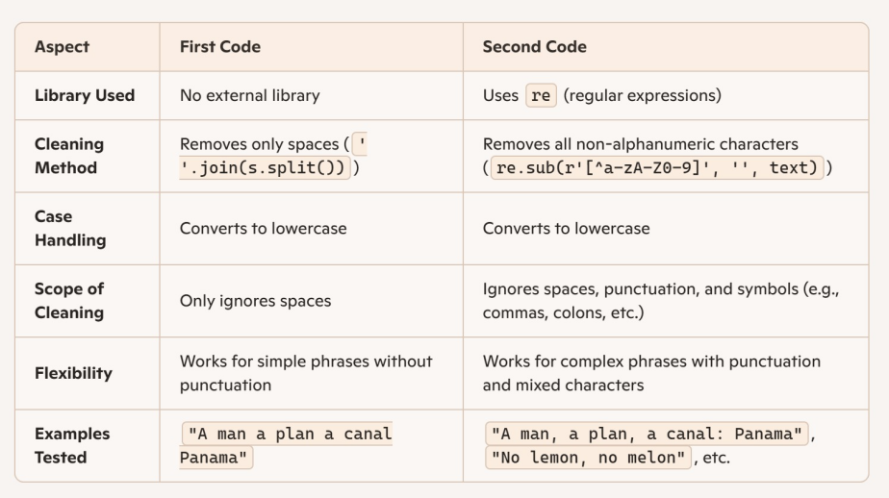
Task 4: Code Explanation Using AI
❖ Scenario:
You are reviewing unfamiliar code written by another developer.
❖ Task:
Ask Gemini to explain a Python function (prime check OR palindrome
check) line by line.
❖ Expected Output:
➢ Code snippet
➢ AI explanation
➢ Student comments on understanding
Note: Report should be submitted as a word document for all tasks in a
single document with prompts, comments & code explanation, and output
and if required, screenshots.

Gemini Explanation: This code defines a Python function is_palindrome that determines if a given string is a palindrome. It first cleans the input string by converting it to lowercase and removing all non-alphanumeric characters using regular expressions. Then, it checks if the cleaned string is equal to its reversed counterpart. If they are the same, the function returns True, indicating it's a palindrome; otherwise, it returns False
Copilot Explanation:
This function checks if a string is a palindrome by first removing spaces and converting all characters to lowercase for consistency. It then compares the cleaned string with its reversed version (cleaned_s[::-1]). If both are equal, the function returns True, meaning the string is a palindrome. For example, "A man a plan a canal Panama" evaluates to True because it reads the same backward and forward.

