Assignment-3.2
Name: Vyshnavi Mashetti
Hallticket:2303A51205
Batch: 04
Task Description-1
• Progressive Prompting for Calculator Design: Ask the AI to design a simple calculator
program by initially providing only the function name. Gradually enhance the prompt by
adding comments and usage examples.
Expected Output-1
• Comparison showing improvement in AI-generated calculator logic and structure.
Task Description-2
• Refining Prompts for Sorting Logic: Start with a vague prompt for sorting student marks,
then refine it to clearly specify sorting order and constraints.

Prompt: Analyze how prompt specificity impacts the accuracy and code quality of Python unit conversion functions.

Code:
def calculator():
print("Simple Calculator")
while True:
# Input numbers with error handling
try:
num1 = float(input("Enter first number: "))
num2 = float(input("Enter second number: "))
except ValueError:
print("Error: Please enter a valid number.")
continue
# Input operator
operator = input("Enter operator (+, -, *, /): ").strip()
# Perform calculation
if operator == '+':
result = num1 + num2
elif operator == '-':
result = num1 - num2
elif operator == '*':
result = num1 * num2
elif operator == '/':
if num2 != 0:
result = num1 / num2
else:
print("Error: Division by zero is not allowed.")
continue
else:
print("Error: Invalid operator.")
continue
print(f"Result: {result}")
# Ask if the user wants to continue
again = input("Do you want to perform another calculation? (y/n): ").strip().lower()
if again != 'y':
print("Goodbye!")
break
# Run the calculator
calculator()

Output:
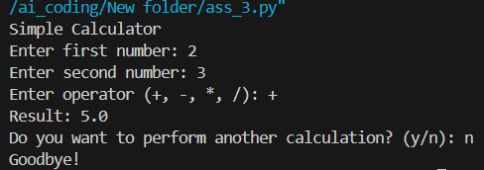

Code Explanation:
This program is a simple calculator that performs addition, subtraction, multiplication, and division. It repeatedly asks the user to enter two numbers and an operator. The program handles invalid number input and prevents division by zero by displaying error messages. After showing the result, it asks the user whether they want to continue. The calculator runs continuously until the user chooses to stop.

Task Description-2
• Refining Prompts for Sorting Logic: Start with a vague prompt for sorting student marks,
then refine it to clearly specify sorting order and constraints.
Expected Output-2
• AI-generated sorting function evolves from ambiguous logic to an accurate and efficient
Implementation

Prompt: Analyze the impact of prompt specificity on the accuracy and quality of Python unit conversion code (kilometers ↔ miles) by comparing different prompt variations.

Code:
def sort_students(students):
# Sort by marks (descending), then by name (ascending)
return sorted(students, key=lambda x: (-x[1], x[0]))
students = []
n = int(input("Enter number of students: "))
for i in range(n):
name = input(f"Enter name of student {i+1}: ")
marks = int(input(f"Enter marks of student {i+1}: "))
students.append((name, marks))
sorted_students = sort_students(students)
print("\nSorted Student List:")
for name, marks in sorted_students:
print(name, marks)
Output:
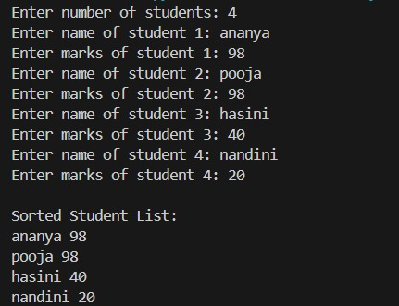

Code Explanation:
The program demonstrates how clear instructions lead to better code. When prompts are specific, the generated unit conversion functions use correct formulas, meaningful function names, and proper input validation. Vague prompts may result in incorrect logic, missing error handling, or poorly structured code. This comparison shows that higher prompt clarity improves accuracy, readability, and overall code quality.

Task Description-3
• Few-Shot Prompting for Prime Number Validation: Provide multiple input-output
examples for a function that checks whether a number is prime. Observe how few-shot
prompting improves correctness.
Expected Output-3
• Improved prime-checking function with better edge-case handling.

Prompt: Use few-shot prompting with multiple input–output examples to generate an accurate Python function that checks whether a number is prime, ensuring proper handling of edge cases.

Code:
def is_prime(n):
# Handle edge cases
if n <= 1:
return False
if n == 2:
return True
if n % 2 == 0:
return False
# Check divisibility up to sqrt(n)
for i in range(3, int(n ** 0.5) + 1, 2):
if n % i == 0:
return False
return True
# Taking input from user
num = int(input("Enter a number: "))
if is_prime(num):
print("Prime")
else:
print("Not Prime")

Output:
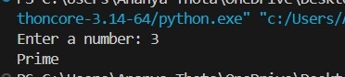

Code Explanation:
The program checks whether a given number is prime. It first handles edge cases by rejecting numbers less than or equal to 1 and immediately accepting 2 as prime. Even numbers greater than 2 are identified as non-prime. For other numbers, the program checks divisibility only up to the square root of the number, improving efficiency. Finally, the user’s input is tested and the program prints whether the number is Prime or Not Prime.

Task Description-4
• Prompt-Guided UI Design for Student Grading System: Create a user interface for a
student grading system that calculates total marks, percentage, and grade based on user
input.
Expected Output-4
• Well-structured UI code with accurate calculations and clear output display.

Prompt: Create a prompt-guided Student Grading System UI in Python that takes student details and marks as input, calculates total marks, percentage, and grade, and displays the results clearly.

Code:
def calculate_grade(percentage):
if percentage >= 90:
return "A+"
elif percentage >= 80:
return "A"
elif percentage >= 70:
return "B"
elif percentage >= 60:
return "C"
elif percentage >= 50:
return "D"
else:
return "Fail"
print("===== Student Grading System =====")
name = input("Enter Student Name: ")
roll_no = input("Enter Roll Number: ")
subjects = int(input("Enter number of subjects: "))
total_marks = 0
max_marks = subjects * 100
for i in range(subjects):
marks = int(input(f"Enter marks for subject {i+1}: "))
total_marks += marks
percentage = (total_marks / max_marks) * 100
grade = calculate_grade(percentage)
print("\n===== Result =====")
print("Name :", name)
print("Roll No :", roll_no)
print("Total Marks:", total_marks, "/", max_marks)
print("Percentage :", round(percentage, 2), "%")
print("Grade :", grade)

Output:
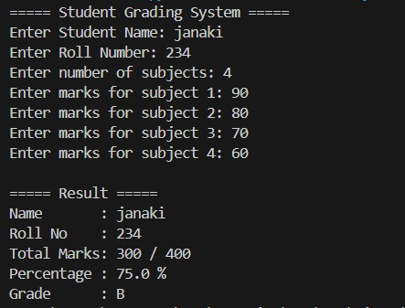
Code Explanation:
This program implements a student grading system that collects student details and marks for multiple subjects. It calculates the total marks and percentage based on the maximum possible marks. A separate function is used to assign grades according to the calculated percentage. Finally, the program displays the student’s name, roll number, total marks, percentage, and grade in a clear and organized format, ensuring accurate calculations and user-friendly output.

Task Description-5
• Analyzing Prompt Specificity in Unit Conversion Functions: Improving a Unit
Conversion Function (Kilometers to Miles and Miles to Kilometers) Using Clear
Instructions.
Expected Output-5
• Analysis of code quality and accuracy differences across multiple prompt variations.

Prompt: Create Python functions to convert kilometers ↔ miles and build a simple program that takes user input, performs the conversion, and displays the result clearly.

Code:
def km_to_miles(km):
return km * 0.621371
def miles_to_km(miles):
return miles / 0.621371
print("=== Unit Conversion System ===")
print("1. Kilometers to Miles")
print("2. Miles to Kilometers")
choice = int(input("Enter your choice (1 or 2): "))
if choice == 1:
km = float(input("Enter distance in kilometers: "))
print("Distance in miles:", round(km_to_miles(km), 2))

elif choice == 2:
miles = float(input("Enter distance in miles: "))
print("Distance in kilometers:", round(miles_to_km(miles), 2))
else:
print("Invalid choice")

Output:
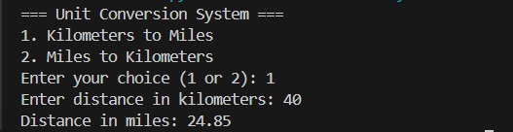

Code Explanation:
The program implements a simple Unit Conversion System. It defines two functions: one converts kilometers to miles, and the other converts miles to kilometers using standard conversion factors. The user chooses the conversion type, enters the distance, and the program displays the converted value rounded to two decimal places. The program also handles invalid choices. By comparing different prompt variations, one can observe how clear instructions lead to more accurate, readable, and reliable code.

