AI ASSISTANT CODING
ASSIGNMENT-13.2
Name: Vyshnavi Mashetti
Ht.no: 2303A51205
Batch: 04

Task Description -1 (Refactoring – Eliminating Repetitive Logic)
• Task: Use AI-assisted coding techniques to restructure a Python
program that performs repeated calculations, transforming it into
a reusable and maintainable design.
Instructions:
• Ask AI to locate repeated computations within the program.
• Encapsulate repeated logic into reusable functions.
• Verify that program output remains unchanged after refactoring.
• Add proper docstrings to all defined functions.

Sample code:
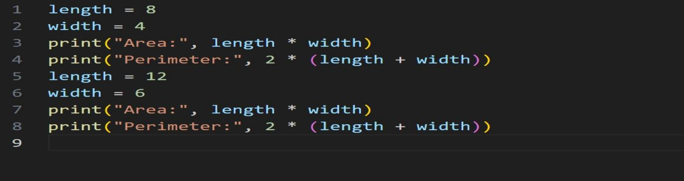

Output:
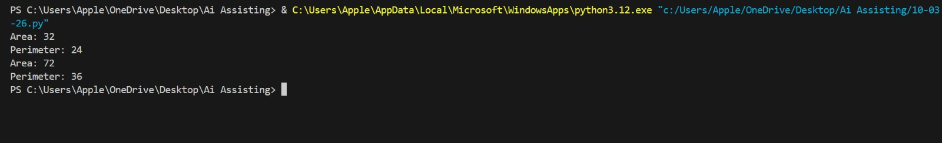

Prompt: Refactor the following Python code by removing repeated calculations, creating a reusable function with proper docstrings, and keeping the program output unchanged.

Refactored Code:
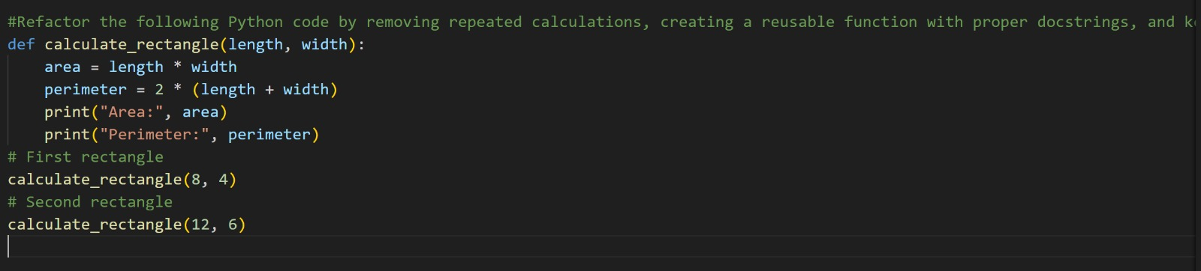

Output:


Refactoring Explanation
- Removed repeated logic – The area and perimeter calculation was written twice.
- Created reusable function → calculate_rectangle(length, width)
- Added docstring explaining:
  - Purpose
  - Parameters
  - Return value
- Improved maintainability – If calculation logic changes, you modify it only in one place.

Task Description -2 (Refactoring – Modularizing Inline
Calculations)
• Task: Use AI to refactor a Python script by extracting repeated
inline calculations into reusable and well-documented functions.
Instructions:
• Identify repeated calculation patterns in the code.
• Convert them into reusable functions.
• Ensure readability and proper documentation.

Sample code:


Output:

Prompt: Refactor the following Python code by extracting the repeated discount calculation into a reusable function with proper docstrings while keeping the same output.

Refactored Code:
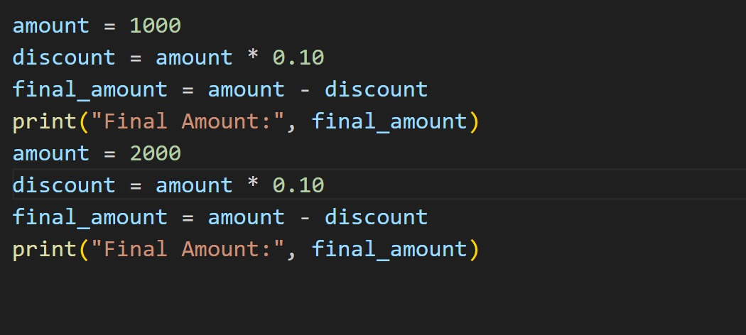

Output:

Explanation:
The original code had repeated discount calculations.
The repeated logic was moved into a reusable function.
The function takes amount as input and calculates the final amount.
A docstring was added for better documentation.
This improves readability, reusability, and maintainability while keeping the same output.

Task Description -3 (Refactoring – Improving Loop and
Conditional Performance)
• Task: Apply AI-based suggestions to enhance the performance of
Python code that relies on nested loops and repeated conditional
checks.
Instructions:
• Use AI to recommend more efficient data structures or logic
simplifications.
• Replace inefficient constructs while preserving program behavior.
• Compare execution efficiency before and after refactoring.
Sample code:
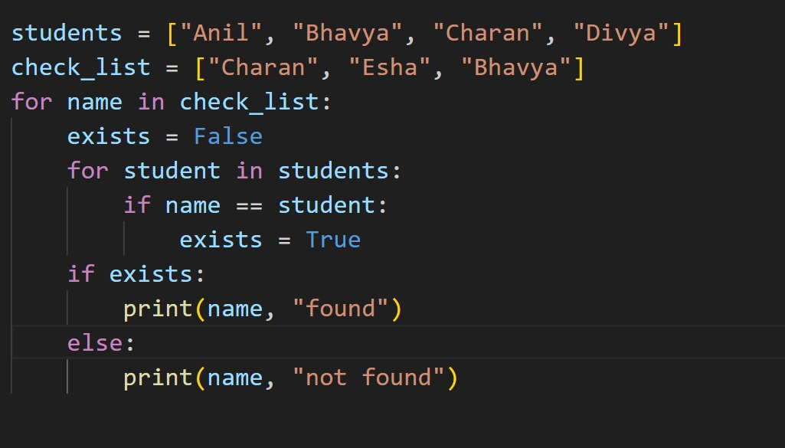

Output:

Prompt:
Refactor the following Python code to improve loop and conditional performance by using a more efficient data structure while keeping the program output the same and adding clear comments.

Refactored code:
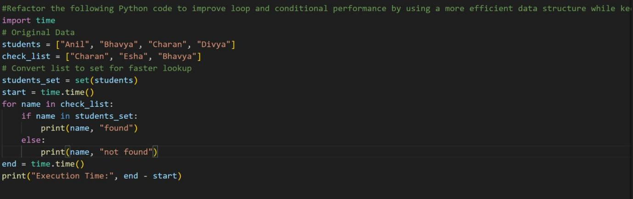

Output:
Explanation:
The original code used nested loops to check if a name exists in the students list.
This approach is less efficient because it checks every element repeatedly.
The refactored code replaces the list with a set, which allows faster lookups.
The nested loop and extra condition variable were removed, simplifying the logic.
This improves performance, readability, and efficiency while keeping the same output.

Task Description -4 (Refactoring – Replacing Hardcoded Values
with Constants)
• Task: Utilize AI assistance to improve maintainability by
replacing hardcoded numerical values with named constants.
Instructions:
• Detect hardcoded numeric values used directly in expressions.
• Define descriptive constants at the beginning of the program.
• Update calculations to use these constants without changing
results.

Sample code:
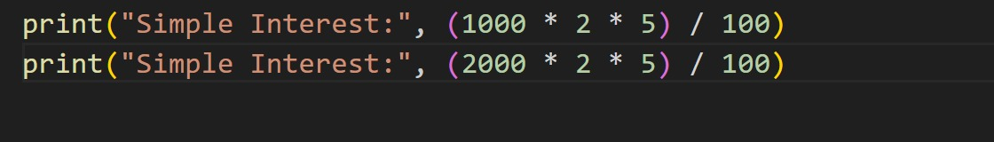

Output:
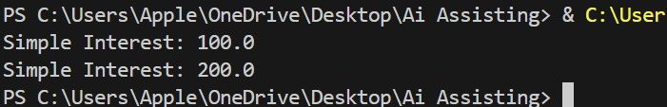

Prompt: Refactor the following Python code by replacing hardcoded numeric values with descriptive constants and keep the program output unchanged.

Refactored Code:
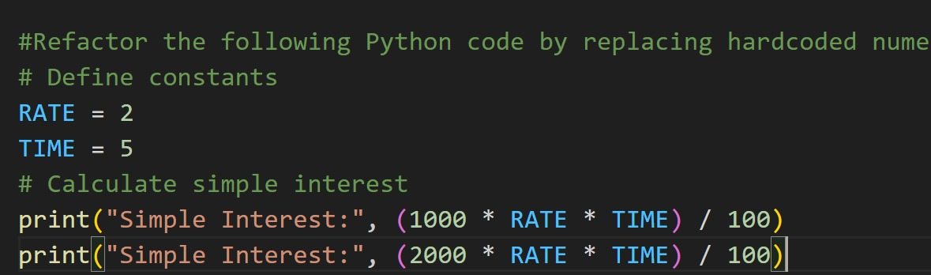

Output:


Explanation:
- Hardcoded values identified – Numbers 2 and 5 were used directly in calculations.
- Constants created – Defined RATE and TIME at the beginning of the program.
- Improved readability – Constant names make the code easier to understand.
- Updated formula – Replaced numbers with constants in the calculation.
- Better maintainability – Values can be changed in one place without affecting the whole code.

Task Description -5 (Re factoring – Enhancing Variable Naming
and Code Clarity)
• Task: Apply AI tools to improve code readability by renaming
unclear variables and adding meaningful comments..
Instructions:
• Replace non-descriptive variable names with meaningful
identifiers.
• Add inline comments where the logic may be unclear.
• Ensure program output remains the same.

Sample code:
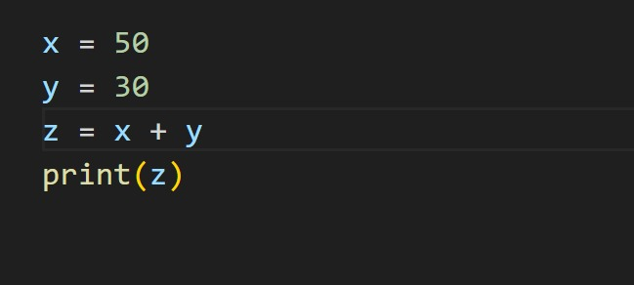

Output:

Prompt:
Refactor the following Python code by renaming unclear variables with meaningful names and adding comments while keeping the program output the same.

Code:
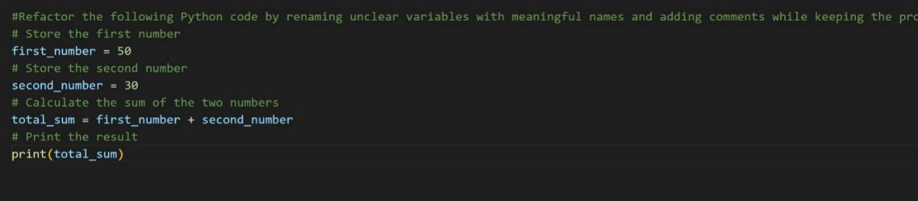

Output:

Explanation:
- Replaced unclear variables x, y, z with meaningful names.
- Added comments to explain each step.
- Improved code readability and clarity.
- Program functionality and output remain the same.

