Assignment 6.2
Name: Vyshnavi Mashetti
Roll Number: 2303A51205
Batch - 04
AI Assisted Coding
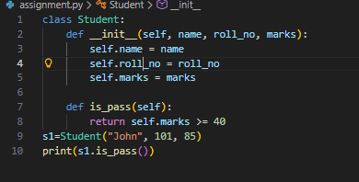
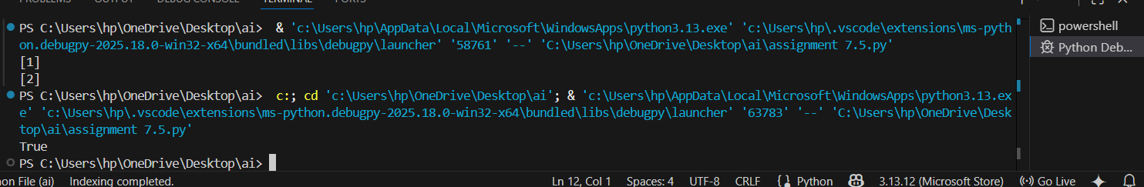
Task 2
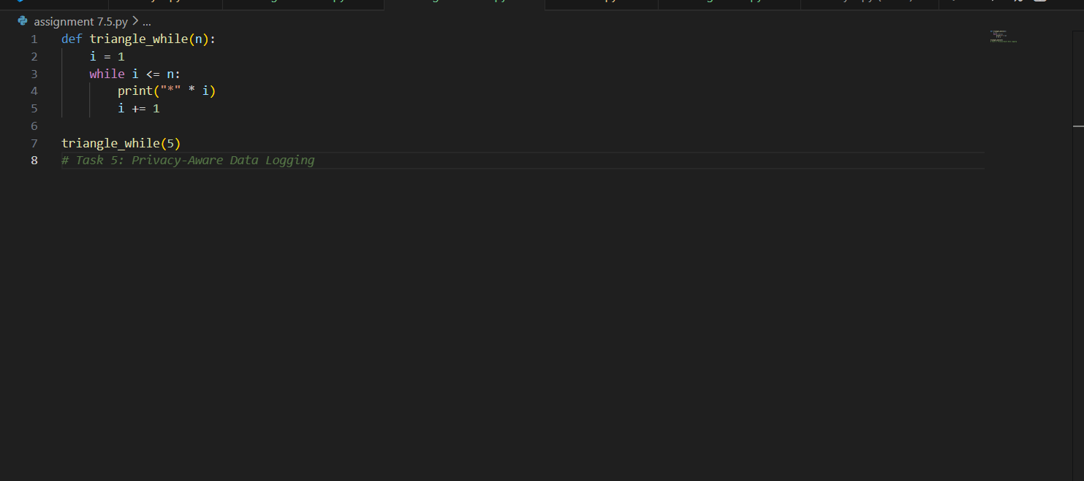
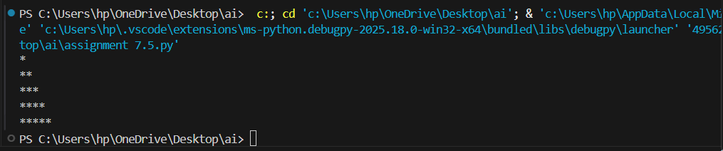
Task 3
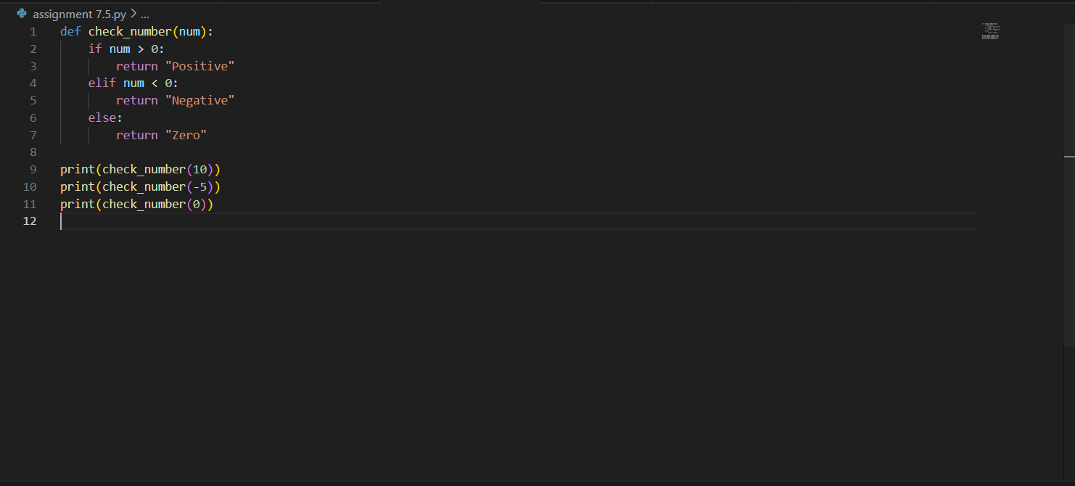
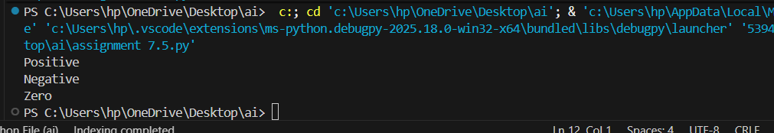
Task 4:
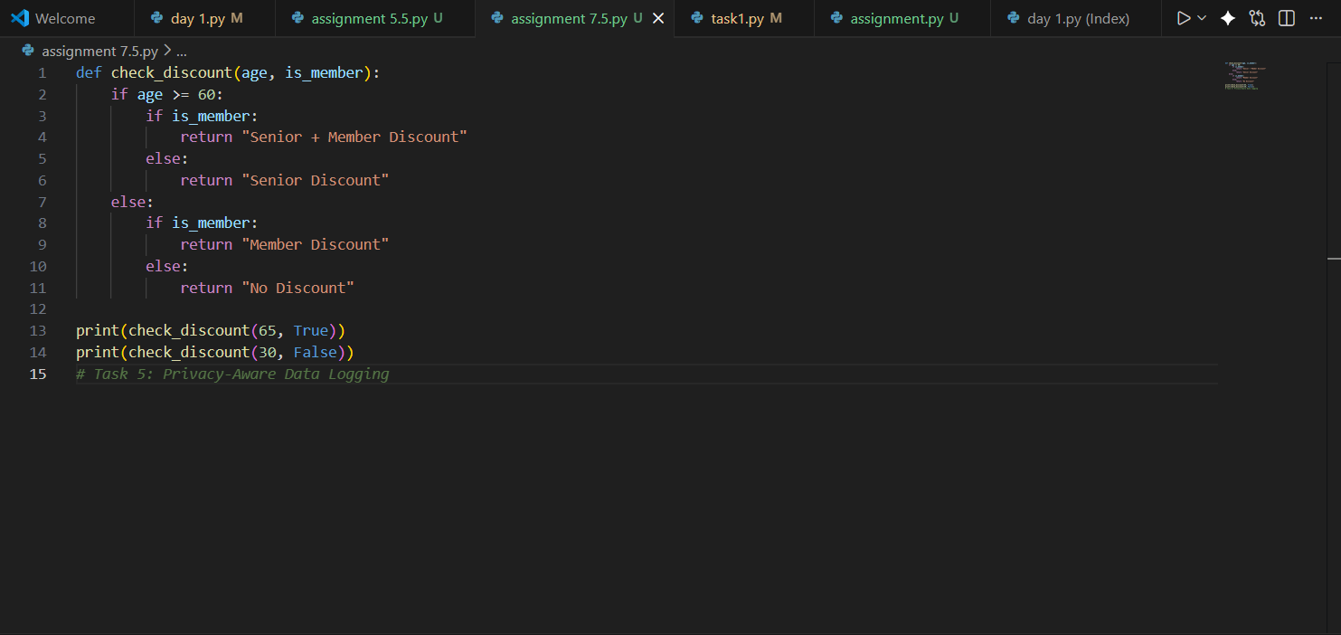
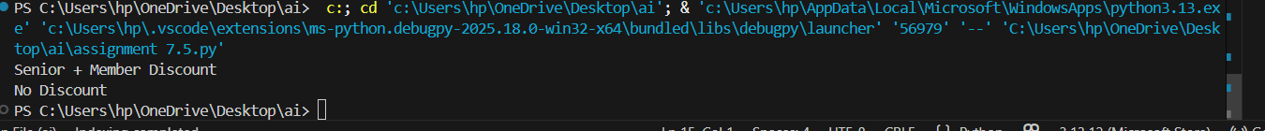
Task 5
