Assignment-8.2
Name: Thalla Sreeja
Roll No: 2303A51220
Batch No: 04

Task 1 – Test-Driven Development for Even/Odd Number Validator

• Use AI tools to first generate test cases for a function is_even(n)
and then implement the function so that it satisfies all generated
tests.
Requirements:
• Input must be an integer
• Handle zero, negative numbers, and large integers
Example Test Scenarios:
is_even(2) → True
is_even(7) → False
is_even(0) → True
is_even(-4) → True
is_even(9) → False
Expected Output -1
• A correctly implemented is_even() function that passes all AI-
generated test cases

General Test Cases Prompt:

Generate general test cases for a Python function is_even(n) and provide a simple Python program that prints outputs for each test case.
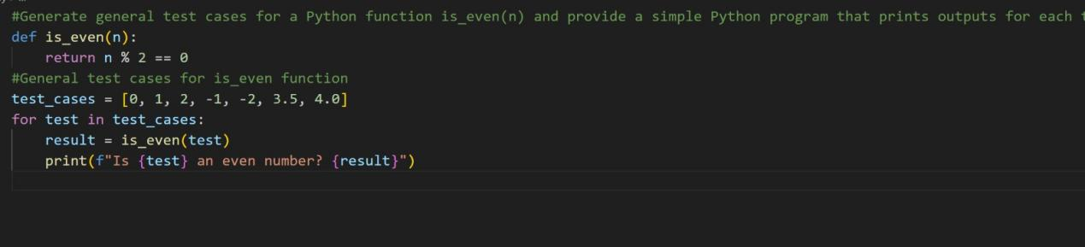

OUTPUT:

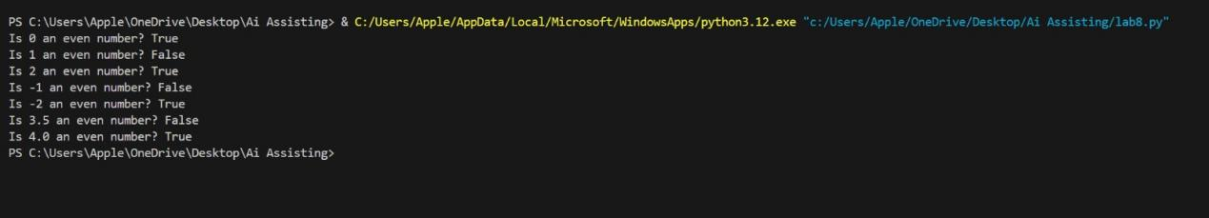

Assertion Test Cases Prompt:

Write assertion-based test cases for a Python function is_even(n).

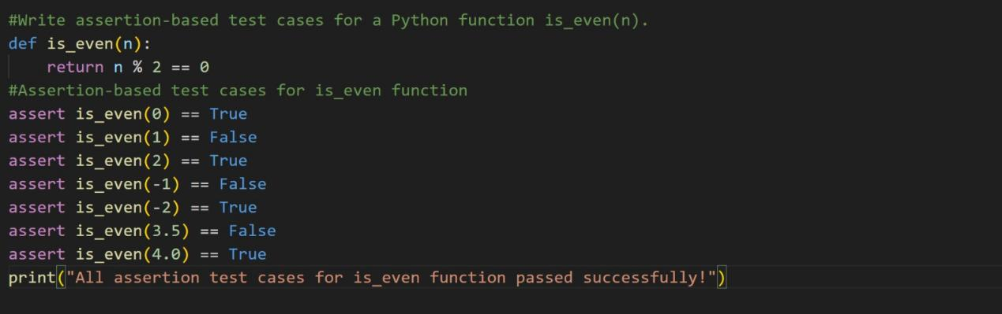

OUTPUT:

Unit Test Cases Prompt:

Generate Python unittest test cases for the function is_even(n).

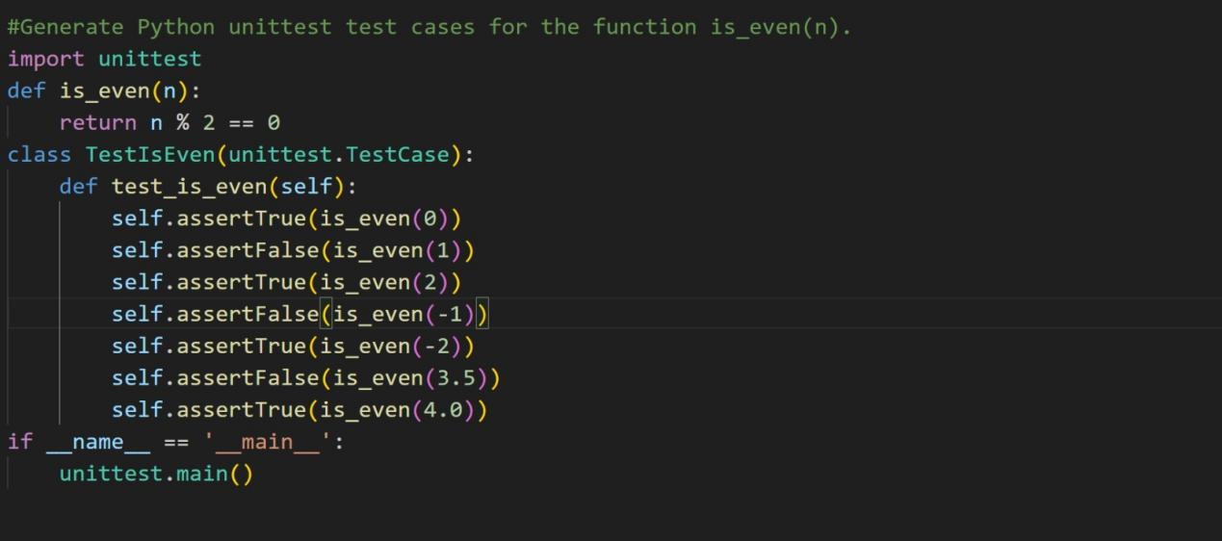

OUTPUT:

Pytest Cases Prompt:

Generate pytest test cases for a Python function is_even(n).

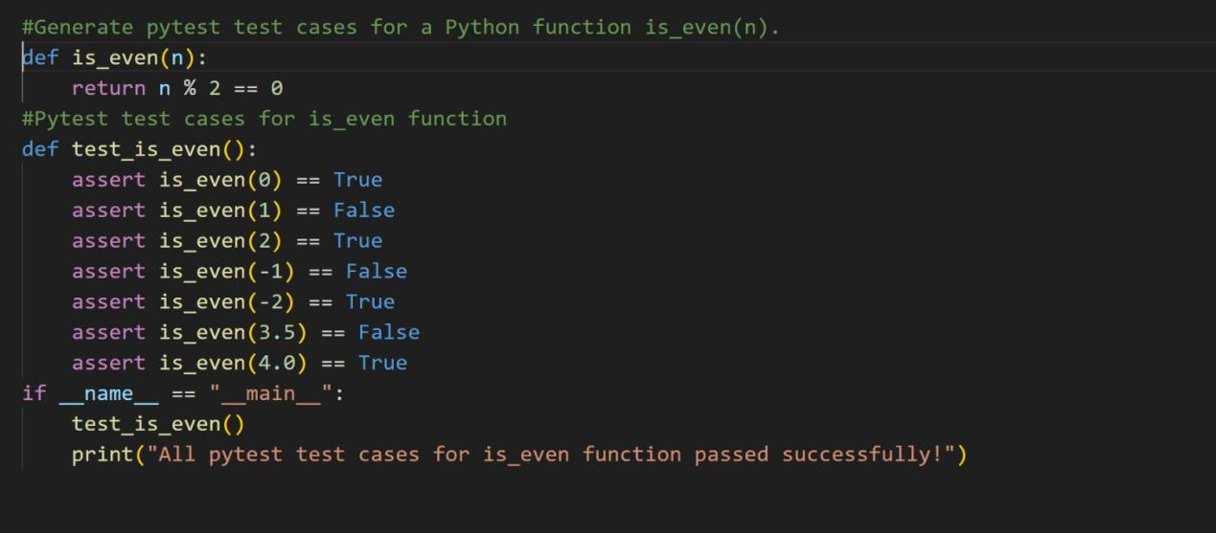

OUTPUT:

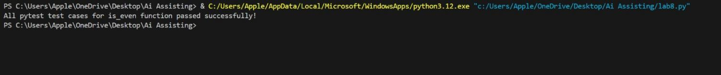

Code Explanation

The function is_even(n) checks whether a given number is even while ensuring valid input. First, it verifies that the input is an integer to prevent errors. Then it uses the modulus operator (n % 2) to determine divisibility by 2. If the remainder is 0, the function returns True (even); otherwise, it returns False (odd).

The function correctly handles edge cases such as zero, negative numbers, and large integers. Test-driven development is used to validate correctness through assertions and automated tests, ensuring reliable behavior.

Task 2 – Test-Driven Development for String Case Converter
• Ask AI to generate test cases for two functions:
• to_uppercase(text)
• to_lowercase(text)
Requirements:
• Handle empty strings
• Handle mixed-case input
• Handle invalid inputs such as numbers or None
Example Test Scenarios:
to_uppercase("ai coding") → "AI CODING"
to_lowercase("TEST") → "test"
to_uppercase("") → ""
to_lowercase(None) → Error or safe handling
Expected Output -2
• Two string conversion functions that pass all AI-generated test
cases with safe input handling.

General Test Cases Prompt:

Generate test cases for two Python functions to_uppercase(text) and to_lowercase(text) that convert string case and handle empty and invalid inputs.
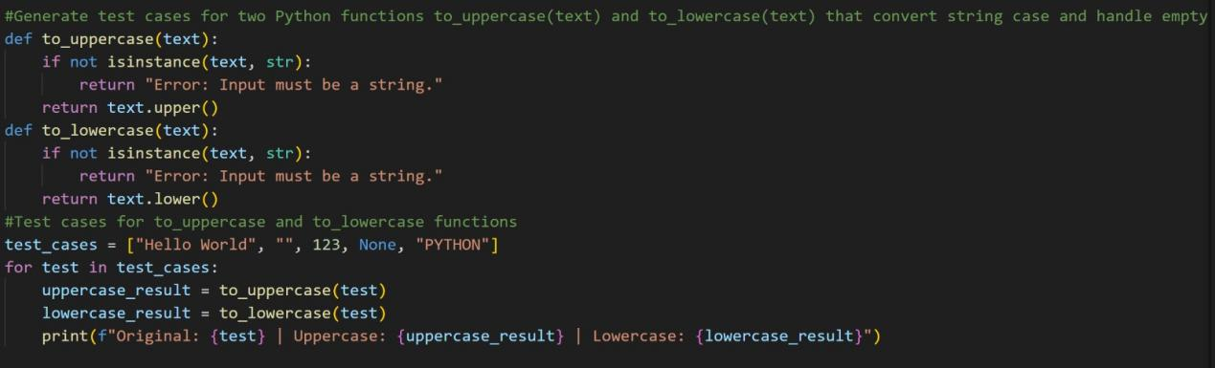

OUTPUT:

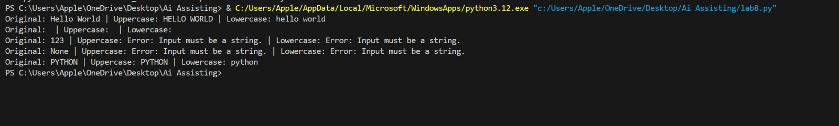

Assertion Test Cases Prompt:

Write Python assertion statements to test to_uppercase(text) and to_lowercase(text) functions.

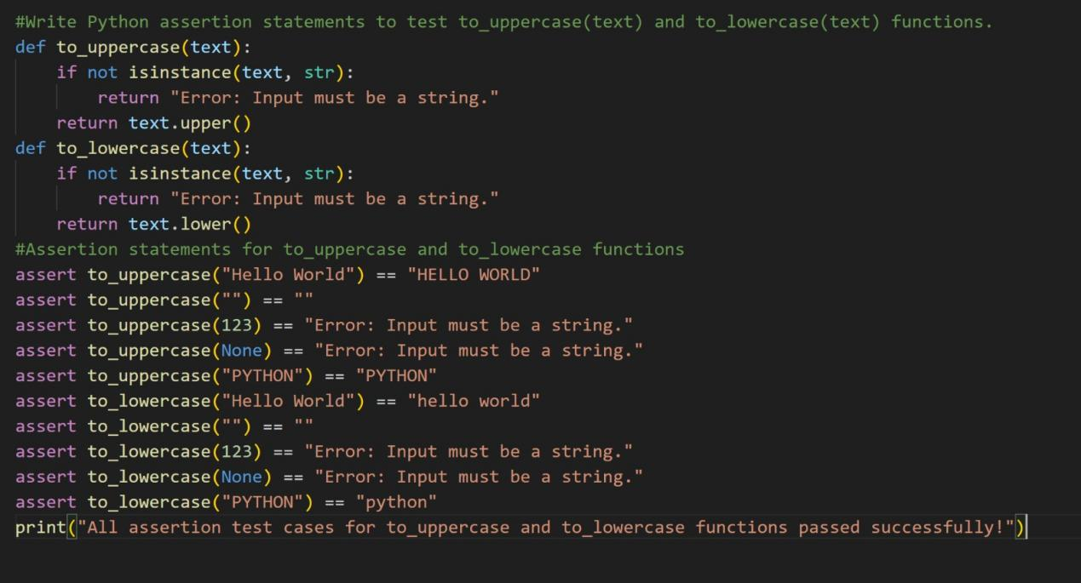

OUTPUT:

Unit Test Cases Prompt:

Write Python unittest test cases for to_uppercase(text) and to_lowercase(text) functions including normal, empty, and invalid input cases.

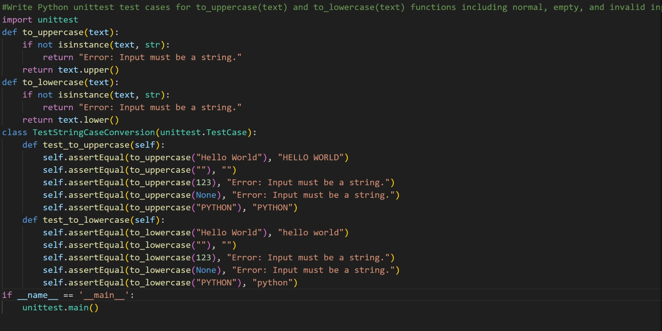

OUTPUT:
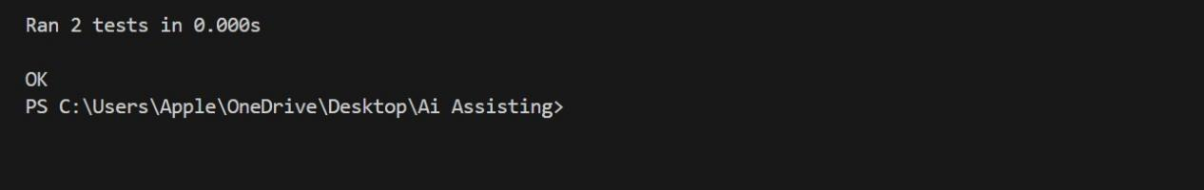

Pytest Cases Prompt:

Generate pytest test cases using assert statements for to_uppercase(text) and to_lowercase(text) functions.

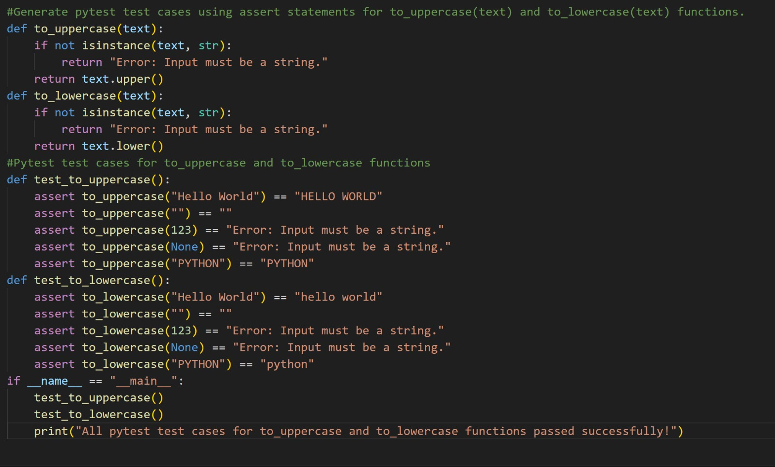

OUTPUT:

Code explanation:

The functions to_uppercase(text) and to_lowercase(text) convert a string into uppercase and lowercase formats. Each function first checks whether the input is a valid string to avoid runtime errors. After validation, built-in string methods are used to perform the conversion efficiently.

The functions handle edge cases such as empty strings and invalid inputs safely. Test-driven development ensures the functions behave correctly under different scenarios, improving reliability and correctness.

Task 3 – Test-Driven Development for List Sum Calculator
• Use AI to generate test cases for a function sum_list(numbers)
that calculates the sum of list elements.
Requirements:
• Handle empty lists
• Handle negative numbers
• Ignore or safely handle non-numeric values
Example Test Scenarios:
sum_list([1, 2, 3]) → 6
sum_list([]) → 0
sum_list([-1, 5, -4]) → 0
sum_list([2, "a", 3]) → 5
Expected Output 3
• A robust list-sum function validated using AI-generated test
Cases

General Test Cases Prompt:

Generate test cases for a Python function sum_list(numbers) that returns the sum of list elements, handles empty lists, negative numbers, and ignores non-numeric values.

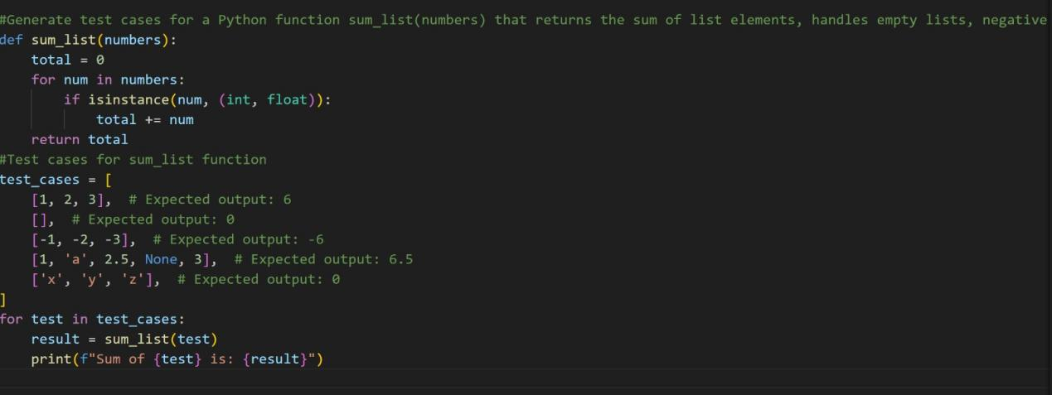

OUTPUT:
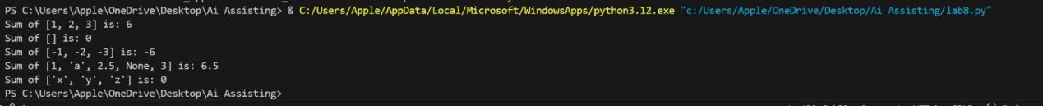

Assertion Test Cases Prompt:

Write Python assertion statements to test the function sum_list(numbers).

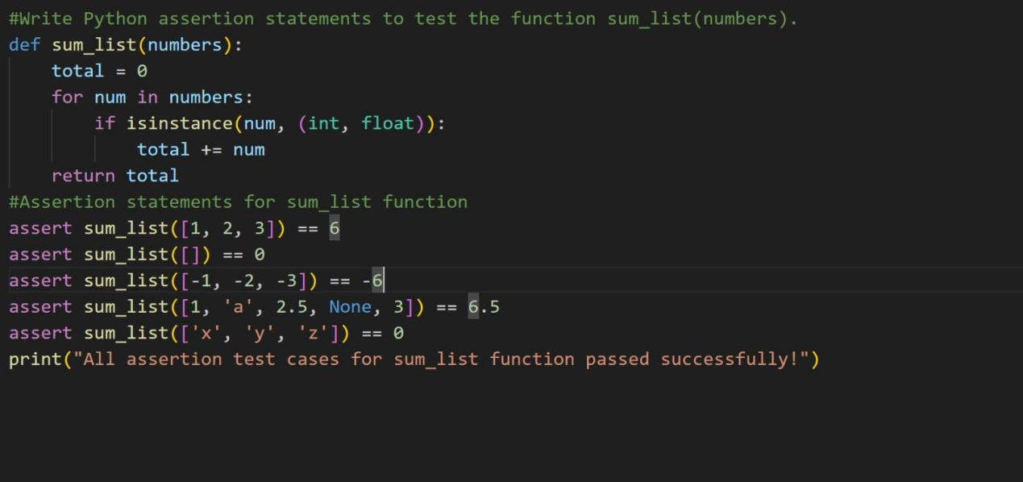

OUTPUT:

Unit Test Cases Prompt:

Write Python unittest test cases for the function sum_list(numbers) including normal, empty, negative, and invalid input cases.

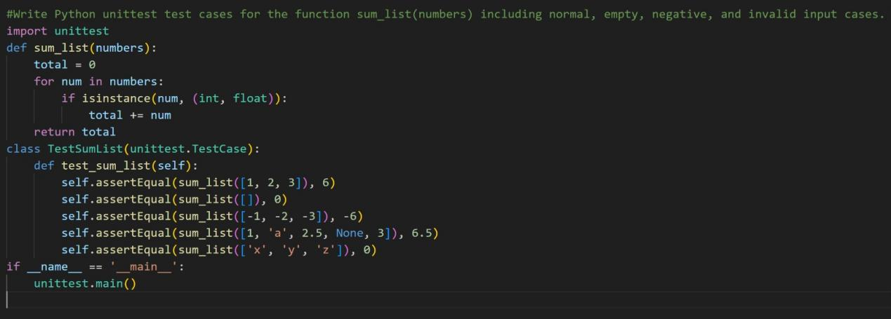

OUTPUT:

Pytest Cases Prompt:

Generate pytest test cases using assert statements for the function sum_list(numbers).

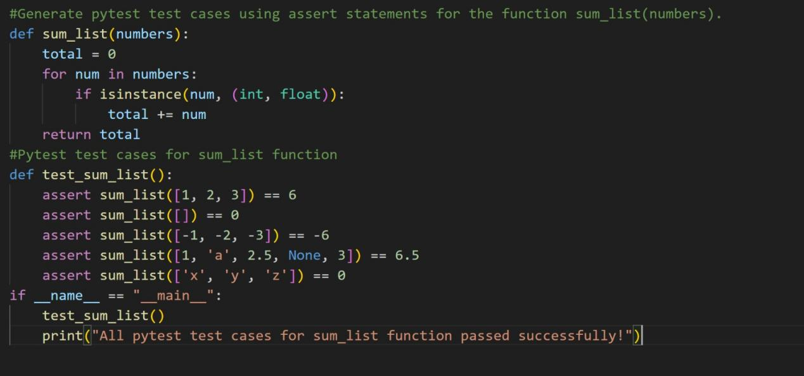

OUTPUT:

Code Explanation:

The function sum_list(numbers) calculates the total of numeric values in a list while safely handling different input cases. It iterates through the list and adds only valid numeric elements, ignoring non-numeric values to prevent errors.

The function also handles edge cases such as empty lists and negative numbers, ensuring stable behavior. Test-driven development is used to verify correctness and robustness through multiple test scenarios.

Task 4 – Test Cases for Student Result Class
• Generate test cases for a StudentResult class with the following
methods:
• add_marks(mark)
• calculate_average()
• get_result()
Requirements:
• Marks must be between 0 and 100
• Average ≥ 40 → Pass, otherwise Fail
Example Test Scenarios:
Marks: [60, 70, 80] → Average: 70 → Result: Pass
Marks: [30, 35, 40] → Average: 35 → Result: Fail
Marks: [-10] → Error
Expected Output -4
• A fully functional StudentResult class that passes all AI-
generated test

General Test Cases Prompt:

Generate test cases for a Python class StudentResult with methods add_marks, calculate_average, and get_result. Marks must be between 0 and 100 and result depends on average.

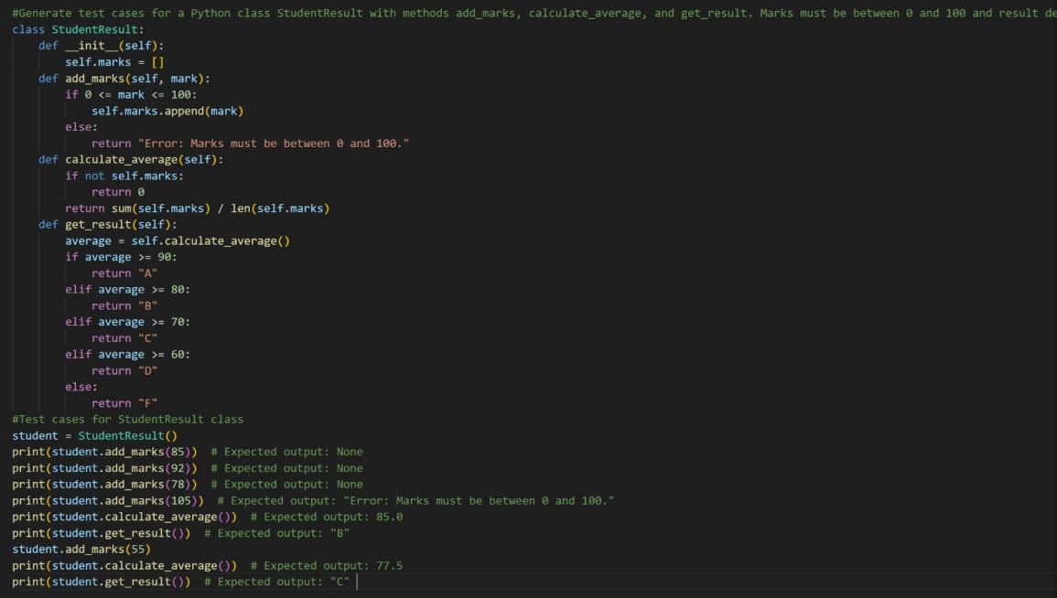

OUTPUT:

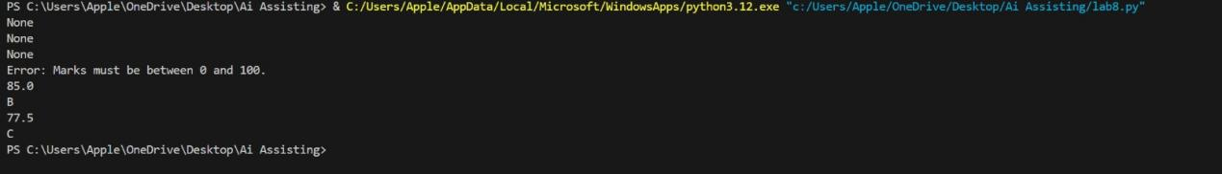

Assertion Test Cases Prompt:

Write Python assertion statements to test the StudentResult class.

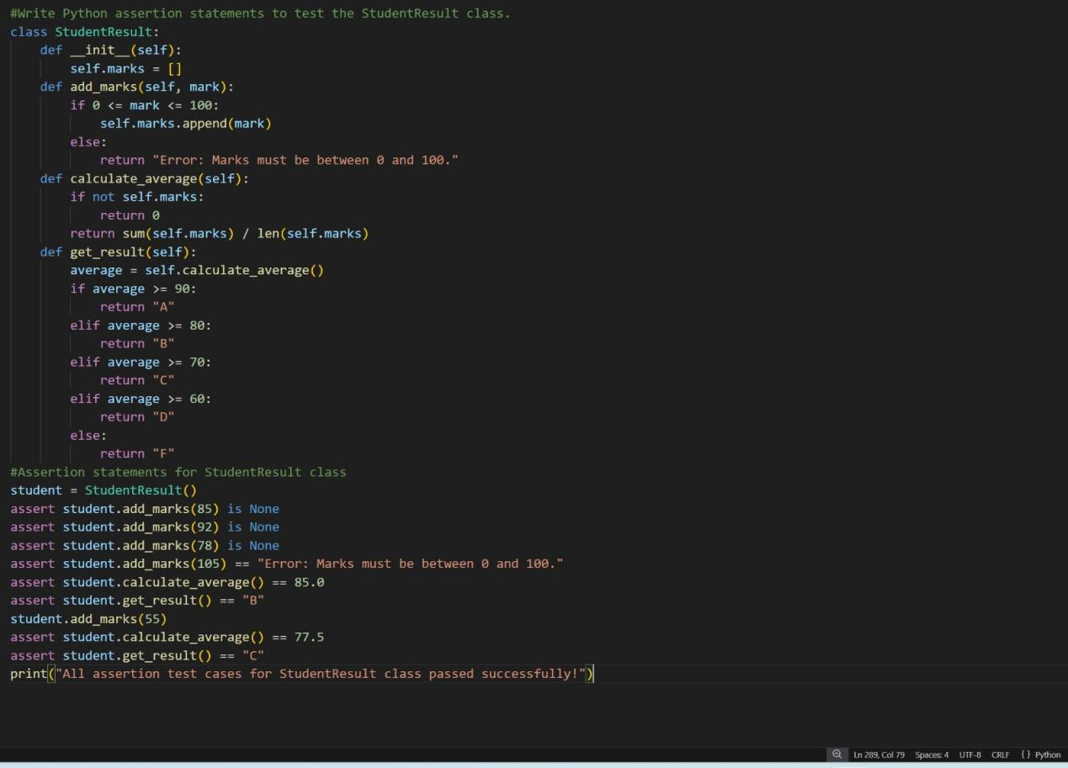

OUTPUT:

Unit Test Cases Prompt:

Write Python unittest test cases for the StudentResult class including valid marks, invalid marks, pass, and fail cases.
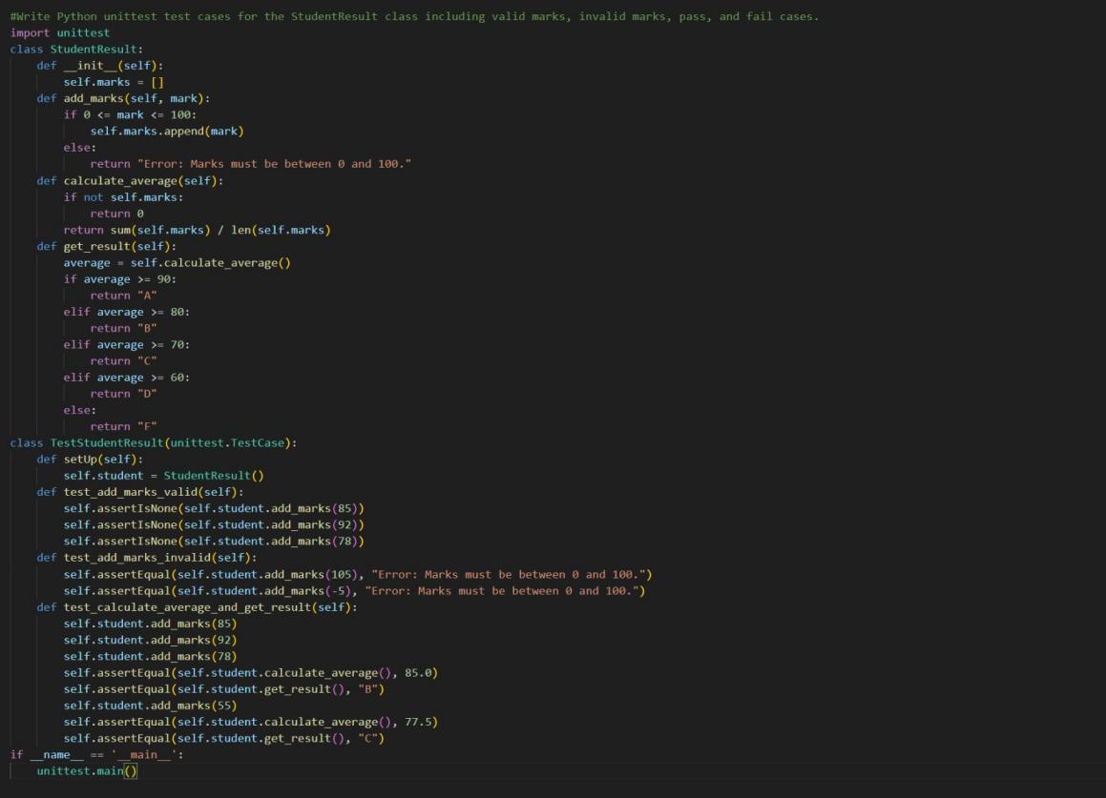

OUTPUT:

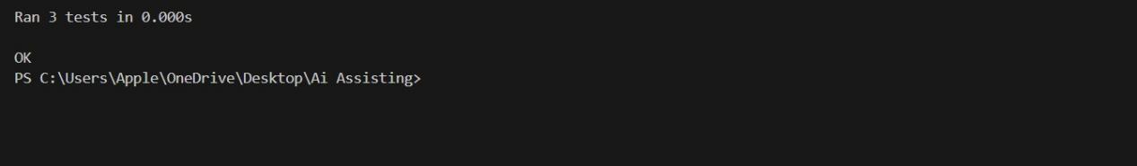

Pytest Cases Prompt:

Generate pytest test cases using assert statements for the StudentResult class methods.

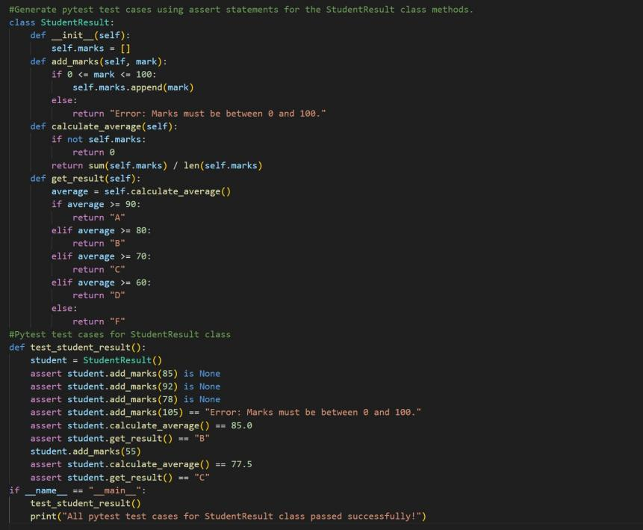

OUTPUT:

Code Explanation:

The StudentResult class manages student marks and determines performance. The add_marks() method validates that marks are within the allowed range (0–100) before storing them. The calculate_average() method computes the average score, and get_result() decides whether the student passes or fails based on that average.

The class includes validation and edge-case handling to ensure reliable behavior. Test-driven development is used to confirm that all methods work correctly under different scenarios.

Task 5 – Test-Driven Development for Username Validator
Requirements:
• Minimum length: 5 characters
• No spaces allowed
• Only alphanumeric characters
Example Test Scenarios:
is_valid_username("user01") → True
is_valid_username("ai") → False
is_valid_username("user name") → False
is_valid_username("user@123") → False
Expected Output 5
A username validation function that passes all AI-generated test cases.

General Test Cases Prompt:

Generate test cases for a Python function is_valid_username(username) that checks minimum length, no spaces, and only alphanumeric characters.

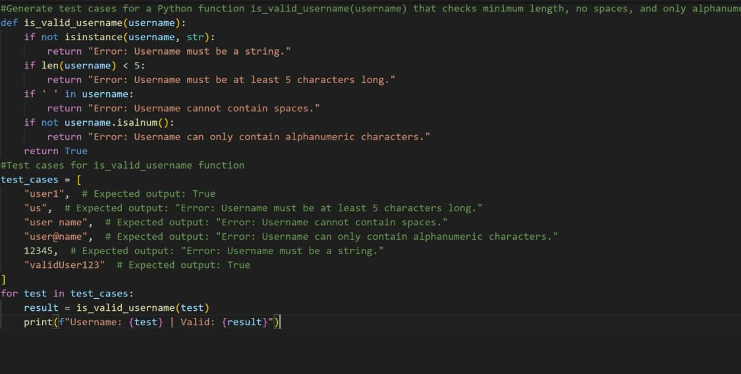

OUTPUT:

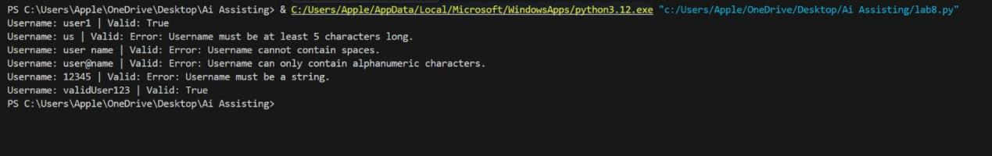

Assertion Test Cases Prompt:

Write Python assertion statements to test the function is_valid_username(username).

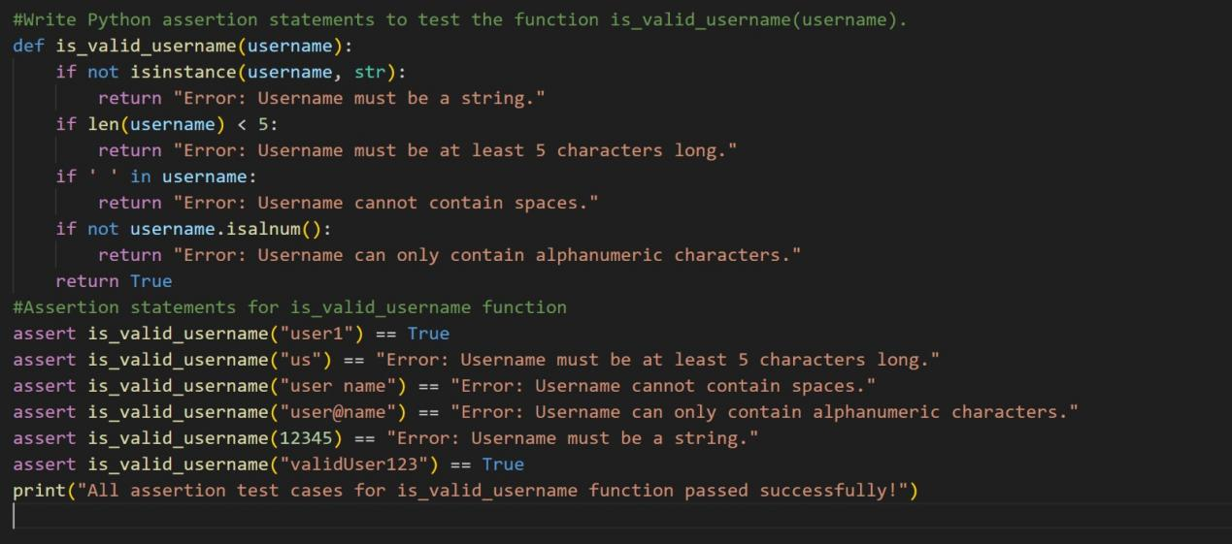

OUTPUT:

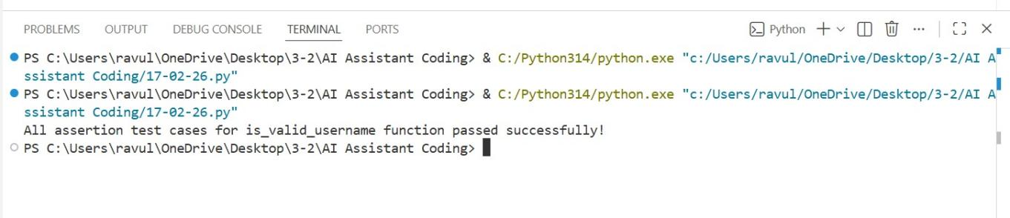

Unit Test Cases Prompt:

Write Python unittest test cases for the function is_valid_username(username) including valid, short, space, and special character cases.

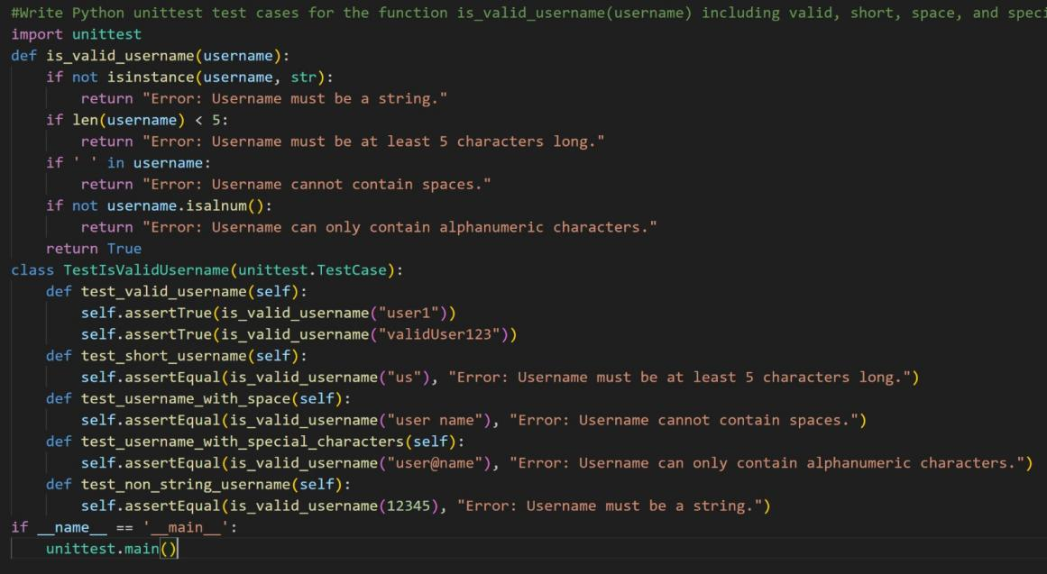

OUTPUT:

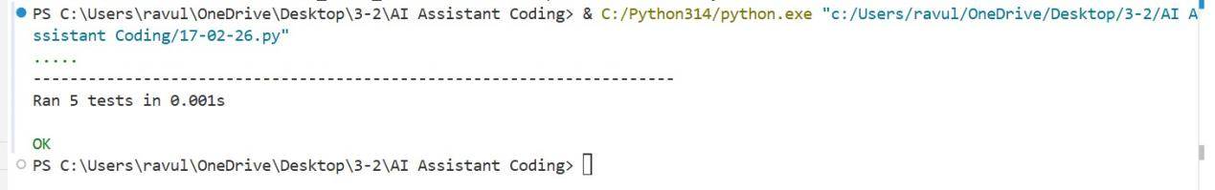

Pytest Cases Prompt:

Generate pytest test cases using assert statements for the function is_valid_username(username).

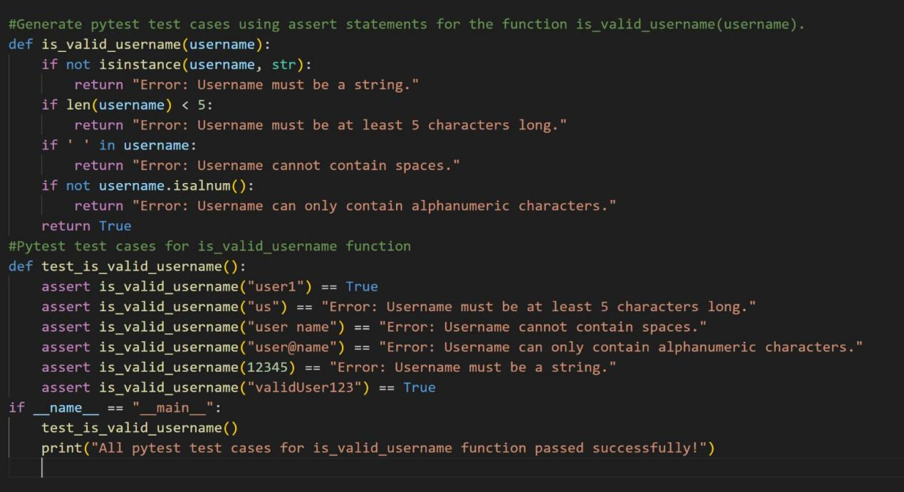

OUTPUT:

Code Explanation:

The function is_valid_username(username) checks whether a username follows the required validation rules. It verifies that the input is a string, has a minimum length of five characters, contains no spaces, and includes only alphanumeric characters.

If any rule is violated, the function returns false, ensuring invalid usernames are rejected. Test-driven development is used to confirm the validator works correctly across valid, invalid, and edge-case inputs.

