AI ASSISTED CODING
ASSIGNMENT-6.1

Name: V. VYSHNAVI
Batch:14
2303A51968

Task Description #1 (AI-Based Code Completion for Loops) Task: Use an AI code completion tool to generate a loop-based program.
Prompt:
“Generate Python code to print all even numbers between 1 and N using a loop.”
Expected Output:
- AI-generated loop logic.
- Identification of loop type used (for or while).
- Validation with sample inputs.
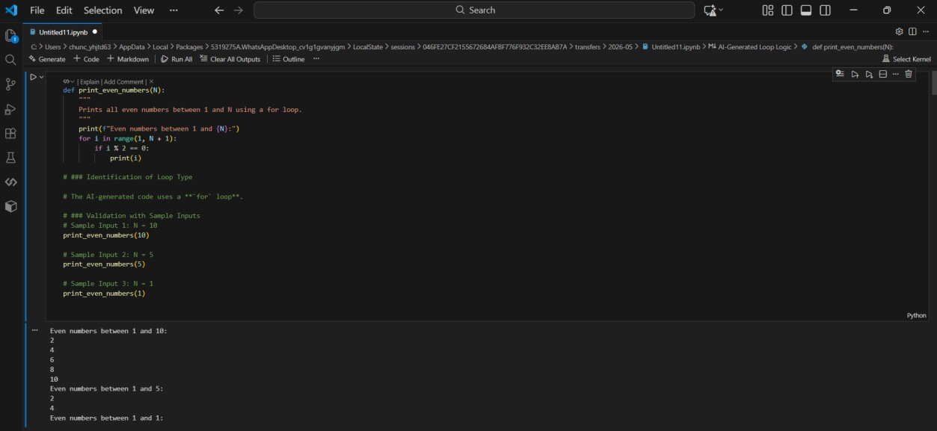
Task Description #2 (AI-Based Code Completion for Loop with
Conditionals)
Task: Use an AI code completion tool to combine loops and conditionals.
Prompt:
“Generate Python code to count how many numbers in a list are even and odd.”
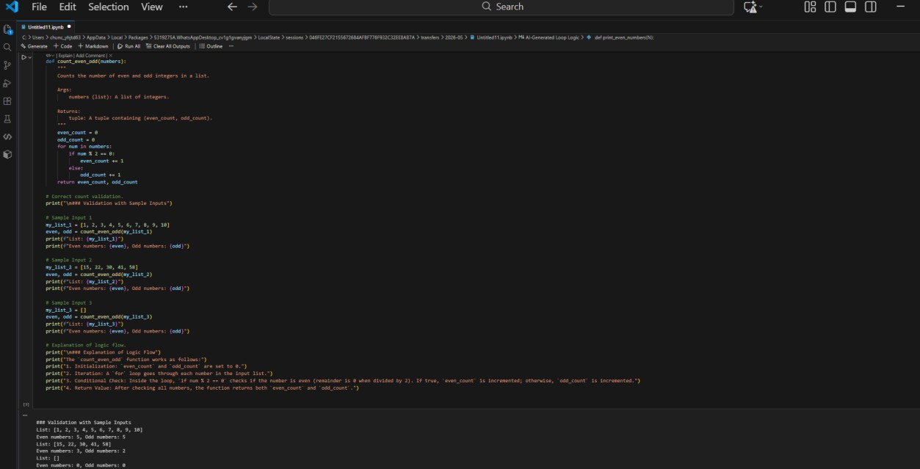
Expected Output:
- AI-generated code using loop and if condition.
- Correct count validation.
- Explanation of logic flow.
Task Description #3 (AI-Based Code Completion for Class
Attributes Validation)
Task: Use an AI tool to complete a Python class that validates user input.
Prompt:
“Generate a Python class User that validates age and email using conditional statements.”
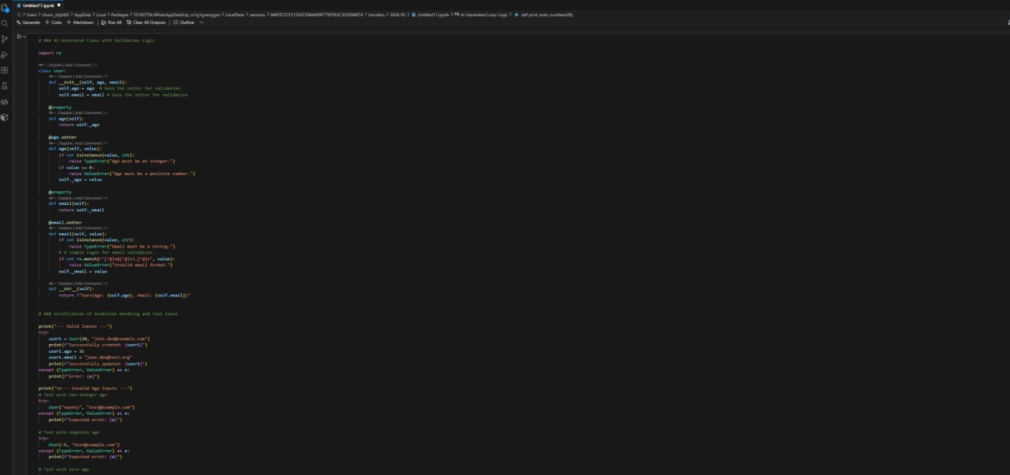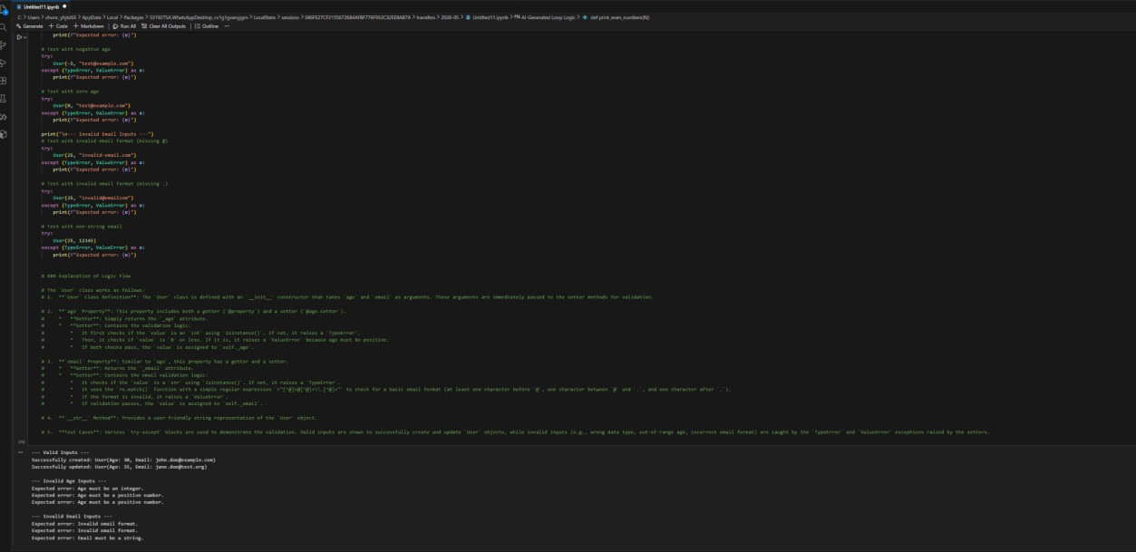
Expected Output:
- AI-generated class with validation logic.
- Verification of condition handling.
- Test cases for valid and invalid inputs.
Task Description #4 (AI-Based Code Completion for Classes) Task: Use an AI code completion tool to generate a Python class for managing student details.
Prompt:
“Generate a Python class Student with attributes (name, roll number, marks) and methods to calculate total and average marks.”
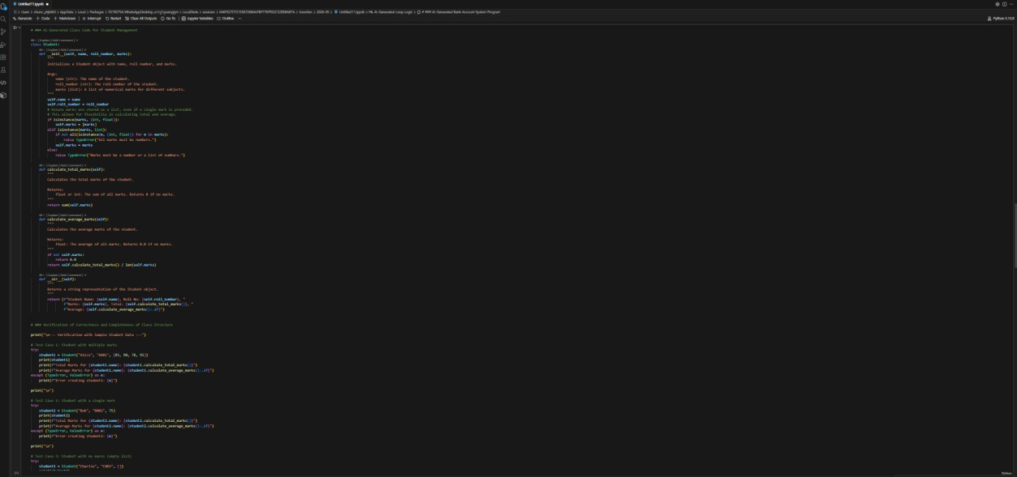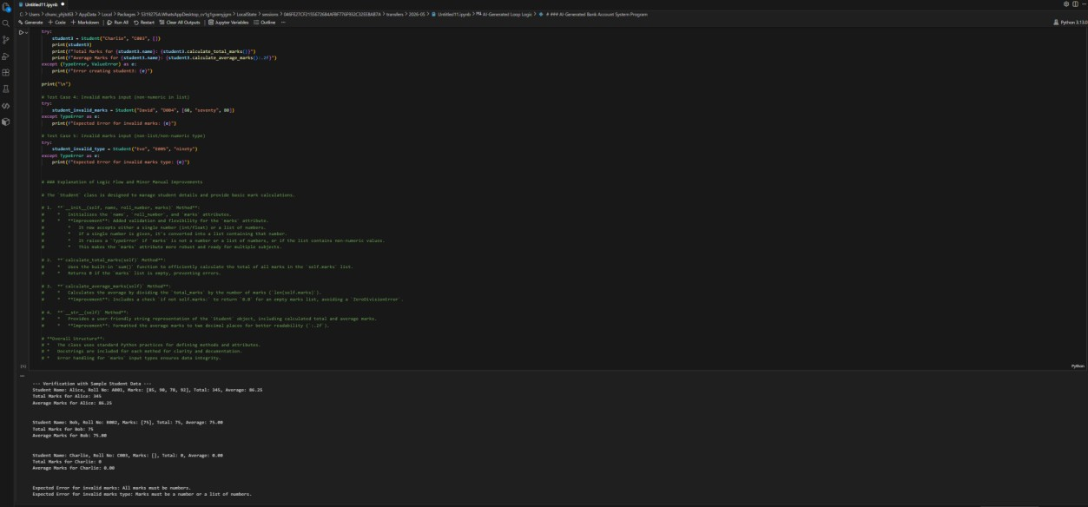
Expected Output:
- AI-generated class code.
- Verification of correctness and completeness of class structure.
- Minor manual improvements (if needed) with justification.
Task Description 5 (AI-Assisted Code Completion Review) Task: Use an AI tool to generate a complete Python program using classes, loops, and conditionals together.
Prompt: “Generate a Python program for a simple bank account system using class, loops, and conditional statements.” 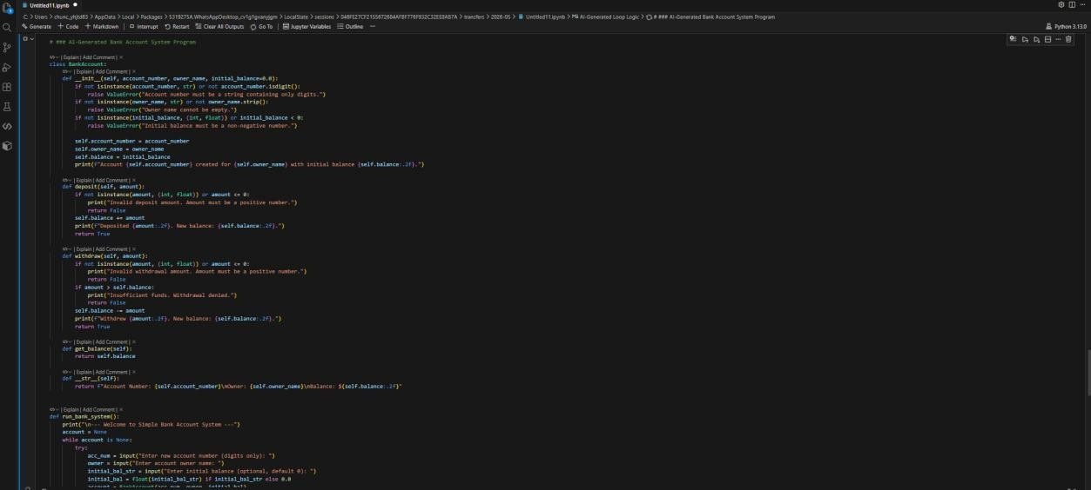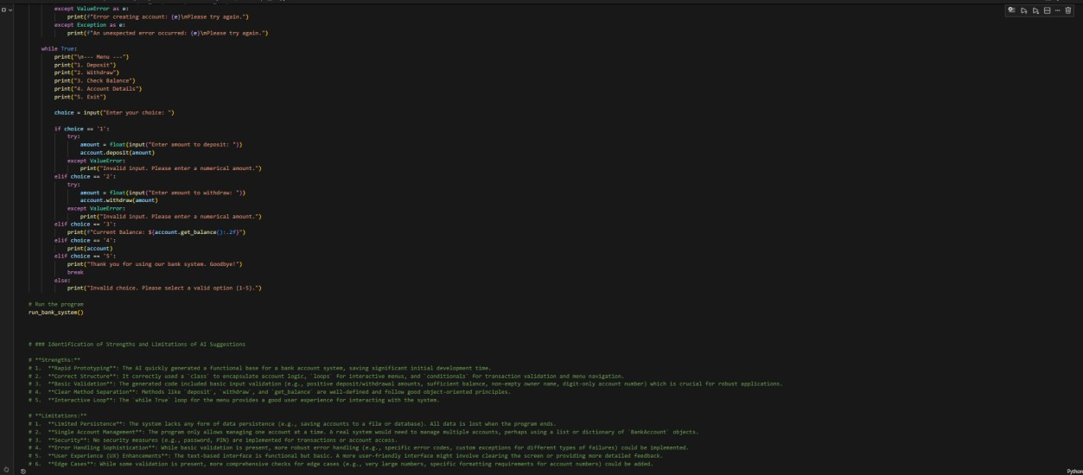
Expected Output:
- Complete AI-generated program.
- Identification of strengths and limitations of AI suggestions.
- Reflection on how AI assisted coding productivity.

