Agile in Jira
Agile is a way of developing software in small, incremental cycles with continuous feedback.
Key Agile values:
- Working software over documentation
- Customer collaboration
- Responding to change
Agile focuses on iterative development with frequent feedback and continuous improvement
Scrum
Scrum is an Agile framework used for development.
Key Scrum terms:
- Sprint
- Backlog
- Sprint Planning
- Daily Stand-up
Used when work is planned in time-boxed iterations.
Scrum Roles:
Role | Responsibility
Product Owner | Prioritizes backlog
Scrum Master | Facilitates Scrum
Development Team | Builds product
Scrum flow in Jira:
Create Backlog → Plan Sprint → Execute Sprint → Review → Retrospective
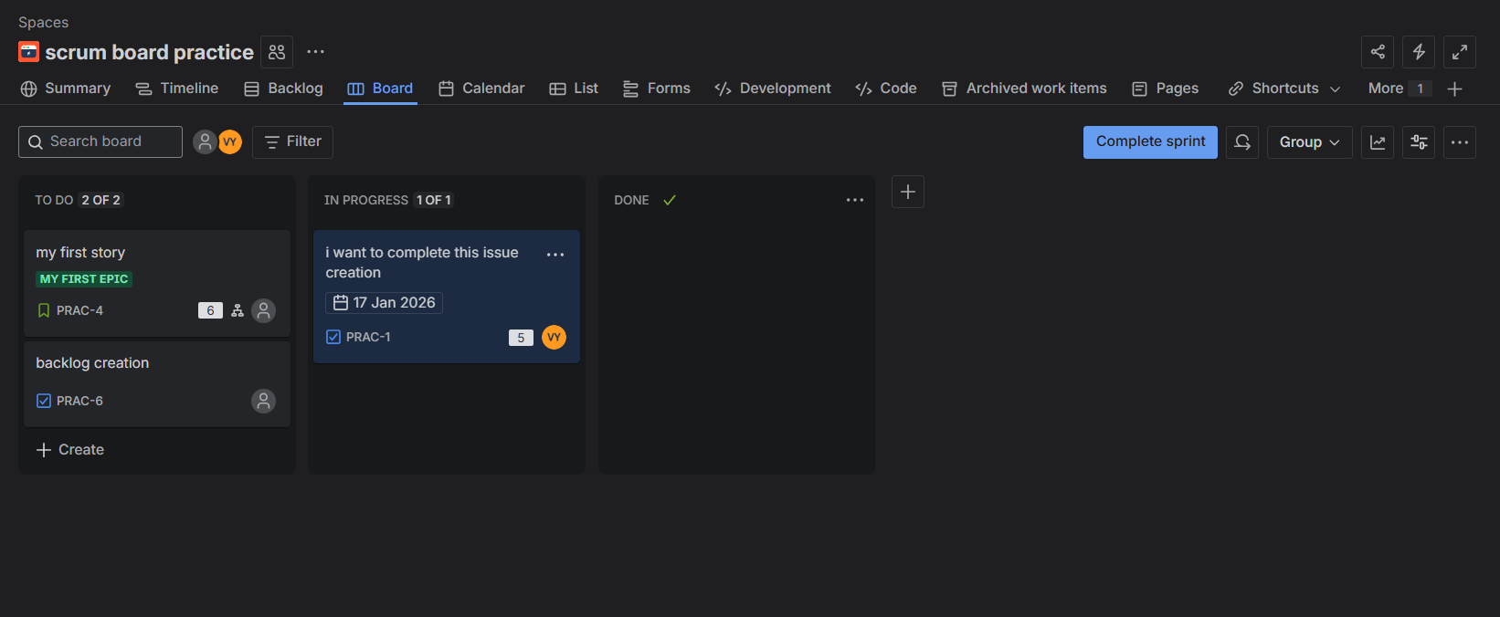
Story Points & Estimation in Jira
Estimation is the process of predicting effort required to complete a task.
Why estimation is needed?
- Sprint planning
- Capacity planning
- Tracking progress
- Predicting delivery
Story Points are relative units of effort used to estimate work.
They consider:
- Complexity
- Effort
- Risk
- Uncertainty
Step-by-Step:
- Open Backlog Click an issue
- Find Story Points field
- Enter value (e.g., 5) Save
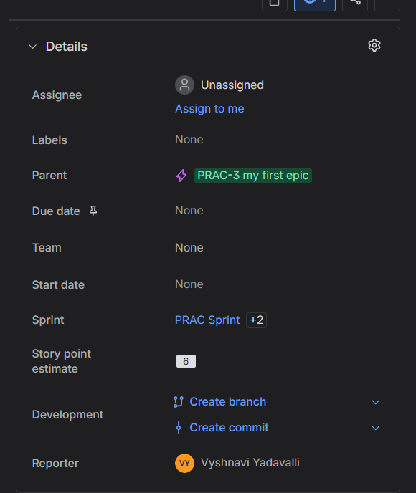
Daily Stand-ups Using Jira
A Daily Stand-up is a short (15-minute) daily meeting where the team synchronizes work.
Board View is used for stand-ups
- Scrum Board → Active sprint only
- Kanban Board → Ongoing work
During stand-ups, we update Jira live to reflect actual progress.
Kanban
Kanban is an Agile method focused on continuous delivery.
Key Principle:
“Stop starting, start finishing.”
- Focus on completing work, not just starting new work.
Key features:
- No fixed sprint
- Continuous workflow
- Work-in-progress (WIP) limits
WIP Limit = Maximum number of issues allowed in a column at a time.
Hands-On (Set WIP Limit in Jira):
- Open Kanban Board
- Click Board Settings → Columns
- Set WIP Limit for each column
- Save
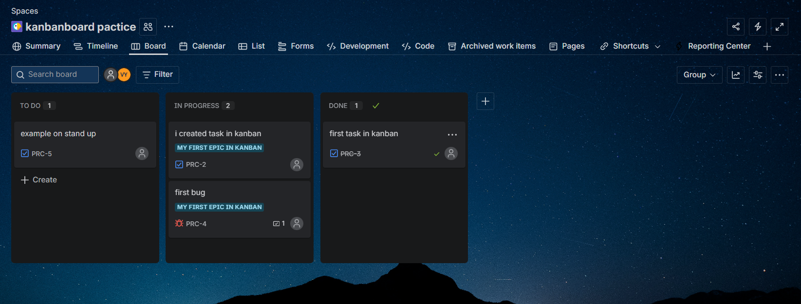
Cumulative Flow Diagram (CFD) in Jira
A Cumulative Flow Diagram (CFD) is a graph that shows the number of issues in each workflow status over time.
It helps you understand:
- How work is flowing
- Where work is getting stuck
- Whether the team is overloaded
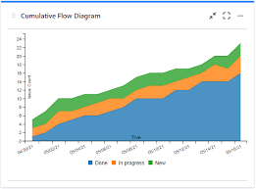
Bug Life Cycle
Open → In Progress → Fixed → Retest → Closed
HANDS-ON – CREATING & MANAGING A BUG IN JIRA
- Click Create
- Issue Type → Bug
- Fill Summary, Description
- Set Priority
- Assign to developer
- Save
