XRAY SETUP & CONFIGURATION
Xray Setup?
Setup = Installing + Configuring Xray so teams can use it properly.
It includes:
✔ Installing Xray
✔ Enabling features
✔ Configuring project behavior
✔ Permissions
✔ Default settings
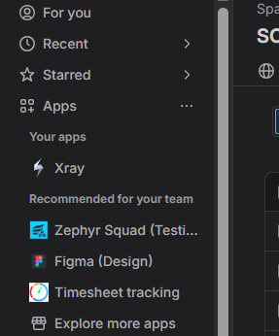
Xray Cloud?
Xray Cloud is Xray hosted on Atlassian Cloud.
You do NOT need:
Servers
Database
Manual upgrades
Everything is handled by Atlassian
User Browser
↓
Jira Cloud
↓
Xray Cloud App
↓
Atlassian Infrastructure

Benefits of Xray Cloud
✔ Quick setup
✔ Always updated
✔ Secure
✔ Scalable
✔ Remote access
✔ Low maintenance
Project-Level Configuration?
Settings that apply only to a specific Jira project.
Example:
Banking Project may need strict workflow,
Demo Project may need simple workflow.
Global Settings
Apply to ALL projects.
Controlled by Jira Admin.
Examples:
✔ License
✔ Global permissions
✔ Integration settings
✔ Storage rules
Project Settings
Apply to ONLY one project.
Controlled by Project Admin.
Examples:
✔ Field visibility
✔ Workflow
✔ Test types
✔ Notifications
Feature | Global | Project
Scope | All projects | Single project
Who controls | Jira Admin | Project Admin
Impact | System-wide | Local
Risk | High | Low
Example | License | Workflow

Xray Issue Types?
Xray adds special issue types inside Jira specifically for test management.
These issue types behave like normal Jira issues but contain testing features and panels.
Main Xray Issue Types:
Test
Test Execution
Test Plan
Test Set
Precondition

Test
Represents a test case.
Contains:
✔ Test steps
✔ Expected results
✔ Test type (Manual / Automated / Cucumber)
✔ Preconditions
✔ Linked requirements
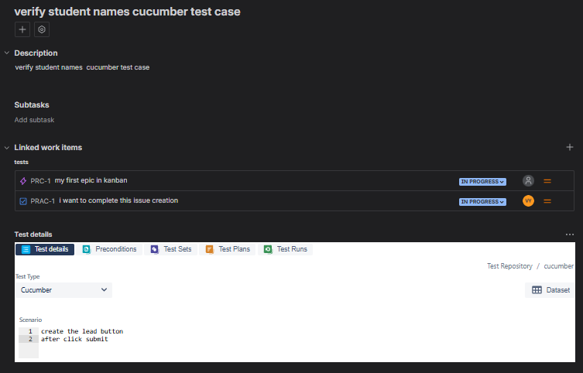
Test Execution
Represents running the tests.
Contains:
✔ Execution status
✔ Tester name
✔ Date & time
✔ Evidence
✔ Linked defects
Test Plan
Defines scope of testing for a sprint or release.
Contains:
✔ Tests to be executed
✔ Schedule
✔ Objectives
✔ Environment info

Test Set
Used to group related tests.
Contains:
✔ List of tests
✔ Logical grouping
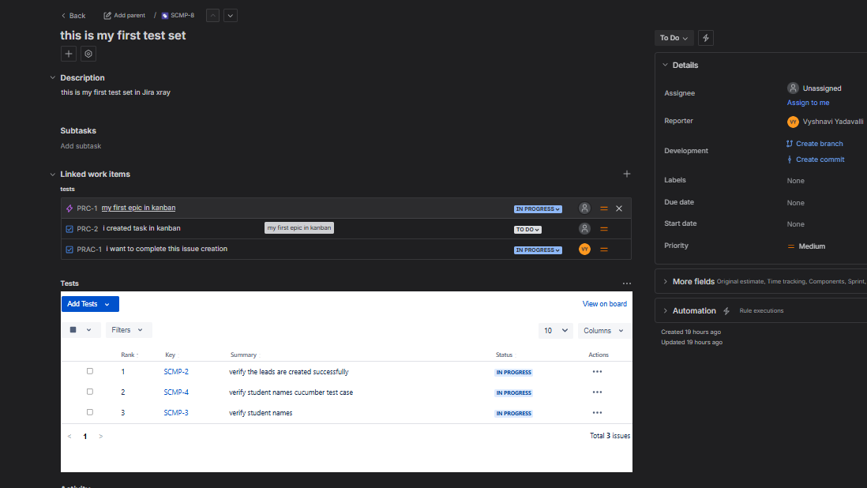
Precondition
Defines what must be true before executing a test.
Reusable.
Contains:
✔ Setup steps
✔ Environment requirement
✔ Data setup

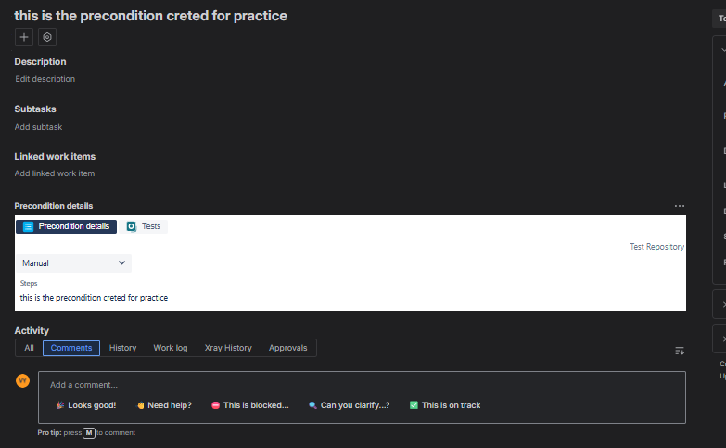
UI & Panels in Xray
When you open a Test, Test Execution, Test Plan, Xray adds special panels (sections) to the Jira issue screen.
These panels show:
✔ Test steps
✔ Coverage
✔ Execution history
✔ Defects
✔ Evidence
Panels = Working area for testers.
Test Details Panel
📍 Found in Test issue
Shows:
- Test steps
- Expected results
- Parameters
- Test type (Manual / Automated / BDD)
✔ Where test logic is written
✔ Supports structured testing
Coverage Panel
📍 Found in Test / Test Plan
Shows:
- Linked Stories
- Requirements
- Defects coverage
- Traceability
✔ Shows what is tested
✔ Detects gaps
✔ Audit compliance
Execution Panel
📍 Found in Test Execution
Shows:
- List of tests
- Execution status
- Executor
- Date & time
- Evidence
✔ Central execution dashboard
✔ Tracks progress
Defect Visibility Panel
📍 Found in Execution/Test
Shows:
- Linked Bugs
- Status of bugs
- Retest history
✔ Quick debugging
✔ Quality tracking

Navigation Shortcuts
📍 Top Menu / Sidebar
Quick access to:
- Tests
- Executions
- Plans
- Reports
✔ Faster navigation
✔ Saves time
Roles & Permissions
Permissions define:
✔ Who can see Xray
✔ Who can create tests
✔ Who can execute tests
✔ Who can edit settings
✔ Who can view reports
Xray uses Jira permission system.
No separate login for Xray.
Common Roles in Projects
QA / Tester Role
✔ Create Tests
✔ Edit Test Steps
✔ Create Test Executions
✔ Execute tests
✔ Attach Evidence
✔ Link defects
✔ View reports
Developer Role
✔ View Tests
✔ Execute assigned tests
✔ View defects
✔ Comment
Project Admin Role
✔ Configure project settings
✔ Manage workflows
✔ Manage permissions
✔ Customize fields
Xray Issue Types:
