MANUAL TEST CASE MANAGEMENT
Create a Test Issue
- Click Create Issue
- Project → Select project
- Issue Type → Select Test
- Fill the fields:
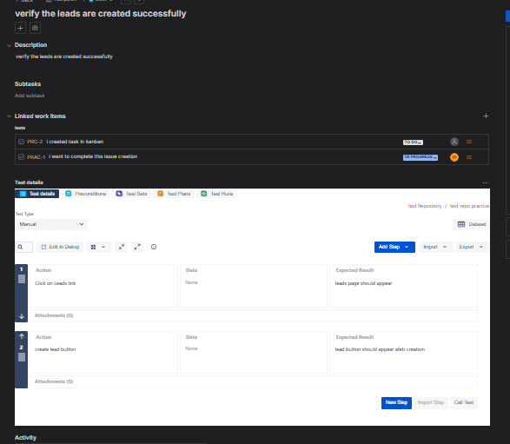
Precondition :
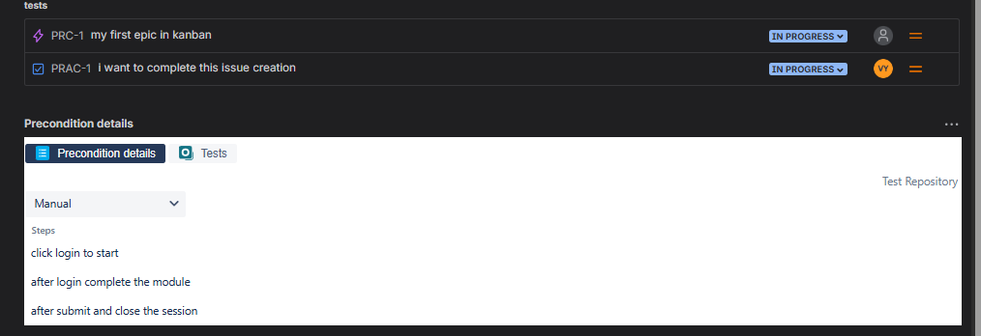

Test Design?
Test Design means:
✔ Deciding how to write test cases
✔ Choosing test structure
✔ Selecting right scenarios
✔ Covering positive & negative flows
Good test design ensures maximum coverage with minimum test cases.
Step-Based Tests (Structured Tests)
These tests contain:
- Step number
- Action
- Expected Result
Step | Action | Expected
1 | Open login page | Page loads
2 | Enter username | Accepted
3 | Enter password | Accepted
4 | Click Login | Dashboard appears
When to use:
✔ Manual testing
✔ Regression testing
✔ Audit compliance
✔ Beginner testers
. Unstructured Tests
These tests are written as plain text.
Example
Open the login page, enter valid credentials, and verify successful login.
When to use:
✔ Exploratory testing
✔ Quick testing
✔ POCs
How to Select Test Scenarios
Use these techniques:
✅ Functional Coverage
- Valid input
- Invalid input
- Boundary values
✅ Business Priority
Test critical flows first:
- Login
- Payment
- Data saving
✅ Risk-Based Testing
High-risk areas:
- Security
- Payment
- Data loss

Test Organization
✔ Structuring test cases logically
✔ Easy searching and maintenance
✔ Faster execution
✔ Better reporting

Types of Test Grouping

Smoke Tests

Small set of critical tests to verify build stability.

Example:
- App launches
- Login works
- Dashboard loads

Regression Tests

Large set of tests to ensure old functionality still works.

Example:
- All modules

Feature-wise Grouping
Group by functionality.
- Example:
- Login Tests
- Payment Tests
- Profile Tests

Environment-wise Grouping

Group by:
- Web
- Mobile
- API

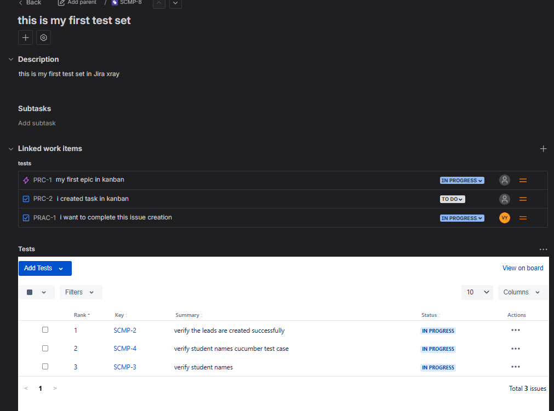

LINKING STRATEGY

Linking in Xray

Linking means connecting:

✔ Tests ↔ Stories

✔ Tests ↔ Tasks

✔ Tests ↔ Bugs

✔ Executions ↔ Defects

So you can track:

What was tested, what failed, and what remains untested.

Link Test to Story
- 1️⃣ Open a Test
- 2️⃣ Click Link Issue
- 3️⃣ Select Tests / Relates to
- 4️⃣ Choose the Story
- 5️⃣ Save

Link Bug to Failed Test
- 1️⃣ Open failed execution
- 2️⃣ Click Create Defect
- 3️⃣ Bug auto-linked
- 4️⃣ Track bug status

Link Test Set to Test Plan
- 1️⃣ Open Test Plan
- 2️⃣ Add Test Sets
- 3️⃣ Save

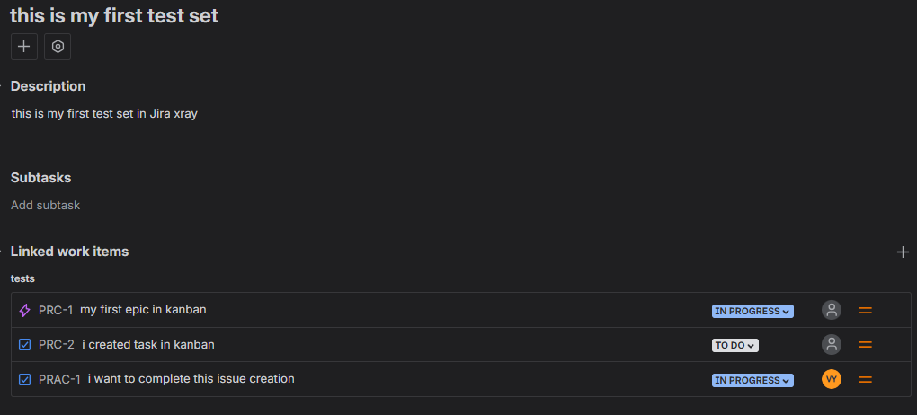

Traceability Visualization

Traceability
👉 Ability to track requirement to test and defect.

Traceability Matrix

Shows:

Requirement → Test → Execution → Defect

Used in:
- Compliance
- Reporting
- Audits

Coverage View
- Tested requirements
- Untested requirements
- Failed coverage

