Xray Basics:
What is Xray?
Xray is a Test Management Tool inside Jira.
It helps teams:
Write test cases
Organize tests
Execute tests
Track defects
Generate reports
Maintain traceability
- Xray works as a plugin/add-on for Jira.
Instead of using Excel or separate tools, everything happens inside Jira.
Example
Imagine you are building a Login Page.
You need to:
- Write test cases
- Run tests
- Report bugs
- Track results
Xray lets you do all this inside Jira itself.
Why Xray Exists?
Before Xray:
❌ Test cases stored in Excel
❌ No traceability
❌ Manual reporting
❌ Difficult collaboration
❌ Data loss risk
🎯 Xray solves these problems:
Problem | Solution
Scattered test data | Centralized inside Jira
No traceability | Requirement → Test → Bug mapping
Manual reports | Automatic dashboards
No audit trail | Full history maintained
Poor collaboration | Team access

Xray in Agile Projects
Agile works in Sprints.
Each sprint has:
- User Stories
- Development
- Testing
- Bug fixing
- Release
- How Xray fits in Agile:
User Story → Create Tests → Execute → Log Defects → Report

Jira vs Xray
Feature | Jira | Xray
Issue tracking | ✅ | ✅
Test management | ❌ | ✅
Test execution | ❌ | ✅
Evidence upload | ❌ | ✅
Traceability | Limited | Full
Reports | Basic | Advanced
Automation integration | ❌ | ✅

👉 Jira = Project Management
👉 Xray = Test Management inside Jira
What is Xray Architecture?
Architecture means how Xray is built, deployed, stored, and accessed.
In simple words:
Where Xray runs, how data is stored, and how users connect.
Xray has two main deployment types:
1️⃣ Xray Cloud
2️⃣ Xray Data Center

Xray Cloud?
Xray Cloud runs on Atlassian Cloud Infrastructure.
You don’t install anything locally. Everything runs online.
- Hosted by Atlassian
- Access through browser
- Automatic updates
- No server maintenance

Architecture Flow – Cloud

User Browser
↓
Jira Cloud
↓
Xray Cloud Plugin
↓
Atlassian Cloud Database

Best for:
Small to medium teams
Startups
Remote teams
Quick setup
No IT maintenance

Xray Data Center?
Xray Data Center is installed on company-owned servers or private cloud.
You control:
- Servers
- Database
- Security
- Backup
- Performance

Architecture Flow – Data Center
User Browser
↓
Company Network
↓
Jira Data Center Server
↓
Xray Plugin
↓
Enterprise Database (Oracle / PostgreSQL)
Best for:
Large enterprises
Banking / Government
Strict security rules
Heavy data usage
Custom integrations
Cloud vs Data Center Comparison

Feature | Xray Cloud | Xray Data Center
Hosting | Atlassian | Company
Maintenance | Atlassian | Company IT
Setup | Very fast | Complex
Scalability | Auto | Manual
Security control | Limited | Full
Cost | Subscription | License + infra
Customization | Limited | High
Performance tuning | Not allowed | Allowed

Licensing Basics
Xray license depends on:
📌 Number of Jira users
📌 Cloud or Data Center
☁️ Cloud Licensing
- Monthly / yearly subscription
- Charged per user
- Managed by Atlassian Marketplace
Data Center Licensing
- Annual license
- Based on number of users
- Separate server cost
Enterprise Usage Scenarios
How Big Companies Use Xray
Scenario 1 – Banking System
Challenges:
- Compliance
- Audit reports
- Security
- Large regression suite
Xray Solution:
Traceability matrix
Audit history
Evidence storage
Role permissions
Automation integration
Scenario 2 – E-Commerce Platform
Challenges:
- Frequent releases
- Heavy automation
- Fast feedback
Xray Solution:
CI/CD integration
Automated execution reports
Real-time dashboards
Release tracking
Xray Core Concepts?
Xray works using special issue types inside Jira.
These issue types help manage testing lifecycle.
Main concepts:
1️⃣ Test
2️⃣ Test Execution
3️⃣ Test Plan
4️⃣ Test Set
5️⃣ Precondition
6️⃣ Evidence
Test (Test Case)
A Test represents a single test case.
✔ What it contains:
- Test steps
- Expected result
- Preconditions
- Test type (Manual / Automated)
- Linked requirement (Story)
📌 Example:
Test Name:
Verify user can login with valid credentials
Steps:
- Open login page
- Enter valid username
- Enter valid password
- Click Login
Test Execution
A Test Execution is where you run the tests.
It stores:
✔ Pass / Fail / Blocked status
✔ Who executed
✔ Date & time
✔ Evidence
✔ Linked defects
📌 Example:
Test Execution:
Sprint 5 Login Testing
Inside it:
- Test 1 → Pass
- Test 2 → Fail
- Bug created
Test Plan
A Test Plan defines what tests will be executed for a release or sprint.
It answers:
✔ What to test?
✔ When to test?
✔ Scope of testing
📌 Example:
Test Plan:
Release 1.2 Regression Plan
Includes:
- Login tests
- Payment tests
- Profile tests
Test Set
A Test Set is just a collection of related tests.
Used for grouping.
📌 Example:
Test Set:
Smoke Tests
Contains:
- Login Test
- Dashboard Load Test
- Logout Test
Precondition
A Precondition defines what must exist before running a test.
Reusable across tests.
📌 Example:
Precondition:
User must be registered and active
Used in:
- Login test
- Password reset test
- Profile update test
Evidence
Evidence is proof of execution.
Includes:
✔ Screenshots
✔ Videos
✔ Logs
✔ Documents
Used for:
- Audits
- Debugging
- Compliance

How they connect:
Story → Test → Test Set → Test Plan → Test Execution → Evidence → Defect
TOOL COMPARISON — XRAY vs ZEPHYR vs TESTRAIL
Feature | Xray | Zephyr | TestRail
Jira Integration | ⭐⭐⭐⭐⭐ | ⭐⭐⭐⭐ | ⭐⭐
Automation Support | ⭐⭐⭐⭐⭐ | ⭐⭐ | ⭐⭐⭐
Traceability | ⭐⭐⭐⭐⭐ | ⭐⭐⭐ | ⭐⭐⭐
Reporting | Advanced | Basic | Advanced
Scalability | Enterprise | Small–Medium | Medium
Compliance | Strong | Limited | Medium
Setup Complexity | Medium | Easy | Medium
Customization | High | Low | Medium
Cloud Support | Yes | Yes | Yes
Data Center | Yes | Limited | No
🏦 Banking Company
Needs:
- Compliance
- Traceability
- Audit
- Security
👉 Best choice: Xray
🚀 Startup Team
Needs:
- Fast setup
- Low cost
- Simple usage
👉 Best choice: Zephyr
🧪 QA Company (No Jira)
Needs:Test-focused tool
- Rich reporting
👉 Best choice: TestRail
Xray Menu
Login to your Jira account
Open any project
Look at the top menu → Click Apps or More
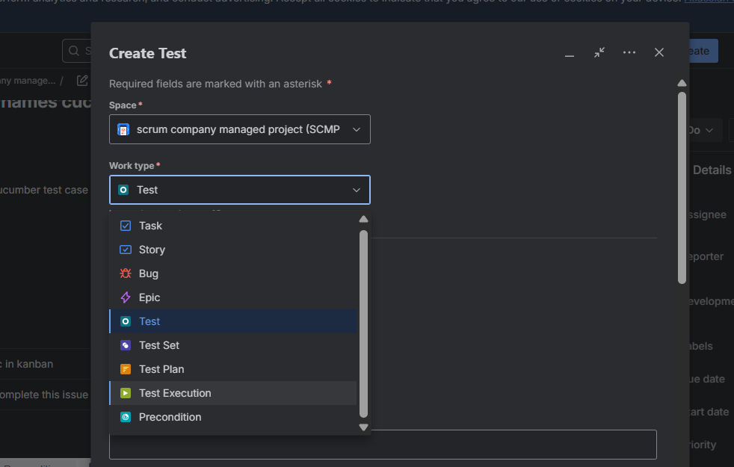
Sample test
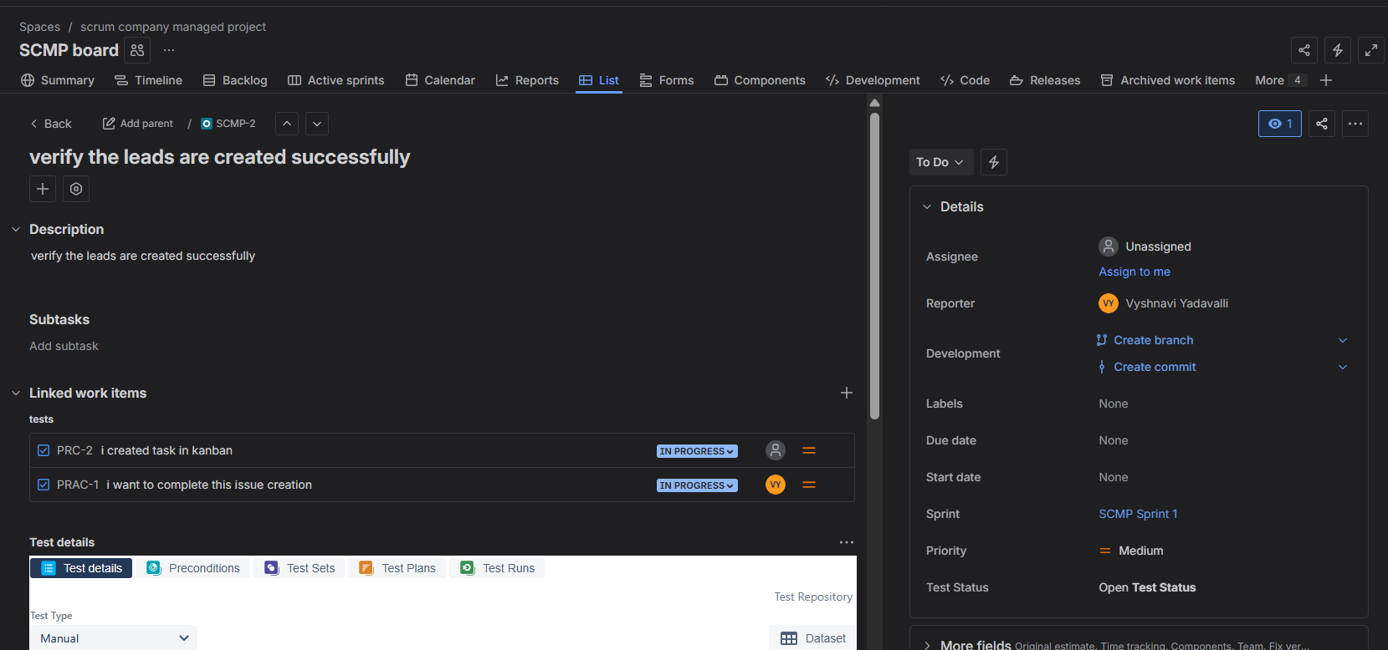
Comparison Table for Story Test and Bug:
Feature | Story | Test | Bug
Purpose | Requirement | Validation | Defect
Description | Business | Steps | Problem
Execution Panel | ❌ | ✅ | ❌
Evidence | ❌ | ✅ | Sometimes
Traceability | Medium | High | Medium
Automation | ❌ | ✅ | ❌

