Question.4)1. Create a rule to automatically assign a bug to a developer when the priority is set to highest give in Jira
Steps to Execute this:
- Go to your Jira project
- Click Project Settings and click Automation
- Click Create Rule
- Add Trigger i.e, Select Issue Created (or) Field Value Changed
- Choose Field Value Changed and select priority
- Now Add Condition --> Click New Condition and
Set:
- Field → Priority
- Condition → equals
- Value → Highest
7.Add another condition IssueType=Bug
8.Click New Action and Assign Issue
Now set Assignee is Select Developer in your team
9.Save and Enable
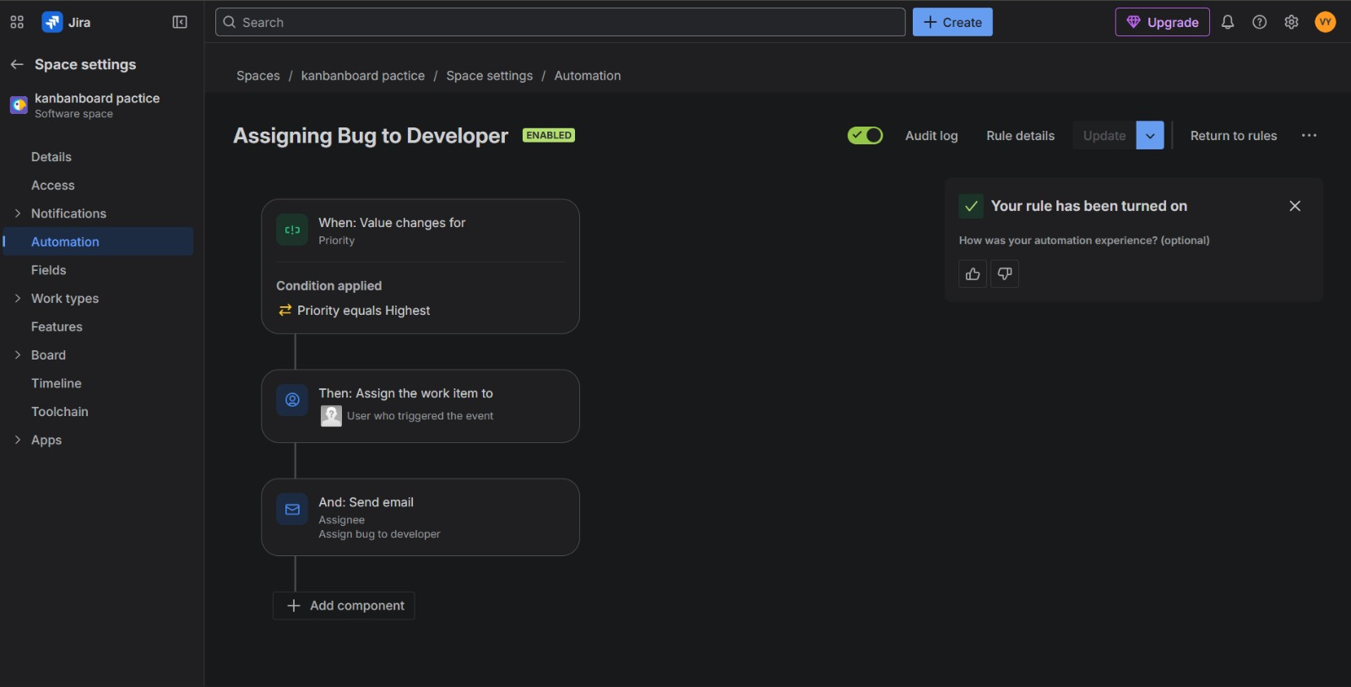

Question.4)2. Write a Query to find all unresolved bugs in a specific project assigned to a specific user example: Project=P1 and Issue Type=Bug and Status !=Done and Assignee=Current User
After execution this query will show:
All open bugs in selected project that was assigned to current user
Steps to execute this query:
1.Open jql in jira
2.After write the required query i.e,
project="kanbanboard pactice" AND issuetype=Bug AND priority=Medium AND status !=Done
- project="kanbanboard pactice": Filters for that specific project
- issuetype=Bug: Only shows items marked as bugs.
- priority=Medium: Only shows issues with a medium priority level.
- Status !=Done: Excludes any issues that are already completed.
