Report in Testing
Execution report, coverage report, and traceability report for test progress, requirement coverage, and end-to-end tracking.
Xray reports provide real-time visibility into test execution status, requirement coverage, and full traceability to support release decisions and audits
A summarized view of testing status for decision making
Reports answer questions like:
- Are we ready to release?
- How much is tested?
- How many tests passed/failed?
- Which requirements are not tested?
- Where are the risks?
Xray Reports
✅ Real-time
✅ Live from Jira data
✅ Audit-ready
✅ Management friendly
Types of Xray Reports
Execution Report
Coverage Report
Traceability Report

Execution Report
Shows test execution progress and results
It answers:
- How many tests executed?
- How many passed?
- How many failed?
- How many blocked?
- What is remaining?
It Contains:
- Total tests
- PASS / FAIL / BLOCKED / TODO count
- Execution progress %
- List of failed tests
- Linked defects
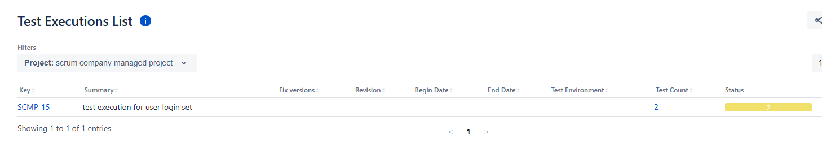
Coverage Report
Shows how much of the requirement scope is covered by tests
It answers:
- Which stories have tests?
- Which stories are not tested?
- Which stories are failing?
- Which stories are fully passed?

It Shows:
Story | Tests | Status
Story-1 | 5 | PASS
Story-2 | 0 | ❌ NO COVERAGE
Story-3 | 3 | ❌ FAIL

Traceability Report
Shows end-to-end links:
Requirement → Test → Execution → Defect
It answers:
- For this story:
  - Which test?
  - Which execution?
  - Which bug?
Used For:
✅ Audits
✅ Compliance
✅ Client reporting
✅ Impact analysis
Dashboard
By creating a Jira dashboard, adding Xray gadgets, and configuring them using Test Plans, Test Executions, or saved JQL filters.
Dashboards in Jira using Xray gadgets provide real-time visual status of test execution, coverage, and defects for stakeholders
A single screen that shows live testing & quality status
Instead of opening 10 issues, managers open 1 dashboard.
✅ Real-time visibility
✅ One-click status
✅ Daily standup tracking
✅ Management reporting
✅ Release go/no-go decisions
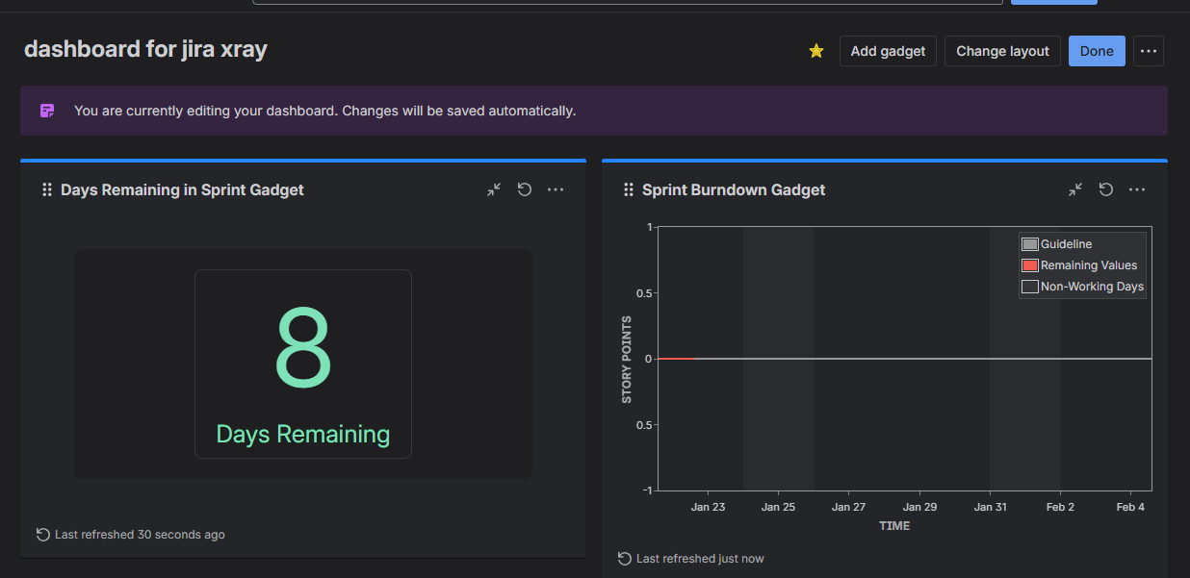
Xray Gadget
Small report widget added to dashboard
Examples:
- Test Execution Status gadget
- Test Plan Progress gadget
- Requirement Coverage gadget
- Traceability gadget
Real Project Dashboard
QA Manager Dashboard:
- Top: Overall execution progress
- Left: Failed tests list
- Right: Blocked tests
- Bottom: Coverage by requirement
Dashboard Sharing & Permissions
You can share:
- With:
  - QA team
  - Developers
  - Managers
  - Client
Permissions:
- View only
- Edit
Quality Metric
A number that tells how good or bad the product or testing is
Metrics help answer:
- Is quality improving?
- Is testing effective?
Types:
Pass Percentage
Pass % = (Passed tests / Total tests) × 100
Used for:
- Daily status
- Go/No-Go decision
2. Defect Leakage
Bugs found in production
Lower = Better quality
3. Reopen Rate
How many bugs come back after being “fixed”
High = Poor fix quality
4. Test Effectiveness
How many bugs were found by QA before release
5. Fail Rate Trend
Is failure going down across sprints?
Xray gives:
- Execution reports
- Trend reports
- Dashboard gadgets
From that you calculate:
- Pass %
- Fail %
- Blocked %
- Coverage %
BDD WITH XRAY
BDD is a behavior-driven approach using Gherkin language, and Xray supports it by allowing Cucumber tests, scenario management, and automation result tracking.
Xray supports BDD by managing Gherkin-based Cucumber tests and tracking their execution and quality metrics through reports and dashboards.
Behavior Driven Development
Tests are written in plain English style
Gherkin Language
BDD uses Gherkin syntax:
Feature: Login
Scenario: Login with valid credentials
Given user is on login page
When user enters valid username and password
Then user should see dashboard

Given – When – Then Meaning
Keyword | Meaning
Given | Precondition
When | Action
Then | Expected result

BDD Workflow
Business writes scenarios
↓
QA reviews/refines
↓
Dev automates
↓
Automation runs
↓
Results imported to Xray
Uses of BDD
Business-readable tests
✅ Common language
✅ Better collaboration
✅ Direct automation mapping
✅ Scenarios become tests
✅ Results tracked in Xray
✅ Reports & traceability maintained
✅ Audit-ready

