TestRail Fundamentals
Testrail:
TestRail is a test management tool used to manage test cases, execute tests, track results, and generate reports. It helps teams maintain traceability and improve testing efficiency
TestRail is a Test Case Management Tool used to:
✔️ Create test cases
✔️ Organize test cases
✔️ Execute test cases
✔️ Track test results
✔️ Generate reports
✔️ Integrate with defect tools (JIRA, etc.)
TestRail helps QA teams manage all testing activities in one place instead of Excel.
TestRail solves :
✅ Centralized system
✅ Real-time collaboration
✅ Automatic reporting
✅ History tracking
✅ Role-based access
Test Case Management
Test Case Management means:
- Writing test cases
- Organizing them
- Executing them
- Tracking results
- Maintaining history
TestRail is a Test Case Management System (TCMS).
Key Components of TestRail
Component | Purpose
Projects | Container for testing
Test Suites | Group of test cases
Test Cases | Individual test scenarios
Test Runs | Execution cycle
Test Plans | Multiple runs
Milestones | Sprint / release
Reports | Metrics
Users | Team members
Uses TestRail by:
- Manual Testers
- Automation Engineers
- QA Leads
- Product Managers
- Business Analysts

TestRail Fits in SDLC
SDLC Phase | TestRail Usage
Requirement | Link test cases
Design | Create test scenarios
Development | Prepare regression
Testing | Execute tests
Release | Generate reports
Maintenance | Reuse cases

Agile Workflow Example
Sprint Planning →Create test cases →Create test run →Execute tests →Log defects →Generate report →Sprint review
Integrations
TestRail integrates with:
- JIRA
- Selenium
- Jenkins
- GitHub
- Azure DevOps

TestRail Interface?
- The TestRail Interface (UI) is the screen where users:
✔️ Navigate projects
✔️ Create and manage test cases
✔️ Execute test runs
✔️ View reports
✔️ Manage users and settings
👉 A good understanding of UI helps you work faster and avoid mistakes.
TestRail UI consists of dashboard, project workspace, navigation bar, and administration panel, enabling efficient test management and execution.
TestRail UI is divided into 5 main areas:
1️⃣ Top Navigation Bar
2️⃣ Dashboard
3️⃣ Projects Page
4️⃣ Project Workspace
5️⃣ Administration Panel
1. Top Navigation Bar
Located at the top of the screen.
Contains:
- 🏠 Dashboard
- 📂 Projects
- 📊 Reports
- ⚙️ Administration
- 👤 User Profile
Purpose:
👉 Allows quick switching between modules.
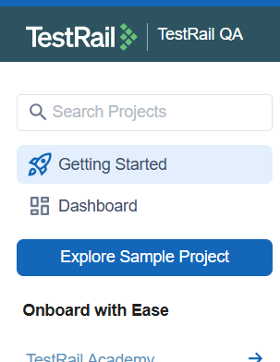
🔹 2. Dashboard
The first screen after login.
Shows:
- Recent projects
- Test activity
- Assigned test runs
- Progress widgets
Used by:
✔️ Testers to see assignments
✔️ Leads to track progress
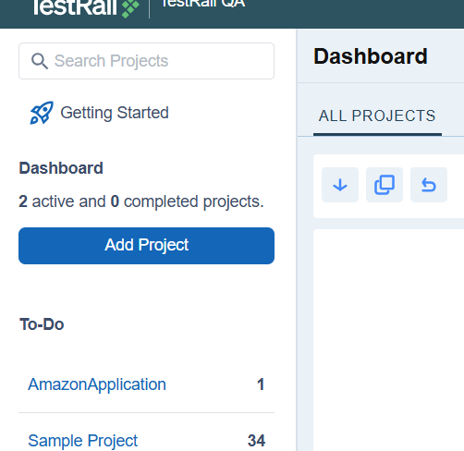
🔹 3. Projects Page
Displays:
- List of all projects
- Project status (active / completed)
- Search projects
- Create new project button

🔹 4. Project Workspace
Inside a project you will see:
Tab | Purpose
Test Cases | Create and manage cases
Test Runs & Results | Execute tests
Milestones | Sprint tracking
Reports | Generate metrics
Project Settings | Configure project
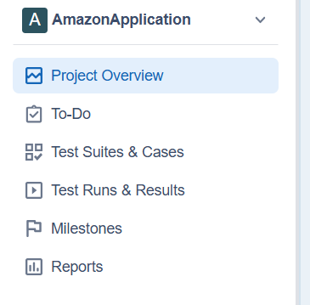
🔹 5. Administration Panel
Visible only for admins.
Contains:
- User management
- Roles & permissions
- Custom fields
- Integrations
- System settings
✔️ UI is divided into navigation, dashboard, workspace
✔️ Project workspace is main working area
✔️ Admin panel controls system
✔️ Filters improve productivity
✔️ Breadcrumb helps navigation
Project in TestRail
A project in TestRail is a workspace that contains test cases, runs, plans, milestones, and reports
A Project is a container that holds:
✔️ Test cases
✔️ Test runs
✔️ Test plans
✔️ Milestones
✔️ Reports
✔️ Users
Every application you test will have one TestRail project.
Example:
- Project Name: E-Commerce Website Testing
- Project contains all test cases related to that website.
Create a Project
When creating a project, you must select:
Project Name
Meaningful and clear.
Repository Type
✅ Single Repository
- One common test case repository.
- Used for small / medium projects.
- Easy maintenance.
✅ Multiple Test Suites
- Separate test suites per module.
- Used for large projects.
- Better organization.
Project Settings
You can configure:
- Project description
- Repository mode
- Access permissions
- Status
- Milestones
- Templates

When to Use Which Repository Type
Scenario | Recommended
Small project | Single Repository
Large enterprise | Multiple Test Suites
Modular system | Multiple Test Suites
Startup MVP | Single Repository
Project Lifecycle
Create → Maintain → Archive → Restore
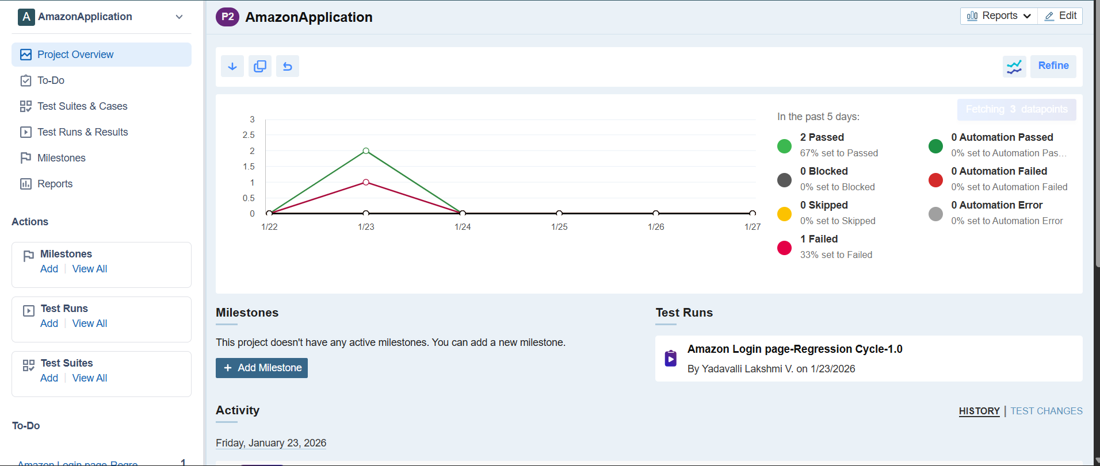

Test Case
A Test Case is a documented set of steps used to verify whether a feature works correctly.
It contains:
✔️ What to test
✔️ How to test
✔️ Expected result
Example:Test Case: Verify user can login with valid credentials.
Why Test Cases Are Important?
- Ensures consistent testing
- Prevents missed scenarios
- Helps regression testing
- Enables automation
- Provides documentation

Test Case Structure in TestRail
A typical test case contains:
Field | Description
Title | Short meaningful name
Preconditions | Setup needed
Steps | Actions
Expected Result | Outcome
Priority | High/Medium/Low
Type | Functional, Regression
Status | Active, Draft
Created By | Author
Last Updated | History
Test Case Templates
Templates define the structure:
- Text-based
- Step-based
- Custom templates
Used to maintain consistency.
Sections (Folders)
Used to organize test cases:
- Login
- Payment
- Profile
Custom Fields
You can add:
- Environment
- Build version
- Automation status
- Browser
History
Tracks:
- Who changed
- What changed
- When changed
Traceability
Link test cases to:
- Requirements
- Defects
- Automation
Parameterization
Same test case used with multiple inputs.
Bulk Operations
Mass edit / move / delete.
HANDS-ON PRACTICE
Step 1: Open Your Project
Step 2: Create Section
Step 3: Create Test Case
Step 4: Create Another Test Case
Step 5: Edit & View History
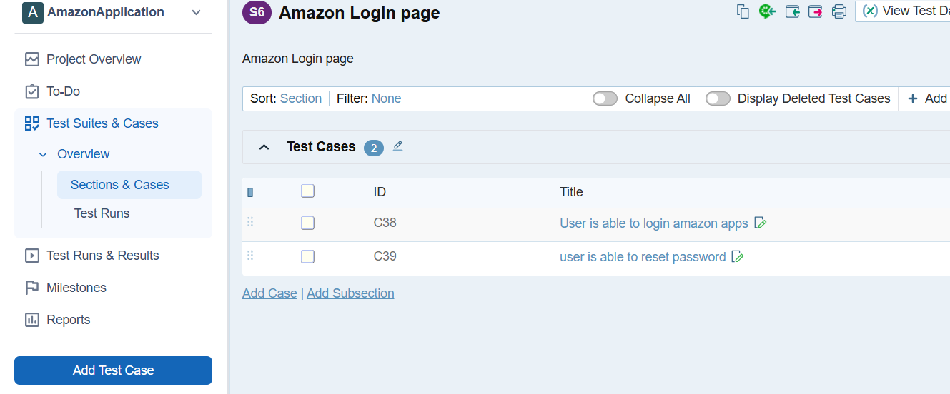Test Case Best Practices
Best practices are standard rules and methods used to:
✔️ Write clear test cases
✔️ Avoid confusion
✔️ Improve maintenance
✔️ Increase test coverage
✔️ Save time during execution
Good test cases = Faster testing + Fewer defects + Better reporting.
Naming Conventions
Format:
Module_Feature_Condition
Example:
Login_ValidCredentials_Success

