Question.5)1. Create a testcase for exploratory testing
Perform exploratory testing on the Login module to identify defects, usability issues, and unexpected behaviors without predefined test steps.
Preconditions for this:
Application is accessible
User is on Login Page
Valid and invalid credentials are available
Test Steps (Exploratory Charter):
- Enter valid username and password → verify successful login
- Enter invalid credentials → verify error message
- Leave fields empty → check validation messages
- Enter special characters and long inputs
- Test password visibility toggle
- Refresh page after entering data
- Try multiple failed login attempts
- Test login with slow internet (if possible)
- Navigate using browser back/forward buttons
- Check UI alignment and responsiveness
Steps to create:
1.Go to project
2.Click the create issue
3.Select Issue Type(Test)
4.Chose test type is Exploratory
5.Give the required steps and description
6.Save the test
7.Execute via TestExecution issue

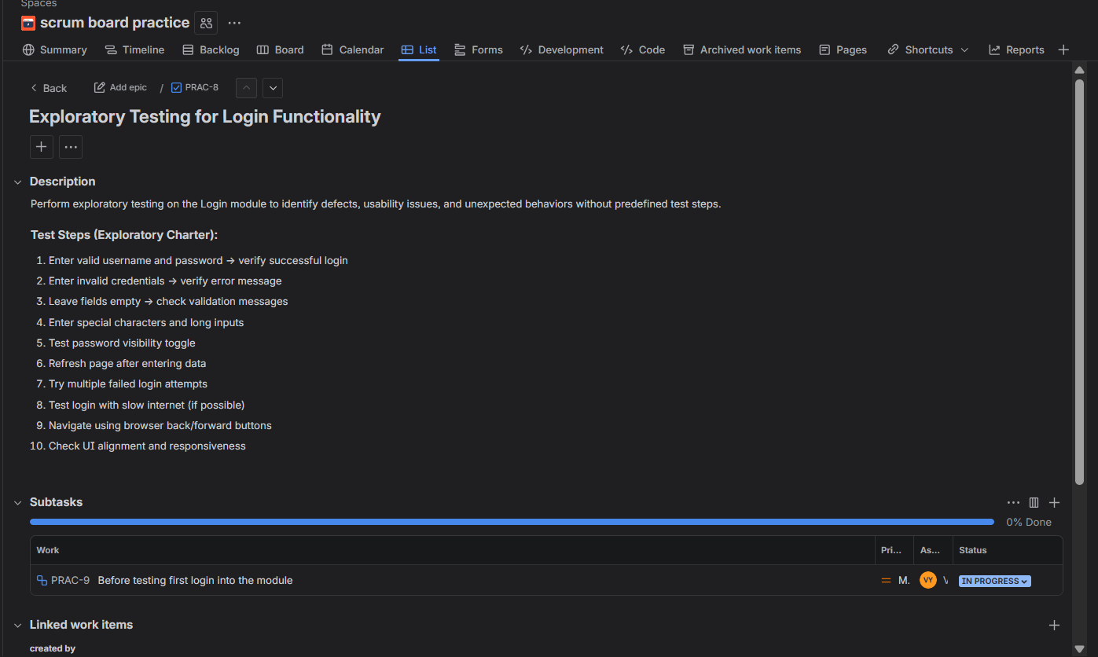
Question.5)2. Track the progress of a specific release or sprint
Steps to track the progress of the sprint
- Got to the project
- Open the active sprint
- Click on the board
- Now click on Reports and select burndown chart
- It shows the work remaining and time
- After select Sprint Report
- It shows the completed tasks, Incomplete tasks
- Select Cumulative flow diagram
- It shows track of todo, in progress, done tasks

